Career Strategy
  - Final Report
Manjari Kannan
Nicholas Decesaris
Oscar Quintero
April 13, 2026

Project Overview

Objective
This project examines job market trends in 2024 from the perspective of job seekers rather than recruiters. Using Lightcast data, we analyze hiring patterns, salaries, skills, and labor market conditions to understand how students can position themselves more effectively.

Research Question
Our project asks:
What trends in the 2024 job market can help students and early career professionals make better career decisions?

Why This Matters
Rapid changes in AI adoption, salary patterns, remote work, and employer skill expectations make the job market harder to navigate. A data driven approach helps identify which roles are growing, which skills matter most, and what kinds of jobs offer the best opportunities.

Planned Analysis
This project includes: - data cleaning and preprocessing - exploratory data analysis - unsupervised learning with KMeans clustering - supervised modeling using regression and classification - skill gap analysis - career recommendations for job seekers

Data Preparation

Overview
Before conducting exploratory analysis and predictive modeling, the Lightcast job postings dataset must be cleaned and standardized. Because the dataset includes many tracking variables, repeated industry and occupation code versions, and missing values, preprocessing is necessary to improve interpretability and reduce noise.

Goals of Data Cleaning
The main goals of data preparation are to: - remove columns that are irrelevant or redundant - keep the most current classification systems - handle missing values consistently - remove duplicate job postings - prepare the dataset for visualization and machine learning

Why Some Columns Should Be Dropped
The raw dataset contains many columns that are not useful for this project, such as URLs, duplicate tracking fields, and outdated industry and occupation code versions. Keeping too many repeated classification columns can make the analysis harder to interpret and may introduce unnecessary complexity.
For example, older NAICS and SOC versions are less useful when more current classifications are already available in the dataset. To keep the analysis focused and consistent, we retain the latest available fields such as NAICS_2022_6 and SOC_2021_4 and remove redundant older versions.

Example Python Cleaning Code
from pyspark.sql import functions as F
columns_to_drop = [
"ID",
"URL",
"ACTIVE_URLS",
"DUPLICATES",
"LAST_UPDATED_TIMESTAMP",
"NAICS2",
"NAICS3",
"NAICS4",
"NAICS5",
"NAICS6",
"SOC_2",
"SOC_3",
"SOC_5"
]
df_clean = df.drop(*columns_to_drop)

Handling Missing Values
Missing values are common in labor market data, especially for salary and skill related fields. Different strategies should be used depending on the data type.
For numerical variables such as salary, replacing missing values with the median is more appropriate than using the mean because salary data is often skewed by very high paying jobs. For categorical variables, missing values can be replaced with “Unknown” so that rows are not lost unnecessarily.
Columns with too many missing values may also be removed if they do not provide enough useful information.

Example Missing Value Handling
median_salary = df_clean.approxQuantile("SALARY", [0.5], 0.01)[0]
df_clean = df_clean.fillna({
"SALARY": median_salary,
"REMOTE_TYPE_NAME": "Unknown",
"NAICS_2022_6_NAME": "Unknown",
"SOC_2021_4_NAME": "Unknown"
})

Removing Duplicate Job Postings
Duplicate job postings can distort the results by counting the same opportunity multiple times. To prevent this, duplicate observations should be removed using a reasonable combination of identifying fields such as title, company, location, and posting date.

Example Duplicate Removal
df_clean = df_clean.dropDuplicates([
"TITLE",
"COMPANY_NAME",
"LOCATION",
"POSTED"
])

Why This Matters
Data cleaning improves the reliability of every later stage of the project. Cleaner data leads to:
- more accurate summaries and charts
- better model performance
- clearer interpretation for job seekers
- more trustworthy career recommendations

Output of Cleaning Step
After cleaning, the dataset is more suitable for:
- exploratory analysis of salary, industry, and remote work patterns
- clustering by occupation or industry categories
- regression models predicting salary
- classification models predicting job categories or remote work type

Exploratory Data Analysis

Overview
Before building any models, we explored the Lightcast job postings dataset to understand the underlying patterns in salary, industry composition, and AI-related job demand. This section summarizes what the data revealed about how AI roles compare to non-AI roles across key dimensions.
All analysis is based on the cleaned dataset of 70,892 job postings.

Defining AI vs Non-AI Roles
To distinguish AI-related jobs from the rest of the dataset, we flagged any posting where the job title or skills field contained keywords such as “ai”, “machine learning”, “artificial intelligence”, “deep learning”, “data science”, “nlp”, “llm”, or “neural network”.
This produced 31,857 AI-related postings (approximately 45% of the dataset) and 39,035 non-AI postings (approximately 55%). The near-even split suggests that AI-related roles have moved well beyond a niche segment of the labor market.

Salary Distribution: AI vs Non-AI
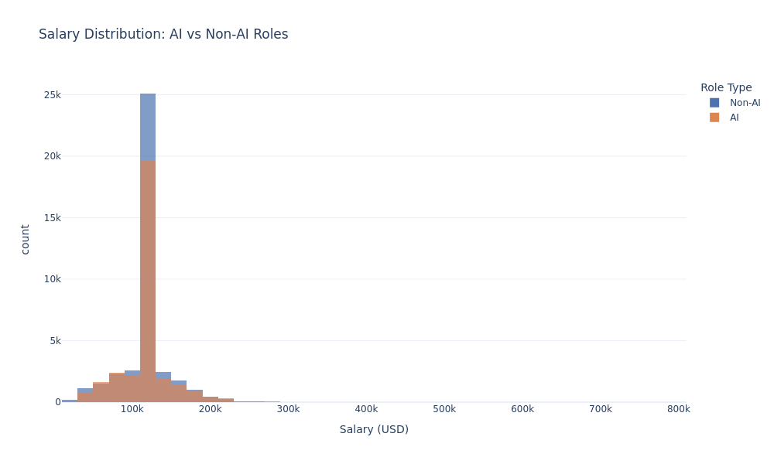
Salary Distribution
The first question we investigated was whether AI roles simply pay more. The overall pattern suggests they do not, at least not uniformly.
Both distributions peak near $112,500 and follow a similar right-skewed shape. The two groups overlap substantially, which indicates that holding an AI-related title does not automatically translate into higher compensation. The relationship between AI and salary appears to be more complex than a simple premium.

Average Salary by Industry: AI vs Non-AI
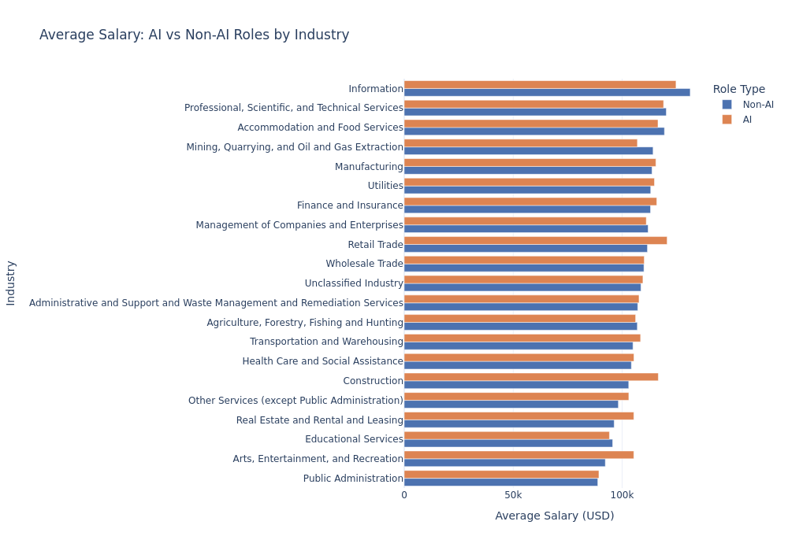
Salary by Industry
Breaking salary down by industry reveals a more nuanced picture. Certain industries show a meaningful AI salary premium, including Arts and Entertainment (approximately +$13,000), Construction (approximately +$13,500), and Retail Trade (approximately +$9,000). In these fields, AI skills remain relatively uncommon, and compensation reflects that scarcity.
In contrast, the Information industry pays AI roles less on average than non-AI roles. This is likely because traditional IT and enterprise infrastructure roles in that sector already command high salaries, making AI titles less financially distinctive by comparison.

Top Industries by AI Job Posting Count
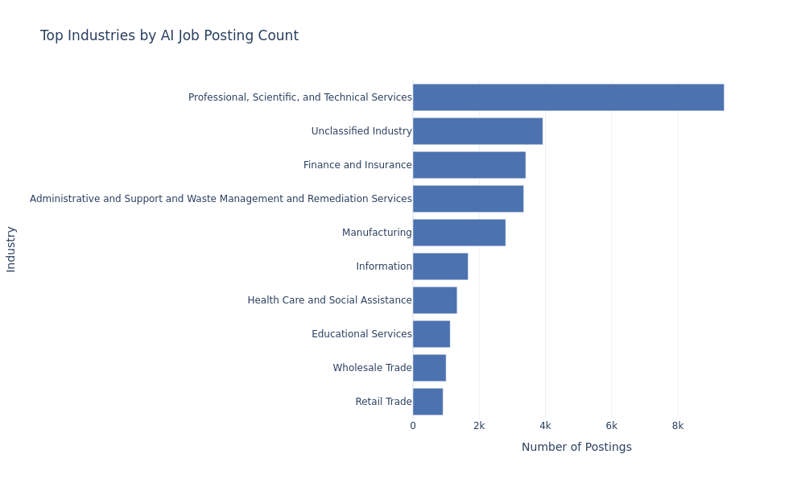
Top Industries
In terms of where AI jobs are being posted, Professional, Scientific, and Technical Services leads by a wide margin, followed by Finance and Insurance and Information. While AI-related roles appear across many sectors, the majority of active hiring remains concentrated in knowledge-intensive industries. For job seekers targeting AI roles, these sectors represent the highest volume of opportunity.

Key Findings
Several patterns emerged from this exploratory analysis worth carrying forward into the modeling phase.
The overall salary difference between AI and non-AI roles is negligible at roughly $100 on average. The salary premium associated with AI skills is industry-specific rather than universal. Fields where AI capabilities are still emerging tend to reward those skills more generously. And the concentration of AI hiring in professional services, finance, and information suggests that the benefits of AI are not evenly distributed across the workforce. Where a worker is employed matters as much as what skills they bring.

Predictive Modeling

Overview
This section applies three machine learning models to the cleaned Lightcast dataset: a linear regression model to predict salary, a logistic regression model to classify AI versus non-AI roles, and a KMeans clustering model to identify natural salary tiers across the job market. Together these models help quantify how job characteristics relate to compensation and AI demand.

Regression Model: Predicting Salary

Objective
The goal of this model is to predict the midpoint salary of a job posting based on observable job characteristics.

Feature Justification
Two versions of the model were tested. The first used industry, remote work type, and AI role flag as features. The second added occupation category and years of experience. Occupation category was expected to be the strongest predictor because salary varies substantially across professional fields regardless of industry.

Results
Model | Features | RMSE | R2
Model 1 | Industry, Remote Type, AI Flag | $31,428 | 0.0094
Model 2 | + Occupation, Experience | $30,040 | 0.0949

Interpretation
Adding occupation category and experience improved R2 from 0.009 to 0.095 and reduced RMSE by roughly $1,400. However, the overall explanatory power remains modest. This is expected given that salary is also shaped by factors not present in this dataset, such as company size, specific technical skills, education level, and negotiation. The low R2 is itself a finding worth noting: structured job characteristics explain only a small portion of salary variance, which suggests that individual and firm level factors play a larger role in determining compensation.

Classification Model: Predicting AI vs Non-AI Roles

Objective
This model attempts to classify whether a job posting is AI-related based on industry, remote work type, and occupation category.

Results
Metric | Score
Accuracy | 55.6%
F1 Score | 0.48
AUC | 0.54

Confusion Matrix
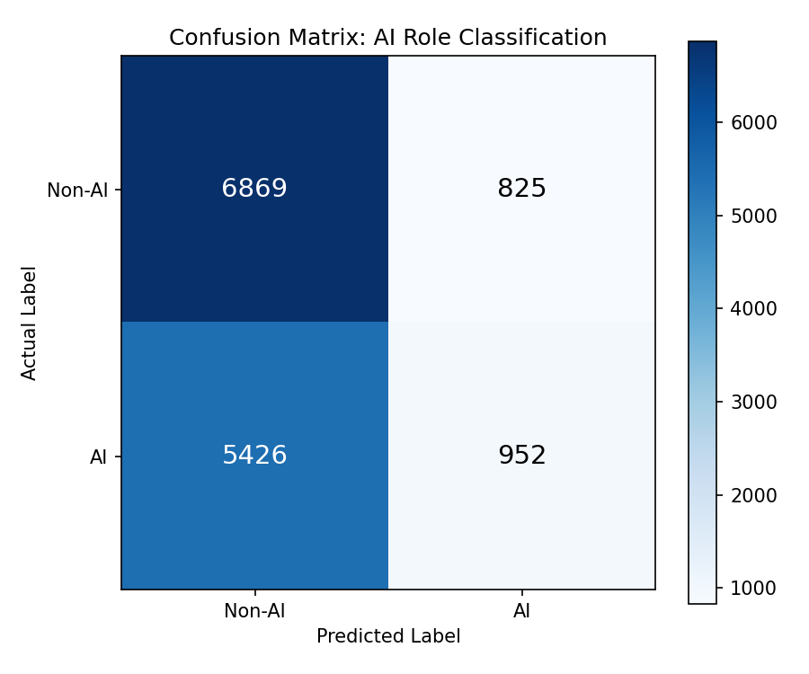
Confusion Matrix
The confusion matrix shows that the model correctly identifies most non-AI roles (6,869 true negatives) but misclassifies the majority of actual AI roles as non-AI (5,426 false negatives). This pattern reflects the core finding that AI roles are not structurally distinguishable from non-AI roles based on industry, remote type, and occupation category alone.

Interpretation
The model performs only slightly better than random guessing. This finding is informative rather than disappointing. It suggests that AI-related roles are spread across industries and occupation categories rather than being concentrated in obvious segments. The distinction between AI and non-AI roles lives primarily in the specific skills and title language of the posting, not in its structural characteristics.

KMeans Clustering: Salary Tiers

Objective
KMeans clustering was used to identify natural groupings in the job market based on industry, occupation, salary, and AI role status. Four clusters were specified based on the expectation that the market would segment into entry, mid, upper mid, and senior tiers.

Results
Cluster | Avg Salary (Non-AI) | Avg Salary (AI) | Job Count
Entry Level | $47,270 | $50,670 | 4,601
Mid Level | $82,528 | $82,259 | 7,700
Upper Mid Level | $114,743 | $114,707 | 51,215
Senior Level | $177,965 | $180,191 | 7,359

Interpretation
The clustering produced four well-separated salary tiers that are intuitive and interpretable. The most striking pattern is that within every cluster, AI and non-AI roles earn nearly identical average salaries. The salary tier a job belongs to is determined by its occupation and industry profile, not by whether it involves AI. This finding is consistent across all three models and forms the central conclusion of this analysis: AI designation alone does not drive salary. Structural job characteristics and market positioning matter more.

Skill Gap Analysis

Overview
This section examines which skills are most in demand across AI and non-AI job postings in the Lightcast dataset, and compares those findings to the skill profile of a typical business analytics student. The goal is to identify where gaps exist and what students should prioritize to remain competitive in an AI-influenced job market.

Top Skills in AI Roles
The fifteen most frequently requested skills across AI-related job postings are listed below.
Skill | Frequency
Communication | 16,483
Data Analysis | 15,188
Management | 12,316
Detail Oriented | 11,753
SQL | 11,717
Problem Solving | 10,351
Computer Science | 9,535
Leadership | 8,852
Python | 7,600
Operations | 7,299
Microsoft Excel | 7,057
Tableau | 6,904
Data Science | 6,617
Dashboard | 6,529
Project Management | 6,266

Top Skills in Non-AI Roles
Skill | Frequency
Communication | 14,621
Data Analysis | 12,502
Management | 11,813
SQL | 9,429
Leadership | 8,350
Problem Solving | 7,715
Project Management | 7,209
Computer Science | 7,133
Business Process | 6,998
Operations | 6,993
SAP Applications | 6,821
Business Requirements | 6,726
Finance | 6,147
Presentations | 5,763
Planning | 5,621

Comparing AI and Non-AI Skill Demand
Several patterns emerge when comparing the two lists. Communication, Data Analysis, Management, SQL, and Problem Solving rank highly in both, confirming that these are foundational skills regardless of whether a role is AI-related. However, AI roles place noticeably higher demand on Python, Tableau, Data Science, and Dashboard skills, while non-AI roles emphasize SAP Applications, Business Requirements, Finance, and Business Process knowledge.
This suggests that the transition into AI-related work requires building on a shared analytical foundation while adding more specialized technical and data visualization capabilities.

Skill Gap Assessment
A typical business analytics graduate entering this job market is likely comfortable with communication, Excel, SQL, and basic data analysis. Based on the demand patterns observed in this dataset, the most significant gaps tend to fall in the following areas.
Python programming appears in the top ten for AI roles but not at all in the non-AI top fifteen, making it one of the clearest differentiators for students targeting AI-related positions. Tableau and dashboard development are heavily requested in AI roles and represent a practical visualization skill that complements SQL and Excel. Data Science as a named competency appears frequently in AI postings and signals employer expectations around modeling, statistical reasoning, and analytical workflows beyond basic reporting.
On the non-AI side, familiarity with enterprise platforms such as SAP and business process documentation skills appear prominently, suggesting that students targeting traditional analyst or operations roles should also develop comfort with enterprise systems.

Recommendations
Students aiming for AI-related roles should prioritize Python, Tableau, and applied data science coursework. Those targeting traditional business or operations roles will benefit from developing familiarity with SAP and structured business process skills. In either path, SQL, communication, and analytical thinking remain the most universally valued capabilities in the current labor market.

Career Strategy

Overview
This section translates the findings from our exploratory analysis, predictive modeling, and skill gap assessment into actionable career guidance for students and early-career job seekers navigating an AI-influenced labor market.

What the Data Tells Us
Several consistent findings emerged across all stages of this project that should directly inform career planning decisions.
AI-related roles do not universally pay more. The average salary difference between AI and non-AI roles in this dataset is approximately $100, which is negligible. Salary is determined more by industry, occupation tier, and job level than by AI designation alone. Students who assume that adding AI skills to their resume will automatically lead to higher pay may be disappointed without also considering the sector and role level they are targeting.
The salary premium for AI skills is industry-specific. Fields such as Arts and Entertainment, Construction, and Retail Trade show AI salary premiums of $9,000 to $13,500, likely because AI capabilities remain scarce in those sectors. In contrast, the Information industry pays non-AI roles more on average because that sector already compensates technical work highly regardless of AI involvement. Job seekers should research salary norms within their target industry rather than relying on general AI salary narratives.
Salary tier matters more than AI status. The KMeans clustering analysis identified four distinct salary tiers in the job market ranging from approximately $49,000 at the entry level to $179,000 at the senior level. Within every tier, AI and non-AI roles earn nearly identical salaries. Moving up a salary tier requires developing the occupation and industry profile associated with that tier, not simply acquiring AI-related keywords.

Recommended Career Paths
Based on the skill demand patterns and salary distributions observed in this dataset, three career directions appear particularly well-suited for business analytics students.
Students with strong SQL, Python, and data visualization skills are well positioned for data science and analytics roles, which appear frequently in the Professional, Scientific, and Technical Services sector and consistently fall in the upper mid salary tier around $114,000.
Students interested in finance and insurance will find that sector offers strong AI role concentration and competitive salaries. Finance-adjacent analytical roles that combine business knowledge with data skills appear to be in high demand.
Students targeting non-AI paths should not overlook the value of enterprise systems experience. SAP, business process management, and ERP skills appear prominently in non-AI postings and are associated with stable demand across multiple industries.

Priority Skills to Develop
Based on the skill gap analysis, the highest-return skills for students to develop before entering the job market are Python programming, SQL, Tableau or equivalent dashboard tools, and applied data science competencies. Communication, problem solving, and project management round out the universal skills that employers expect regardless of role type.

Final Takeaway
The rise of AI is reshaping the job market, but not in the simple way that headlines often suggest. Our analysis shows that AI skills matter most in specific industries and role contexts, that salary outcomes depend heavily on occupation tier and sector, and that foundational analytical skills remain the most consistently valued capabilities across the entire labor market. Students who build a strong analytical foundation and develop targeted technical skills for their chosen industry will be better positioned than those who chase AI credentials without strategic direction.

