FINAL PROJECT PROPOSAL
A GRAPHIC REPRESENTATION OF COVID-19 DATA

Computer Graphics. Course 2019/2020

Antonio Manjavacas Lucas

1. Introduction
The world is currently in a critical situation due to the problems caused by the expansion of COVID-19. On this basis, a correct visualization of the data when making decisions, informing the population or taking stock of the progress of the pandemic may be of special relevance nowadays.
At the same time, there are multiple sources of information on the Internet that gather data on the progress of the pandemic with respect to the total number of cases, deaths and recoveries. A highly reliable example is https://www.worldometers.info/coronavirus/#countries, where such information is perfectly summarized for every country around the world.

2. Objective
The objective of the project to be developed will be the development of a program capable of producing 3D bar charts that provide information on COVID-19 in three dimensions:
- Total number of cases
- Deaths
- Recoveries
The input data received will come from a .csv file following the format shown in Figure 1. After the processing of the data by the program, an .obj file will be generated with the graphic representation of these data, as shown in Figure 2 as an example.
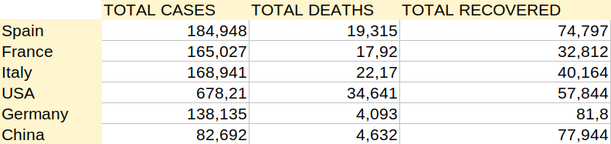Figure 1: Sample CSV input file

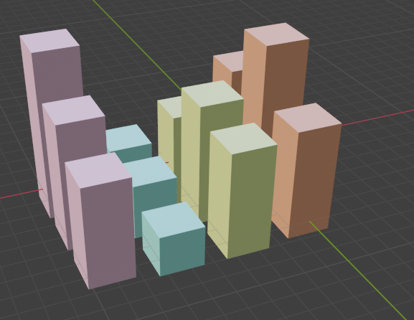Figure 2: 3D Barplot generated as output OBJ file

3. Program execution
The execution of the program will be carried out by command line following the syntax below:
$ 3Dbarplot <input.csv> <output.obj>

A correct check of input and file format errors will also be implemented.

