i **ii**

**iiiCLIMATEiCHANGEiPREDICTIONiUSINGiMACHINEiLEARNING**

iiiiiiiiiii(foritheipartialifulfillment*i*ofiMastersiinicomputeriapplication)

I iiiiiiiiiiiiiiiiiii*Submittediby*

**iiiiMANJEETiSINGH**

**iiiiiiiiiiiiiiiiiiIiiiiiUnderitheiguidance**

**iiiiiiiiiiiofii**

*ii iiiii***iiMr.iAtikaiGupta**



**i**

**i**

**i**

i

# DEPARTMENTiOFiCOMPUTERiSCIENCEiANDiENGINEERINGi

**iiiiiiiiiGRAPHICiERAiHILLiUNVERSITY,iDEHRADUN**

**CERTIFICATE**

ThisiisitoiconfirmithatiManjeetiSingh'sithesis,i"iweatheriitemperatureichangeiprediction,"iwhichiwasisubmitteditoiGraphiciEraiHilliUniversityiforiconsiderationiofitheiMasteriofiComputeriScienceidegree,iisianiaccurateiaccountiofitheistudyithatiwasicarriedioutiunderiouridirection.iNoiotheriInstituteioriUniversityihasireceivedithisiproject'simaterialsiinifullioriinipartiforitheipurposeiofiawardingiaidegreeioricertificate.

**PROJECTiINCHARGE**

**Mr.iAtikaiGupta**

**(Assistantiprofessor,iGEHU)**

### **ACKNOWLEDGEMENT**

Weiwouldilikeitoithanki**Ms.iAtikaiGupta**iforiheripatience,iencouragement,iandisupportiasiweiworkeditoifinishithisiprojectiandiforibelievingiinime.iAdditionally,iweithankiallitheieducatorsiwhoiprovidediusiwithiinsightfulirecommendationsiforitheiproject.iWeiareigratefuliforiouriparents'iongoingihelpiandiinspiration.iWeialsoiwantitoiexpressiourigratitudeitoithemiforigivingiusitheichanceitoigetithusifariiniouriacademicipursuits.iWeiwouldilikeitoithankiouriprojecticoordinatoriandiprojectiguideiiniparticular.iLastly,ibuticertainlyinotileast.iAlliotheripeopleiwhoiassistediusithroughoutithisiendeavour,iwhetheridirectlyiori

indirectly,iiareihighlyiowed.

Mr.iManjeetiSingh (RolliNo.-i2101110)

**ABSTRACTi**

**i**

Long term weather temperature change prediction has major importance in various sectors like climate related studies, agricultural, energy, medical and many more. This paper evaluates the performance of several Machine Learning algorithm Linear Regression, in problem of annual weather temperature change prediction, from previous measured values. The first challenge dwells on creating a reliable, efficient statistical reliable data model on large data set and accurately capture relationship between average annual temperature and potential factors. The data is predicted and forecasted by linear regression because it is obtaining the highest accuracy for greenhouse gases and temperature among all the technologies which can be used. The weather temperature change can help the whole world because not only human but also different animals are suffering from the global temperature.

.

**TABLEiOFiCONTENTSi**

**i**

**i**

**iiiiiiiiiiiiiiiiiiiiiiiiiiiiiiiiiiiiiiiiiiiiiiiiiiiiiiiiiiiiiiiiiiiiiiiiiiiiiiiiiiiiiiiiiiiiiiiiii**

|  |  |
| --- | --- |
| **CERTIFICATE** | **Iiiiiiiiiiiiiiiiiiiiiiiiiiiiiiiiiiiiiiiiiiiiiiiiiiii2** |
| **ACKNOWLEDGEMENT** | **3** |
| **ABSTRACT** | **4** |
| **CHAPTERi1** | **6** |
| INTRODUCTION | **6** |
| **CHAPTERi2** | **7** |
| REQUIREMENTiANALYSIS | **7-8** |
| **CHAPTERi3** | **9-10** |
| SOFTWRAEi/iPROJECTiDESIGN | **9** |
| DATAiCOLLECTION  DATAiPRE-PROCESSING  PREDICTION  VISUALIZATION | **10** |
| **CHAPTERi4** | **11-17** |
| WORKFLOW | **12-14** |
| LIBRARIESiANDiMODULES | **15-17** |
| **CHAPTERi5** | **18-21** |
| CODEiSNAPSHOT | **18-21** |
| **CHAPTERi6** | **22-25** |
| CONCLUSIONiANDiFUTUREiSCOPE | **22-23** |
| RESULT  REFERENCES | **24-25** |

**CHAPTERi–i1**

**INTRODUCTION**

**i**

Usingimoreithaniaicentury'siworthiofihistoricalimeteorologicalidata,iweiwilliattemptitoisolveitheiproblemiofiestimatingitheiaverageiworldwideilandiandioceanitemperature.iWe'reigoingitoipretendithatiweidon'tihaveiaccessitoianyiforecastsiforitheiweather.iWeidoihaveiaccessitoihistoricaliworlditemperatureiaveragesiforitheipasti100iyears,iincludingiglobalimaximumiandiminimumitemperaturesiasiwelliasiglobalilandiandioceanitemperatures.iWithialliofithis,iweimayiconcludeithatitheiproblemiisioneirequiringisupervised,iregressionimachineilearning.

Theitargetimakesithisiairegressionijobibecauseiitiisicontinuous,ianditheifactithatiweihaveibothitheifeaturesianditheitargetithatiweiwantitoiforecastimakesiitisupervised.iMultipleiregressionimodelsiwillireceiveibothitheifeaturesianditheitargetsiduringitraining,ianditheyimustifigureioutihowitoitranslateitheidataiintoiaiprediction.iAdditionally,ibecauseitheitargetivalueiisicontinuous,ithisiisiairegressionitaski(asiopposeditoidiscreteiclassesiiniclassification).

**LineariRegression:**

Ailinkibetweeniaidependentivariableioriscalarivariableiandianiindependentivariableioriexplanatoryivariableicanibeideterminediusingitheilineariregressioniapproach.iInithisiapproach,ilinearipredictorifunctioniisiuseditoirepresentitheirelationships.iHere,ithisitechniqueiisiuseditoitrainitheidata.iMakingianiobjectioutiofithatifunctioniandiusingiitiforipredictionirequiresitheiuseiofiailinearipredictorifunction.iTheidataiisiprojectediforitheifutureiafteritheiformationiofitheithing.

Theiwidelyiutilisedimethodiforiforecastingiinifieldsilikeiclimateipredictioniandiotheridomainsiisiregression.iSimilaritoihowitheiweathericanichangeidramaticallyidayibyiday,itheiclimateicanibeidefinediasitheiaverageistateiofitheiatmosphereioveriailongeriperiodiofitime.

**CHAPTER-2**

## iiiiiiiiiiREQUIREMENTiANALYSIS

**i**

### **1.1iMatplotlibi**

Fori2Didisplaysiofiarrays,iMatplotlibiisiaifantasticiPythonivisualisationilibrary.iAimulti-platformidataivisualisationipackageicallediMatplotlibiwasicreateditoidealiwithitheilargeriSciPyistackiandiisibasedioniNumPyiarrays.

Oneiofivisualization'sibiggestiadvantagesiisithatiitigivesiusivisualiaccessitoivastivolumesiofidataiiniformsithatiareisimpleitoiunderstand.iThereiareinumerousiplotsiiniMatplotlib,iincludingiline,ibar,iscatter,ihistogram,ietc..i

**1.2iBasiciplotsiiniMatplotlib:i**

ThereiareinumerousiplotitypesiavailableiiniMatplotlib.iPlotsiaidiinirecognisingitrends,ipatterns,iandirelationships.iTheyiareifrequentlyitoolsiforireasoningiaboutiquantitativeidata.i

i

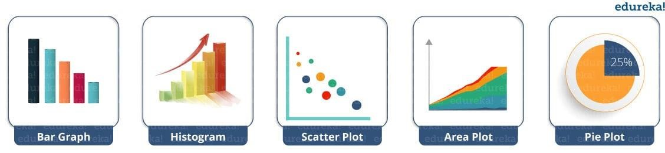

Figurei2.1iVariousigraphiinimatplotlibi

##### **2.1iJUPYTERiNOTEBOOKi**

Toicreateiandishareidocumentsiwithiliveicode,iequations,ivisualisations,ianditext,iyouicaniuseitheifreeiandiopen-sourceiJupyteriNotebookiwebitool.

TheiIPythoniproject,iwhichiformerlyihadianiIPythoniNotebookiprojectiofiitsiown,igaveiriseitoiJupyteriNotebooks.iTheiprimaryiprogrammingilanguagesiitisupportsiareiJulia,iPython,iandiR,ihenceitheinameiJupyter.iPythoniprogrammingiisisupportedibyitheiIPythonikernelithaticomesiwithiJupyter.

**2.2iBenefitsiofijupyterinotebook**i:-ii

* LanguageiofiChoiceiii
* ShareiNotebooksii
* InteractiveiOutputii
* BigiDataiIntegrationi

**3.iLineariRegressioni-**iOneiofitheisimplestiandimostiwidelyiusediMachineiLearningitechniquesiisilineariregression.iItiisiaistatisticalitechniqueiforiperformingipredictiveianalysis.iTheilineariregressionialgorithm,iofteniknowniasilineariregression,idemonstratesiailinearirelationshipibetweeniaidependenti(y)iandioneiorimoreiindependenti(X)ivariables.iGivenithatilineariregressionidemonstratesiailinearirelationship,iitimayibeiuseditoidetermineihowitheidependentivariable'sivalueichangesiasiaifunctioniofitheiindependentivariable'sivalue.

Theilinkibetweenitheivariablesiisirepresentedibyiaislopingistraightilineiinitheilineariregressionimodel.iThinkionitheiphotoibelow:

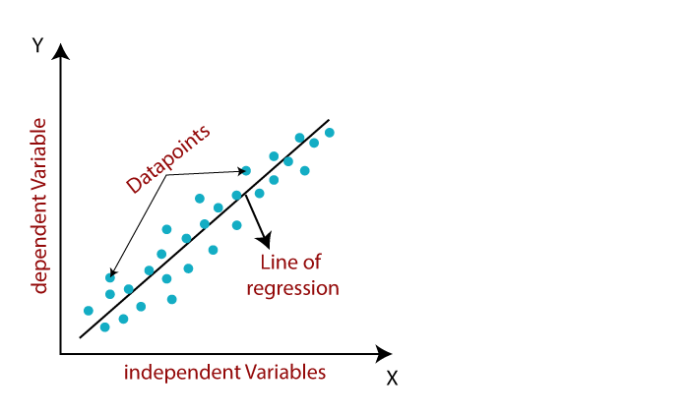

**Figurei1:iLineariRegression**

**CHAPTERi–i3**

**SOFTWRAEi/iPROJECTiDESIGN**

|  |  |  |
| --- | --- | --- |
| **SR.iiNOii** | **SOFTWAREiREQUIREMENTSi** | |
| **1.i** | **OperatingiSystem:ii** | **Windows-7,8,10.** |
| **2.i** | **ProgrammingiEnvironments:ii** | **JupyteriNotebooki** |
| **3.i** | **LanguagesiUsed:ii** | **Pythoni** |

**i**

## 3.1iDataiCollectioni

**i**i

Inithisimoduleitheirawiisicollectedidataifromidifferentidataiset.iThenitheidataisetiisichangediasiperineed.iThisirawidataicannotibeipredictedidirectly.iSo,iitiisineededitoicleaniandipre-process.ii

i

## 3.2iDataiPre-processingii

i

Inithisimoduleitheidataiisicleaned.iAftericleaningiofitheidata,itheidataiisigroupediasiperirequirement.iThisigroupingiofidataiisiknowniasidataiclustering.iThenicheckiifithereiisianyimissingivalueiinitheidataisetiorinot.iItithereiisisomeimissingivalueithenichangesiitibyianyidefaultivalue.iAfterithatiifianyidataineeditoichangeiitsiformat,iitiisidone.iTotaliprocessibeforeitheipredictioniisiknowniisidataipreprocessing.iAfterithatitheidataiisiusediforitheipredictioniandiforecastingistep.ii

i

* 1. **DataiPredictioniandiforecasting:i**i

i

Inithisistep,itheipre-processedidataiisitakeniforitheiprediction.iThisipredictionicanibeidoneiinianyiprocessiwhichiareimentionediabove.iButitheiLineariRegressionialgorithmiscoresimoreipredictioniaccuracyithanitheiotherialgorithm.iSo,iinithisiprojectitheilineariregressionimethodiisiusediforitheiprediction.iForithat,itheipre-processedidataiisisplittediforitheitrainianditestipurpose.iTheniaipredictiveiobjectiisicreateditoipredictitheitestivalueiwhichiisitrainedibyitheitrainedivalue.iThenitheiobjectiisiuseditoiforecastidataiforinextifewiyears.ii

i

**3.4iVisualization:i**i

i

Inithisistep,itheipredictediandiforecastedidataiisiuseditoiprovideiaigraphicaliinterfaceiseparately.iAtifirstitheipredictedidataiisiplottediiniaigraphiseparatelyiwithitheihelpiofimatplotilibrary.iThenitheiforecastedidataiofitemperatureiisiplottediinigraphiwithiproperiscale.iThenitheigreenhouseigasesiforecastedidataiareiplottediiniaisingleigraphiwithiproperiscale.i

i

i

**i**

I iiiiiiii**CHAPTERi-5**

**DATASET**

**i**

**Datasetiwithidate,iLandAverageTemperatureiLandAverageTemperatureUncertainty,i**i**LandMaxTemperature,iLandMinTemperature,iLandAndOceanAverageTemperature.**

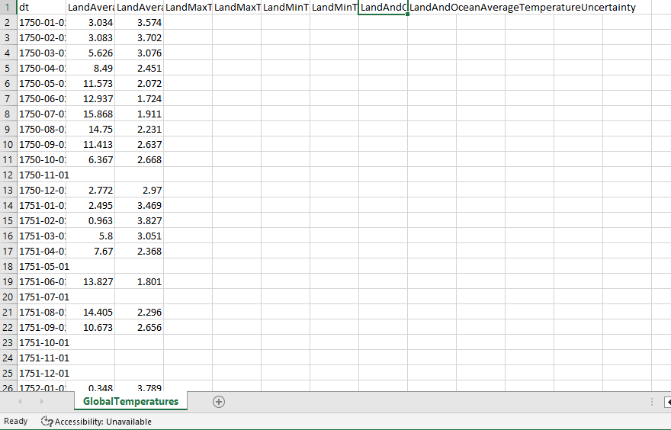i

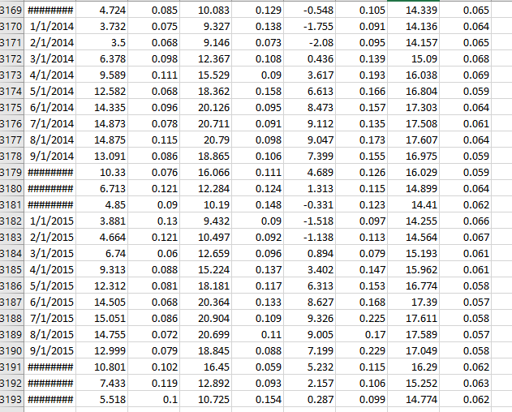

**Alliidataiisicollectedifromii1750itoi2000iiandithereiiisi3193irowsiandii9icolumninitheientireidataset.iiii**

iiiiiiiiiiiiiiiiiiiii**WORKFLOW**

# Let'silookiatiaiprocessitoibetterigraspiwhatiwe'reigoingitoidoiinithisiprojectisoithatiyouicanicomprehendiouristrategy.i

Knowingiwhatiliesiahead,iweiwillistartiwithitheiveryibasiciandimosticrucialicomponentiofimachineilearning—aidataset—iniorderitoicompleteithisiassignment.

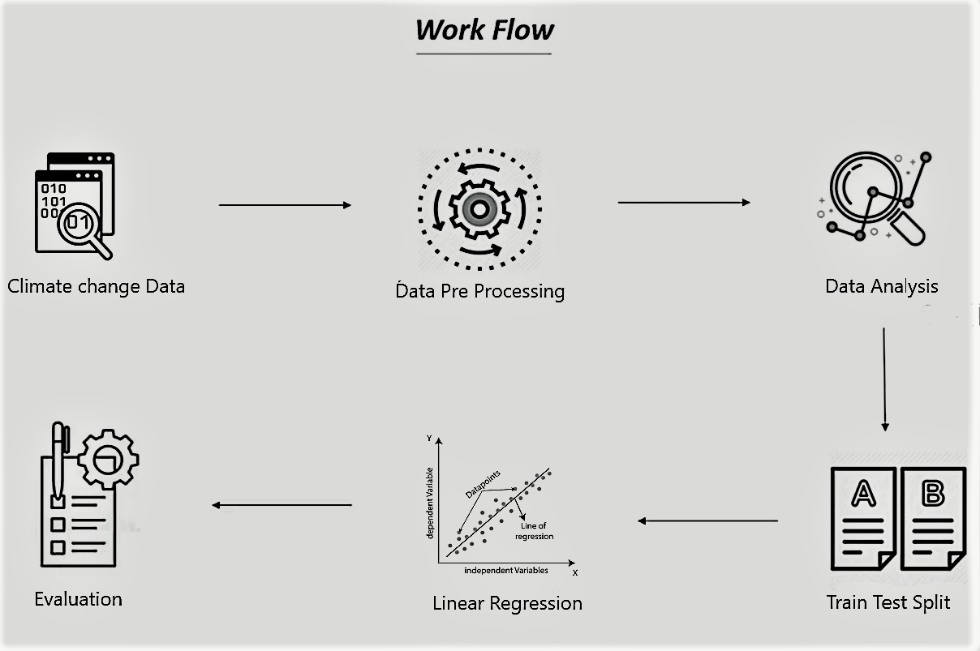

**iiiiiiiiiiiiiiiiiiiiiiiiiiiiiiiiiiiiiiiiiiiiiiiiiiiFigurei2:iworkflowi**

**Aboutitheidataset:i**Asitheinameiimplies,iaidatasetiisiaicollectioniofidata.iProjectsiusingimachineilearningiusuallyirequireiaidataset.iFirst,iiniorderitoitrainiourimodeliandiaidiiniprediction,iweirequireitheitrainingidataset.iThen,iweiforecastiandievaluateitheiaccuracyiofiourimodeliusingitestingidatasets.iI'veiutiliseditheiKaggleidatasetiforimyiproject.iThereiareiseveralisuchiwebsitesiavailableiforidownloading.i(Takeinoteithatitheimodeliwillirequireimoreitimeitoitrainitheigreateritheidataset.iI'lliadviseiyouitoistartiwithiaimediumsizedidatasetithatidoesn'tihaveitooimanyivaluesiiniorderitoibetterigraspihowiitiworksiasiaibeginning.)iHowever,iyouishouldibeiawareithatiwhileitheimoreidataiyouiinputitheimodeliforitrainingiallowsiusitoitrainiitimoreithoroughlyiandiproduceimoreiaccurateiresults,iitialsoilengthensitheicompilationiprocess.

**Requiredidependencies:i**Importingitheiessentialidependenciesithatiweiwilliuseiinitheifollowingisectioniofitheiprogrammeiisitheifirstithingithatiweineeditoiaccomplish.iWeiwillibeiutilisingiNumpy,iPandas,iMatplotlib,iandiSklearniinithisiproject.Youiwillilearnihowieachiofitheseicomponentsiisiusediasiouriprojectiprogresses..

### **ReadingiTheiDataifromitheiDataset**:iiTheidownloadedidatasetimustibeiinsertediintoiouriprogramisoithatiouricodeicanireadiitiandiuseiititoicarryioutitheirequiredioperations.

### WeiwillirequireitheipandasimoduleitoireaditheidatasetifileibecauseiitiwasidownloadediasiaiCSVifile.iItiincludesitheiread.csv()ifunctioniforireadingiCSVifiles.iPutiitiiniaivariableicalledi"climateidata,"i

### Usingitheicommandivariableiname.head(),iweicaniviewitheifirstifiveirowsiofitheitableiandiexamineihowitheidataiwasisavediinitheivariable.

**Let’siSplititheidataiintoitargetivaluesiandifeatureivalues:**iHere,iXiisitheifeatureivariable,iwhichiincludesiallitheicharacteristics—withitheiexceptioniofitheitempratureiandiDateicolumn—thatiaffectitheipriceiofigold.iTheseifeaturesiincludeiiY,ionitheiotherihand,iisitheidesiredioutcome,ioritheipriceiofigold,ithereforeiitiisitheitargetivariable.i(OnlyitheiLandiAverageiTempratureicolumniisipresent.)

### SplittingiXiandiYiintoitrainingianditestingivariables:iTheidataiwillibeidividediintoifourvariables:iXitrain,iYitrain,iXitest,iandiYitest.i

### Xitrain:iConsistsiofiairandomiassortmentiofivaluesiforitheivariablei"X"

### Theioutputi(AverageTemprature)iofitheimatchingivalueiofiXitrainiisicontainediinitheiYi

### train.

### Xitest:idoesinotiincludeivaluesifromiXitrainiandicontainsiairandomiselectioniofivaluesi

### fromivariablei"X"i(iasitheyiareialreadyitaken).

Theioutputi(AveragePredictiveTemprature)iofitheirelevantiXitestivalueiisicontainediintheiYitrain.

### ModeliTraining:iLineariRegression:iHere,iweireferitoiourimodeliasiai"Reg."i

Reg.fit(xi,iy)

Let'sitrainitheimodeliusingitheivariablesi(Xitrain,iYitrain)ifromitheitrainingidataset.

regressor.fit(X_train,Y_train)

"WhenitheivaluesiofiXiareithese,ithenitheivalueiofiYiisithis,"iisihowitheimodeliinstructsiitsiusers.

### ModeliEvaluation:iLet'siuseitheipredict()ifunctionitoiforecastitheivaluesiofitheiXitestidatasetinow.

### DataiPredictioni=iReg.Predict(Xitest).

# iLIBRARIESiANDiMODULES

# NUMPY

# iTheiPythonipackageiNumPyiisiuseditoimanipulateiarrays.iAdditionally,iiticontainsimatrices,ifourieritransform,iandifunctionsiforiworkingiinitheiareaiofilinearialgebra.

# TravisiOliphantidevelopediNumPy.iYouicaniuseiitiforifreeibecauseiitiisianiopenisourceiproject.iNumericaliPythoniisireferreditoiasiNumPy.

# TheiequivalentiofiarraysiiniPythoniareilists,ialthoughitheyitakeiailongitimeitoiexecute.iTheigoaliofiNumPyiisitoiofferiarrayiobjectsithatiareiupitoi50itimesiquickerithaniconventionaliPythonilists.iTheiNumPyiarrayiobjectiisireferreditoiasindarray,iandiitihasiainumberiofisupportingimethodsithatimakeiusingindarrayirelativelyisimple.iInidatairesearch,iwhereispeediandiresourcesiareicrucial,iarraysiareiemployediailot.iInicontrastitoilists,iNumPyiarraysiareikeptiiniaisingleicontinuousilocationiinimemory,imakingiitiveryieasyiforiprogrammesitoiaccessiandimodifyithem.iInicomputeriscience,ithisicharacteristiciisiknowniasilocalityiofireference.iThisiisitheiprimaryifactorithatimakesiNumPyiquickerithanilists.iAdditionally,iitiisienhanceditoifunctioniwithimoderniCPUiarchitectures.

# AlthoughisomeiofitheiPythonilibraryiNumPyiisiwritteniiniPython,itheimajorityiofitheiportionsithaticalliforiquickicomputationiareiimplementediiniCioriC++.

# PANDAS

# iPython'siPandasipackageiisiuseditoimanipulateidataicollections.iItioffersitoolsiforidataiexploration,icleaning,ianalysis,iandimanipulation.iWesiMcKinneyicameiupiwithitheimonikeri"Pandas"iini2008,iandiitirefersitoibothi"PaneliData"iandi"PythoniDataiAnalysis."

# WithitheiaidiofiPandas,iweicaniexamineilargeidataisetsiandidrawiconclusionsibasedionistatisticaliprinciples.iPandasicaniorganize,idisorganized,idataisets,imakingithemiunderstandableiandiuseful.iInidataiscience,irelevantidataiisicrucial.

# Rowsithatiareiirrelevantioricontainiincorrectidata,isuchiasiemptyioriNULLivalues,icanialsoibeideletedibyiPandas.iThisiprocessiisiknowniasidataicleansing.

# MATPLOTLIB

# imatplotlib.pyplotiMatplotlibicanioperateilikeiMATLABithanksitoitheifeaturesiinipyplot.iEachipyplotifunctionimodifiesiaifigureiinisomeiway,isuchiasibyicreatingiaifigure,iaiplottingiregioniwithiniaifigure,isomeilinesiwithiniaiplottingiarea,ilabellingitheiplot,ietc.

# Theiplottingifunctionsiareidirecteditoitheicurrentiaxes,iandidifferentistatesiareiretainediinimatplotlib.pyplotibetweenifunctionicallsitoikeepitrackiofithingsilikeitheicurrentifigureiandiplottingiareai(pleaseinoteithati"axes"ihereiandiinimostiplacesiinitheidocumentationirefersitoitheiaxesipartiofiaifigureiandinotitheistrictimathematicalitermiforimoreithanioneiaxis).

# SEABORNi

# AimatplotlibbasediPythonidataivisualisationipackageiisicallediSeaborn.iItioffersiaisophisticatedidrawingitooliforicreatingieye-catchingiandieducationalistatisticsivisuals.

# Youicanireaditheiintroductoryinotesioritheipaperiforiaiquickioverviewiofitheiconceptsiunderlyingitheilibrary.iToilearnihowitoidownloadiandiuseitheipackage,igoitoitheiinstallationipage.iSeeisomeiofitheithingsiyouicaniaccomplishiwithiSeabornibyibrowsingitheisampleigallery,iandithenilearnihowibyilookingiatitheitutorialsioriAPIidocumentation.iPlotsiareimostlyiuseditoishowihowidifferentivariablesirelateitoioneianother.iTheseivariablesimayibeientirelyinumericaliorimayirepresentiaicategory,isuchiasiaigroup,iclass,ioridivision.

# Seabornicategorisesitheiplotiintoitheifollowingigroups.i–

# RelationalinarrativesiToicomprehenditheirelationshipibetweenitwoivariables,iutiliseithisifigure.

# Categoricaliplots:iThisigraphicidiscussesicategoricalivariablesianditheivisualisationiofithem.

# Plotsiuseditoiexamineiunivariateiandibivariateidistributionsiincludeidistributioniplots.

# Regressioniplots:iTheimainipurposeiofitheiregressioniplotsiiniSeaborniisitoiprovideiaivisualiaidithatihighlightsitrendsiiniaidatasetiduringiexploratoryidataianalysis.

# Aniarrayiofiscatterplotsimakesiupiaimatrixiplot.iMultipleiinstancesiofitheisameiploticanibeidrawnionivariousidatasetisubsets,iwhichiisiaihandyistrategyiforimulti-plotigrids.

# SKLEARNiSELECTION

# iItiisiaiPythonipackageithatiprovidesiairangeiofidataiprocessingifeaturesithatimayibeiusediforimodelichoice,iclustering,iandiclassification.iModeliselectioniisiaitechniqueiforicreatingianianalysisiplaniandiutilisingiititoigaugeifreshidata.iWhenicreatingiaiforecast,ichoosingitheiappropriateimodelienablesiyouitoiprovideipreciseiresults.Youimustiuseiaicertainidatasetitoitrainiyourimodeliiniorderitoidoithat.iAfterithat,iyouicompareitheimodelitoiaidifferentidataset.

# Youimustifirstidivideiyouridataset,iifiyouionlyihaveione,iusingitheiSklearnitrainitestisplitifunction.

# TheiSklearnimodeliselectionifunctionitrainitestisplitidividesidataiarraysiintoitrainingidataianditestingidataisubsets.iThisifunctionieliminatesitheirequirementiforimanualidatasetidivision.

# Usingidefault,itheitwoisubsetsiwillibeirandomlyipartitionedibyiSklearnitrainitestisplit.iHowever,iyouimayialsoigiveitheioperationiairandomistate.

# X,iy.iTheidatasetiyouichooseitoiutiliseiisitheifirstiparameter.

# Trainisize:Theitrainingidataset'sisizeiisisetibyithisioption.iThreeichoicesiareiavailable:iThreeioptionsiareiavailable:iNonei(theidefault),iInti(whichiasksiforitheipreciseiamountiofisamples),iandifloati(whichihasiairangeiofi0.1itoi1.0).

# Testisize:iTheitestingidataset'sisizeiisispecifiedibyithisioption.iTheitrainingisizeiisisuitableiforitheidefaultistate.iIfitheitrainingisizeiisileftiatidefault,iitiwillibeisetitoi0.25.

# randomistate.iTheidefaultioptioniusesinp.randomitoiachieveiairandomisplit.iAsianialternative,iyouimightiaddianiintegeriusingiaipreciseisum.

# LINEARiREGRESSOR:i

Lineariregressioniisiaistatisticalimethodiforimodellingitheiconnectioniamongiaiscalarioutputiandioneiorimoreicausalifactorsi(alsoicallediindependentiandidependentivariables).iTheiregressioniequationiisiusediwhenithereiisionlyioneiindependentifactor;iregressionianalysisiisiusediwhenithereiisimoreithanioneiindependentifactor.iThisiphraseidiffersifromimultidimensionalilineariregression,iwhichipredictsiseveralilinkedidependentivariablesiinsteadiofiaisingleiscalarivariable.i



Connectionsiareirepresentediusingilinearipredictoriequationsiwhoseiuncertainiparameterivaluesiareiderivedifromiinformationiinilineariregression.iTheseikindsiofimodelsiareiknowniasilinearimodels.iTheiconditionediaverageiofitheiansweribasedionitheivaluesiofitheiindependentivariablei(oripredictors)iisimostitypicallyibelieveditoibeiailinearicombinationiofithoseinumbers.iLineariregression,ilikeiotherikindsiofiregressionianalysis,iconcentratesionitheiconditionalidistributioniofitheiansweritoiprovidingitheiattributeivaluesiinsteadiofitheijointidistributioniofialliofitheseifactors,iwhichiisitheirealmiofitheimultivariateimodel.

Lineariregressioniwasitheifirstiformiofilogisticiregressionitoibeicarefullyiexplorediandiwidelyiemployediinireal-worldiapplications.iItiisidueitoitheifactithatiequationsithatiareilinearlyiconnecteditoitheiriuncertainivariablesiareiableitoiarrangeithanisystemsithatiareinon-linearlyiconnecteditoitheirifactors,ianditheistatisticalimethodsiofitheigeneratediestimationitechniquesiareieasieritoirecognize.

Lineariregressionioffersiaiwideirangeiofiapplications.iTheimajorityiofiapplicationsifalliintoitwoimainigroups:

* Ifipredictingiforecast,iorireducedierrorsiareitheigoals;ilineariregressionicanibeiuseditoiadaptiaistatisticalimodelitoianiacquiredigivenidatasetiofiresponderiandiexogenousivariablesidata.iIfinewivaluesiofitheiindependentivariableiareiobtainediwithoutianiassociatediexpectedivalueiaftericreatingiairatheristructure,itheicontrollerimoduleimayibeiuseditoiassessitheieffects.
* Ifitheipurposeiisitoiexamineidifferencesiinitheidependentivariablesidueitoichangeiinitheicausalivariables,ilineariregressionianalysisimayibeiuseditoiassessitheistrengthiofitheirelationshipsiamongitheireactionianditheiinformativeifactors.iEvaluateiifianyiexplanatoryifactorsihaveinoilinearilinkiwithitheiansweriatiall,iorifindiwhicheverisubgroupsiofiindependentivariablesiincludeiredundantidataiaboutitheianswer.

# iiiiiiiiiiiiiiiiiiiiiiiiiiiiiiiiiiiiiiiiiiiiiiiiiiiiiiiiiiiiiiiiiiiiiiiiiiiiiiiiiiiiiiiiiiiiiii

# iSKLEARNi:iForiparticulariuses,itheisklearnimoduleicontainsiroutinesiforimeasuringipredictionierror.iSectionsioniClassificationimetrics,iMultilabelirankingimetrics,iRegressionimetrics,iandiClusteringimetricsiprovideimoreiinformationionitheseimeasures.iiiiiiiiiiiiiiiiiiiiiiiiiiiiiiiiiiiiiiiiiiiiiiiiiiiiiiiiiiiiiiiiiiiiiiiiiiiiiii

# ii

**CHAPTERi-i6**

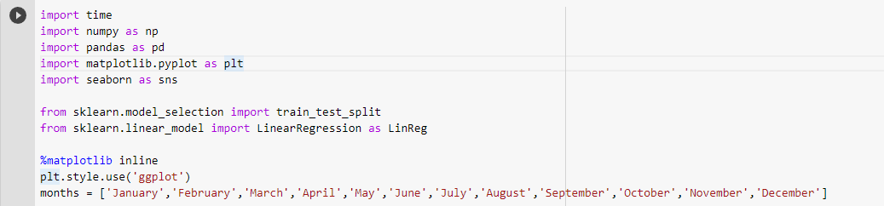

**Figurei3:iimportedilibraries**

2.

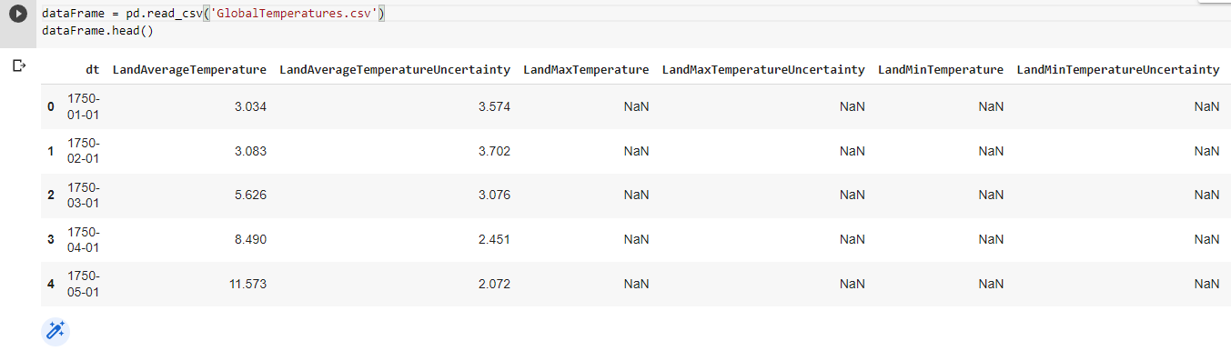

**Figurei4:iHeadiofidataset**

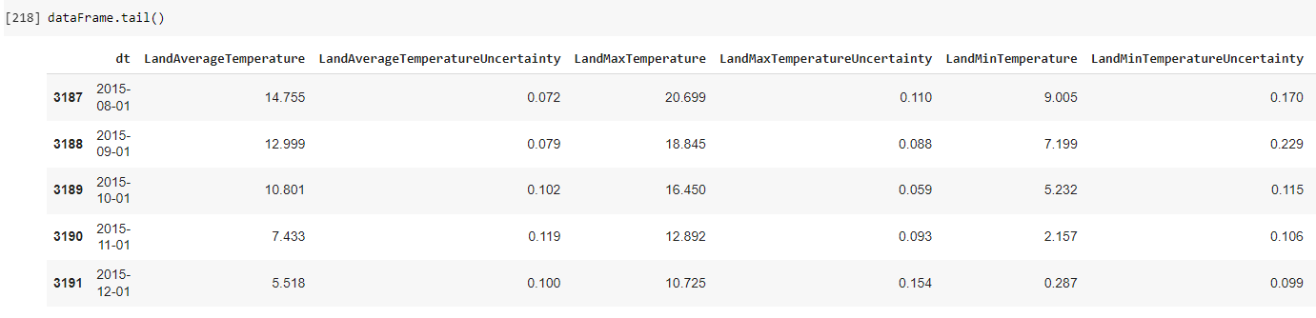

**Figurei5:iTailiofidataset**

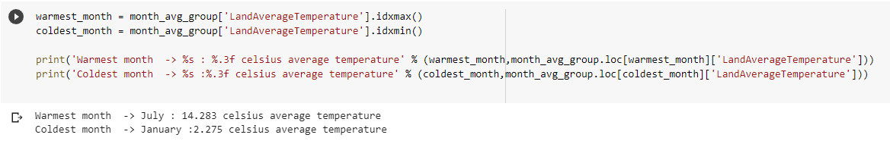

**Figurei6:iWarmestiandiColdestiMonthiData**

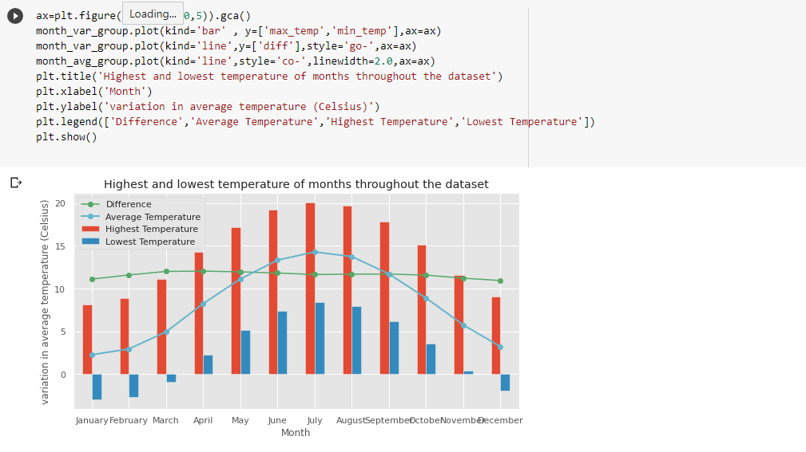

**Figurei7:**i**Highestiandilowestitemperatureiofimonthsithroughoutitheidataset**

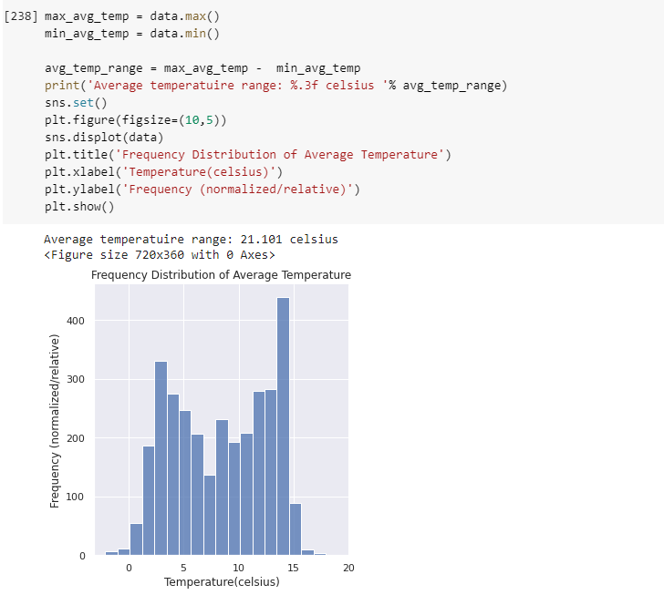

**Figurei8:iFrequencyiDistributioniofiAverageiTemperature**

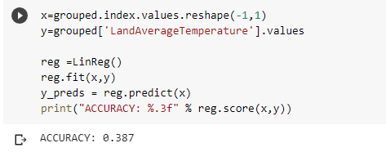

**Figurei9:iAccuracyiofiSet**

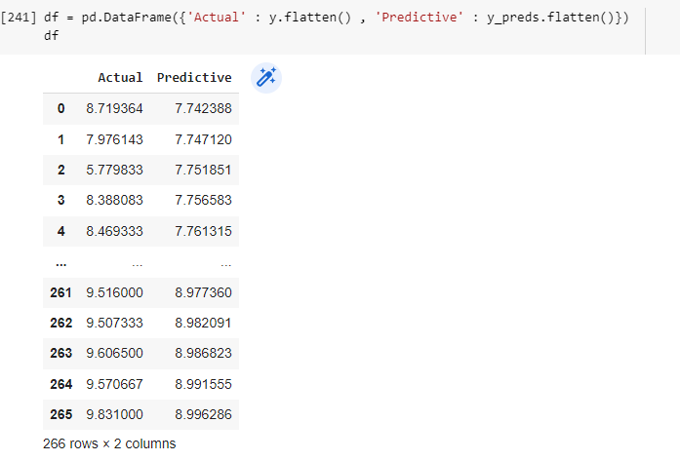

**Figurei10:iActualiandipredictiveitemperature**

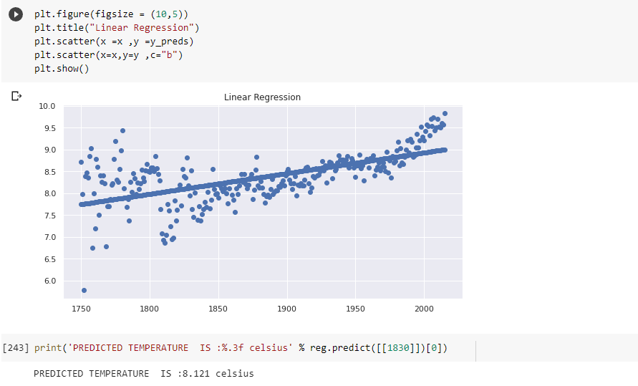

**Figurei11:iPredictediTemperature**

# iiiiii

# iiiiiiiiCHAPTERi-i7

# iiiiiiiCONCLUSION

# Accordingitoitheiscenarios,ithisiprojectiwillihelpiusidetermineitheiidealimomentiandiInithisipaper,itheidatai(temperature)iofi100-150iyearsiisianalyzed.iLineariRegressioniandiLinearimodeliareiuseditoipredictiandiforecastitheitemperatureiandigreenhouseigasesiforitheinexti10iyearsiiniaverage.iTheimatplotlibilibraryiisiuseditoiplotitheipredictedianditheiforecastedidata.iSo,iatilastitheifollowingiconclusionicanibeidrawni–iAimodeliforiforecastingidataiforinexti10iyearsiisitrainedianditestediwithidifferentiinputivariablesilikeitemperature,iSomeigraphsiareiplottediasiaigraphicaliinterfaceiforitheipredictediandiforecastedidataiforiallitheiinputsiwithitheihelpiofimatplotlibilibrary.

# Asiyouicaniseeifromithisiproject,iweideployiaimachineilearningimodelithatihasialreadyibeenitraineditoimakeipredictions.iSimilaritoithis,ianyimodelimayibeisignificantlyiimprovedibyigivingiitiaiveryihugeidatasetitoiprovideiaihighlyiexactiscorei(butiitiwillibeiprettyitime-consuming).iIithoughtitheidatasetiIiusediwasiquiteigoodiforiaibeginning.

**LIMITATIONiANDiFUTUREiWORK**

Thereiisisomeilimitationiinithisistudyiorithisiproject.iThisimodeliisipredictedionlyitheimeanitemperature.iItidoesn’tiexplainieachiweek’siandieachicountry’sidataiseparately.iTheidataisetiisiusediforithisimodelifori100i–i150iyears.iButitheipredictioniwillibeibetteriifiweigoimoreithani200-iori250yearsidata.iInifutureitheipredictionicanibeibetteriforiusingiaigreaterinumberiofidata.iTheiotheriphysicalientitiesiwhichiareiresponsibleiforitemperatureiincreasingicanibeialsoipredicted.iTheidataicanibeipredictediforieachiweekiasiwelliasieachicountry,iwhichiwillimakeithisimoreiattractiveiandireasonableiforiallipeople

## iiiiiiiiiiiiiiiiiiiiiiiiiiiiiiiiiiiiiRESULT

Iniourimodelitheiscoreivalueiwhichipredictitheicorrelationibetweenitheioriginalianditheipredictedidataiisiapproximateisame.iThatiindicateithatiourimodelifitiveryiwelliwithitheidataset.

Theipredictedivalueishowniinitheigraphilieimostlyionitheioriginalivalue.

UsingithisimodeliweicanigetioripredictitheiTempratureifluctuationiwhichidependsionivariousifactorsilikeiLandiTemprature,iOceaniTempratureietc.

**i**

**REFERENCES**

[1]i“Ainewiapproachiforisimulatingiandiforecastingitheirainfall-runoffiprocessiwithinitheinextitwoimonths”ibyiM.JiAlizadeh,iM.R.iKavianpour,iOzguriKisi;iVahidNourani,iJournaliofiHydrologyi(Voli–i548);iMay-2017

i[2]i“MonthlyipredictioniofiairitemperatureiiniAustraliaiandiNewiZealandiwithimachineilearningialgorithms”ibyiS.iSalcedo-Sanz,iR.iC.iDeo,iL.iCarro-Calvo,iB.iSaavedraMoreno;iTheoreticaliandiAppliediClimatologyi(Voli–i125);iJuly-2016i

[3]i“MultipleiregressioniandiArtificialiNeuraliNetworkiforilong-termirainfalliforecastingiusingilargeiscaleiclimateimodes”ibyiF.iMekanik,iM.A.iImteaz,iS.iGato-Trinidad,iA.iElmahdi;iJournaliofiHydrologyi(Voli–i503);iOctober-2013i

[4]i“DevelopmentiandiAnalysisiofiANNiModelsiforiRainfalliPredictionibyiUsingiTime-SeriesiData”ibyiNeelamiMishra,iHemantiKumariSoni,iSanjiviSharma,iAKiUpadhyay;iInternationaliJournaliofiIntelligentiSystemsiandiApplications;iJanuary-2018i

[5]i“ApplicationiofiArtificialiNeuraliNetworksitoiRainfalliForecastingiiniQueensland,iAustralia”ibyiJohniAbbotiandiJenniferiMarohasy,iAdvancesiiniAtmosphericiSciences;iJuly-2012i

[6]i“GlobaliWarming:iCauses,iEffectsiandiSolutions”ibyiUmairShahzad;iDurreesaminiJournali(Voli–i1),iAugust2015i

[7]i“Supportivectoriregressioniwithireduceditrainingisetsiforiairitemperatureipredictioniaicomparisoniwithiartificialineuralinetworks”ibyiRobertiF.iC,iGerritHoogenboom,iRonaldiW.iMcClendon,iJ.iA.iPaz;iNeuraliComputingiandiApplicationsi(Voli–i20);iFebruary-2011i

[8]i“PredictioniofitheilikelyiimpactioficlimateichangeionimonthlyimeanimaximumiandiminimumitemperatureiinitheiChaliyaririveribasin,iIndia,iusingiANN-ibasedimodels”ibyiN.R.iChithra,iS.G.iThampi,iS.iSurapaneni,iR.iNannapaneni,iA.A.K.iReddy,iJ.D.iKumar;iTheoreticaliandiAppliediClimatologyi(Voli–i121);iAugust-2014

i[9]i“BigiDataiandiClimateiChange”ibyiH.iHassani,iXuiHuangiandiE.iSilva;iFebruary-2019i

[10]i“AtmosphericiTemperatureiPredictioniusingiSupportiVectoriMachines”ibyiY.RadhikaiandiM.Shashi;iInternationaliJournaliofiComputeriTheoryiandiEngineeringi(Voli–i1);iApril-2009