**Assignment 1**

Prediction Search

Data Structure used: Trie (N-ary tree)

I have used **Trie** because it is very suitable for searching elements using prefixes, which is basically the task here.

First scanned trie for the prefix, if it exists then applied Depth First Search to find all the words containing the prefix, one by one from left to right. Stored all the words into a string vector and finally printed them.

Here is a screenshot of the output:

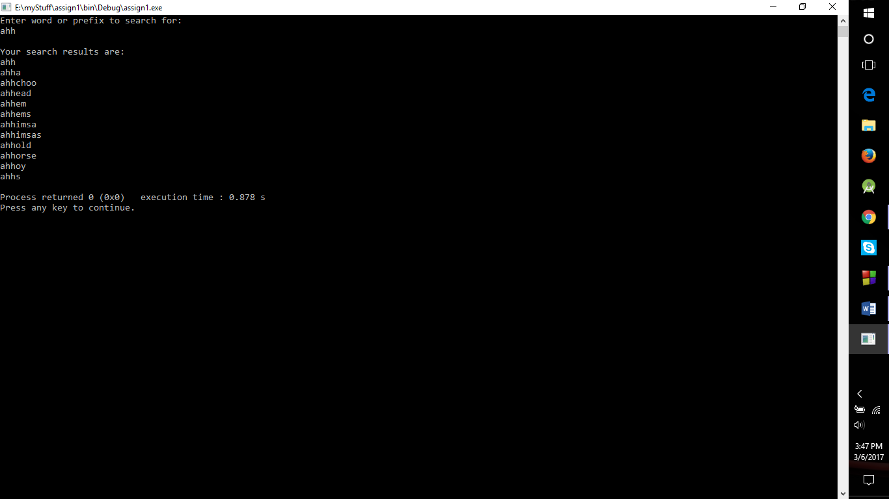

**Assignment 2**

Index of 1s in binary of a decimal number

Data structure used: Vector

For this one, I chose to go with vector because of unknown size array of indexes of 1.

Also, used **bitwise and** instead of explicit binary conversion to save the conversion overhead.

Here is a screenshot of the output:

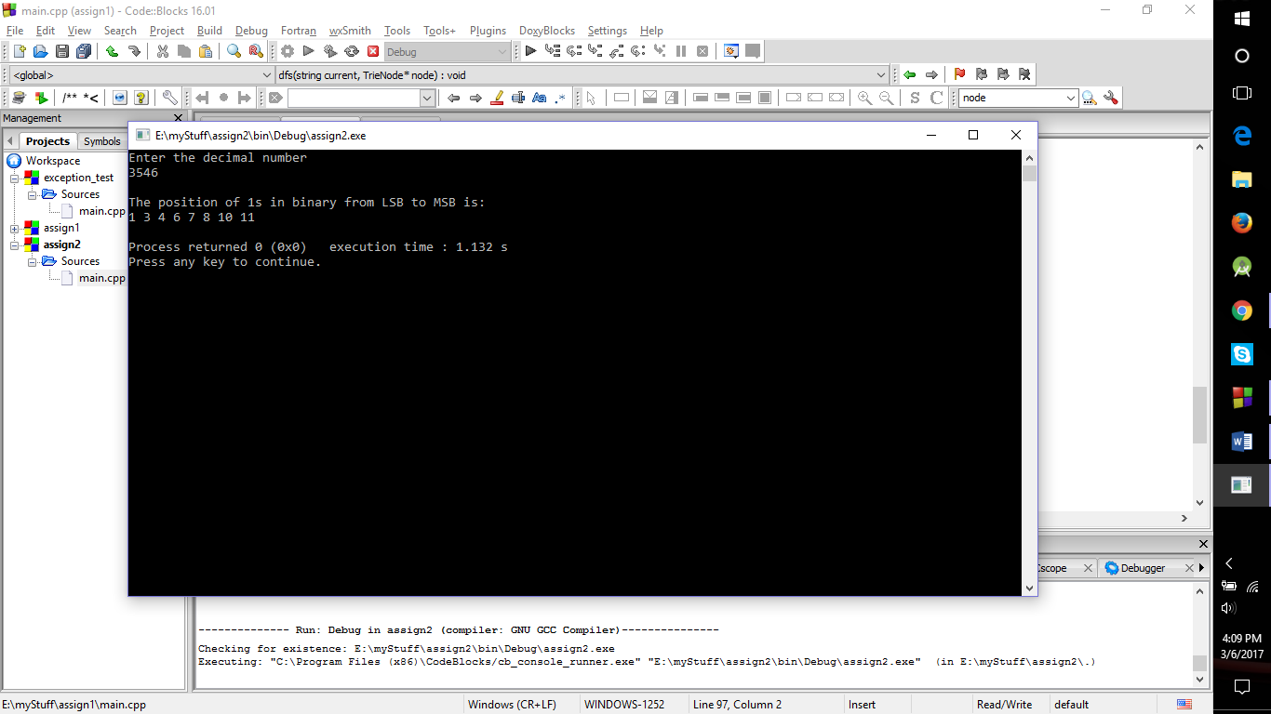

**Note:** The execution time in screenshots includes the time taken to enter the input values.