54635 - Add "Digital River Order ID" to the payload passed to OC Fulfillment during order create

Requirements:

This bug will track the new feature request for XDL Platform to pass the Digital River order ID information to Microsoft as part of the order to create a payload.

Currently, the DR Order ID is available in magento admi (screenshot below) however this is not one of the fields passed to Microsoft during order creation. This data was identified as needed for a regular report that Microsoft will provide to Digital River monthly.

As a new work item, there will be dev effort both on the Tengun/Gorilla side to integrate this new field into order create, as well as work on the OC Fulfillment and Microsoft SAP teams to capture and store this field in SAP.

Approach:

Currently Fulfillment API is sending currency, market, purchase order id and short order id, etc. Just need to add Digital River Order id to the body payload.

Action:

We need to add DR Order ID in fulfillment API as request Param with existing Payload.

**API Endpoint:**

**POST /v1.0/order: Creates a Fulfillment Order from the supplied Fulfillment Order.**

This endpoint is used as an outbound connection from Magento to push order details to the Microsoft Fulfillment Service (Oc

Fulfillment)

|  |  |  |
| --- | --- | --- |
| **Base URL:** | https://fulfillment-int.mp.microsoft.com/ |  |
|  |  |  |

**app\code\Xbdl\MicrosoftFulfillmentApi\Model\Integration\Request\FulfillmentBodyProvider.**

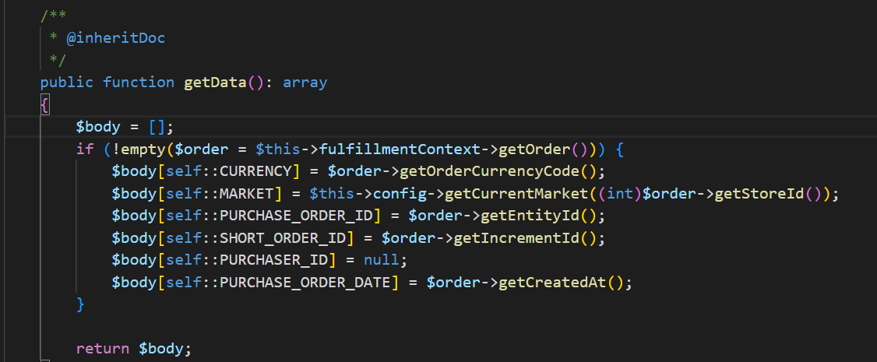

In the above file we need to add one param for “**DR_ORDER_ID**” to payload which can be retrieved from order.

Dependency:

SAP Team to check and verify and need to make changes to their API code to consume the new requested data.