How to change existing project DB in docker

-> sed 's/\sDEFINER=`[^`]*`@`[^`]*`//g' -i src/xbdl.sql

Make sure your file 3yngm4t3tho6a--staging2-5zxmgzy--mysql--3yngm4t3tho6a_stg2--dump.sql

Is existing in this path - C:\Users\v-mkhullar\Sites\local.xbox.com\src

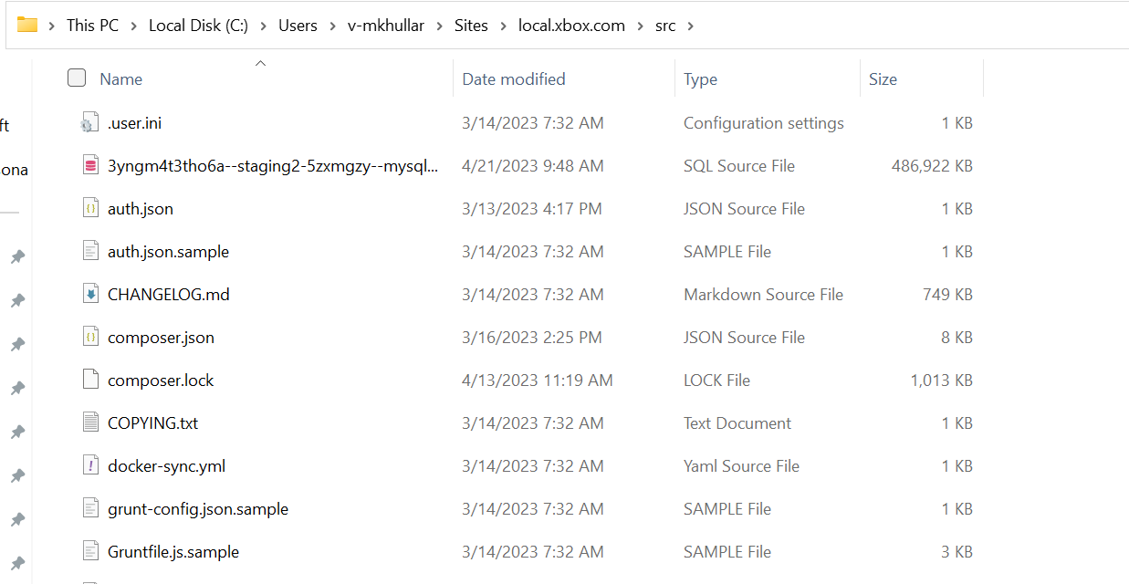

->bin/magento app:config:import

->bin/setup-domain local.xbdl.com