How to set up existing project

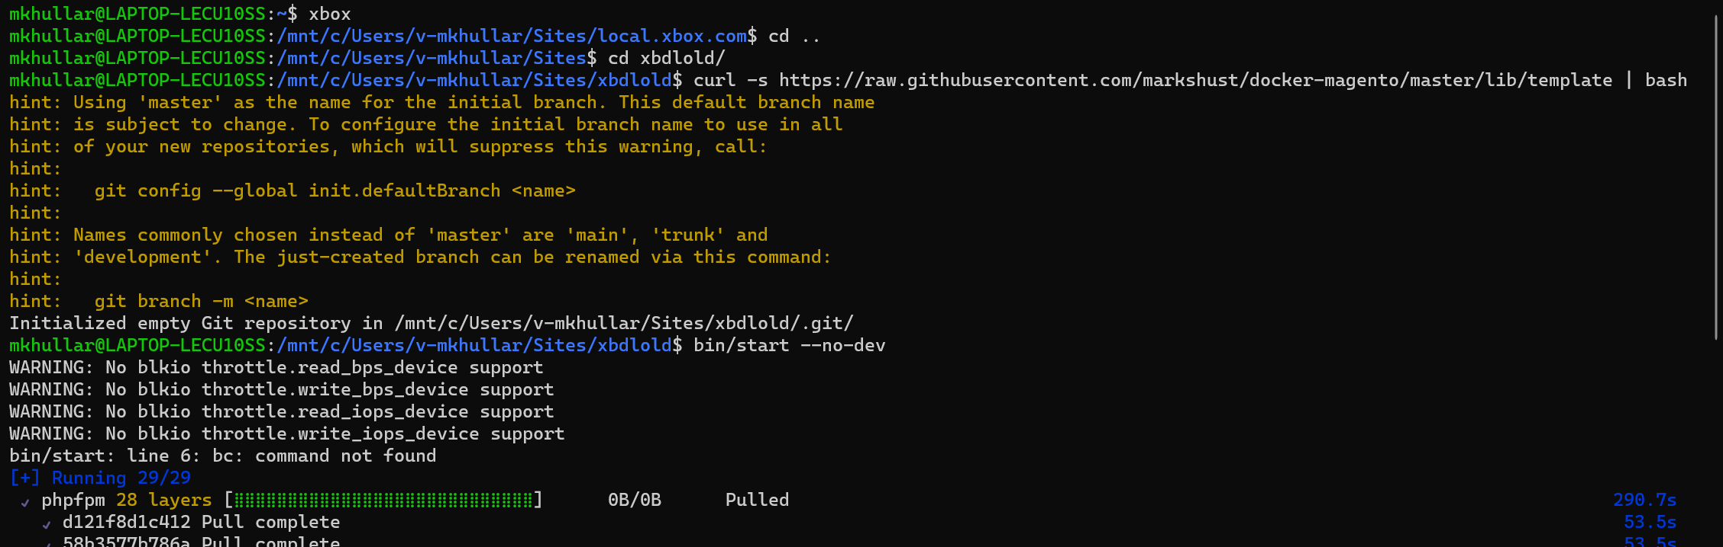

curl -s https://raw.githubusercontent.com/markshust/docker-magento/master/lib/template | bash

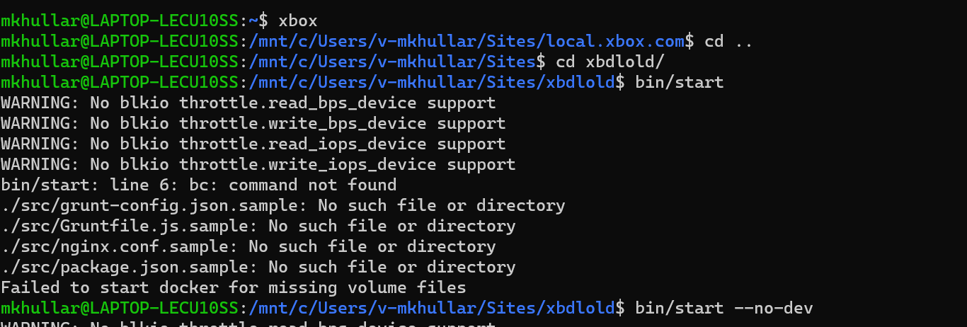

bin/start --no-dev

mkdir -p src

bin/copytocontainer --all