How to Deploy code on stage 2

Step1 – dB dump: -

C:\Users\v-mkhullar> magento-cloud db:dump -e staging2.

We need to create a one single branch and merged those PRs

For rename branch

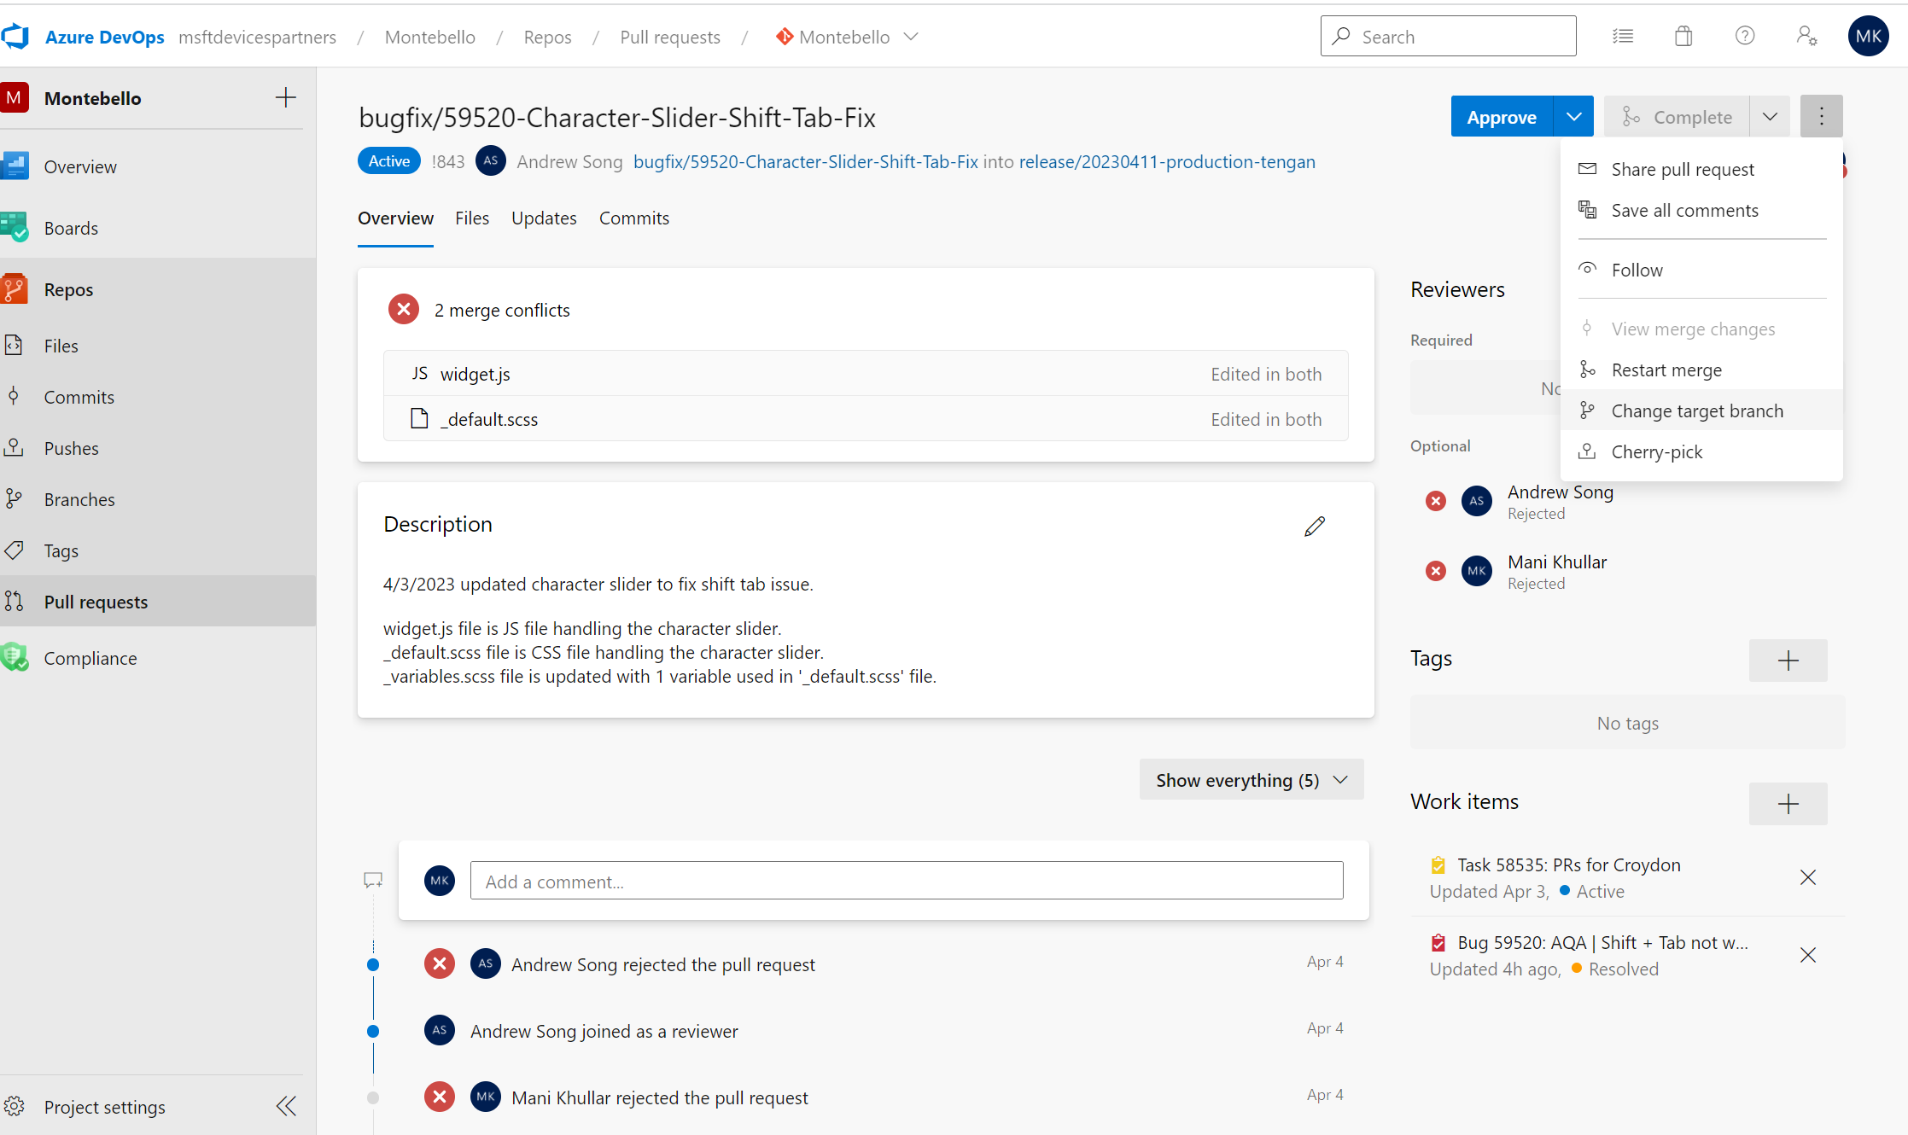

Click on change target branch and paste you branch and click down corner on change button

Click complete and merge

Step2 –

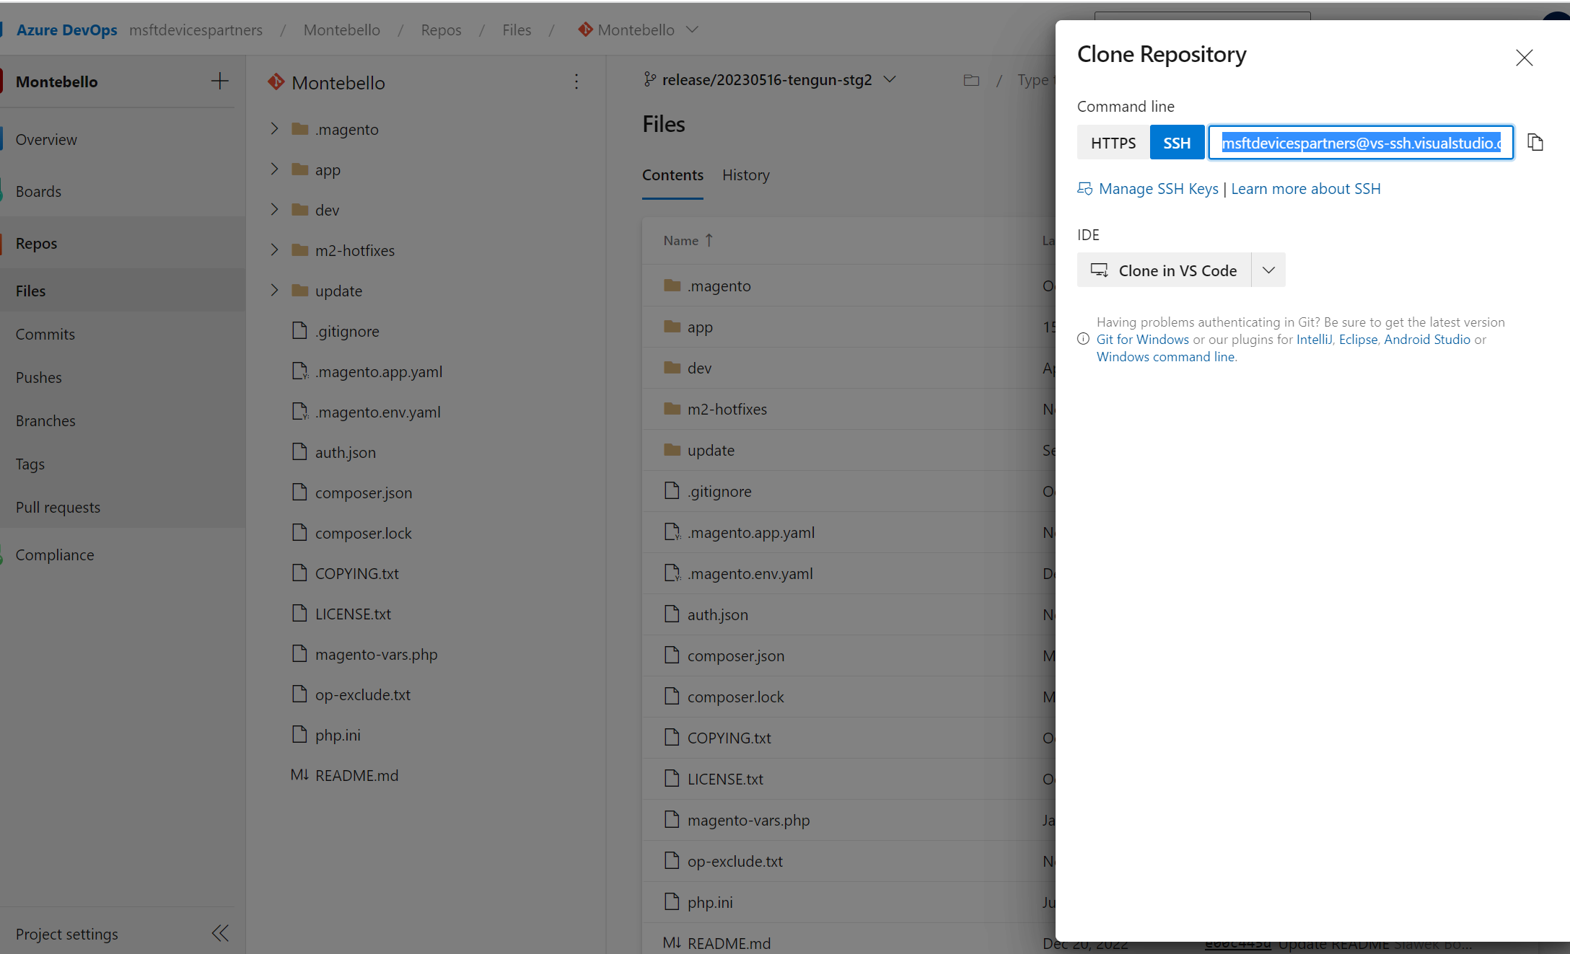

git clone msftdevicespartners@vs-ssh.visualstudio.com:v3/msftdevicespartners/Montebello/Montebello .

