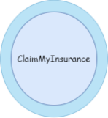
ClaimMyInsurance
Solution Design

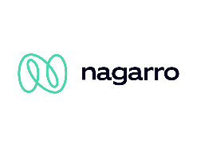
Nagarro Software Pvt. Ltd.
Microsoft Architecture Group

Revision History
Version | Date | Author/Contributor | Comments
1.00 |  | Manjeet Rana | Initial Draft

Contents
1. Introduction 4
2. Strategy Overview 5
3. Glossary 6
1.1 Terms 6

Introduction

This document contains information about solution design and a high-level application architecture for ClaimMyInsurance application that is developed on the microservices architecture which would be deployed in the cloud/on premise.

Strategy Overview

This document provides an architectural overview for insurance claiming application and is intended for Business Analysts, Product owners, developers and other teams involved in software development life cycle.
For this solution, we'll develop the backend system in microservices architecture where each event driven microservices would be developed in JAVA with Spring boot framework and Database would be per microservices. Spring Boot is a tool that makes developing web application and microservices with Spring Framework faster and easier through three core capabilities: Autoconfiguration, an opinionated approach to configuration and the ability to create standalone applications.
These backend microservices would expose rest endpoints through API gateway which can be consumed by frontend applications (Both Mobile and Web applications) to interact with Backend system.
The Frontend of this application would be developed on the Angular framework. Angular is a full-featured JavaScript framework that provides an extensive library of tools to support your development process. One of the main benefits of using Angular is it helps you quickly write your first application by providing many useful features out of the box and making it easy to get started with other features as needed. It is also suited for CRM applications.
The application would be containerized with docker, and it would be deployed on Kubernetes cluster. The application build, deployment and other related steps would be automated through the Gitlab pipeline.

Design Requirements

Below are some design requirements for ClaimMyInsurance application
- Design for evolution, flexibility, and reuse
- Componentize functionality as services
- ClaimMyInsurance environment should be up and running 24 x 7. In case of any crashes system should again restart on its own.
- System should be reliable.
- System should have enough logging to help in debug any error condition.

Non-Functional Requirements

- The website should be mobile friendly
- The offered solution must complete 99% of provided services in less than 5000 milliseconds, over both the peak and non-peak hours
- Proposed solution will have the ability to monitor and maintain the system, and include testability, configurability, and upgradeability.
- System should have flexible design and it should be able to handle increased load in future.
- Systems is only in English with no multi-lingual requirements.

Assumptions

- Authentication is being managed by managed services like IAM, LDAP, Active directory etc.
- Payment life cycle would be managed by 3rd party System/APIs
- We’ll consume the external systems APIs only on HTTPS protocol and the external system API lifecycle, security and maintenance would be managed by Vendors only.
- Payment will be done using third party tools and bills will be managed through same application.
- Workshops will be available to client from website as well.
- Client may raise request for claim one Auto is reached the partner workshop and can take help from partner workshop to raise the authentic claim request.
- Documents to be uploaded will be of limit size – 20 KB maximum.

Technology Stack

  - JAVA 11
  - Angular (as frontend)
  - Spring Boot (as a framework for backend microservices)
  - Spring Cloud Routing (acts as API Gateway)
  - Spring Cloud Contract (for Consumer Driven Contracts approach)
  - Spring Cloud Sleuth (for tracing)
  - Feign Client (for synchronous communication between microservices)
  - Lombok (Java library tool to minimize/remove boilerplate code)
  - Junit 5 (for unit tests)
  - MockMVC (for testing the rest APIs endpoint i.e., controller class)
  - Mockito (to mock external dependencies)
  - Flyway DB (as data migration tool
  - Swagger (to create the documentation of the APIs)
  - Messaging Queue Apache Kafka (for event-based communication)
  - Postgres SQL DB
  - Docker (For containerization)
  - Kubernetes (As Container orchestration tool)
  - Istio with Kubernetes (for traffic management, observability, and security for cloud native applications.)
  - Helm (tool that streamlines installing and managing Kubernetes applications)
  - Gradle (build automation tool)
  - GitLab (for code repository and CICD pipeline)
  - Sonar Lint, SonarQube (for code quality and analysis)
  - Documentum (as document management system)
  - Eclipse IDE
  - Postman
  - JMeter

High Level Application Architecture

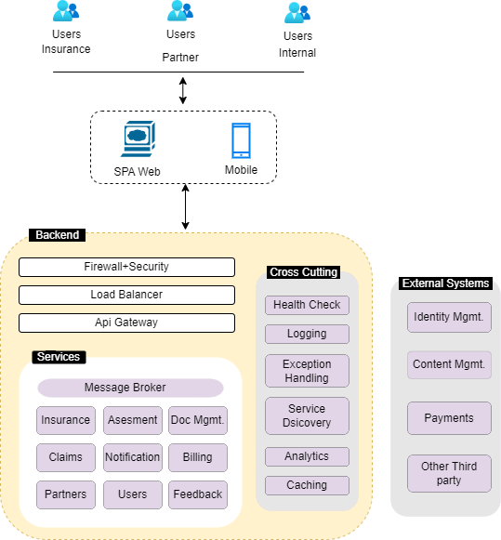

Component Description

7.1 Firewall
A firewall is a network security system that monitors, and controls incoming and outgoing network traffic based on predetermined security rules. A firewall typically establishes a barrier between a trusted network and an untrusted network, such as the Internet.

7.2 Load Balancer
A load balancer is a device that acts as a reverse proxy and distributes network or application traffic across several servers. Load balancers are used to increase capacity (concurrent users) and reliability of applications.

7.3 API Gateway
The API gateway is the entry point for clients. Instead of calling services directly, clients call the API gateway, which forwards the call to the appropriate services on the back end. An API gateway is an API management tool that sits between a client and a collection of backend services. An API gateway acts as a reverse proxy to accept all application programming interface (API) calls, aggregate the various services required to fulfil them, and return the appropriate result. We can implement the circuit breaker in API-Gateway and provide a default and standard fallback response for all microservices APIs. If any microservice is not available, then API gateway would provide this default fallback response.
Advantages of using an API gateway include:
- It decouples clients from services. Services can be versioned or refactored without needing to update all the clients.
- Services can use messaging protocols that are not web friendly, such as AMQP.
- The API Gateway can perform other cross-cutting functions such as authentication, logging, SSL termination, and load balancing.
- Out-of-the-box policies, like for throttling, caching, transformation, or validation.

7.4 Message Broker
An message queue (MQ) software is used to do a variety of tasks asynchronously. It is used to enable process-related asynchronous communication within IT systems with queue messaging system. Asynchronous communication means that the endpoints that are producing and consuming messages interact with only the queuing service, not with each other. Message queue mq provides asynchronous protocols to communicate remotely and at different times between senders and receivers. Messages consist of requests, replies, or alerts depending on the sender’s need.
Open-source message broker is an important part of software systems to send or receive messages in text and other formats. Message queuing service allows software applications to communicate and flow between various services within a system. Message queue software provides temporary message storage when the destination program is busy on other tasks. Internally, message broker software use a queue system to send or receive all messages and work on the principle of LIFO (Last-In, First-Out). Messages placed onto the queue are stored in lightweight buffer and then run in the background. Kafka is an open-source messaging system and a robust queue broker. It is distributed event streaming platform and has the ability to handle a high volume of messages.

7.5 Microservices
Backend application is developed is microservices architecture. A microservices architecture consists of a collection of small, autonomous services. Each service is self-contained and should implement a single business domain capability. These microservices are designed around business domain capabilities, can be deployed independently on the public/private cloud using CI/CD pipeline and loosely coupled. It should be designed for stateless computing, resiliency, and failure. Each microservices would have its own database and it would be responsible to handle its domain specific data.
Microservices uses two types of messages to communicate:
- Synchronous Messages — In this message type the client waits for the response from service which is generally used REST (Representational State Transfer) which is stateless and HTTP protocol.
- Asynchronous messages — In this message type the client won’t wait for the response, which is generally used protocols such as AMQP, STOMP, TCP.Cross Cutting concerns
In the Application diagram, there are some other components which depicts the cross-cutting concerns like Security, Configuration, Exception handling, Logging, Tracing, Visualization etc. They can be implemented using shared libraries or modules.

7.6 External Systems/3rd party systems
External systems/3rd party system are not maintained and managed by the Ecommerce Application, but they provide different APIs to integrate its services with the Ecommerce application so that we can use those time-tested systems, instead of implementing the solution in-house which would help reducing time to market and spare the bandwidth of the resources to focus on the business implementation.

High Level System Architecture
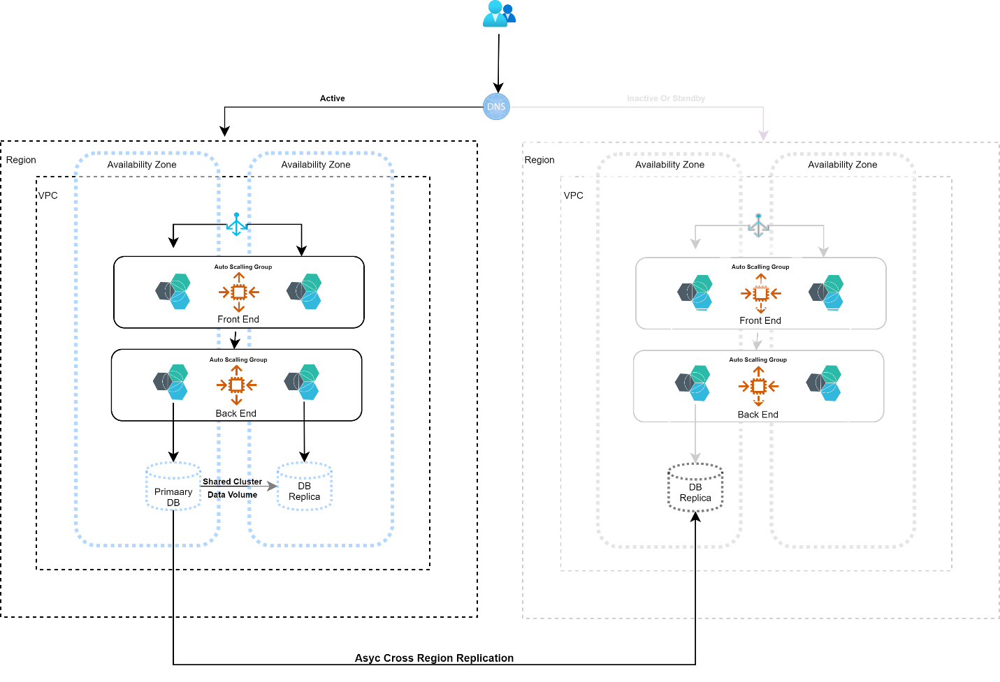
This System architecture is created keeping in mind the High availability and durability of the application. In this approach, we are replicating the data from one region to another region and have provisioned a copy of core workload infrastructure. Resources required to support data replication and backup, such as databases and object storage, are always on. Other elements, such as application servers, are loaded with application code and configurations, but are switched off and are only used during testing or when disaster recovery failover is invoked. In this strategy, your core infrastructure is always available, and you always have the option to quickly provision a full-scale production environment by switching on and scaling out your application servers.
A pilot light approach minimizes the ongoing cost of disaster recovery by minimizing the active resources and simplifies recovery at the time of a disaster because the core infrastructure requirements are all in place. As we can from diagram that it is multi-tier, highly available architecture where Load Balancers, microservices instance are deployed in multiple zones and for relation DB.
Now, look at the passive side which is greyed out. Right now, we don’t have any running microservices instance deployed, mean that they are scaled to 0 but if needed, we can scale it quickly but scaling the instances on the infrastructure. We can also Follow Infrastructure as a code strategy and create template for setting up infrastructure with the help of DevOps tools like Terraform, Ansible etc.
But do note that data is getting replicated continuously using async cross-region replication, but we can also do the DB snapshot which may be used to restore data back in time, in case, there is some data corruption happened.

Glossary

9.1 Terms

Glossary Term | Definition
DB | Database.
OAuth | Open Authentication.
K8S | Kubernetes
JSON | Java Script Object Notation
CI | Continuous Integration
CD | Continuous Delivery

9.2 Appendix

Gitlab Pipeline | https://docs.gitlab.com/ee/ci/pipelines/
Mongo DB | https://www.mongodb.com/docs/atlas/
Postgres | https://www.postgresql.org/docs/
Angular | https://angular.io/start
Spring Boot | https://spring.io/projects/spring-boot
Gradle | https://docs.gradle.org/current/userguide/userguide.html
Junit | https://junit.org/junit5/docs/current/user-guide/
Swagger | https://swagger.io/
Docker | https://docs.docker.com/
Kubernetes | https://kubernetes.io/docs/home/
Helm | https://helm.sh/docs/
Istio | https://istio.io/latest/docs/
Kafka | https://kafka.apache.org/downloads
SonarQube | https://docs.sonarqube.org/latest/setup/get-started-2-minutes/
JMeter | https://jmeter.apache.org/

