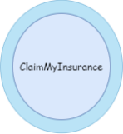
ClaimMyInsurance
Solution Design

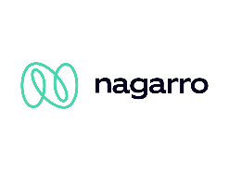
Nagarro Software Pvt. Ltd.
Microsoft Architecture Group

Revision History
Version | Date | Author/Contributor | Comments
1.00 |  | Manjeet Rana | Initial Draft

Table of Contents
1 Introduction 1
2 System Overview 1
3 Requirement 1
3.1 Business Requirement 1
3.2 Functional Requirement 1
3.2.1 Web application 1
3.2.2 Customer Self-Service Portal 1
3.2.3 Internal Portal — Adjustor / Case Manager 1
3.2.4 Surveyor Portal 1
3.2.5 Alert and Notification System 1
3.2.6 3rd Party Integration 1
3.2.7 Reporting 1
4 Technology Overview 1
5 Assumptions 1
5.1 In Scope 1
5.2 Out of Scope 1
6 NFR Considerations 1
6.1 Usability 1
6.2 Reliability 1
6.3 Performance 1
6.4 Security 1
6.5 Supportability 1
6.6 Auto Scalability 1
7 Solution Architecture 1
7.1 High Level Solution Diagram 1
7.2 Components Description 1
7.2.1 API Gateway 1
7.2.2 Microservices 1
7.2.3 Cross-Cutting Concerns 1
8 Application Architecture 1
8.1 Architecture Diagram 1
8.2 Modules Description 1
8.2.1 API Gateway 1
8.2.2 Microservices Decomposition Pattern 1
8.2.3 Sidecar Design Pattern 1
8.2.4 Service Mesh 1
8.2.5 Database Design Pattern 1
9 Network Architecture 1
9.1 Network Diagram 1
9.2 Network Component Description 1
9.2.1 Cloud Armor WAF 1
9.2.2 GKE Ingress (Istio IngressGateway) 1
9.2.3 API Gateway Service 1
9.2.4 GKE Autopilot Cluster 1
9.2.5 Cloud SQL (PostgreSQL 15) 1
9.2.6 Cloud Storage (GCS) 1
9.2.7 Cloud Memorystore (Redis) 1
9.2.8 Notification Services (SendGrid + Twilio) 1
9.2.9 Docker 1
9.2.10 Disaster Recovery 1
10 Deployment Architecture 1
10.1 Continuous Integration 1
10.2 Continuous Delivery 1
10.3 GCP Cloud Build Pipeline 1
11 Glossary 1
11.1 Terms 1
11.2 Appendix 1

Introduction
"YCompany" is one of the renowned names in Insurance providers in industry, providing auto insurance to customers in the US. They serve more than 200 million customers across various geographies. YCompany sells insurance policies through a well-organised electronic process. However, the claims processing part of the business remains manual and heavily driven by manual touch points, causing significant delays, customer dissatisfaction and operational inefficiency.
This document provides the solution design and high-level application architecture for the ClaimMyInsurance (eClaims) platform — a cloud-native, event-driven microservices portal that digitises the end-to-end claim lifecycle. The solution reduces claim turnaround time from 14+ days to 3 days, providing real-time transparency to customers, adjustors, surveyors and partner workshops.
The platform is built on Java 17 and Spring Boot 3.2 microservices, a React.js 18 TypeScript frontend, Apache Kafka event streaming, Camunda 8 BPMN workflow orchestration and deployed on Google Cloud Platform (GCP) using GKE Autopilot with full GitHub Actions CI/CD automation.

System Overview
"YCompany" serves more than 200 million customers across various geographies. The eClaims platform eliminates manual claim processing through a fully digital, event-driven system. The platform provides role-based portals for all stakeholders — customers, adjustors, surveyors and partner workshops — all communicating through a centralised API Gateway backed by Apache Kafka for asynchronous event streaming.
To overcome the challenges of the manual process, the eClaims platform provides:
- Customer self-service portal for online claim submission with photograph and document upload, GPS location capture, and real-time claim status tracking
- Automated surveyor assignment based on geolocation — Haversine algorithm with Google Maps Distance Matrix API for proximity and ETA-based ranking
- BPMN 2.0 workflow orchestration via Camunda 8 / Zeebe with automated escalation timers (72h surveyor, 48h adjustor)
- Electronic payment settlement via Stripe (PCI-DSS Level 1) to both customer and partner workshop
- Automated email (SendGrid / Google Cloud SMTP) and SMS (Twilio) notifications at every claim status transition
- Secure document management with MinIO / Google Cloud Storage, pre-signed URLs, and 7-year retention compliance
- Role-based reporting for regional managers, case managers and executive leadership

Requirement

Business Requirement
"YCompany" is willing to build a customer portal and mobile-responsive web application which customers can use to inform of an accident or loss, submit details regarding the accident (e.g., photograph of accident or police report) and receive a claims ID corresponding to their policy. The incident manager, adjustor and surveyor must be notified automatically. The customer must be constantly updated with the status of claims processing. Customers must be provided with a list of partner workshops where they can take the vehicle for repairs, and be able to book an appointment from the portal. The partner workshop must be intimated of the initial accident details. Any change in the status of the vehicle must trigger a customer notification. Upon settlement, payment must be processed electronically.

Functional Requirement

Web application
The web-based application is available to authorised users: Customer, Internal Users (Adjustor, Surveyor, Case Manager) and Administrator.
- Customer Self-Service Portal
- Internal Portal / Case Management Team
- Adjustor / Surveyor Portal
- Admin Portal

Customer Self-Service Portal
Accessible by all customers online to perform:
- Sign up and link insurance policies to account
- Login / logout from the portal
- Submit a claim online and upload supporting documents and photographs
- Capture accident location via GPS
- Track claim status in real time through the complete 12-state lifecycle
- Receive automated notifications (email and SMS) at every status change
- Select a partner workshop from a geo-located list and book a repair appointment
- Download claim documents and payment receipts

Internal Portal — Adjustor / Case Manager
Accessible by all internal staff of YCompany to perform:
- Login / logout from the portal
- Review claims queue with SLA timers and priority indicators
- Approve or reject claims with financial breakdown (approved amount, deductible, insurer/customer split)
- Delegate and escalate complex claims to case managers
- Access role-specific reports and analytics

Surveyor Portal
Accessible by registered surveyors to perform:
- Receive claim assignment notifications with accident location
- Submit damage assessment with category (Minor / Moderate / Severe / Total Loss) and estimated repair cost
- Upload GPS-tagged photographs from the accident site

Alert and Notification System
This system sends automated notifications (via email and SMS) to customers and internal staff for the following events:
- Claim submitted — notifies incident manager, adjustor and surveyor
- Surveyor assigned — notifies customer and surveyor
- Claim approved or rejected — notifies customer and partner workshop
- Workshop assigned — notifies customer and partner workshop
- Repair status changes — notifies all relevant parties
- Payment processed — notifies customer and workshop

3rd Party Integration
3rd party integrations are provided for external service providers:
- Stripe — Electronic payment processing (PCI-DSS Level 1, PAY AS YOU GO)
- Google Maps Platform — Distance Matrix API for geo-based workshop and surveyor ranking
- Twilio — SMS notification delivery to 180+ countries
- SendGrid — Transactional email delivery for all notification types
- Partner workshops can submit work orders, repair estimates and completion updates via REST API or portal

Reporting
- Regional Manager: claims processed by region, individual processing time, fraud report, ageing matrix
- Case Manager: claims by status, SLA adherence, escalation report
- Executive Dashboard: cross-region analytics via BigQuery and Looker Studio
- CSV export for all report types with configurable date/region filters

Technology Overview
The eClaims platform uses a modern, cloud-native technology stack chosen for performance, security and long-term maintainability. Technology decisions are documented in Design Architecture Records (DARs) covering Payment Gateway, Frontend Framework and SMS Service selection.

Layer | Technology | Version | Purpose
Backend Language | Java | 17 LTS | JVM runtime — long-term support
Backend Framework | Spring Boot | 3.2.x | Microservices framework with autoconfiguration
API Gateway | Spring Cloud Gateway | 2023.x | JWT validation, rate limiting, routing
Workflow Engine | Camunda 8 / Zeebe | 8.4 | BPMN 2.0 claim orchestration
Messaging | Apache Kafka | 7.5 | Event streaming — 11 topics, 3 partitions
Database | PostgreSQL | 15 | Transactional data (5 schemas, Flyway migrations)
Document Storage | MinIO / GCS | Latest | Claim evidence, 7-year retention
Frontend Framework | React.js | 18 | Single Page Application (SPA)
Frontend Language | TypeScript | 5.x | Type-safe frontend development
UI Styling | Tailwind CSS | 3.x | Utility-first responsive styling
Identity Provider | Keycloak | 23.x | OAuth2 / OpenID Connect / RBAC
Container Platform | Docker | 24+ | Multi-stage images (~180MB per service)
Orchestration | Kubernetes / GKE | 1.27+ | GKE Autopilot, HPA 2–10 pods
Cloud Platform | Google Cloud Platform | N/A | Production cloud environment
CI/CD | GitHub Actions | N/A | 11-job automated pipeline with quality gates
GitOps | ArgoCD | 2.9 | Kubernetes deployment automation
IaC | Terraform | 1.6 | Cloud resource provisioning
Service Mesh | Istio | 1.19 | mTLS, circuit breaker, observability
Payment Gateway | Stripe | Latest | PCI-DSS Level 1, PAY AS YOU GO
SMS Service | Twilio | Latest | Transactional SMS, 180+ countries
Email Service | SendGrid | Latest | Transactional email notifications
Code Quality | SonarQube | Latest | Static analysis, 80% coverage gate
Security Scan | OWASP + Trivy + CodeQL | Latest | Dependency, container and SAST scans

Assumptions

In Scope
- The application supports English language only
- Authentication is managed via Keycloak (OAuth2/OIDC); no custom auth implementation
- Payment is handled by Stripe (PCI-DSS Level 1); card details never reach YCompany servers
- External APIs (Stripe, Google Maps, Twilio, SendGrid) are consumed over HTTPS; their lifecycle and security is managed by the respective vendors
- Partner workshops and surveyors are pre-registered in the eClaims system
- Document uploads support JPEG, PNG and PDF formats; maximum 20MB per file
- Claims cover motor (auto) insurance only in this phase
- All source code, CI/CD and documentation hosted on GitHub
- GCP is the target cloud platform for all production workloads
- Response from external services will be in JSON format with proper error messages

Out of Scope
- Multi-language support is not provided in this phase
- Insurance policy creation and underwriting — policy data is read-only from eClaims
- Native mobile application (iOS/Android) — mobile-responsive web only in this phase
- Automated ML-based fraud detection — manual fraud flag only
- Real-time GPS tracking of surveyors en route to the accident location
- Bulk historical data migration of existing customers and claims — handled via a separate workstream
- Rental vehicle booking from partner site is out of scope for Phase 1
- Changes to requirements after SRS sign-off are managed via a formal change request process
- Test data will be provided by YCompany

NFR Considerations

Usability
- The application is accessible on any device supporting modern web browsers (Chrome, Firefox, Safari, Edge)
- The UI is responsive and optimised for desktop, tablet and mobile-responsive web using React.js 18 and Tailwind CSS
- Role-based navigation renders only the portal sections relevant to the authenticated user role
- The system does not require any special training for end users
How will we achieve Usability?
- React.js 18 with Tailwind CSS provides a consistent, accessible design system and responsive layout across all portals
- Familiar navigation patterns, clear headings and role-appropriate menus reduce cognitive load
- Nagarro brand palette applied consistently across all portal screens

Reliability
- Target availability: 99.9% uptime in the production environment
- Kubernetes HPA ensures a minimum of 2 replicas per service in production — pods auto-restart on failure
- All state-changing operations publish Kafka events with at-least-once delivery guarantee
- Cloud SQL PostgreSQL with synchronous HA replication across two availability zones
- Disaster Recovery: us-east1 pilot light — RTO < 1 hour, RPO < 15 minutes
How will we achieve Reliability?
- GKE Autopilot automatically replaces failed nodes and reschedules pods
- Kafka dead-letter queues capture failed events for manual review and replay
- Cloud SQL automated daily backups with point-in-time recovery

Performance
- 99% of requests must be serviced in under 5,000 milliseconds over both peak and non-peak hours
- System must support 1,000 concurrent users sustained load (verified by JMeter load tests)
- GKE HPA scales services from 2 to 10 replicas based on CPU (70%) and memory (80%) thresholds
- Redis Memorystore caches claim status and partner geo-search results to reduce database load
How will we achieve Performance?
- Spring Cloud Gateway rate limiting prevents traffic spikes from overwhelming downstream services
- Docker multi-stage images (~180MB) minimise container startup time
- Kafka partitioning (3 per topic) enables parallel consumer processing across scaled service replicas

Security
- All communication over TLS 1.3; Google Cloud Armor WAF protects the GKE ingress
- Keycloak OAuth2/OIDC with JWT tokens (60-minute validity); 6 defined roles with @PreAuthorize enforcement
- Istio mTLS between all microservices prevents unauthorised service-to-service calls
- PCI-DSS compliance via Stripe.js tokenisation — card details never reach YCompany infrastructure
- GCP Secret Manager stores all credentials; no secrets in code, environment variables or Git
- OWASP Dependency Check, Trivy container scan and CodeQL SAST run in every CI/CD pipeline execution
How will we achieve Security?
- Non-root container execution (runAsUser: 1000) with read-only root filesystems in all pods
- GKE binary authorisation ensures only signed, scanned images are deployed to production
- Google Cloud Audit Logs records all administrative actions for compliance and audit

Supportability
- GitHub Actions CI/CD pipeline automates build, test, security scan and deploy on every code push
- ArgoCD GitOps ensures cluster state matches Git at all times with automatic self-healing
- Structured JSON logging to Google Cloud Logging with request correlation IDs for distributed trace lookup
- Prometheus + Grafana dashboards for real-time metrics, latency percentiles and error rates per service
- All APIs documented via Swagger/OpenAPI accessible at /swagger-ui.html per service

Auto Scalability
- GKE Autopilot provisions and scales compute nodes automatically — no manual node management
- HPA scales each microservice independently based on observed CPU and memory metrics
- Kafka partition count (3 per topic) enables parallel consumer processing across multiple service replicas
- Canary deployment via Istio VirtualService — gradual traffic shifts: 5% → 25% → 100% per production release

Solution Architecture

High Level Solution Diagram
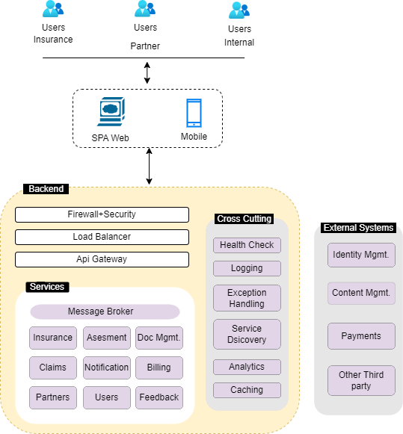
Figure 1: High Level Solution Diagram

Components Description

API Gateway
The API Gateway (Spring Cloud Gateway, port 8080) is the single entry point for all client requests. It validates JWT tokens issued by Keycloak, applies rate limiting (100 requests per minute per user, burst 20), routes traffic to appropriate downstream microservices, and provides circuit breaker fallback responses. CORS is configured to allow requests only from known frontend origins.

Microservices
The eClaims backend consists of 7 independently deployable microservices. Each service owns its own PostgreSQL schema (database-per-service pattern), communicates asynchronously via Apache Kafka events, and exposes a versioned REST API. Services are packaged as Docker multi-stage images (JDK 17 build stage → JRE slim runtime, ~180MB) and deployed on GKE with HPA.

Cross-Cutting Concerns
Cross-cutting concerns — security, logging, tracing, exception handling and monitoring — are implemented centrally. Spring Security with @PreAuthorize annotations enforces RBAC on all endpoints. Google Cloud Logging receives structured JSON logs with correlation IDs. Cloud Trace provides distributed request tracing. Prometheus metrics are exposed via /actuator/prometheus and visualised in Grafana dashboards.

Application Architecture

Architecture Diagram
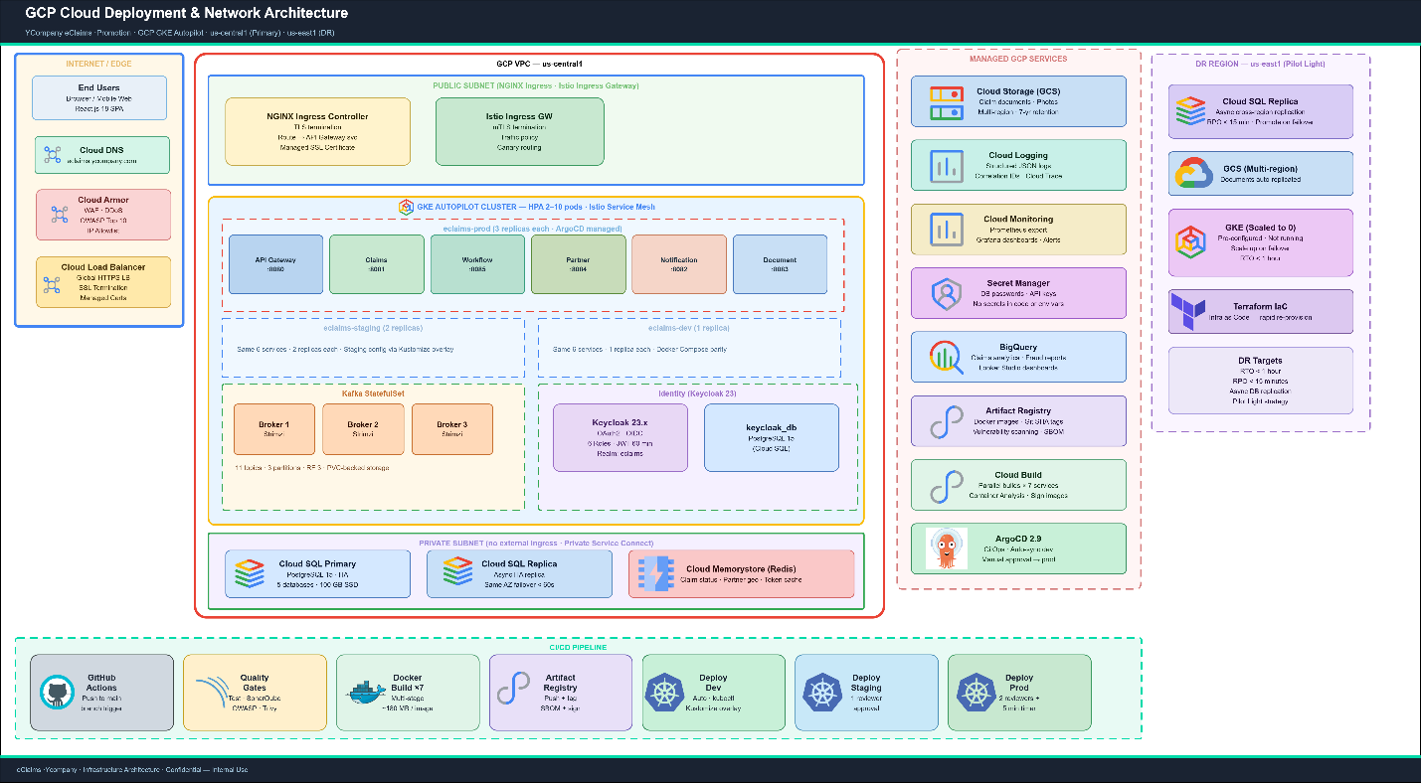
Figure 2: Application Architecture — Microservices and Event Flow

Modules Description

API Gateway
An API Gateway is a reverse proxy that accepts all API calls, applies various services to fulfil the calls, and returns the appropriate output. The Spring Cloud Gateway (:8080) is responsible for JWT validation via Keycloak JWKS endpoint, per-user rate limiting, request routing to downstream microservices, circuit breaker with configurable fallback responses, and CORS policy enforcement.
Advantages of using an API Gateway:
- It decouples clients from services — services can be versioned or refactored without updating all clients
- The Gateway handles cross-cutting concerns: authentication, logging, SSL termination and rate limiting
- Circuit breaker pattern provides resilience — downstream service failures do not cascade to clients

Microservices Decomposition Pattern
The eClaims backend follows the microservices architecture, splitting the application into 7 loosely coupled, independently deployable services. Each microservice is designed around a specific business domain capability and owns its data.
The 7 microservices are:
- Claims Service (:8081) — 12-state claim lifecycle, FNOL intake, status management, Kafka event publishing
- Notification Service (:8082) — Email/SMS consumers across 6 Kafka topics, idempotency guard, retry handling
- Document Service (:8083) — MinIO/GCS upload, pre-signed URLs, EXIF GPS extraction, 7-year retention
- Partner Service (:8084) — Geo-radius workshop search, Haversine algorithm, Google Maps API, GPS verification
- Workflow Service (:8085) — Camunda 8 / Zeebe BPMN process orchestration, 8 job workers, escalation timers
- API Gateway (:8080) — Single entry point, JWT validation, rate limiting, circuit breaker
- Shared Events Library — Kafka event DTOs shared across all services; single source of truth

Sidecar Design Pattern
Istio 1.19 is deployed as a service mesh across the GKE Autopilot cluster. An Envoy proxy sidecar is automatically injected into each service pod via the istio-injection=enabled namespace label on eclaims-dev, eclaims-staging and eclaims-prod. The Envoy sidecar intercepts all inbound and outbound traffic at the pod level, handling mutual TLS (mTLS) for all east-west service-to-service traffic, circuit breaking, retries, timeout enforcement and telemetry collection. The application code is entirely decoupled from network security and observability concerns — the sidecar handles them transparently without any changes to the Java microservice code.
The Istio control plane runs as a managed deployment (istiod) within the GKE cluster and is responsible for:
- Pilot — distributes routing rules, service discovery and traffic management policies to all Envoy sidecars via xDS APIs
- Citadel — acts as the internal Certificate Authority (CA), issuing and rotating SPIFFE/X.509 certificates for each workload identity, enabling zero-trust mTLS without managing certificates manually
- Galley — validates and distributes Istio configuration (VirtualService, DestinationRule, AuthorizationPolicy) to the data plane
Benefits of the Sidecar Pattern in the eClaims GKE deployment:
- Reduces complexity in microservice code by abstracting all network security, retry and timeout logic to a separate infrastructure layer — the 7 Spring Boot services contain zero Istio-specific code
- Eliminates code duplication — mTLS, circuit breaking and distributed tracing are configured once via Kubernetes CRDs and applied uniformly across all services
- Provides loose coupling between application code and the underlying network platform — security policies can be updated, tightened or relaxed via YAML without redeploying any microservice
- Enables uniform policy enforcement — AuthorizationPolicy CRDs restrict which services may call each other (e.g. only the API Gateway may call Claims Service), preventing lateral movement in a breach scenario

Service Mesh
Istio provides a service mesh layer on top of the GKE Autopilot infrastructure, enabling fully managed, observable and zero-trust-secured communication between all 7 eClaims microservices. The mesh is configured entirely via Kubernetes Custom Resource Definitions (CRDs) — VirtualService, DestinationRule, Gateway, AuthorizationPolicy and PeerAuthentication — all version-controlled in Git and applied via ArgoCD. Core capabilities are described below.

Security — Zero-Trust mTLS
A PeerAuthentication policy set to STRICT mode enforces mutual TLS across the entire eclaims-prod namespace. Every service-to-service call (e.g. API Gateway to Claims Service, Claims Service to Notification Service via Kafka sidecar) requires a valid SPIFFE X.509 certificate issued by Istio’s internal CA. Unauthenticated or plaintext calls are rejected at the sidecar level before reaching the application container.
AuthorizationPolicy CRDs define fine-grained allow-lists for inter-service calls:
- Only the API Gateway service account may call Claims Service, Partner Service and Workflow Service REST endpoints
- Notification Service and Document Service may only be called by Claims Service and Workflow Service — direct external calls are rejected
- Certificates are automatically rotated every 24 hours by Istio Citadel with zero downtime — no manual certificate management is required

Traffic Management
Istio VirtualService and DestinationRule CRDs govern all traffic routing within the mesh. Key traffic management configurations for eClaims include:
- Canary releases — VirtualService weight-based routing shifts production traffic incrementally: 5% canary → 25% canary → 100% stable. ArgoCD Rollouts triggers each shift after a configurable observation window with automatic rollback if error rate exceeds 1%
- Retries — DestinationRule configures 3 automatic retries with 25ms base delay for 503 and 504 responses on all inter-service calls, eliminating transient failures under GKE pod churn
- Timeouts — per-route timeouts are enforced at the sidecar (e.g. Partner Service geo-search 3s, Document Service upload 30s) ensuring SLA timers are not exceeded by slow dependencies
- Circuit breaker — outlier detection ejects a pod from the load-balancing pool after 5 consecutive 5xx responses within a 10-second window, isolating unhealthy instances and gradually reintroducing them after a 30-second sleep
- Fault injection — used in staging to simulate downstream service failures (delay and abort faults injected via VirtualService) to validate circuit breaker and retry behaviour before production releases

Observability
Istio’s Envoy sidecars emit rich telemetry that feeds directly into the eClaims observability stack without requiring any instrumentation in the application code:
- Metrics — request count, latency percentiles (p50/p95/p99) and error rates per service pair are scraped by Prometheus and visualised in Grafana. Alerts fire when p99 latency exceeds 2 seconds or error rate exceeds 0.5% over a 5-minute window
- Distributed tracing — Envoy injects W3C Trace Context headers (traceparent) on every request. Cloud Trace aggregates spans from all 7 services into a single end-to-end trace, enabling root-cause analysis of latency across service boundaries
- Service topology — Kiali provides a real-time graph of all inter-service calls, traffic volumes, error rates and mTLS status per edge. This is the primary tool for on-call engineers to identify which service in the mesh is producing errors during an incident
- Access logs — Envoy access logs (request method, path, response code, latency, upstream cluster) are shipped to Google Cloud Logging and linked to Cloud Trace spans via the x-request-id correlation header

GKE Autopilot Integration
Istio is installed on GKE Autopilot using the managed Anthos Service Mesh (ASM) add-on, which eliminates the need to manage the control plane or upgrade Istio independently. ASM is version-pinned in Terraform (asm_version = “1.19”) and automatically upgraded during GKE minor version upgrades. Key GKE-specific considerations:
- Sidecar resource budgets — each Envoy sidecar is allocated 100m CPU and 128Mi memory in the pod resource requests to ensure GKE Autopilot schedules pods correctly and does not undercount resource consumption
- Ingress Gateway — the Istio IngressGateway serves as the sole north-south entry point. TLS is terminated at the IngressGateway using Google-managed SSL certificates; all traffic inside the cluster flows over Istio mTLS with no plaintext hops
- Namespace isolation — each environment namespace (eclaims-dev, eclaims-staging, eclaims-prod) has its own PeerAuthentication and AuthorizationPolicy scope; a policy misconfiguration in dev cannot affect production

Database Design Pattern
Each microservice owns an independent PostgreSQL schema (database-per-service), aligned with Domain-Driven Design bounded-context principles:
- claims_db — Claims, ClaimStatusHistory, ClaimDocuments tables
- notification_db — NotificationLog table with UNIQUE idempotency_key
- document_db — DocumentMetadata, DocumentAudit tables
- partner_db — Surveyors, Workshops, WorkOrders tables with PostGIS extension
- workflow_db — Process audit and escalation log tables
Data consistency across services is maintained via the SAGA pattern through Kafka event choreography — there are no distributed transactions. Event Sourcing is partially implemented via the immutable ClaimStatusHistory audit table. Schema changes are managed via Flyway versioned migration scripts.

Network Architecture

Network Diagram
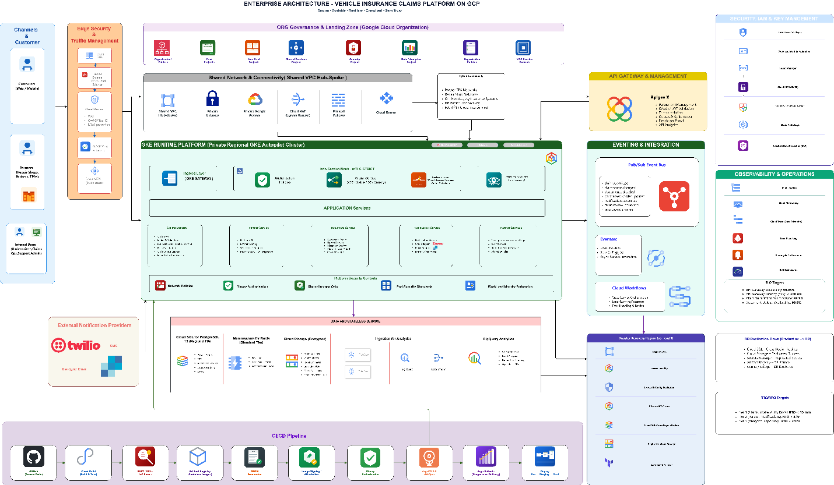
Figure 3: GCP Cloud Deployment and Network Architecture

Network Component Description

Cloud Armor WAF
Google Cloud Armor acts as a Web Application Firewall at the ingress layer. It provides DDoS protection, IP-based access control, OWASP Top 10 rule enforcement and rate limiting before traffic reaches the GKE cluster.

GKE Ingress (Istio IngressGateway)
The Istio IngressGateway acts as the single north-south entry point for all external HTTPS traffic entering the GKE cluster. It is exposed via a Google Cloud Load Balancer with a static external IP, protected by Google Cloud Armor WAF upstream. TLS termination is handled at the IngressGateway using Google-managed SSL certificates bound via a Kubernetes Gateway resource. Once traffic enters the mesh, the IngressGateway forwards it to the API Gateway service over Istio mTLS — there is no plaintext hop at any point inside the cluster. The IngressGateway is deployed in the istio-system namespace with a dedicated node pool and HPA (min 2, max 5 replicas) to ensure ingress availability is independent of application workload scaling.

API Gateway Service
Spring Cloud Gateway (:8080) acts as the internal reverse proxy and API management layer. It handles JWT validation, rate limiting, request routing and circuit breaking before forwarding to downstream microservices within the same GKE namespace.

GKE Autopilot Cluster
Google Kubernetes Engine Autopilot provisions and manages compute nodes automatically. Microservices are deployed in separate namespaces (eclaims-dev, eclaims-staging, eclaims-prod) with HPA scaling pods from 2 to 10 based on CPU and memory. Kustomize overlays manage environment-specific configuration. ArgoCD watches the Git repository and auto-syncs the dev namespace within 3 minutes of any change.

Cloud SQL (PostgreSQL 15)
Google Cloud SQL provides fully managed PostgreSQL 15 with synchronous HA replication across two availability zones. Automatic daily backups with point-in-time recovery. The database resides in a private VPC subnet with access restricted to the GKE cluster via Private Service Connect.

Cloud Storage (GCS)
Google Cloud Storage stores claim documents and photographs with multi-region redundancy. The Document Service generates pre-signed URLs (1-hour expiry) for time-limited, direct client download without routing file data through the application tier. Lifecycle policies enforce 7-year retention compliance.

Cloud Memorystore (Redis)
Redis Memorystore provides in-memory caching for frequently accessed data — claim status lookups, partner geo-search results and Keycloak token validation. This reduces PostgreSQL query load under peak claim volumes.

Notification Services (SendGrid + Twilio)
SendGrid handles transactional email delivery for all notification types. Twilio handles SMS delivery to customers, surveyors and partner workshops across 180+ countries. Both services are consumed via HTTPS REST APIs from the Notification Service.

Docker
Each microservice is packaged as a Docker multi-stage image: JDK 17 for the build stage and JRE slim for the runtime stage, resulting in ~180MB images. Images are stored in Google Artifact Registry and signed for GKE Binary Authorisation.

Disaster Recovery
The eClaims platform is designed for high availability and rapid recovery. The production environment runs in GCP us-central1 (primary region) with a pilot light DR environment in us-east1 (secondary region). The DR strategy targets RTO under 1 hour and RPO under 15 minutes for all Tier 1 components. All infrastructure is managed as code via Terraform, enabling rapid and repeatable environment re-provisioning without manual intervention.
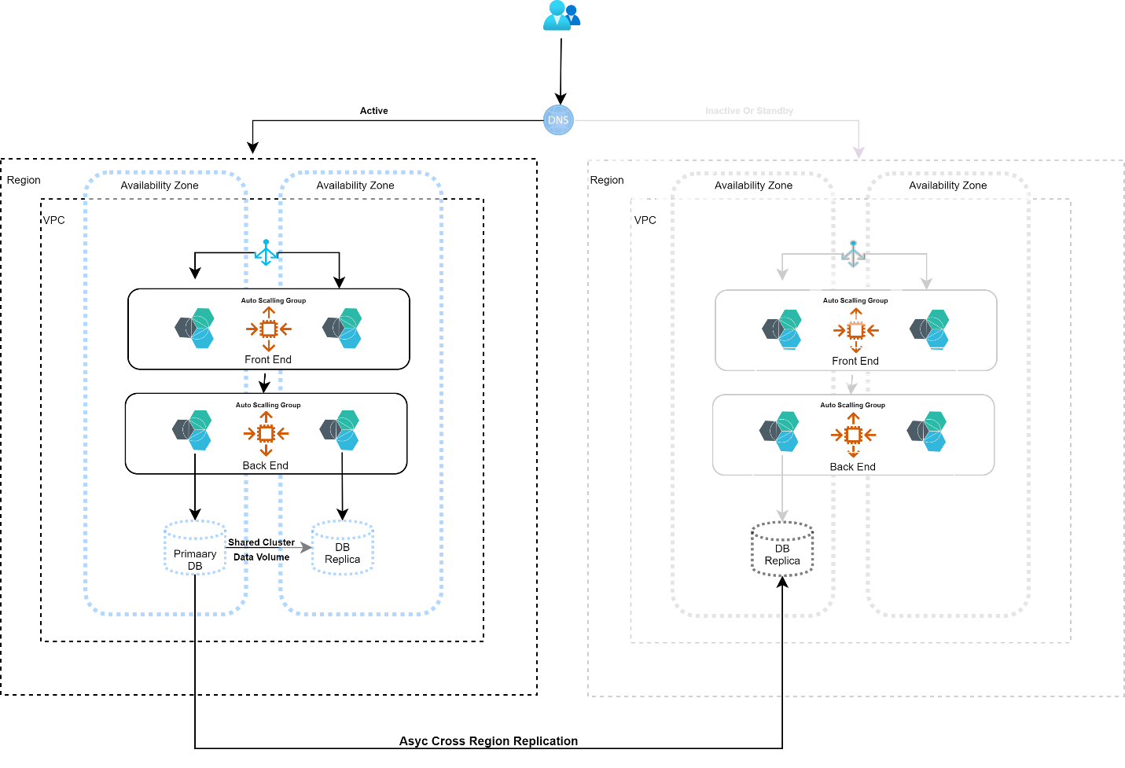

DR Architecture — Pilot Light
The pilot light pattern keeps a minimal warm standby in us-east1 that can be brought to full capacity quickly. The following components are maintained in the DR region at all times:
- Cloud SQL read replica — a synchronous HA replica of the primary PostgreSQL 15 instance is maintained in us-east1 via Cloud SQL cross-region replication. On failover, the replica is promoted to a standalone primary (typically under 60 seconds); RPO is determined by the replication lag, which is monitored and alerted if it exceeds 5 minutes
- GKE Autopilot cluster (DR) — a pre-provisioned GKE Autopilot cluster in us-east1 runs all 7 microservices scaled to zero (0 replicas). On failover activation, a Cloud Deploy promotion + ArgoCD sync scales all deployments to their minimum production replica counts (2 per service) within approximately 8 minutes
- Google Cloud Storage — GCS buckets storing claim documents are configured with multi-region storage class (us-central1 + us-east1), providing automatic cross-region redundancy with no failover action required for document access
- Cloud Memorystore (Redis) — a separate Redis instance is provisioned in us-east1 in standby mode. Cache is treated as ephemeral; on failover, the DR Redis instance starts empty and warms up within minutes as traffic is served from Cloud SQL
- Apache Kafka — Kafka is deployed within GKE with topic replication factor 3 across availability zones in us-central1. For DR, a mirrored Kafka cluster in us-east1 uses MirrorMaker 2 to replicate all 11 eClaims topics. On failover, consumers reconnect to the DR Kafka bootstrap; in-flight events not yet consumed are replayed from the mirrored offset
- GCP Secret Manager — secrets are replicated across regions automatically by GCP; no additional action is required to provide the DR cluster access to credentials

Failover Procedure
The failover process is triggered manually by an on-call SRE after primary region failure is confirmed via Cloud Monitoring uptime checks. Steps are as follows:
- Step 1 (0–5 min) — Cloud Monitoring alert fires; on-call SRE declares a DR event and initiates the DR runbook stored in the GitHub repository (runbooks/dr-failover.md)
- Step 2 (5–10 min) — Cloud SQL cross-region replica in us-east1 is promoted to primary via gcloud sql instances promote-replica; application connection strings in GCP Secret Manager are updated to point to the DR database endpoint
- Step 3 (10–20 min) — Cloud Deploy promotes the last production release to the DR target; ArgoCD on the us-east1 cluster syncs the GitOps overlay and scales all 7 microservices from 0 to 2 replicas; Istio IngressGateway in the DR cluster is verified healthy
- Step 4 (20–30 min) — Google Cloud Load Balancer DNS A-record is updated (or Cloud DNS failover policy activates) to route traffic to the DR cluster’s Istio IngressGateway external IP; Smoke tests run automatically via a GitHub Actions workflow against the DR endpoint
- Step 5 (30–60 min) — HPA scales DR workloads to full production replica counts based on observed traffic; DR declared live; incident communication sent to stakeholders

Backup and Recovery
- Cloud SQL automated backups run daily at 02:00 UTC with 30-day retention; point-in-time recovery (PITR) is enabled with a 7-day binary log window, allowing recovery to any second within the past week
- GCS claim documents are protected by Object Versioning; accidental deletions can be recovered by restoring the previous object version via gcloud or the GCP Console
- All Terraform state is stored in a GCS backend bucket with versioning enabled; infrastructure can be re-provisioned from scratch in a clean GCP project in under 45 minutes using terraform apply
- DR drills are scheduled quarterly; the full failover procedure is executed against the DR environment to validate RTO/RPO targets and update the runbook

Deployment Architecture

Continuous Integration
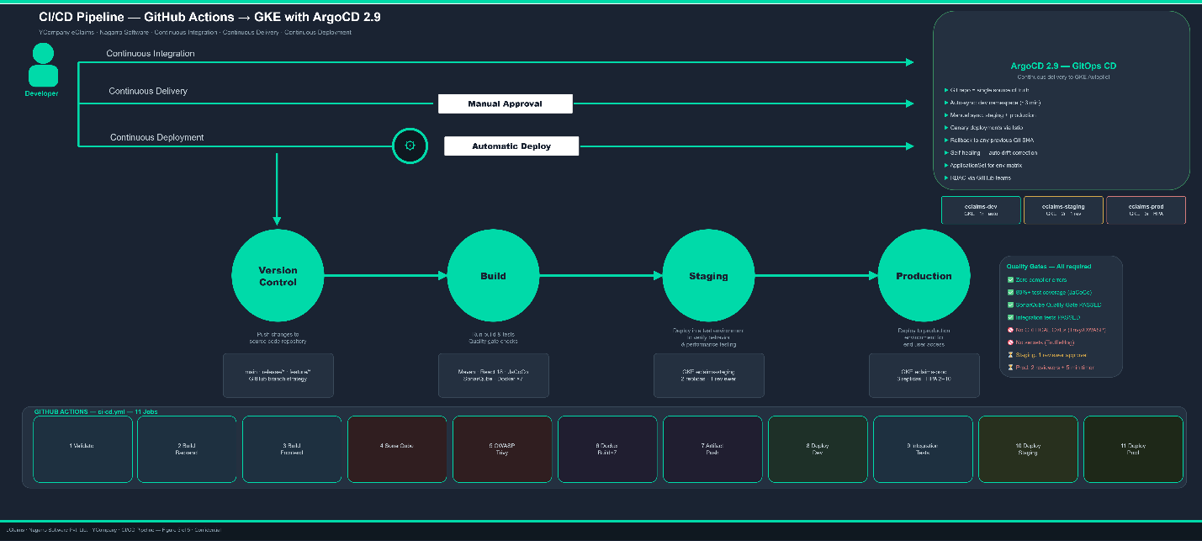
Figure 4: CI/CD Pipeline — GitHub Actions to GKE

Every push to the main branch triggers the full GitHub Actions CI/CD pipeline (11 jobs). The pipeline enforces quality gates at each stage — no stage can proceed if the previous fails. Docker images are tagged with the Git SHA (8 characters) and pushed to Google Artifact Registry. ArgoCD then takes over as the GitOps delivery engine, syncing the declared Kubernetes state from Git to the live GKE cluster — ensuring the cluster never drifts from what is committed in source control.
Pull Request quality checks (pr-checks.yml) run on every PR raised against main:
- Maven compile — zero compiler errors required
- Unit tests with Testcontainers PostgreSQL + EmbeddedKafka — 80% coverage target
- TypeScript type-check and React npm build
- TruffleHog secret scan — blocks merge if secrets are detected

Continuous Delivery
The full CI/CD pipeline (ci-cd.yml) runs on merge to main and includes:
- Validate — Maven validate and Kustomize manifest linting
- Build Backend — Maven compile, unit tests, JaCoCo coverage report
- Build Frontend — TypeScript and React production bundle
- SonarQube — Quality Gate analysis (blocks pipeline on fail)
- Security — OWASP Dependency Check, CodeQL SAST, Trivy filesystem scan
- Docker Build — 7 parallel matrix builds with Artifact Registry push and Trivy image scan
- Deploy Dev — GitHub Actions updates the Kustomize image tag in the GitOps repository (gitops/eclaims/overlays/dev/kustomization.yaml) and commits the change; ArgoCD detects the Git diff within 3 minutes and auto-syncs the eclaims-dev namespace, replacing running pods with the new image via a rolling update
- ArgoCD GitOps Sync — ArgoCD continuously watches the GitOps repository and reconciles cluster state to match the declared manifests. If any out-of-band change is detected in the cluster (manual kubectl edit, config drift), ArgoCD self-heals by reverting to the Git-declared state within 3 minutes. The ArgoCD UI provides a real-time view of sync status, resource health and rollout history for all three environments
- Integration Tests — End-to-end Testcontainers suite against the dev environment
- Deploy Staging — Requires 1 reviewer approval via GitHub Environment
- Deploy Production — Requires 2 reviewer approvals + 5-minute wait timer (release/* branches only); creates a GitHub Release with image SBOMs

GCP Cloud Build Pipeline
The GCP Cloud Build pipeline (cloudbuild.yaml) runs as a parallel path to GitHub Actions and is the primary pipeline for production promotion. It provides parallel Docker builds using BuildKit layer cache, Container Analysis vulnerability scanning (pipeline fails on any CRITICAL finding), Kustomize image tag patch and Cloud Deploy release creation. Cloud Deploy manages the promotion sequence: dev → staging → production, with each stage requiring explicit approval in the Cloud Deploy console or via gcloud CLI. ArgoCD monitors the GitOps repository and executes the actual Kubernetes rollout for each environment on approval.
ArgoCD Rollback and Disaster Recovery Integration:
- Instant rollback — any production release can be rolled back in under 2 minutes by reverting the Kustomize image tag commit in Git. ArgoCD detects the revert and re-deploys the previous image SHA automatically, without re-running the full CI pipeline
- DR environment promotion — the DR GitOps overlay (gitops/eclaims/overlays/dr) mirrors the production overlay. During a DR failover, Cloud Deploy promotes the last known-good release to the us-east1 DR cluster; ArgoCD syncs it within 3 minutes of the failover trigger
- Canary automation — Istio VirtualService weight patches are committed to Git by the pipeline and applied by ArgoCD Rollouts; Prometheus metrics gate each weight increment (5% → 25% → 100%) with automatic rollback if the error rate SLO is breached

Glossary

Terms
Term | Definition
API Gateway | Single entry point for all client requests; handles routing, JWT validation and rate limiting
BPMN | Business Process Model and Notation — standard for workflow diagram definition (used by Camunda 8)
CI/CD | Continuous Integration / Continuous Delivery — automated build, test and deploy pipeline
GCP | Google Cloud Platform — the cloud provider used for production deployment
GKE | Google Kubernetes Engine — managed Kubernetes used for container orchestration
HPA | Horizontal Pod Autoscaler — automatically scales pods based on CPU/memory metrics
JWT | JSON Web Token — secure signed token used for stateless authentication
Kafka | Apache Kafka — distributed event streaming platform for async microservice communication
Keycloak | Open-source Identity and Access Management; implements OAuth2 / OpenID Connect
K8S | Kubernetes — container orchestration platform
mTLS | Mutual TLS — both client and server verify identity; used by Istio service mesh
OIDC | OpenID Connect — authentication layer built on OAuth2
PCI-DSS | Payment Card Industry Data Security Standard — compliance certification for card payment
RBAC | Role-Based Access Control — permissions enforced per user role via @PreAuthorize annotations
SAGA | Pattern for managing distributed transactions via compensating Kafka events
SPA | Single Page Application — loads once and updates dynamically without full page reloads
Zeebe | Workflow execution engine embedded in Camunda 8 — handles BPMN orchestration
DB | Database
OAuth | Open Authentication
JSON | JavaScript Object Notation

Appendix
Resource | URL / Location
GitHub Repository | https://github.com/manjeetrananagap/promotioncasestudy-eclaims
Spring Boot 3.2 | https://spring.io/projects/spring-boot
React.js 18 | https://react.dev
Apache Kafka | https://kafka.apache.org/downloads
Camunda 8 / Zeebe | https://docs.camunda.io
Keycloak 23 | https://www.keycloak.org/documentation
GKE Autopilot | https://cloud.google.com/kubernetes-engine/docs
Stripe API | https://stripe.com/docs
Twilio SMS | https://www.twilio.com/docs/sms
SendGrid | https://docs.sendgrid.com
GitHub Actions | https://docs.github.com/en/actions
ArgoCD | https://argo-cd.readthedocs.io
SonarQube | https://docs.sonarqube.org
PostgreSQL 15 | https://www.postgresql.org/docs/15
Docker | https://docs.docker.com
Kubernetes | https://kubernetes.io/docs/home
Terraform | https://registry.terraform.io
JMeter | https://jmeter.apache.org
Swagger | https://swagger.io

