Packet 1: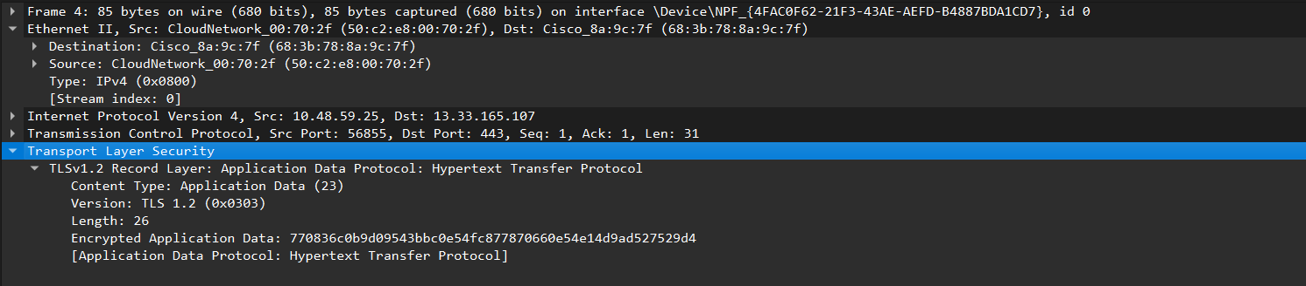

Encapsulation

|  |  |  |  |
| --- | --- | --- | --- |
| Message | | | L5: Application Layer |
| 56855 | 443 | Message | L4: Transport Layer |
| 10.48.59.25 | 13.33.165.107 | Segment | L3: Network Layer |
| 50:c2:e8:00:70:2f | 68:3b:78:8a:9c:7f | Packet | L2: Data Link Layer |
| Bits | | | L1: Physical Layer |

Decapsulation

|  |  |  |  |
| --- | --- | --- | --- |
| Message | | | L5: Application Layer |
| 56855 | 443 | Message | L4: Transport Layer |
| 10.48.59.25 | 13.33.165.107 | Segment | L3: Network Layer |
| 50:c2:e8:00:70:2f | 68:3b:78:8a:9c:7f | Packet | L2: Data Link Layer |
| Bits | | | L1: Physical Layer |

Packet 2:

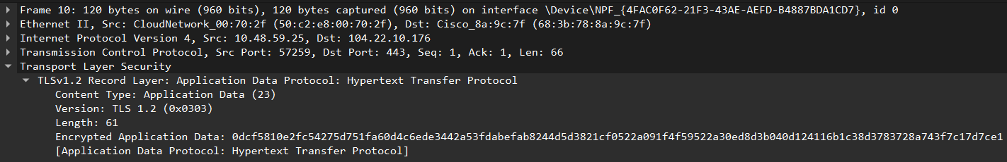

Encapsulation:

|  |  |  |  |
| --- | --- | --- | --- |
| Message | | | L5: Application Layer |
| 57259 | 443 | Message | L4: Transport Layer |
| 10.48.59.25 | 104.22.10.176 | Segment | L3: Network Layer |
| 50:c2:e8:00:70:2f | 68:3b:78:8a:9c:7f | Packet | L2: Data Link Layer |
| Bits | | | L1: Physical Layer |

Decapsulation

|  |  |  |  |
| --- | --- | --- | --- |
| Message | | | L5: Application Layer |
| 57259 | 443 | Message | L4: Transport Layer |
| 10.48.59.25 | 104.22.10.176 | Segment | L3: Network Layer |
| 50:c2:e8:00:70:2f | 68:3b:78:8a:9c:7f | Packet | L2: Data Link Layer |
| Bits | | | L1: Physical Layer |

Packet 3: 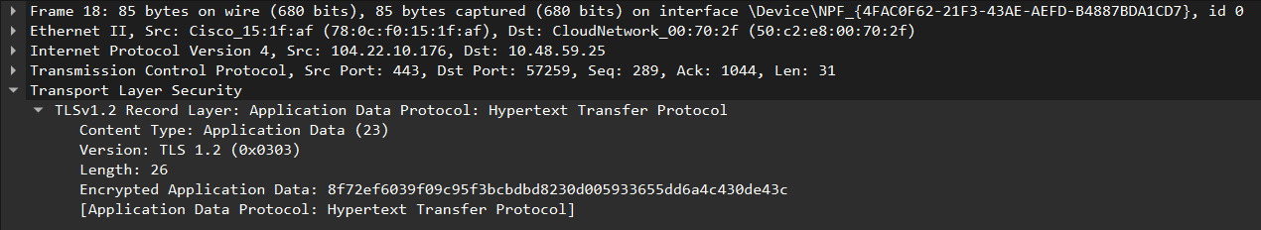

Encapsulation

|  |  |  |  |
| --- | --- | --- | --- |
| Message | | | L5: Application Layer |
| 57259 | 443 | Message | L4: Transport Layer |
| 104.22.10.176 | 10.48.59.25 | Segment | L3: Network Layer |
| 78:0c:f0:15:1f:af | 50:c2:e8:00:70:2f | Packet | L2: Data Link Layer |
| Bits | | | L1: Physical Layer |

Decapsulation

|  |  |  |  |
| --- | --- | --- | --- |
| Message | | | L5: Application Layer |
| 57259 | 443 | Message | L4: Transport Layer |
| 104.22.10.176 | 10.48.59.25 | Segment | L3: Network Layer |
| 78:0c:f0:15:1f:af | 50:c2:e8:00:70:2f | Packet | L2: Data Link Layer |
| Bits | | | L1: Physical Layer |