**Assignment.1-3 (Chap.4 CSS Box model & Web Graphics)**

This assignment is a continuation of the previous assignment with a focus on the application CSS box-model for preliminary layout configuration and web graphics for visual engagement. The expected outputs for home plants page are given blow:

**Task.1 – create case study folder and image files**

1. Copy the entire case study folder “ggarden1.2” and name the copy as “ggarden1.3”
2. Download image files from course website and save them in a subfolder named “imgs” under the root folder.

**Task.2 - HTML**

1. Remove all &nbsp; and <br> from html files;
2. On both pages, create a <div> element with id=”wrapper” as a child of <main> that encloses all elements inside. Then insert an <img> element inside <main>, ahead of #wrapper with ‘id=heroimg”
   1. On home page, set image’s source as: “zen-garden-with-autumn-colors.jpg”
   2. On Plants page, set image’s source as: “curly-tendrils-of-potted-plants-on-wooden-shelf.jpg”

The wireframe for the changed document structure should be as follows

1. On home page, Use <p> elements to enclose each text line inside <address> section after the subheading “address”
2. On plants page, replace the <dl> with a <div id=”categories”>, and change all <dt>’s to <h3>’s and <dt>’s to <span>’s. Then enclose each pair of <h3> and <span> inside a <section> element. Insert an <img> element between each <h3> and <span>, and use the following image sources inside each section:
   1. Evergreen – “gold-shelf-with-a-green-vine-house-plant.jpg”
   2. Flowering shrubs – “close-up-on-evergreen-bonzai.jpg”
   3. Vines – “bee-covered-in-yellow-dust.jpg”
   4. Trees – “summer-garden-with-pink-phlox.jpg”
   5. Anuals – “imgs/sunflower-fills-center-of-a-frame.jpg”

The wireframe for the changed document structure of this section is shown below as a reference. Don’t forget to give each image a descriptive “alt”

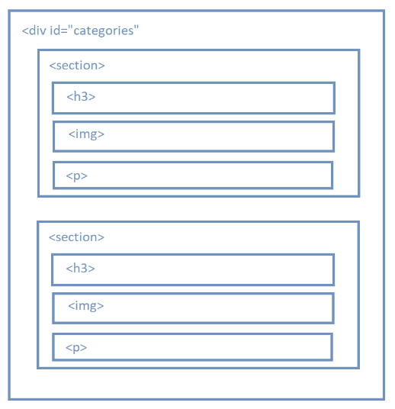

**Task.3 - CSS**

1. set the margin of <body> and <h1> to zero;
2. set the background image of <header> to “hand-grips-a-gardening-tool-to-cut-back-a-plant.jpg”, use “background-size” and “background-position” to cover and center the image;
3. for <h1>, change the background color to “ rgba(5, 72, 12, .5)”, and add text shadow “2px 2px 10px white”;
4. set the display property of “nav a” to “inline-block” and give it 10px top/bottom padding and 20px left/right padding;
5. center the content of “#wrapper” by setting

width: 80%;

margin: auto;

1. for <footer>, give it “10px” top/bottom padding and “10%” left/right padding, and then give it “20px” top margin;
2. use the selector “footer > div” to set the immediate child <div> elements of <footer> as “inline-block” display, and then give each of them a width value of 33%;
3. for <ul>, set padding to zero; and set “list-style” to “none” ;
4. for the selector “footer nav a”, change the display property to “block”, set padding to zero, and align text to left;
5. set the following properties for #heroimg selector
   1. width: 100%;
   2. height:300px;
   3. use “object-fit” to cover the entire image box to avoid distortion
   4. use “object-position” to align the center of the image with the image box;
6. set 40px top/bottom margin and 0px left/right margin to “#categories” ;
7. set 20px bottom margin to <section> elements inside “#categories” ;
8. Since the description list has been replaced with other document structures, the corresponding selectors should be removed from CSS.