**Assignment.1-1 (Chapt.2 HTML Basics) instructions**

This assignment is the first step of building up a responsive website for a garden center “Gabriel Green Garden House”. The site map is shown as below:

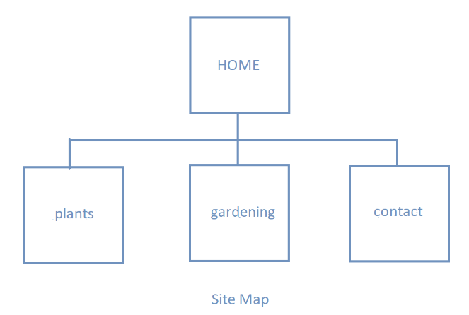

In this assignment, you are going to construct the home page (index.html) and plants page (plants.html).

**Task.1 – create case study folder**

1. Create a folder named “ggarden1.1” as the root folder of the website

**Task. 2 – construct the home page “index html”**

1. Give an appropriate title for home page (e.g., the name of the garden center)
2. Based on the given wire frame, create the skeleton of the home page structure

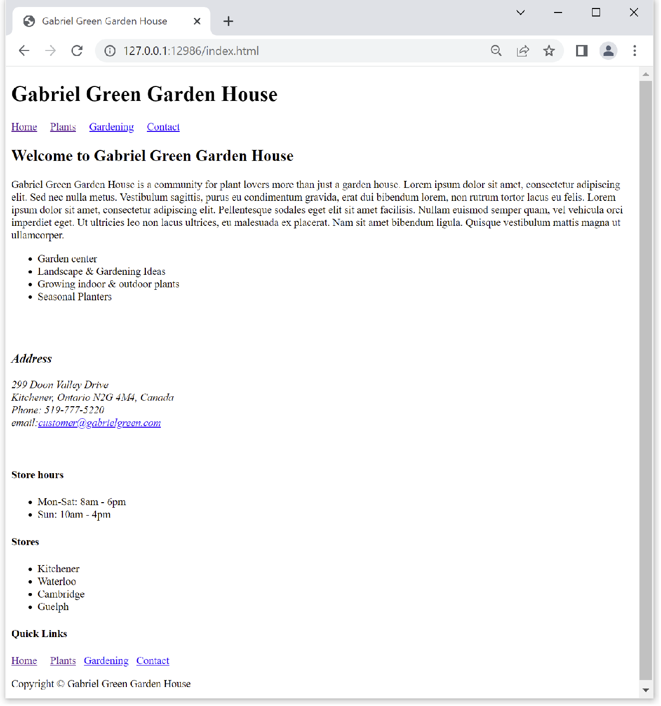

1. Inside <header>, create a page heading “Gabriel Green Garden House” with <h1>;
2. Inside <nav>, create page links with <a> that link to “index.html”, “plants.html”, “gardening.html” and “contact.html”; use a proper number of white spaces to separate the links;
3. Inside <main>,
   1. Create a subheading “Welcome to Gabriel Green Garden House” with <h2>
   2. Create a paragraph with proper amount of random text (using <https://www.lipsum.com/>)
   3. Create an unordered list with the following four items: ”Garden center”, “Landscape & gardening Ideas”, “Grow indoor & outdoor plants” and “Planters”
   4. Code a subheading “Address” using <3> element, then create an <address> element that encloses the detailed address information as shown in the output; the email address must be facilitated with an email link; use <br> properly to break lines
4. Inside <footer>,
   1. Create a <div> that encloses a subheading “store hours” (using <h3>) and the actual store hours as show (with an unordered list)
   2. Create a <div> that encloses a subheading “stores” (using <h3>) and the actual store locations as shown (with an unordered list )
   3. Create a <div> that enclose a subheading “quick links” (using <h3>) and a copy of all the page links (including <nav> itself)
   4. Create the copyright information (with a <p> element)

**Task.3 – construct plants.html**

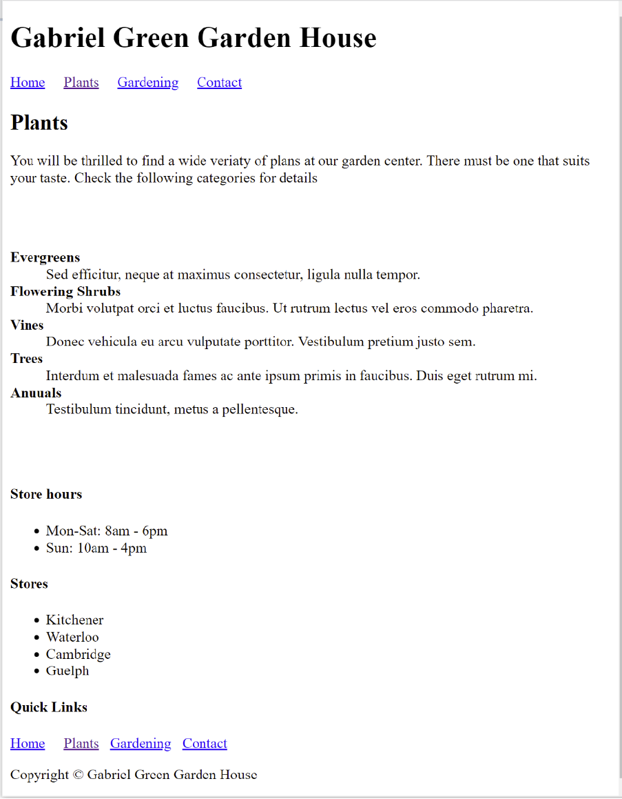

1. Copy index.html page and rename the copy file as “plants.html”
2. Assign a unique and representative title to the plants page. e.g., “Gabriel Green Garden House – Plants”
3. Delete all elements/content enclosed inside <main>, and then:
   1. Add a page subheading “Plants” with a <h2>
   2. Create a <p> element with proper length of random text
   3. Create a description list with 4 terms: “Vines”, “Evergreens”, “Flowering Shrubs” & “Trees” and use random text as term description. Use <br> to generate proper vertical spacing above and below

Note:

* Feel free to use any number of “&nbsp;” and <br> to format the output. They will later be swapped out once we understand the CSS box model.
* Non-critical content (such as texts inside <p> or <dd>) can be filled with proper length of random words.