­­**Assignment.1-2 (Chapt.3 CSS Basics)**

This assignment incorporates generic CSS styles (color, font & text) to the website, the expected outputs of index.html and plants.html are shown below:

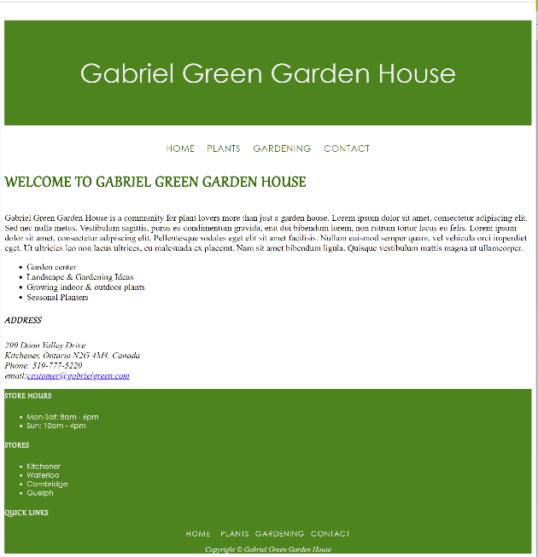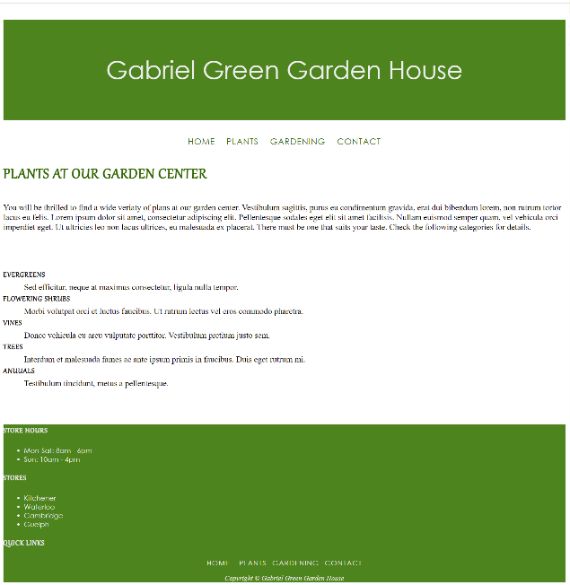

**Task.1 – create case study folder**

Copy the entire case study folder “ggarden1.1” and name the copy as “ggarden1.2”

**Task.1 – HTML**

1. In both index.html and plants.html, assign an “id” attribute with value “copyright” to the last <p> element inside <footer>

**Task. 2 – CSS**

1. Create an external css file “site.css” in the website root folder and use <link> element (inside <head> section) to associate both index.html and plants.html to “site.css”
2. Font styles:
   1. Configure the font family of <h1>, <nav> and <footer> with the fallback typeface values: "Century Gothic" and “serif”
   2. Configure the font family of <h2>, <h3> and <dt> with the fallback values “Gabriola” and “sans-sefif“
   3. For <h1>, set the font size to “3em”, and the font weight to “500”
   4. For <h2>, set the font size to “2em”
   5. For <dt>, set the font weight to “bold”
   6. For <footer>, set the font size to “smaller”
   7. For id selector “#copyright”, set font family to “serif” and apply “italic” style
3. Color styles:
   1. For <header>, <footer>, set the background color as: “rgb(65,132, 42)”; and set text color as “#eee”
   2. For <h2> and the navigation links, set the text color as: “rgb(35,102, 12)”
   3. Set the text color of descendant selector “footer nav a” as: “#eee”
4. Text styles:
   1. set up “400%” line height” for <h1>
   2. for <h2>, <h3>, <dt> and the descendant selector ““nav a”, apply “uppercase” for “text-transform” property, and apply “1px” letter spacing
   3. for <h1>, <nav> and “#copyright”, align text to “center”
   4. set the text decoration of all navigation links (“nav a”) to “none”