$t_{cal}$=2.4
4. Level of Significance: $\left(1-α\right)=$ 5%
- Critical Value: $df=n-1=9$
$$t_{tab}=1.833$$
- Decision: $\left|t\right|=2.4>t_{tab}=1.833,$ reject $H_{0}$at 5% level of significance.
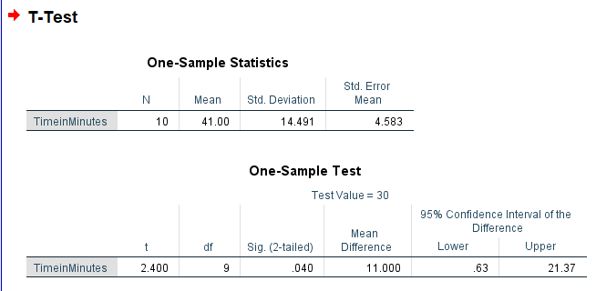

Interpretation of Results
- t-value: Indicates the result.
  - If t $>$ t_{tab}, reject the null hypothesis.
  - If t $≤$ t_{tab}, fail to reject the null hypothesis.
- Confidence Interval: Gives a range of values within which the true population mean is likely to fall.
Conclusion
We reject the null hypothesis. There is sufficient evidence at the 5% significance level to conclude that the average time spent by customers in the cybercafé is more than 30 minutes.
3. Two kinds of manure were applied to sixteen one-hectare plot, other condition remaining the same. The yields in quintals are given below:
Manure-I 18 20 36 50 49 36 34 49 41
Manure-II 29 28 26 35 30 44 46
Is there any significant difference between mean yields? Use 5% level of significance.
Given,
Sample size ($n_{1})=9$, $\left(n_{2}\right)=7$
Problem to test
- Null Hypothesis H₀: There is no significant difference between mean yields. ${H_{0}:μ}_{1}=μ_{2}$
- Alternative Hypothesis H₁: There is significant difference between mean yields. ${H_{1}:μ}_{1}≠μ_{2}$
- Test Statistics: Mathematical formulation: $t=\frac{\overline{x}-\overline{ y}}{\sqrt{S^{2}\left(\frac{1}{n_{1}}+\frac{1}{n_{2}}\right)}}$
- Level of Significance: $\left(1-α\right)=$ 5%
- Critical Value: $df=n_{1}+n_{2}-2=9+7-2=14$
$$t_{tab}=2.145$$
- Decision: $\left|t\right|=0.577<t_{tab}=2.145,$ accept $H_{0}$at 5% level of significance.
Guide to Perform Independent Samples T-Test in SPSS

Enter Data into SPSS
- Open SPSS.
- Create a New Dataset:
  - Go to Variable View:
    - Create a variable named Manure with the type numeric.
    - Create another variable named Type as a string with values like "Manure-I" and "Manure-II".
- Data Entry:
  - Enter the data in Data View as follows:

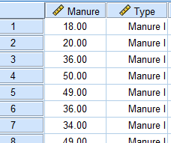

Steps to Perform Paired Sample T-Test in SPSS:
- Open SPSS and create a new dataset.
- Enter Data:
  - In a new variable column, enter "Before" scores and in another column enter "After" scores side by side.
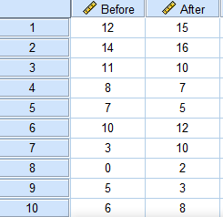
- Analyze Data:
  - Click on Analyze from the main menu.
  - Select Compare Means and then choose Paired-Samples T Test.
- Define the Variables:
  - Move the "Before" scores to the Variable 1 box and "After" scores to the Variable 2 box.
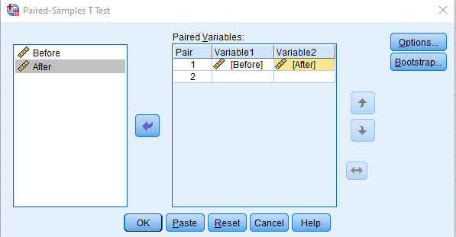
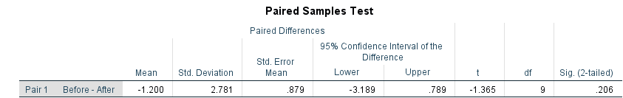
- Run the Test: Click OK

Interpretation
- In the output window, look for the t value.
- Reject $H_{0}$ at $α$ level of significance if |t| $>$ t_{tab}, accept otherwise.

Conclusion
There is no significant difference in scores before and after training. Hence the training was ineffective.
5. In 30 toss of a coin the following sequence of heads (H) and tails (T) is obtained.
H T T H T H H H T H H T T H T H T H H T H T T H T H H T H T.
Test at 0.05 level of significance level whether the sequence is random.
Given,
Number of heads ($n_{1}$) = 16, Number of tails $\left(n_{2}\right)=$14, Number of runs (r) = 22
Problem to test
- Null Hypothesis H₀: The sequence is in random order.
- Alternative Hypothesis H₁: The sequence is not in random order.
- Test Statistics: r = 22
- Level of Significance: $\left(1-α\right)=$ 5%
- Critical Value:$\left(\underline{r},\overline{r}\right)=(10,22)$
- Decision: $r ∉\left(\underline{r},\overline{r}\right)=22∉(10,22),$ reject $H_{0}$at 5% level of significance.
Steps to Conduct a Runs Test in SPSS 1. Open SPSS:
  - Launch SPSS on your computer.
- Enter Your Data:
  - Create a new dataset and enter the coin toss results.
  - In the Variable View, create a variable named Toss, with values “1” Head & “2” Tail.
  - Switch to Data View and enter the sequence of results:
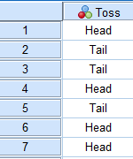
- Analyze Data

6. Test whether the coin is unbiased from the following observations.
TTHHTHTHHTHHHTHHHHHHTTTTHTTTTTTTHTTTHTTTTHTTHTHTTT
Solution:
Number of Head$\left(n_{1}\right)=$ 20
Number of Tails$\left(n_{2}\right)=30$
Problem to test
- Null Hypothesis H₀: The coin is unbiased. $H_{0}:P=\frac{1}{2}$
- Alternative Hypothesis H₁: The coin is biased. $H_{1}:P≠\frac{1}{2}$
- Test Statistics:$X_{0}=min\{n_{1},n_{2}\}$
- Level of Significance: $\left(1-α\right)=$ 5%
- Critical Value:$p=Prob\left(X≤x\right)=\sum_{x=0}^{x=k}{\left(\begin{aligned}n \\ x\end{aligned}\right){\left(\frac{1}{2}\right)}^{n}}=0.203$

- Decision: $2p=2×0.203=0.406>α=0.05,$ accept $H_{0}$at 5% level of significance.
Guide to Perform a Binomial Test in SPSS Step 1: Open SPSS and Create a New Dataset
- Open SPSS on your computer.
- Create a New Dataset:
  - Click on File → New → Dataset.

Step 2: Enter the Data
- Variable View:
  - Click on the Variable View tab at the bottom of the window.
  - Create a variable named Outcome with the following characteristics:
    - Name: Outcome
    - Type: Numeric
- Data View:
  - Switch to Data View.
  - Enter the data for the coin tosses:
    - For each outcome, assign a value:
      - Assign 1 for Heads (H)
      - Assign 2 for Tails (T)

Step 3: Set Up the Binomial Test
- Analyze Menu:
  - Click on Analyze in the top menu.
- Nonparametric Tests:
  - Hover over Nonparametric Tests, then select Legacy Dialogs → Binomial.
- Define the Test:
  - In the Binomial Test dialog box:

7.Test the hypothesis of no difference between ages of male and female employees of a certain company using the Mann-Whitney U test for the data below. Use $α$=0.1
Male | 35 | 43 | 26 | 44 | 40 | 42 | 33 | 38 | 25 | 26
Female | 30 | 41 | 34 | 31 | 36 | 32 | 25 | 47 | 28 | 24
Male | Ranks | Female | Ranks
35 | 12 | 30 | 7
43 | 18 | 41 | 16
26 | 4.5 | 34 | 11
44 | 19 | 31 | 8
40 | 15 | 36 | 13
42 | 17 | 32 | 9
33 | 10 | 25 | 2.5
38 | 14 | 47 | 20
25 | 2.5 | 28 | 6
26 | 4.5 | 24 | 1
 | $$R_{1}=116.5$$ |  | $$R_{2}=93.5$$

Sample size of male ($n_{1})$=10
Sample size of female ($n_{1})$=10
Sum of ranks of male ($R_{1})=$116.5
Sum of ranks of female ($R_{2})=$93.5
$$U_{1}=n_{1}n_{2}+\frac{n-1 \left(n_{1}+1\right)}{2}-R_{1}=38.5$$
$$U_{2}=n_{1}n_{2}-U_{1}=10×10-38.5=61.5$$
$$U_{0}=\min\left\{U_{1},U_{2}\right\}=38.5$$
Let Md₁ and Md₂ be median age of male and female employees respectively.
Problem to test
- Null Hypothesis H₀: There is no significant difference between age of male and female employee (Md₁=Md₂)
- Alternative Hypothesis H₁: There is significant difference between age of male and female employee (Md₁$≠$Md₂)
- Test Statistics:$U_{0}=38.5$
- Level of Significance: $\left(α\right)=$ 0.10
- Critical Value: $U_{tab}=27$
- Decision: $U_{0}=38.5>U_{α\left(n_{1},n_{2}\right)}=27,$ accept $H_{0}$at 0.01 level of significance.
- Conclusion: There is no significant difference between ages of male and female employee.
Guide to Perform Mann-Whiteney Test in SPSS
Step 1: Open SPSS and Create a New Dataset
- Open SPSS on your computer.

- Data below shows one week growth of maize plant from two different localities

Sample-I 10 11 8 8 14
Sample-II 9 12 13 9 15 9 17
Test whether the two samples have come from the same population with respect to their medians. Use median test at 0.05 level of significance.

Solution:

Here, to find the median of combined group, arranging the data in ascending order,
8,8,9,9,9,10,11,12,13,14,15,17
n=12, Md =10.5
no of observations in first sample less than or equal to median (a) =3
First sample size ($n_{1})$ =5
Second sample size ($n_{2})$= 7 , k=$\frac{n_{1}+n_{2}}{2}=\frac{5+7}{2}=6$
Let Md₁ and Md₂ be median of I population & II population respectively.
Problem to test

- Null Hypothesis H₀: There is no significant difference between median of I population and median of II population (Md₁=Md₂)
- Alternative Hypothesis H₁: There is significant difference between median of I population and median of II population (Md₁$≠$Md₂)
- Test Statistics:$P\left(A=a\right)=\frac{c\left(5,a\right)c(7,6-a)}{c(12,6)},a=0,1,2,3,4,5$
- Level of Significance: $\left(α\right)=$ 0.05
- Critical Value: $P=P\left(A≥a\right)=P\left(A≥3\right)=∑\frac{c\left(5,a\right)c\left(7,6-a\right)}{c(12,6)}=0.5$

- Decision: $2P=1>α=0.05,$ accept $H_{0}$at 0.05 level of significance.
Guide to Perform Mean Test in SPSS

Step 1: Open SPSS and Create a New Dataset
- Open SPSS on your computer.
- Create a New Dataset:
  - Click on File → New → Dataset.

Step 2: Enter the Data
- Variable View:

9.Following are the scores obtained by trainees in 3 different categories. Test whether 3 categories are equally performed.
categories | scores
A | 68 | 65 | 92 | 82 | 62 | 64 | 68 | 92 | 59 | 64
B | 93 | 86 | 73 | 87 | 76 | 85 | 67 | 79 | 75 | 75
C | 95 | 72 | 85 | 70 | 80 | 80 | 78 | 85 | 72 | 90
Solution:
Sample sizes: $n_{A}=n_{B}=n_{C}=10$, total n = 30
All 30 observations were ranked together (average ranks used for ties).
Sum of ranks:
  - $R_{1} = 105$
  - $R_{2} =177$
  - $R_{3} = 183$
$$∑\left(t_{i}^{3}-t_{i}\right)=60$$
$$∑\frac{R_{i}^{2}}{n_{i}}=7584.3$$
Let Md₁, Md₂ and Md₃ be median of category A, B and C respectively.
Problem to test
- Null Hypothesis H₀: All categories performed equally (Md₁=Md₂= Md₃)
- Alternative Hypothesis H₁: At least one category is different. (Md₁$≠$Md₂$≠$Md₃)
- Test Statistics: $H=\frac{\frac{12}{n(n+1)}∑\frac{R_{i}^{2}}{n_{i}}-3(n+1)}{1-\frac{∑\left(t_{i}^{3}-t_{i}\right)}{n^{3}-n}}=$7.872
- Level of Significance: $\left(α\right)=$ 0.05
- Critical Value: $χ_{0.05(2)}^{2}=5.991$
- Decision: $H=7.872>χ_{0.05(2)}^{2}=5.991,$ reject $H_{0}$at 0.05 level of significance.
Guide to Perform Mean Test in SPSS

Step 1: Open SPSS and Create a New Dataset
- Open SPSS on your computer.
- Create a New Dataset:
  - Click on File → New → Dataset.

Step 2: Enter the Data
- Variable View:
  - Switch to the Variable View tab.
  - Create two variables:
    - Name: Scores (Type: Numeric)
    - Name: Category (Type: Numeric)
- Data View:
  - Switch to the Data View tab.
  - Enter the data as follows:
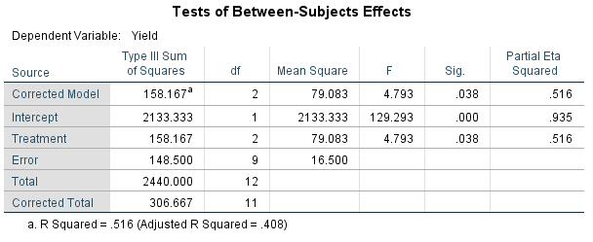

4.Level of Significance: $\left(α\right)=$ 0.05
5.Critical Value:$F_{Tab}=4.26$
6. Decision: $F=4.793>F_{Tab}=4.26,$ reject $H_{0T}$ at 0.05 level of significance.
Guide to Perform CRD design in SPSS
Step 1: Open SPSS and Create a New Dataset
- Open SPSS on your computer.
- Create a New Dataset:
  - Click on File → New → Dataset.
Step 2: Enter the Data
Variable View:
- Switch to the Variable View tab.
- Create two variables:
  - Name: Yield (Type: Numeric)
  - Name: Treatment (Type: Numeric)
Data View:
- Switch to Data View and enter the data as follows:
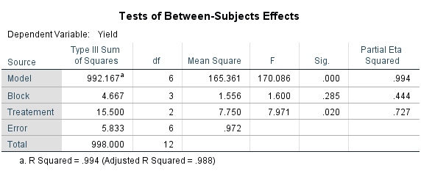
- Level of Significance: $\left(α\right)=$ 0.05
- Critical Value:$F_{0.05(2,6)}=5.14 \& F_{0.05\left(3,6\right)}=4.75$
- Decision: $F_{T}=7.971>F_{α\{\left(t-1\right),t\left(r-1\right)\}}=5.14,$ reject $H_{0T}$ at 0.05 level of significance.
$F_{B}=1.6<F_{α\{\left(r-1\right),t\left(r-1\right)\}}=4.75,$ accept $H_{0B}$ at 0.05 level of significance.
Guide to Perform CRD design in SPSS

Step 1: Open SPSS and Create a New Dataset
- Open SPSS on your computer.
- Create a New Dataset:
  - Click on File → New → Dataset.

Step 2: Enter the Data
- Variable View:
  - Switch to the Variable View tab.
  - Create three variables:
    - Name: Yield (Type: Numeric)
    - Name: Treatment (Type: Numeric)
    - Name: Block (Type: Numeric)
- Data View:
  - Switch to Data View and enter the data as follows:

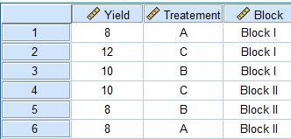

Step 3: Perform ANOVA for RBD in SPSS

- Alternative Hypothesis
H_{1T}: There is significant difference treatments.
H_{1R}: There is significant difference rows.
H_{0C}: There is significant difference columns.
- Test Statistics:
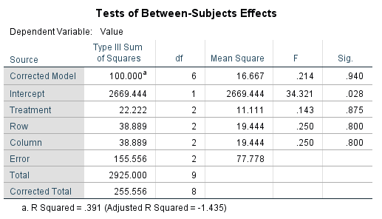

- Level of Significance: $\left(α\right)=$ 0.05
- Critical Value:$F_{0.05(2,2)}=19$
- Decision: $F_{R}$ = 0.250 < $F_{0.05(2,2)}=19$, accept $H_{0R}$ at 5% level of significance.
$F_{C}$ = 0.250 < $F_{0.05(2,2)}=19$, accept $H_{0C}$ at 5% level of significance.
$F_{T}$= 0.143 < $F_{0.05(2,2)}=19$, accept $H_{0T}$ at 5% level of significance.
Guide to Perform CRD design in SPSS

Step 1: Open SPSS and Create a New Dataset
- Open SPSS on your computer.
- Create a New Dataset:
  - Click on File → New → Dataset.

  - Where:
    - $b_{0}$​ is the intercept (constant).
    - $b_1$ ​ and $b_2​$ are the coefficients for $X_{1}​ and X_{2}$​, respectively.

Conclusion
Based on the coefficients obtained from SPSS, substitute the values into the regression equation to find the final equation i.e.
$Y=-7.862-0.049X_{1}-0.278X_{2}$​
15. Two kinds of protein were given to sixteen gym goers, other condition remaining the same. The yields in 3 weeks are given below:
Protein 1 | 20 | 22 | 36 | 45 | 12 | 41 | 26 | 46 | 31
Protein 2 | 26 | 33 | 32 | 39 | 46 | 49 | 55
Is there any significant difference between mean yields? Use 1% level of significance.
Sample size ($n_{1})=9$, $\left(n_{2}\right)=7$
Problem to test
- Null Hypothesis H₀: There is no significant difference between mean yields. ${H_{0}:μ}_{1}=μ_{2}$
- Alternative Hypothesis H₁: There is significant difference between mean yields. ${H_{1}:μ}_{1}≠μ_{2}$
- Test Statistics: Mathematical formulation: $t=\frac{\overline{x}-\overline{ y}}{\sqrt{S^{2}\left(\frac{1}{n_{1}}+\frac{1}{n_{2}}\right)}}$
- Level of Significance: $\left(1-α\right)=$ 1%
- Critical Value: $df=n_{1}+n_{2}-2=9+7-2=14$
- $t_{tab}=2.977$
- Decision: $\left|t\right|=0.145<t_{tab}=2.977,$ accept $H_{0}$at 5% level of significance.
Guide to Perform Independent Samples T-Test in SPSS

Enter Data into SPSS
Open SPSS.
Create a New Dataset:
  - Go to Variable View:
    - Create a variable named Protein with the type numeric.
    - Create another variable named Type as a numeric with values like "Protein 1" and "Protein 2".
Data Entry:
  - Enter the data in Data View as follows:

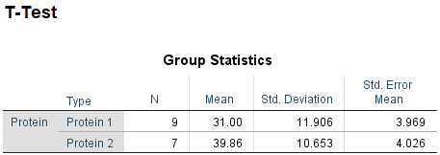
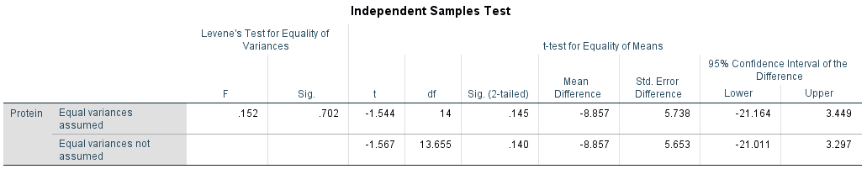

Interpretation
Levene's Test for Equality of Variances:
  - Check the significance value under this test (if it is greater than 0.01, assume equal variances).
T-Test Results:
  - Look at the significance value (2-tailed) for the t-test results.

Conclusion
We accept the null hypothesis. There is no significant difference between mean yields. ${H_{0}:μ}_{1}=μ_{2}$
16. Test whether the coin is unbiased from the following observations.
H H T H T H H T H H T H H H T H T H H T H H T H H H T H H T H H T H H T H T T T
Use α=0.10
Solution:
Number of Heads$\left(n_{1}\right)=$ 25
Number of Tails$\left(n_{2}\right)=15$
Problem to test
- Null Hypothesis H₀: The coin is unbiased. $H_{0}:P=\frac{1}{2}$
- Alternative Hypothesis H₁: The coin is biased. $H_{1}:P≠\frac{1}{2}$
- Test Statistics:$X_{0}=min\{n_{1},n_{2}\}$=15
- Level of Significance: $\left(α\right)=$ 0.10%
- Critical Value:$p=Prob\left(X≤x\right)=\sum_{x=0}^{x=k}{\left(\begin{aligned}n \\ x\end{aligned}\right){\left(\frac{1}{2}\right)}^{n}}=0.154$

- Decision: $2p=2×0.154=0.308>α=0.10,$ accept $H_{0}$at 5% level of significance.

Run the Test:
  - Click OK to run the binomial test.
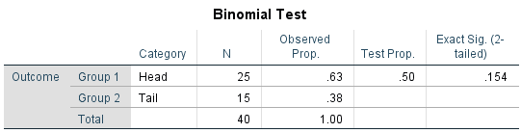

Interpretation
Find the section labeled Binomial Test in output.
- Observed N: The number of successes (heads).
- Test Proportion: The expected proportion (0.5).
- Exact Sig. (2-tailed): This is the p-value for the test.

Conclusion
Since, 2p ≥ 0.05: Accept $H_{0}$ at $α$ level of significance. Hence, conclude that the coin is unbiased.
17. In 15 toss of a coin the following sequence of heads (H) and tails (T) is obtained.
H T T H T H H H T H H T T H T .
Test at 0.05 level of significance level whether the sequence is random.
Given,
Number of heads ($n_{1}$) = 8, Number of tails $\left(n_{2}\right)=$7, Number of runs (r) = 10
Problem to test
- Null Hypothesis H₀: The sequence is in random order.
- Alternative Hypothesis H₁: The sequence is not in random order.
- Test Statistics: r = 10
- Level of Significance: $\left(1-α\right)=$ 5%
- Critical Value:$\left(\underline{r},\overline{r}\right)=(4,13)$
- Decision: $r ϵ\left(\underline{r},\overline{r}\right)=10ϵ(4,13),$ accept $H_{0}$at 5% level of significance.
Steps to Conduct a Runs Test in SPSS
Open SPSS:
  - Launch SPSS on your computer.
Enter Your Data:
  - Create a new dataset and enter the coin toss results.
  - In the Variable View, create a variable named Toss, with values “1” Head & “2” Tail.

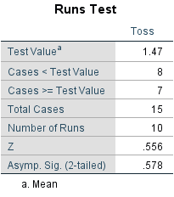

Interpretation
Check for number of runs in output. Accept $H_{0}$ at $α$ level of significance if $rϵ\left(\underline{r},\overline{r}\right),$reject otherwise.

Conclusion
$r ϵ\left(\underline{r},\overline{r}\right)$ at 5% level of significance so, accept $H_{0}$. Hence, the sequence is in random order.
18. Performance of 10 students was tested before and after training, State whether the training was effective or not from the following scores;
Roll no | 1 | 2 | 3 | 4 | 5 | 6 | 7 | 8 | 9 | 10
Before Training | 10 | 12 | 11 | 8 | 9 | 11 | 6 | 1 | 6 | 8
After Training | 20 | 20 | 21 | 19 | 16 | 20 | 20 | 12 | 13 | 18
Use α=0.001
Problem to test
- Null Hypothesis H₀: There is no significant difference in scores before and after training.
$H_{0}:μ_{d}$ = 0
- Alternative Hypothesis H₁: There is a significant difference in scores, indicating that training was effective.
$$H_{1}:μ_{d}≠0$$
- Test Statistics: Mathematical formulation: $t=\frac{\overline{d}}{\frac{S_{d}}{\sqrt{n}}} where d=X-Y, \overline{d}=\frac{∑d}{n}$
$t_{cal}$= $-$14.532
- Level of Significance: $\left(α\right)=$ 0.001
- Critical Value: $df=n-1=9$
$$t_{tab}=4.781$$
- Decision: $\left|t\right|=14.532>t_{tab}=4.781,$ reject $H_{0}$at 0.001 level of significance.

Interpretation
- In the output window, look for the t value.
- Reject $H_{0}$ at $α$ level of significance if |t| $>$ t_{tab}, accept otherwise.

Conclusion
Since, $\left|t\right|=14.532>t_{tab}=4.781$accept H₀ i.e. there is significant difference in scores before and after training. Hence the training was effective.
19. Data below shows one week growth of bamboo from two different localities
Sample 1 | 21 | 18 | 13 | 20 | 23 | 26
Sample 2 | 19 | 22 | 18 | 20 | 21 | 23 | 25 | 16
Test whether the two samples have come from the same population with respect to their medians. Use median test at 0.05 level of significance.
Solution:
Here, to find the median of combined group, arranging the data in ascending order,
13, 16, 18, 18, 19, 20, 20, 21, 21, 22, 23, 23, 25, 26
n=14, Md =21
no of observations in first sample less than or equal to median (a) =4
First sample size ($n_{1})$ =6
Second sample size ($n_{2})$= 8 , k=$\frac{n_{1}+n_{2}}{2}=\frac{6+8}{2}=7$
Let Md₁ and Md₂ be median of I population & II population respectively.
Problem to test
- Null Hypothesis H₀: There is no significant difference between median of I population and median of II population (Md₁=Md₂)
- Alternative Hypothesis H₁: There is significant difference between median of I population and median of II population (Md₁$≠$Md₂)
- Test Statistics:$P\left(A=a\right)=\frac{c\left(6,a\right)c(8,7-a)}{c(14,7)},a=0,1,2,3,4,5$
- Level of Significance: $\left(α\right)=$ 0.05
- Critical Value: $P=P\left(A≥a\right)=P\left(A≥4\right)=∑\frac{c\left(6,a\right)c\left(8,7-a\right)}{c(14,7)}=0.313$

- Decision: $2P=0.627>α=0.05,$ accept $H_{0}$at 0.05 level of significance.
Guide to Perform Mean Test in SPSS

Step 1: Open SPSS and Create a New Dataset
Open SPSS on your computer.

