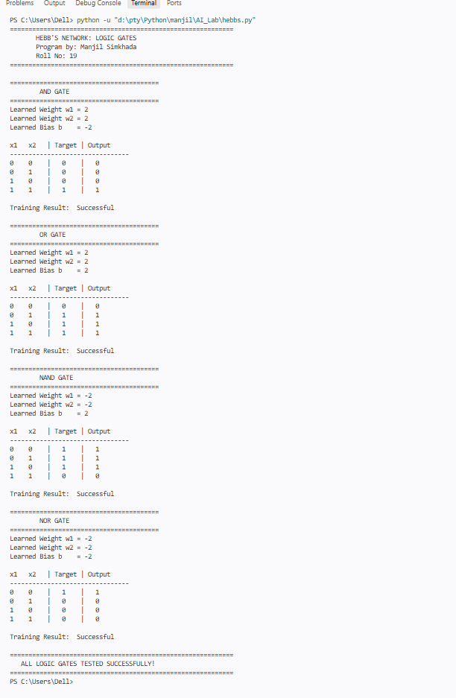

Conclusion
Hebb's network was successfully implemented using Python to perform AND, OR, NAND and NOR logic operations. The weights and bias were adjusted using the supervised Hebbian learning rule with bipolar inputs and targets. The trained network produced outputs matching the expected truth tables for all four logic gates.

