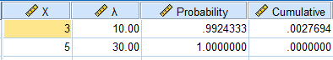
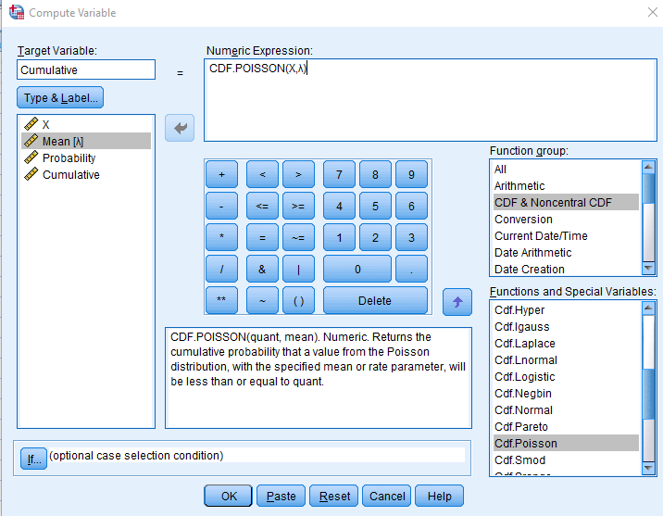
Interpretation: This model is valuable for predicting workload at the message center. Higher probabilities indicate more common outcomes, guiding staffing and resource allocation.
Conclusion: The computed probabilities quantify how likely it is to receive certain numbers of messages in given time intervals.
- From a sample of 800 keyboards mean life is found to be 66 months with standard deviation of 5 months, find the probability that number of keyboards having life
(a) between 65 and 70.
(b) greater than or equal to 72.
Given Data

