Statistics-I (Practical)
- The marks distribution of 20 students of a college is as follows:
50,55,67,80,45,87,98,65,68,79,71,80,42,92,78,77,83,84,80,86
calculate, (i) mean, median, mode etc.
(ii) Q.D, skewness and kurtosis
Step 1: Enter Data
In the Data View, enter data in a single column ("Marks")
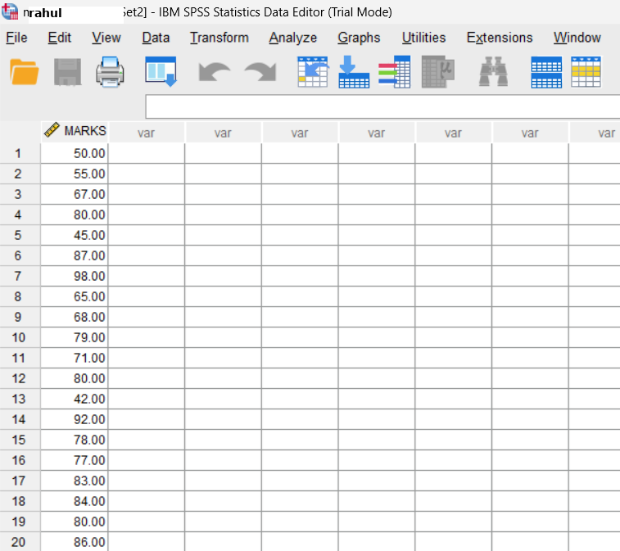
Step 2: Calculate Mean, Median, and Mode
- Go to the Analyze menu.
- Select Descriptive Statistics > Descriptives.
- Move the "Marks" variable into the Variable(s) box.
- Click on Options.
- Check the boxes for Mean, Std. Deviation, Minimum, Maximum.
- Click Continue, then OK
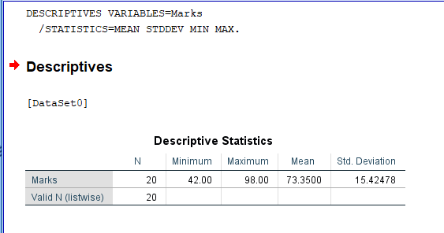
- For median and mode:
  - Go to Analyze > Descriptive Statistics > Frequencies.
  - Move "Marks" into the Variable(s) box.
  - Click on Statistics and check Median and Mode.
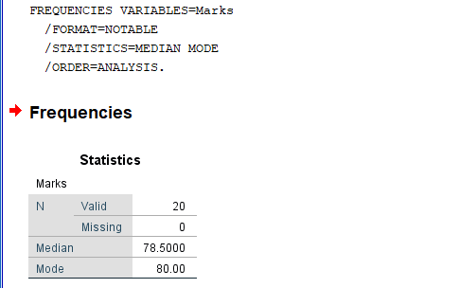
  - Click Continue, then OK.
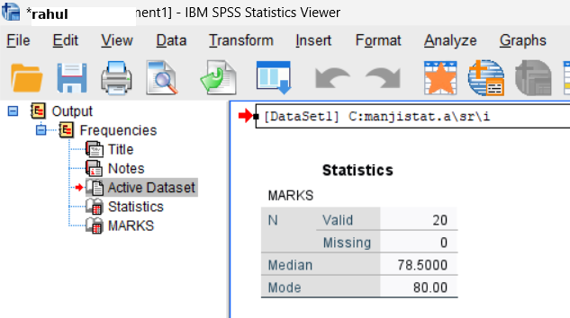
Step 3: Calculate Quartile Deviation, Skewness and Kurtosis
- Go to Analyze > Descriptive Statistics > Explore.
- Move "Marks" into the Dependent List box.
- Click on Statistics and check Quartiles, Skewness and Kurtosis.
- Click Continue, then OK.
- The output will include the quartiles (Q1 and Q3), skewness and kurtosis values. Calculate the Quartile Deviation:
$$Q.D=\frac{Q3-Q1}{2}​$$
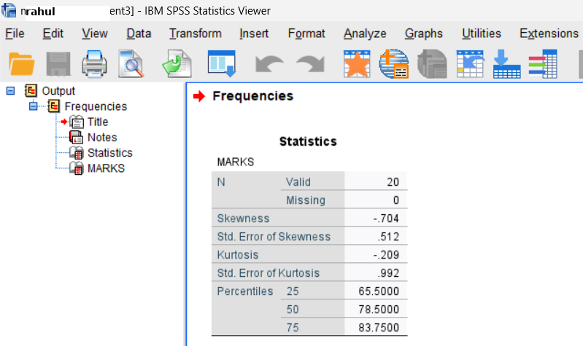

Interpretation: The mean reflects the overall average performance, the median shows the middle point unaffected by extreme scores, and the mode highlights the most common score. Comparing them can indicate skewness — if they’re close, the marks are fairly symmetrically distributed.
Conclusion: The calculated mean, median, and mode give three central tendency measures, helping to identify the typical marks scored by students.
- From the following data calculate
Marks | 0-20 | 20-40 | 40-60 | 60-80 | 80-100
No. of Students | 8 | 10 | 15 | 7 | 5
(a) Mean, Median, Mode, SD,
(b) skewness, kurtosis.
(c) plot histogram
Step 1: Enter Data
- In the Data View, enter data in a columns("Lower Limits (LL), Upper Limits (UL), Frequencies (F))
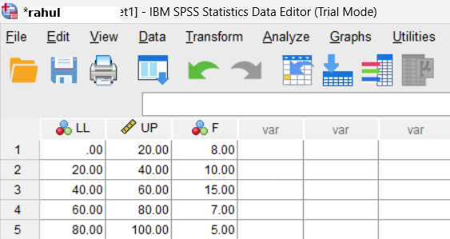
Step 2: Calculate Midpoint (X) for each interval:
$$X=\frac{LL+UL}{2}$$
- Go to Transform/Compute Variable enter expression and press ok.
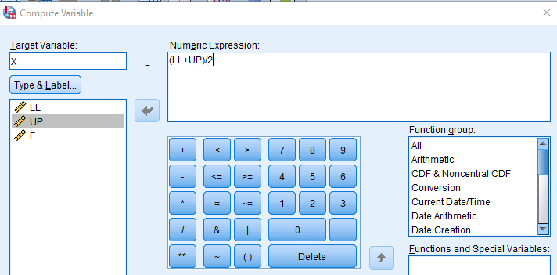
- The following will appear.
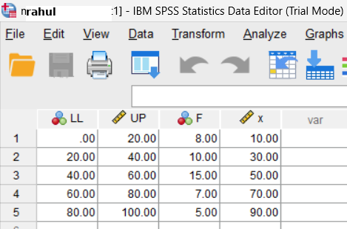
Step 3: Calculate Mean, Median, Mode, SD, Skewness & Kurtosis
- Go to Data/Weight Cases and move frequency into weight cases.
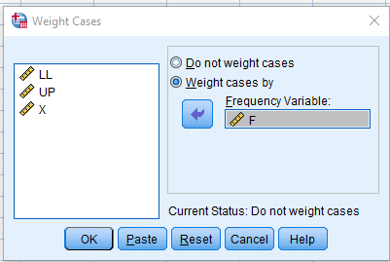
- Go to Analyze > Descriptive Statistics > Frequencies.
- Move "X" into the variables box.
- Click on Statistics and check Mean, Median, Mode, Std. Deviation, Quartiles, Skewness and Kurtosis.
- Click Continue, then OK. 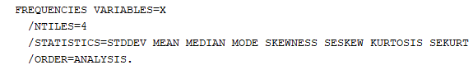
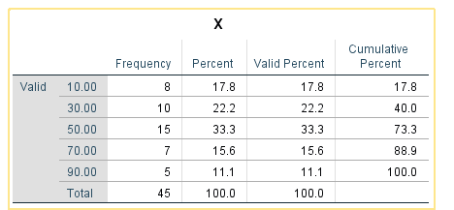
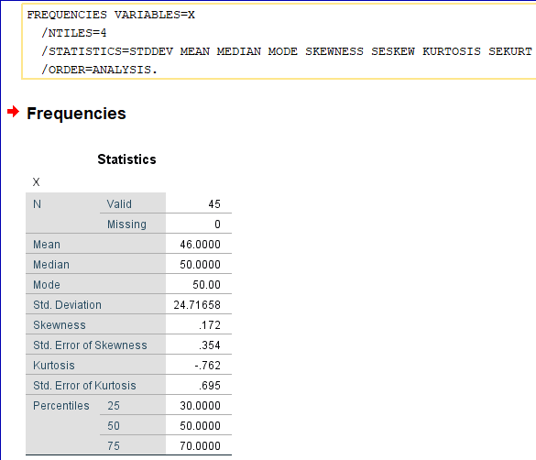
Step 4 Plot Histogram
- In SPSS, go to Graphs > Legacy Dialogs > Histogram.
- Select the variable for the histogram (input frequencies).
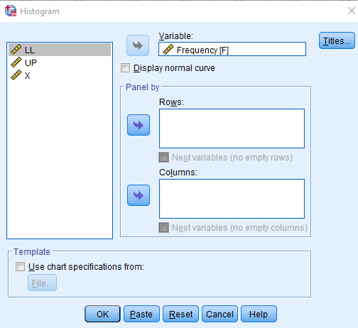
- Click OK to generate the histogram.
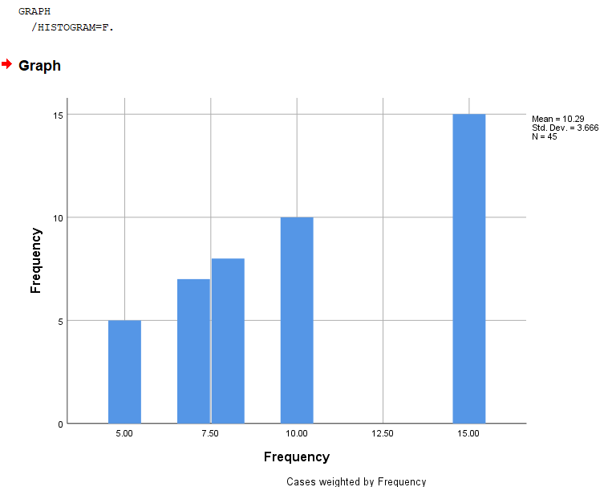

Interpretation: These measures help in summarizing the overall performance of the group and understanding the spread. A large difference between mean and median would suggest skewness in student marks.

Conclusion: The class midpoints, frequencies, and cumulative frequencies enable calculation of mean, median, and mode for grouped data.

- Message arrive at an electronic message center at random order, with an average of 10 messages per hour.
(a) What is the probability of receiving at least three messages during the next hour?
(b) What is the probability of receiving exactly five messages during the next three hours?
Step 1: Enter X, $λ$(Mean)
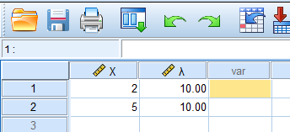
Step 2: Calculate Probability for a
- Go to Transform > Compute variable and input as follows then press OK.
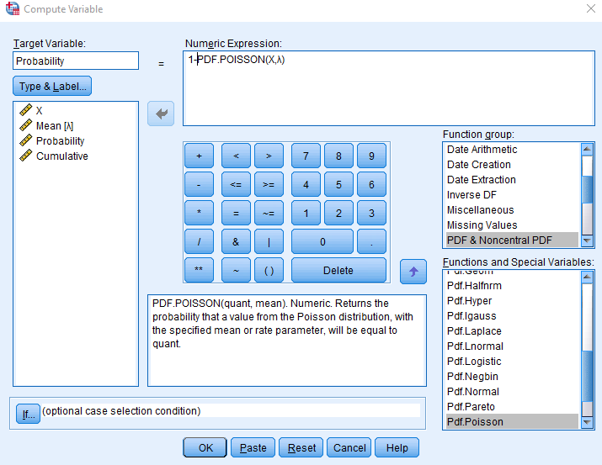
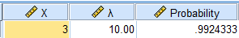
Step 3: Calculate Cumulative for b
- Go to Transform > Compute variable and input as follows then press OK
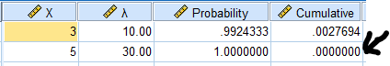
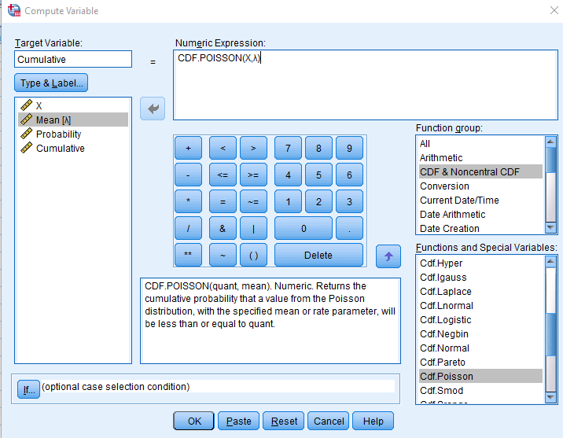 Answer

Interpretation: This model is valuable for predicting workload at the message center. Higher probabilities indicate more common outcomes, guiding staffing and resource allocation.
Conclusion: The computed probabilities quantify how likely it is to receive certain numbers of messages in given time intervals.
- From a sample of 800 keyboards mean life is found to be 66 months with standard deviation of 5 months, find the probability that number of keyboards having life
(a) between 65 and 70.
(b) greater than or equal to 72.
Given Data
- Sample size (n) = 800
- Mean (μ) = 66 months
- Standard deviation (σ) = 5 months
To find probabilities, we'll convert the life of keyboards into a standard normal distribution (Z-distribution) using the formula:
​ $Z=\frac{X-μ}{σ}$
where X is the value of interest.
Step 1: Compute Z-scores
- Open the Compute Variable Dialog:
  - Go to Transform > Compute Variable.
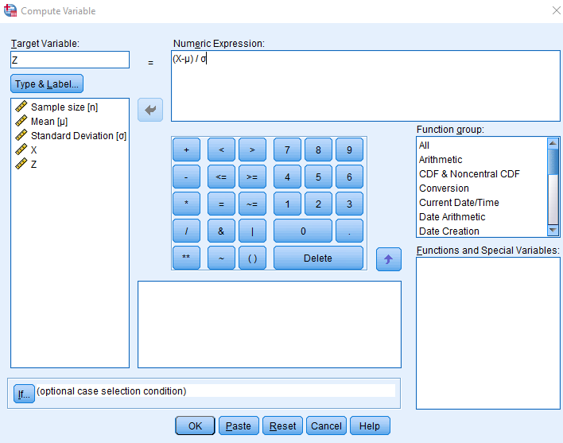
- Calculate Z-scores for the values of interest (65, 70, and 72 months).
Step 3: Calculate Probabilities Using the Normal Distribution
- Open the Compute Variable Dialog Again:
  - Go to Transform > Compute Variable.
- Calculate Probability for 65 and 70:
  - Target Variable: P_Between_65_70
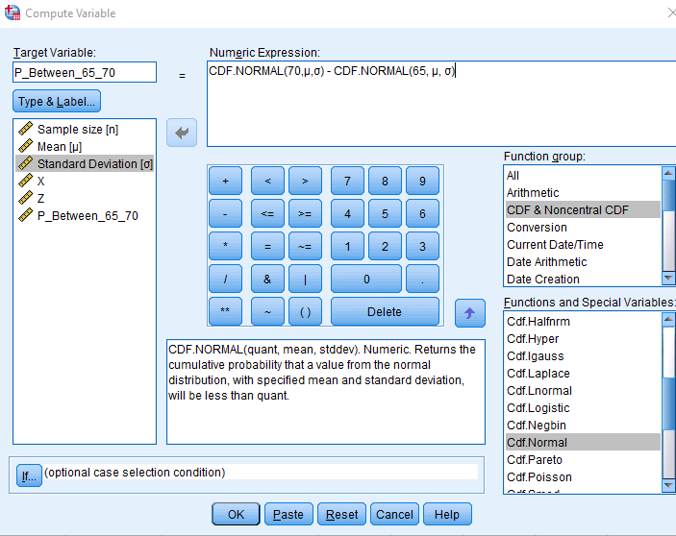
Calculate Probability for Greater Than or Equal to 72:
- Target Variable: P_Greater_72
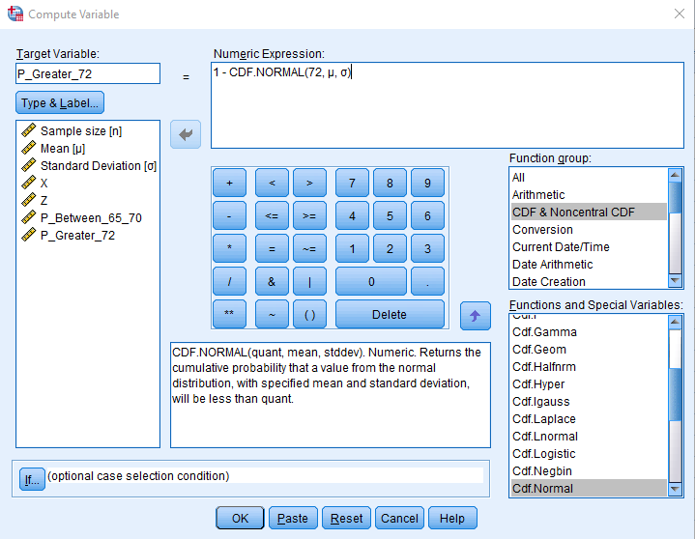
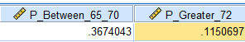

Conclusion: Exact and at-least probabilities for heads were found using the binomial distribution.
Interpretation: This shows how likely specific outcomes are in a fair coin experiment. Rare events (like 8 or more heads) have much lower probabilities compared to moderate outcomes.
5. Ten unbiased coins are tossed simultaneously. find the probability of obtaining
(a) Exactly 6 heads
(b) At least 8 heads
Step 1: Calculate Probability of Exactly 6 Heads
(a) Probability of obtaining exactly 6 heads
- Open the Compute Variable Dialog:
  - Go to Transform > Compute Variable.
- Define the Variable:
  - Target Variable: P_Exactly_6
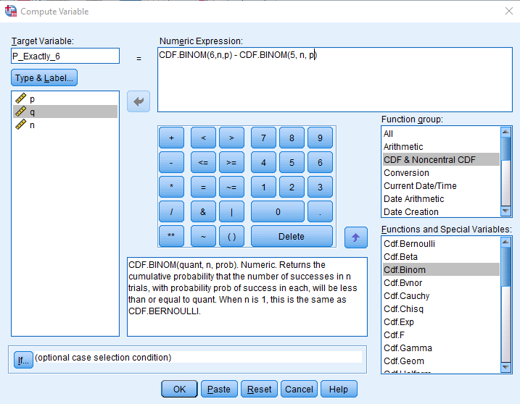
- This calculates P(X=6) using the binomial probability formula.
- Click OK:
- This creates a new variable that contains the probability of obtaining exactly 6 heads.
Step 2: Calculate Probability of At Least 8 Heads
(b) Probability of obtaining at least 8 heads
- Open the Compute Variable Dialog Again:
  - Go to Transform > Compute Variable.
- Define the Variable:
  - Target Variable: P_AtLeast_8
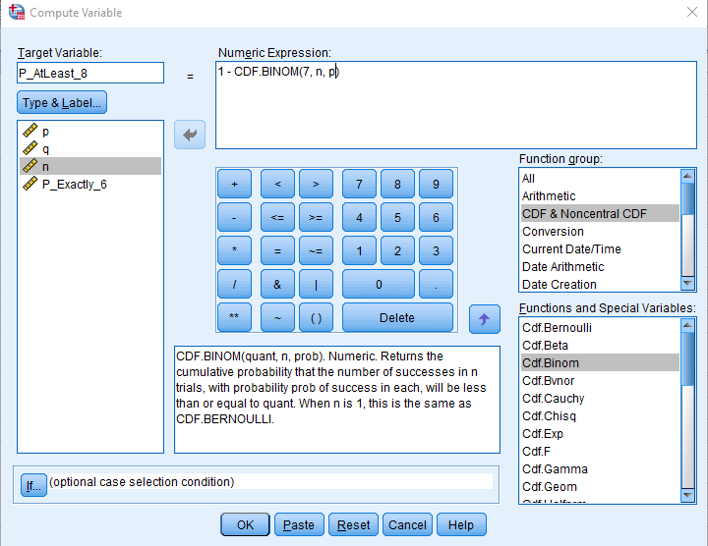
- This calculates P(X≥8)
- Click OK:
- This creates a new variable that contains the probability of obtaining at least 8 heads.

Interpretation:
The binomial model shows that outcomes near the average (like 6 heads) are much more probable than extreme ones (like 8 or more heads).
Conclusion:
The probability of exactly 6 heads was found to be moderate, while the probability of at least 8 heads is low, indicating such events are rare.

- A coin is biased so that a head is twice as likely to appear as a tail. If the coin is tossed 6 times, find the probability of getting
  - Exactly 2 heads
  - At least 3 heads
  - At most 3 heads.
Step 1: Calculate Probability of Exactly 2 Heads
(a) Probability of obtaining exactly 2 heads
- Open the Compute Variable Dialog:
  - Go to Transform > Compute Variable.
- Define the Variable:
  - Target Variable: P_Exactly_2
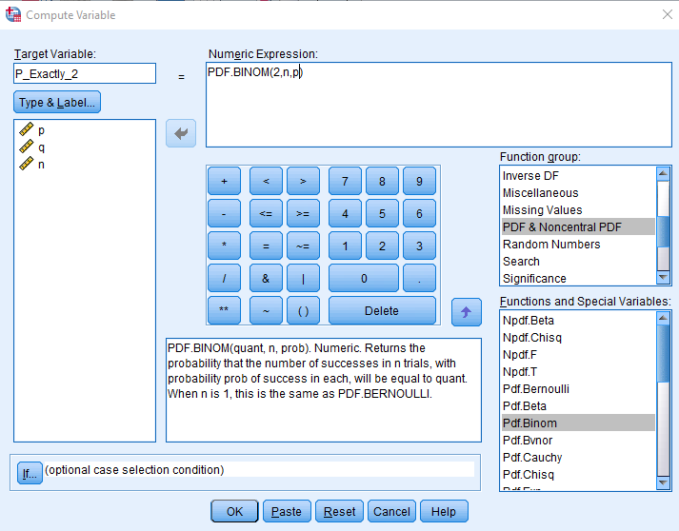
- This calculates the probability of getting exactly 2 heads in 6 tosses.
- Click OK:
- This creates a new variable that contains the probability of obtaining exactly 2 heads.
Step 2: Calculate Probability of At Least 3 Heads
(b) Probability of obtaining at least 3 heads
- Open the Compute Variable Dialog Again:
  - Go to Transform > Compute Variable.
- Define the Variable:
  - Target Variable: P_AtLeast_3
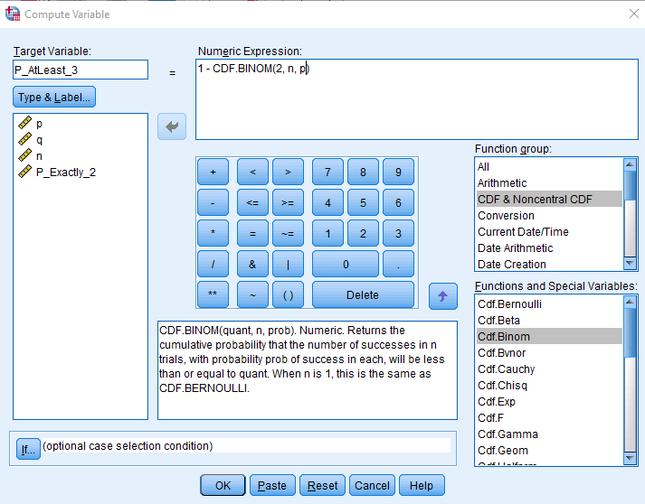
  - This calculates P(X≥3)P(X \geq 3)P(X≥3).
- Click OK:
  - This creates a new variable that contains the probability of obtaining at least 3 heads.
Step 3: Calculate Probability of At Most 3 Heads
(c) Probability of obtaining at most 3 heads
- Open the Compute Variable Dialog Again:
  - Go to Transform > Compute Variable.
- Define the Variable:
  - Target Variable: P_AtMost_3
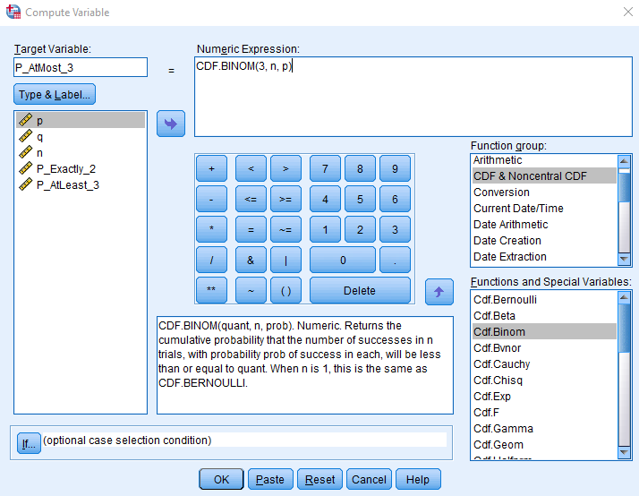
  - This calculates P(X≤3)
- Click OK:
  - This creates a new variable that contains the probability of obtaining at most 3 heads.
Interpretation:
When one outcome is more likely, the distribution shifts — more probable results cluster around the favored outcome, and rare results become less likely.
Conclusion:
The binomial probabilities for exactly 2 heads, at least 3 heads, and at most 3 heads were determined, showing the clear influence of bias on expected results.

- Construct a box and whisker plot for following data:
61,55,18,90,32,27,85,26,75,61,51,88,34,65,48
Step 1: Enter the Data
- Open a New Data Sheet:
- Input the Data:
  - In the first column (Variable View), rename the variable to Values.
  - In the Data View, enter data in values column
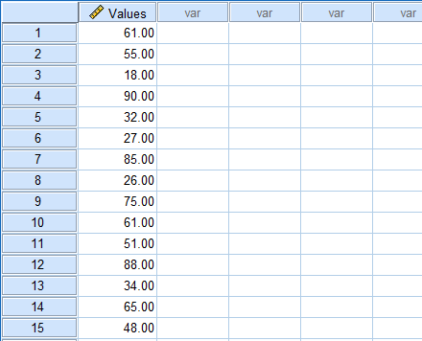
Step 2: Create the Stem and Leaf and Box and Whisker Plot
- Go to Analyze > Descriptive Statistics > Explore.
- Input values as dependent list:
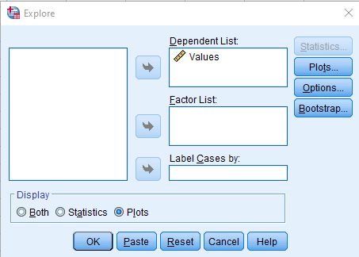
- Click the Plots menu and select Stem and Leaf & Box Plot > Factor Level together
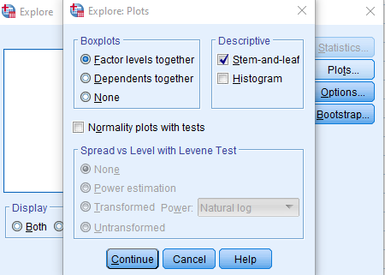
- Click OK:
  - Click the OK button to create the box and whisker plot.
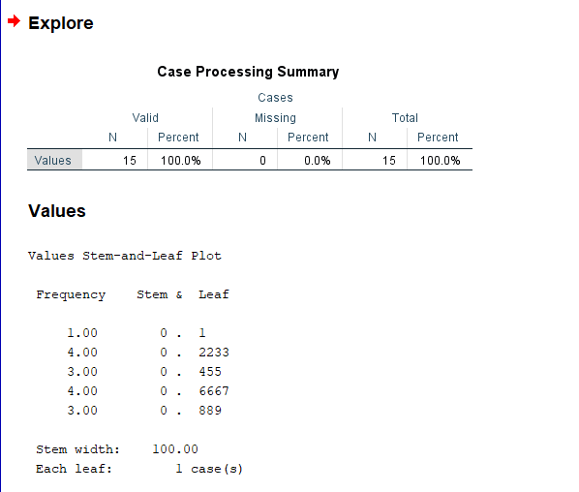
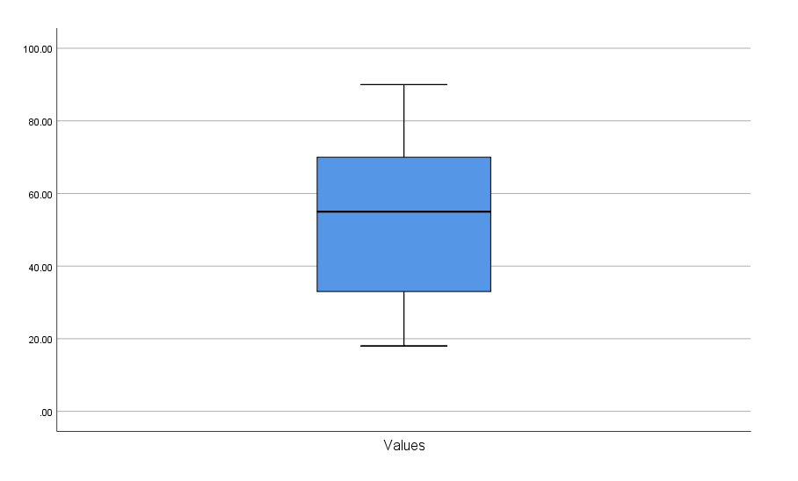
Interpretation:
The plot reveals the central value, spread, and any unusual extreme values in the dataset, highlighting symmetry or skewness in the distribution.
Conclusion:
The boxplot constructed for the given data visually summarized the distribution, clearly identifying median, quartiles, and potential outliers.

- Calculate the correlation coefficient between sales and repair of computers as given below:
Sales | 50 | 55 | 55 | 60 | 65 | 70 | 65 | 60
Repair | 11 | 13 | 14 | 16 | 16 | 15 | 15 | 20
Step 1: Enter the Data
- Open a New Data Sheet:
- Input the Data:
  - In the Variable View, create two variables:
    - Sales
    - Repair
  - In the Data View, enter data as follows:
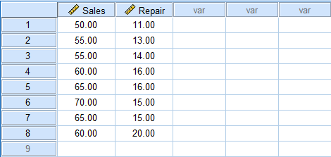
Step 2: Calculate the Correlation Coefficient
- Open the Correlation Dialog:
  - Go to Analyze > Correlate > Bivariate.
- Select Variables:
  - In the Bivariate Correlations dialog, select both variables (Sales and Repair) from the left list and move them to the Variables box on the right.
- Choose Correlation Coefficient:
  - Check the Pearson option.
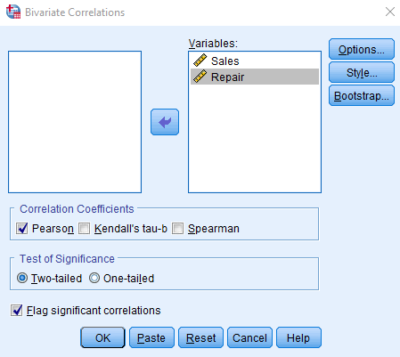
- Click OK:
  - Click the OK button to run the correlation analysis.
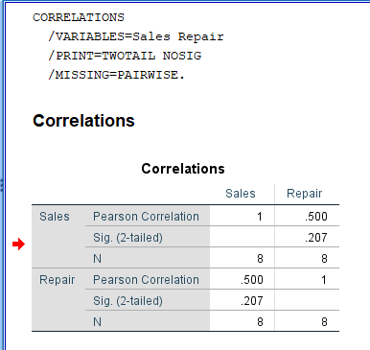
Interpretation:
A positive correlation means sales and repairs tend to increase together, while a negative one means they move oppositely. The magnitude shows how strong the relationship is.
Conclusion:
The computed correlation coefficient quantified the relationship between sales and repairs, indicating whether sales growth is associated with increased repair cases.

- FOLLOWING ARE THE MARKES OBTAINED BY DIFFERENT STUDENTS INTWO DIFFERENT COLLEGES.
COLLEGE-X
51 | 58 | 43 | 28 | 32 | 38 | 40 | 46
39 | 30 | 24 | 29 | 50 | 49 | 56 | 43
40 | 29 | 22 | 33 | 35 | 36 | 34 | 39
48 | 50 | 53 | 56 | 50 | 29 | 28 | 59
COLLEGE-Y
42 | 41 | 39 | 32 | 38 | 56 | 39 | 36 | 28 | 53
59 | 46 | 38 | 56 | 58 | 50 | 29 | 30 | 38 | 46
49 | 52 | 56 | 58 | 39 | 21 | 20 | 28 | 39 | 36
48 | 46 | 35 | 36 | 58 | 59 | 38 | 46
BY USING APPROPRIATE SOFTWARE.
- CALCULATE MEAN, MODE, RANGE, AND STANDARD DEVIATION FROM THE ABOVE DATA OF BOTH COLLGES.
- IF CONSISTENCY IS THE CRITERIA TO AWARD FOR PRIZE DISTRIBUTION, WHICH COLLEGE WILL BE AWARDED?
- IF YOU ARE GOING TO ADMIT, WHICH COLLEGE DO YOU SELECT AND WHY?

WORKING EXPRESSION:
- Mean: The ratio of sum of all the observations to the total number of observations is called mean. It is denoted by and given by:
= $\frac{\sum_{i=1}^{n}{x_{i}}}{n}$
where, n = number of observations
- Mode: The most recurring value in a set of data is the mode. It is denoted by M_{o}.
- Range: The difference between the maximum and minimum value is range. It is denoted by R.
- Standard Deviation: The square root of arithmetic mean of square of deviations taken from arithmetic mean is called standard deviation. It is denoted by and given by
$σ=\sqrt{\frac{\sum{(x-\overline{x})^{2}}}{n}}$
$σ=\sqrt{\frac{\sum{x^{2}}}{n}-{\left(\frac{\sum{x}}{n}\right)}^{2}}$
where, n = number of observations.
- Coefficient of Variation: The ratio of standard deviation to the arithmetic mean is called the coefficient of variation. It is denoted by C.V and given by
$$C.V= \frac{σ}{X}$$
- Relation between C.V. and consistency: Coefficient of Variation (C.V.) is a measure of relative variability in a dataset, and a lower C.V. indicates greater consistency or similarity between the values in the dataset. i.e., C.V. is inversely proportional to consistency.
$$C.V∝ \frac{1}{consistency}$$
CALCULATION:
- The mean, mode, range, and standard deviation from the above data are calculated as follows:

For College Y
Statistical Measure | Symbol | Value
Mean |  | 42.578947
Mode | M_{o} | 39
Range | R | 39
Standard Deviation |  | 10.834458
i)Using SPSS:
For College X
Statistical Measure | Symbol | Value
Mean |  | 40.53125
Mode | M_{o} | 29
Range | R | 37
Standard Deviation |  | 10.631615
For College Y
N | Valid | 38
 | Missing | 0
Mean |  | 42.58
Mode |  | 38ª
Std. Deviation |  | 10.834
Range |  | 39
For College X
N | Valid | 32
 | Missing | 6
Mean |  | 40.53
Mode |  | 29ª
Std. Deviation |  | 10.632
Range |  | 37

- To compare consistency, the coefficient of variance is calculated as follows:
For College X
Statistical Measure | Symbol | Value
Coefficient of variance | C.V | 0.26230

  - Using SPSS:
Ratio Statistics for For College X / one
Mean | Coefficient of Variation
 | Mean Centered
40.531 | 26.2%
Ratio Statistics for For College Y / one
Mean | Coefficient of Variation
 | Mean Centered
42.579 | 25.4%

INTERPRETATION:
To determine which college would be awarded based on consistency, we look for the lower coefficient of variation. In this case, College Y has a lower coefficient of variation (0.254455762) compared to College X (0.26230663). Therefore, College Y would be awarded the prize for consistency. Similarly, if we prioritize consistency in the admission decision, College Y would be the preferred choice to get admitted.
RESULT:
The mean, mode, range, standard deviation, and coefficient of variance of the given marks obtained by college X are 40.53125, 29, 37, 10.63161559 and 0.26230663 respectively and that for college Y is 42.57894737, 39, 39, 10.83445849 and 0.254455762 respectively.
CONCLUSION:
In this way, the mean, mode, range, standard deviation, and coefficient of variance were computed using SPSS software and the college deserving the award and college to get admission was determined.
- Find the regression line of sons height on father height.
Father: | 67 | 63 | 66 | 71 | 69 | 65 | 62 | 70 | 61 | 72
Son: | 68 | 66 | 65 | 70 | 67 | 67 | 64 | 71 | 62 | 63
Step 1: Enter the Data
- Open a New Data Sheet:
  - You should see a blank data sheet.
- Input the Data:
  - In the Variable View, create two variables:
    - Father_Height
    - Son_Height
  - In the Data View, enter data as follows:
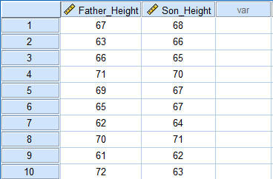
Step 2: Perform Regression Analysis
- Open the Regression Dialog:
  - Go to Analyze > Regression > Linear.
- Select Variables:
  - In the Linear Regression dialog:
    - Move Son_Height to the Dependent box.
    - Move Father_Height to the Independent(s) box.
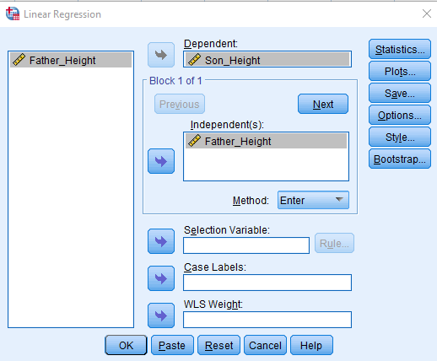
- Click OK:
  - Click the OK button to run the regression analysis.
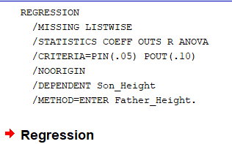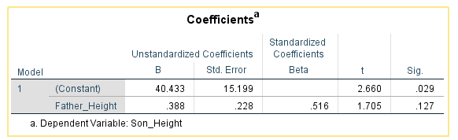
Required Regression equation is: $y=40.433+0.388 x$
Interpretation:
The regression line predicts a son’s height based on the father’s height, with the slope showing how much change in one relates to change in the other.
Conclusion:
The regression equation obtained helps forecast the son’s height using the father’s height, demonstrating the relationship between the two.
- Calculate correlation coefficient between X and Y
X | 6 | 2 | 10 | 4 | 8
Y | 9 | 11 | 5 | 8 | 7
Step 1: Enter the Data
- Open a New Data Sheet:
- Input the Data:
  - In the Variable View, create two variables:
    - X
    - Y
  - In the Data View, enter data as follows:
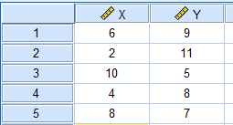
Step 2: Calculate the Correlation Coefficient
- Open the Correlation Dialog:
  - Go to Analyze > Correlate > Bivariate.
- Select Variables:
  - In the Bivariate Correlations dialog, select both X and Y from the left list and move them to the Variables box on the right.
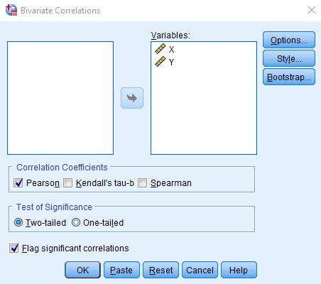
- Click OK:
  - Click the OK button to run the correlation analysis.
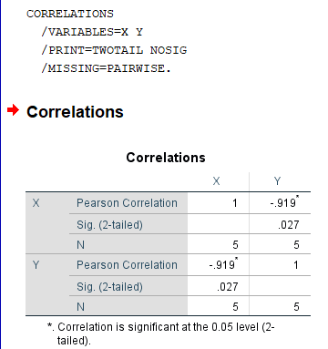
Interpretation:
Correlation measures the strength and direction of linear association between two variables. A value near 0 indicates little relationship; values near ±1 show strong association.
Conclusion:
The calculated correlation coefficient described how closely X and Y vary together, confirming the nature and degree of their relationship.

- The marks obtained by 30 students in an examination is as follows:
Grade | A | B | C | D | E
No. of Students | 7 | 9 | 6 | 5 | 3
plot on pie-chart.
Step 1: Enter the Data
- Open a New Data Sheet:
- Input the Data:
  - In the Variable View, create two variables:
    - Grade
    - Students
  - In the Data View, enter data as follows:
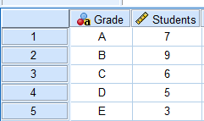
Step 3: Create the Pie Chart
- Open Graphs.
- Go to Legacy Dialogs > Pie
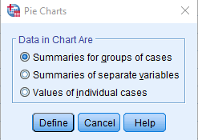
Define Slices by:
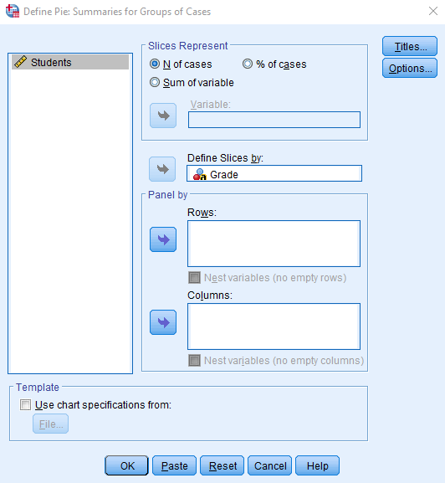
- Click OK:
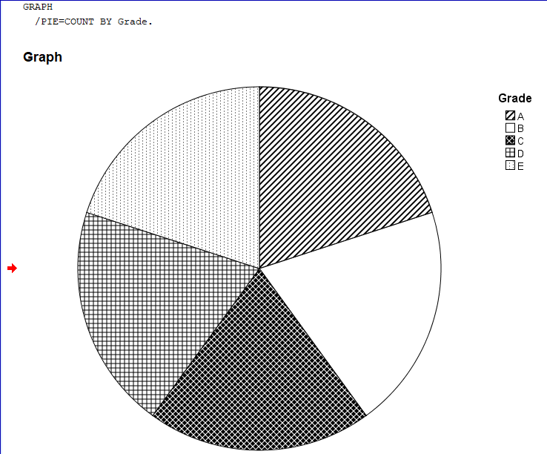

Interpretation:
The distribution of grades shows the proportion of students in each performance category, highlighting strengths and weaknesses in the group’s achievement.
Conclusion:
The grade analysis revealed the overall performance spread, with the largest group sizes pointing to the most common performance levels.
13:
STATEMENT:
PAST DATA INDICATES THAT DOWNLOADING “ON CAMPUS” WEB PAGES IS NORMALLY DISTRIBUTED WITH MEAN 7 SECONDS AND STANDARD DEVIATION OF 2 SECONDS. WHAT IS THE PROBABILITY THAT DOWNLOADED TIME WILL BE.
- BELOW 3.5 SECONDS.
- BETWEEN 3.2 TO 6.2 SECONDS.
- WHAT IS THE TIME BY WHICH 70% OF WEB PAGES ARE DOWNLOADED?

WORKING EXPRESSION:
- Normal Distribution: A continuous random variable X is set to follow normal distribution (Gaussian distribution) with parameters $μ$ and $σ$ if it’s p.d.f. is:
$f(x) = \frac{1}{σ\sqrt{2π}} e^{\frac{-1}{2}{\left(\frac{x-μ}{σ}\right)}^{2}}$
where, -∞ < x < ∞, $σ$ > 0
- Standard Normal Distribution: let $X\sim N\left(μ, σ^{2}\right)$ be the normal variable it can be standardized by the relation $Z=\frac{X-μ}{σ}$ then it’s p.d.f. is given by:
$f\left(z\right)= \frac{1}{\sqrt{2π}} e^{\frac{-1}{2}{\left(\frac{z}{σ}\right)}^{2}}$ where, -∞ < z < ∞, $σ$ > 0
- Probability/Area under standard normal distribution:
P(-∞ < z < ∞) = 1
P(-∞ < z < 0) = P(0 < z < ∞) = 0.5
P(-a < z < 0) = P(0 < z < a)
CALCULATION:
Using SPSS to generate probability distribution table:
x | P(X ≤ x)
3.2 | 0.028717
3.5 | 0.040059
6.2 | 0.344578
- The probability that downloaded time will be below 3.5 seconds is computed as follows:
From above probability distribution table, P(X ≤ 3.5) = 0.040059
  - Using SPSS:
CDF.NORMAL(3.5, 7, 2)
Result: 0.04
- The probability that downloaded time will be between 3.2 to 6.2 seconds is computed as follows:
From above probability distribution table,
P(3.2 ≤ X ≤ 6.2) = P(X ≤ 6.2) - P(X ≤ 3.2)
= 0.0512
  - Using SPSS:
CDF.NORMAL(6.2, 7, 2) - CDF.NORMAL(3.2, 7, 2)
Result: 0.32
- The time by which 70% of web pages are downloaded is computed as follows:
=NORM.INV(0.7, G1,G2)
= 8.048801025
  - Using SPSS:
IDF.NORMAL(0.7, 7, 2)
Result: 8.05

INTERPRETATION:
In analyzing the results, firstly, the probability of a downloaded time being below 3.5 seconds is 0.04, indicating a 4% chance of observing a time below this threshold. Secondly, the probability of the downloaded time falling between 3.2 and 6.2 seconds is 0.32, suggesting a 32% chance of observing a time within this range. Lastly, the time at which 70% of web pages are downloaded is approximately 8.05 seconds.

RESULT:
Hence, the probability that downloaded time will be below 3.5 seconds is 0.04, between 3.2 to 6.2 seconds is 0.32 and the time by which 70% of web pages are downloaded is 8.05 seconds.

CONCLUSION:
In this way, the probability that downloaded time will be below 3.5 seconds, between 3.2 to 6.2 seconds and the time by which 70% of web pages are downloaded were computed using SPSS Software.
14. Find the regression equation X on Y from the following data.
X | 5 | 15 | 20 | 25 | 30
Y | 50 | 60 | 80 | 110 | 130
Step 1: Enter the Data
- Open a New Data Sheet:
- Input the Data:
  - In the Variable View, create two variables:
    - X
    - Y
  - In the Data View, enter data as follows:
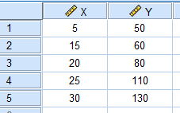
Step 2: Perform Regression Analysis
- Open the Regression Dialog:
  - Go to Analyze > Regression > Linear.
- Select Variables:
  - In the Linear Regression dialog:
- Move X to the Dependent box.
- Move Y to the Independent(s) box.
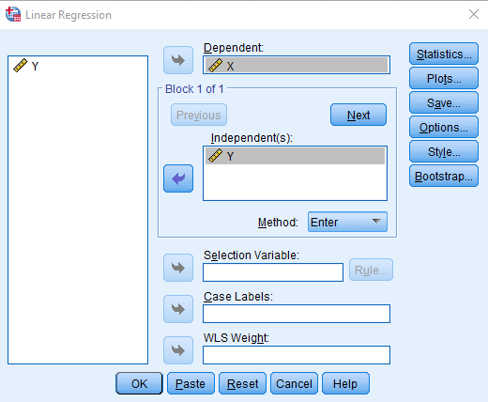
- Click OK:
- Click the OK button to run the regression analysis.
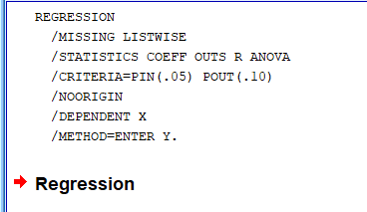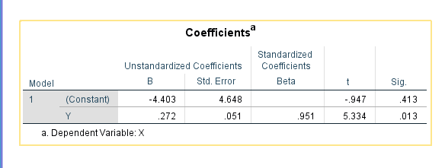
Required Regression equation is: $x=0.272 y-4.403$
Interpretation:
The regression equation allows estimation of one variable when the other is known, with the slope indicating the rate of change.
Conclusion:
The derived regression line for X on Y enables predictions and analysis of their linear relationship.
15

STATEMENT:
THE DATA BELOW GIVES THE MARKS SECURED BY CERTAIN CANDIDATES AT EXAMINATION:
21, 31, 35, 52, 64, 74, 89, 53, 42, 07, 22, 35, 43, 67, 76, 35, 46, 26, 23, 40, 54, 45, 32, 28, 71, 63, 38, 43, 72, 15, 18, 52, 73, 86, 50, 39, 55, 47, 12, 69, 72, 65, 50, 40, 39, 85, 67, 58, 44, 57, 63, 05, 56, 79, 37, 24, 54, 82, 49, 51, 54, 68, 29, 34, 44, 58, 62, 59, 65, 72
BY USING APPROPRIATE SOFTWARE,
- CONSTRUCT A FREQUENCY DISTRIBUTION OF THE MARKS IN THE MANNAR 0F 0-10, 10-20, …., ETC.
- CALCULATE THE MEAN MARKS SECURED BY THE CANDIDATES.
- PLOT THE FREQUENCY CURVE, LESS THAN CUMULATIVE FREQUENCY CURVE AND MORE THAN CUMULATIVE FREQUENCY CURVE.

WORKING EXPRESSION:
- Frequency: The number of times a value of variable repeats is called frequency. It is denoted by f.
- Frequency Distribution: A tabular display containing the value of variables along with their respective frequencies is called frequency distribution. It is of three types: Individual frequency distribution, discrete frequency distribution, continuous frequency distribution.
- Mean: The ratio of sum of all the observations to the total number of observations is called mean. It is denoted by $\overline{x}$ and given by:
=
where, n = number of observations
- Frequency Curve: It is a smooth continuous curve that represents the frequencies of the distribution graphically.
- Less Than Cumulative Frequency Curve: A frequency curve where the frequencies of all preceding classes are added to the frequency of a class.
- More Than Cumulative Frequency Curve: A frequency curve where the frequencies of the succeeding classes are added to the frequency of a class.

CALCULATION:
- The continuous frequency distribution of the marks obtained by the students is constructed as:

Marks | Tally Bar | Frequency
0-10 | // | 2
10-20 | /// | 3
20-30 | //// // | 7
30-40 | //// //// | 10
40-50 | //// //// / | 11
50-60 | //// //// //// | 15
60-70 | //// //// | 10
70-80 | //// /// | 8
80-90 | //// | 4

- By using SPSS:
 |  | Frequency
Valid | 0-10 | 2
 | 10-20 | 3
 | 20-30 | 7
 | 30-40 | 10
 | 40-50 | 11
 | 50-60 | 15
 | 60-70 | 10
 | 70-80 | 8
 | 80-90 | 4
 | Total | 70
- The arithmetic means for the marks secured by the candidates is:

Marks | LCL | UCL | frequency (f) | mid value (m) | fm | mean
0-10 | 0 | 10 | 2 | 5 | 10
10-20 | 10 | 20 | 3 | 15 | 45
20-30 | 20 | 30 | 7 | 25 | 175
30-40 | 30 | 40 | 10 | 35 | 350
40-50 | 40 | 50 | 11 | 45 | 495 | 49.85714
50-60 | 50 | 60 | 15 | 55 | 825
60-70 | 60 | 70 | 10 | 65 | 650
70-80 | 70 | 80 | 8 | 75 | 600
80-90 | 80 | 90 | 4 | 85 | 340
 |  |  | 70 | 405 | 3490
- By using SPSS:
N | Valid | 70
 | Missing | 0
Mean |  | 49.86
- The frequency curves of the distribution are as follows.
- By using IBM SPSS STATISTICS:

- By using SPSS:
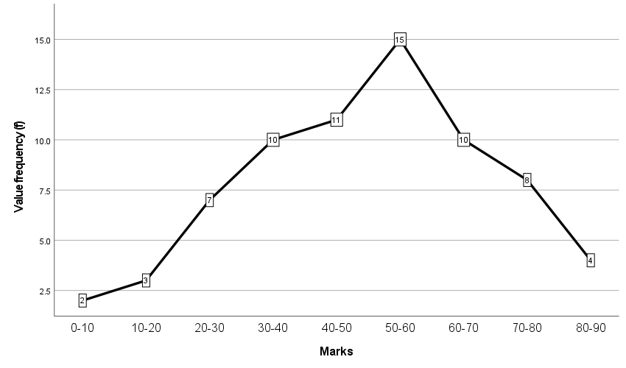
Fig. Frequency Curve
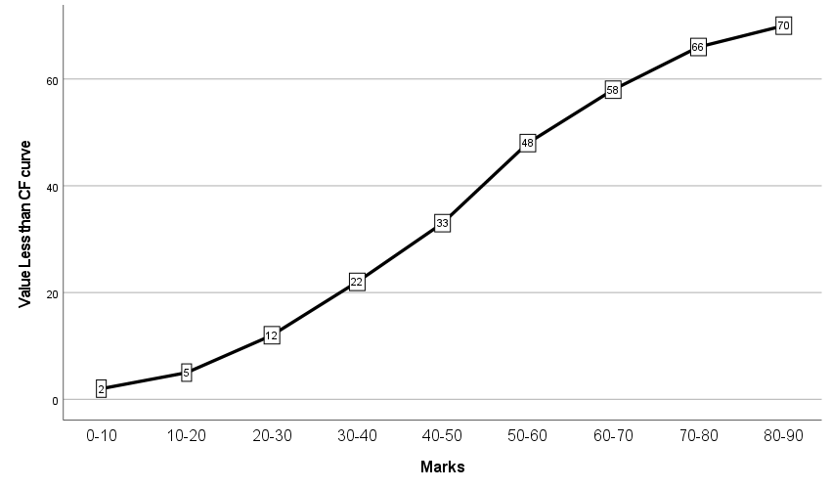
Fig. Less than Frequency Curve

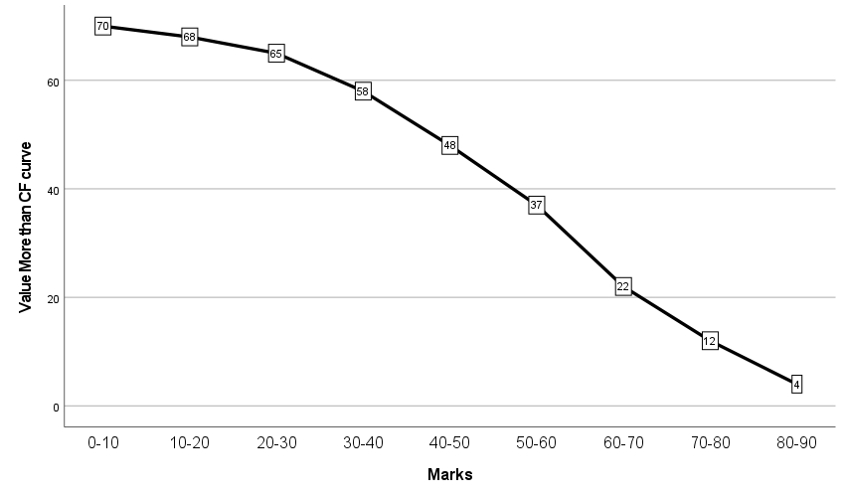
Fig. More than Frequency Curve

INTERPRETATION:
We can clearly observe that the frequency distribution has a regular curve when plotted in accordance with the class and its frequency. The curve with individual values and their frequency is a discontinuous curve. The mean marks obtained by the students was 49.85, hence the average performance of the class was mediocre at best.
RESULT:
The mean marks secured by the candidates was 49.85714.
CONCLUSION:
In this way the mean marks obtained by the students, the frequency distribution of the dataset and frequency curves from the given data were computed using SPSS software.
16
STATEMENT:
Following are the weights (in kgs) of certain students which is given below:
Weights (in kgs):
52, 81, 82, 54, 83, 77, 66, 63, 68, 65, 54, 69, 45, 68, 48, 66, 50, 92, 91, 85, 85, 85, 54, 55, 86, 71, 87, 72, 66, 63, 73, 67, 84, 67, 45, 68, 41, 69, 55, 35, 99, 77, 56, 53, 59, 63, 46, 77, 49, 53, 56, 59, 65, 60, 63, 82, 80, 73, 75, 76, 68, 53, 67, 73, 85
Use appropriate software
- Compute mean, MEDIAN, MODE, range, standard deviation and coefficient of variation.
- calculate coefficient OF skewness and KURTOSIS and interpret the resulT.
- Construct the histogram stem and leaf display and Box-and-whisker plot for the weights of the students.
WORKING EXPRESSION:
- Mean: The ratio of the sum of all the observations by the total number of observations is called mean. It is denoted by $\overline{x}$and given by:
$\overline{x}$ =$\frac{\sum_{i=1}^{n}{x_{i}}}{n}$,
where i = 0, 1, 2, 3, …, n
- Median: The middlemost value of the ordered set of data is called the median. It is denoted by M_{d} and given by:
,
where n = number of observations
- Mode: The most recurring value in a set of data is the mode. It is denoted by M_{o.}
- Range: The difference between the largest and smallest value in a set of data is the range.
- Standard Deviation: The square root of arithmetic means of square of deviations taken from the arithmetic mean is called the standard deviation. It is denoted by σ and given by:
$$σ=\sqrt{\frac{1}{n}(∑{\left(x-\overline{x}\right)}^{2})}$$
- Coefficient of Variation: The ratio of standard deviation to the arithmetic mean is called the coefficient of variation. It is denoted by C.V and given by
$$C.V= \frac{σ}{x}$$
- Coefficient of Skewness: The measure of asymmetry of the frequency distribution curve is called the coefficient of skewness. A positive value of the coefficient denotes a curve that is positively skewed, i.e., the values are more clustered towards the right side of the graph. Meanwhile a negative value denotes a curve that is negatively skewed i.e., the values are more clustered towards the left end of the graph.
- Coefficient of Kurtosis: The measure of the peak-ness or flatness of a given frequency curve is the coefficient of kurtosis. It is denoted by K and is given by:
$$K= \frac{P_{75}-P_{25}}{2(P_{90} - P_{10})}$$
A value of 0.263 represents a mesokurtic curve, a value less than 0.263 represents a platykurtic curve and a value greater than 0.263 represents a leptokurtic curve.
- Stem and Leaf Display: A stem-and-leaf display is a data visualization tool used in statistics to organize and display a set of numerical data in a way that shows the distribution of the data while retaining the individual values. In a stem-and-leaf display, the data values are split into two parts: the stem and the leaf. The stem represents the highest place value(s) of the data values, while the leaf represents the remaining digits.
- Box and Whisker Plot: A box-and-whisker plot, also known as a box plot, is a type of data visualization tool used in statistics to display the distribution of a set of numerical data. It shows the minimum and maximum values, the median (or second quartile), and the first and third quartiles of the data set. The box-and-whisker plot is created by drawing a box with a vertical line at the median of the data set. The bottom and top edges of the box represent the first and third quartiles, respectively. The "whiskers" are drawn as vertical lines that extend from the box to the minimum and maximum value.
CALCULATION:
- The mean, median, mode, range, standard deviation, and coefficient of variation are computed as follows:
  - Using SPSS Formula
Statistical Measure | Symbol | Value
Mean |  | 66.98461538
Median | M_{d} | 67
Mode | M_{o} | 63
Standard Deviation |  | 13.93791177
Sample Variance | ² | 194.2653846
Range | R | 64
Coefficient of Variance | CV | 20.80763127
Sum |  | 4354
  - Using SPSS Data Analysis:
Statistical Measure | Symbol | Value
Mean |  | 66.98461538
Median | M_{d} | 67
Mode | M_{o} | 63
Standard Deviation |  | 13.93791177
Sample Variance | ² | 194.2653846
Range | R | 64
Coefficient of Variance | CV | 20.80763127
Sum |  | 4354
  - Using SPSS
N | Valid | 65
 | Missing | 0
Mean |  | 66.98
Median |  | 67.00
Mode |  | 63ª
Std. Deviation |  | 13.938
Variance |  | 194.265
Range |  | 64
Sum |  | 4354
- The coefficient of skewness and kurtosis are computed as follows:
  - Using SPSS Formula:
Statistical Measure | Symbol | Value
Kurtosis | K | -0.5697
Skewness | S_{k} | 0.01377
  - Using SPSS Data Analysis:
Statistical Measure | Symbol | Value
Kurtosis | K | -0.5697
Skewness | S_{k} | 0.01377
  - Using SPSS
Skewness | .014
Kurtosis | -.570
- The histogram stem and leaf display and box-and-whisker plot for the weights of the students are drawn as follows:
  - Using SPSS Data Analysis:

Stem and Leaf Plot
Stem | Leaf | Leaf Positions
3 | 5
4 | 1 | 5 | 5 | 6 | 8 | 9
5 | 0 | 2 | 3 | 3 | 3 | 4 | 4 | 4 | 5 | 5 | 6 | 6 | 9 | 9
6 | 0 | 3 | 3 | 3 | 3 | 5 | 5 | 6 | 6 | 6 | 7 | 7 | 7 | 8 | 8 | 8 | 8 | 9 | 9
7 | 1 | 2 | 3 | 3 | 3 | 5 | 6 | 7 | 7 | 7
8 | 0 | 1 | 2 | 2 | 3 | 4 | 5 | 5 | 5 | 5 | 6 | 7
9 | 1 | 2 | 9

  - Using SPSS
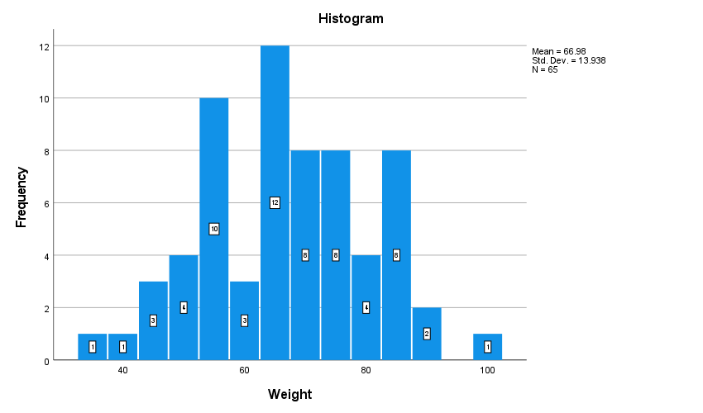
V1 Stem-and-Leaf Plot

Frequency Stem & Leaf
1.00 3 . 5
6.00 4 . 155689
14.00 5 . 02333444556699
19.00 6 . 0333355666777888899
10.00 7 . 1233356777
12.00 8 . 012234555567
3.00 9 . 129

Stem width: 10
Each leaf: 1 case(s)
Box and Whisker Plot
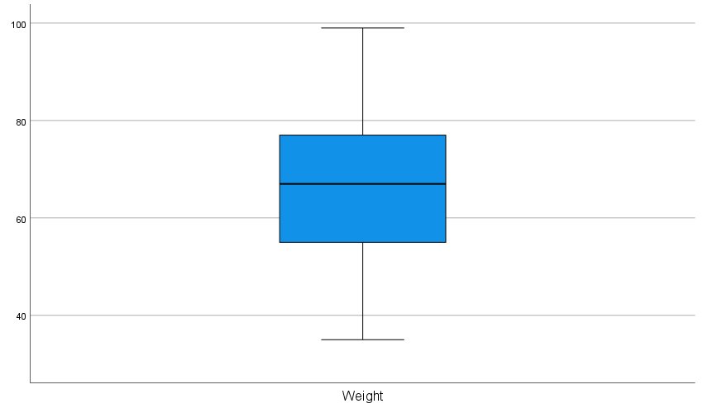
INTERPRETATION:
The frequency distribution is discontinuous.
The value of coefficient of skewness was obtained as 0.018, which is a positive value. Hence the distribution is positively skewed. The value, however, is very minuscule in the range from -1 to 1. Hence the distribution is slightly positively skewed.
The value of kurtosis was obtained as -0.575, which is clearly less than 0.273. Hence the distribution’s curve is platykurtic in nature.
RESULTS:
The mean, median, mode, range, standard deviation, and coefficient of variation were obtained as 66.992, 67, 63, 64, 13.9235, and 20.62. The values of coefficient of kurtosis and skewness were obtained as -0.575 and 0.018.

CONCLUSION:
In this way the mean, median, mode, range, standard deviation, coefficient of skewness and kurtosis and coefficient of variation of the given weight were computed and histogram stem and leaf display and box-and-whisker plot were plotted using MS SPSS and SPSS software.
17
STATEMENT:
EIGHT STUDENTS WERE EVALUATED BY THE TWO TEACHERS ON TWO SEPARATE TESTS AND MARKS OBTAINED BY THESE STUDENTS ARE GIVEN BELOW:
STUDENT | 1 | 2 | 3 | 4 | 5 | 6 | 7 | 8
MARKS IN TEST A | 23 | 39 | 47 | 47 | 55 | 61 | 72 | 85
MARKS IN TEST B | 19 | 25 | 38 | 38 | 30 | 48 | 57 | 70
BY USING APPROPRIATE SOFTWARE, CALCULATE THE SPEARMAN RANK CORRELATION.
WORKING EXPRESSION:
- Spearman’s rank correlation: The Spearman’s Rank Correlation is a measure of relation between any variables in a data set, that is calculated by ranking the observed values. It is denoted by r_{s}, and given by:
$$r=1- \frac{6\sum{d^{2}}}{n\left(n^{2}-1\right)},$$Where d = r₁ - r₂ is the difference between ranks of two consecutive values, and n is the total number of observations.
CALCULATION
The spearman’s rank correlation coefficient is calculated as follows:
- Using SPSS:
Marks in test A | Marks in test B | r₁ | r₂ | d | d²
23 | 19 | 8 | 8 | 0 | 0
39 | 25 | 7 | 7 | 0 | 0
47 | 38 | 5.5 | 4.5 | 1 | 1
47 | 38 | 5.5 | 4.5 | 1 | 1
55 | 30 | 4 | 6 | -2 | 4
61 | 48 | 3 | 3 | 0 | 0
72 | 57 | 2 | 2 | 0 | 0
85 | 70 | 1 | 1 | 0 | 0
 |  |  |  |  | 6
 |  | Spearman's Correlation |  |  | 0.92857

- Using SPSS:
Correlations
 |  |  | Rank of Marks in text A | Rank of Marks in text B
Spearman's rho | Marks in Test A | Correlation Coefficient | 1.000 | .928
 |  | Sig. (2-tailed) | . | .001
 |  | N | 8 | 8
 | Marks in Test B | Correlation Coefficient | .928 | 1.000
 |  | Sig. (2-tailed) | .001 | .
 |  | N | 8 | 8
INTERPRETATION:
A correlation coefficient of 0.9295 represents that the students receive similar marks in both tests. i.e., if student no. 1 received low marks in test A, then they will also receive low marks in test B.
RESULT:
The Spearman’s Rank correlation was calculated as 0.9295.
CONCLUSION:
In this way Spearman’s Rank correlation of the marks of the students in test A and test B was computed using MS SPSS and SPSS software.
18
STATEMENT:
THE AGE OF THE STUDENTS OF THE B.SC. FIRST YEAR PHYSICS OF ST. XAVIER’S COLLEGE IS GIVEN AS:
S.N. | GENDER | AGE(YRS.)
1 | MALE | 20
2 | MALE | 18
3 | FEMALE | 19
4 | MALE | 18
5 | MALE | 19
6 | FEMALE | 19
7 | FEMALE | 20
8 | MALE | 21
9 | MALE | 18
10 | FEMALE | 20
11 | MALE | 21
12 | FEMALE | 20
13 | FEMALE | 18
14 | MALE | 19
15 | MALE | 20
16 | FEMALE | 21
17 | MALE | 18
18 | MALE | 20
19 | FEMALE | 18
20 | FEMALE | 19
21 | MALE | 18
22 | FEMALE | 20
23 | MALE | 19
24 | MALE | 21
25 | FEMALE | 20
26 | MALE | 19
27 | MALE | 18
28 | MALE | 20
29 | FEMALE | 20
30 | FEMALE | 19
BY USING APPROPRITE SOFTWARE
- CONSTRUCT A BAR DIAGRAM OF GENDER AND AGE OF THE STUDENTS.
- FIND RANGE, MAXIMUM, MINIMUM, MEAN, SUM, STANDARD DEVIATION AND VARIANCE OF THE AGE OF THE STUDENTS USING DESCRIPTIVE STATISTICS OF SPSS SOFTWARE.
- CONSTRUCT A DISCREATE FREQUENCY DISTRIBUTION FOR THE AGE OF THE STUDENTS.

WORKING EXPRESSION:
- Bar Diagram: A bar diagram is a visual representation of data using rectangular bars of different lengths, where the height of each bar corresponds to the quantity or frequency of a particular category or value.
- Range: The difference between the maximum value and the minimum value is called range. It is denoted by R and given by:
R = x_{max} - x_{min}
- Frequency: The number of times a value of variable repeats is called frequency. It is denoted by f.
- Frequency Distribution: A tabular display containing the value of variable along with their respective frequencies is called frequency distribution. It is of three types: Individual frequency distribution, discrete frequency distribution, continuous frequency distribution
- Continuous frequency distribution: The frequency distributions where the values of variables are given by certain class interval.
- Minimum Value: The smallest value of the entire dataset is called minimum value. It is denoted by x_{min}.
- Maximum Value: The largest value of the entire dataset is called minimum value. It is denoted by x_{max}.
- Mean: The ratio of sum of all the observations to the total number of observations is called mean. It is denoted by and given by:
$\overline{x}$ = $\frac{\sum_{i=1}^{n}{x_{i} }}{n}$
where, n = number of observations
- Median: The middlemost value of ordered set of data is called median. It is denoted by M_{d} and given by:
M_{d} = ${\left(\frac{n+1}{2}\right)}^{th}value$
where, n = number of observations
- Standard Deviation: The square root of arithmetic mean of square of deviations taken from arithmetic mean is called standard deviation. It is denoted by and given by
$σ=\sqrt{\frac{\sum{(x-\overline{x})^{2}}}{n}}$
$σ=\sqrt{\frac{\sum{x^{2}}}{n}-{\left(\frac{\sum{x}}{n}\right)}^{2}}$
where, n = number of observations.
- Total Sum: The value obtained by adding all the observations is called total sum.
- Variance: The arithmetic mean of square of deviations taken from arithmetic mean is called variance. It is denoted by ².
$σ^{2}=\frac{\sum{(x-\overline{x})^{2}}}{n}$
$σ^{2}=\frac{\sum{x^{2}}}{n}-{\left(\frac{\sum{x}}{n}\right)}^{2}$
where, n = number of observations.
CALCULATION:
  - A clustered bar diagram showing gender wise age of students is drawn as follows:
    - Using SPSS

    - Using SPSS:
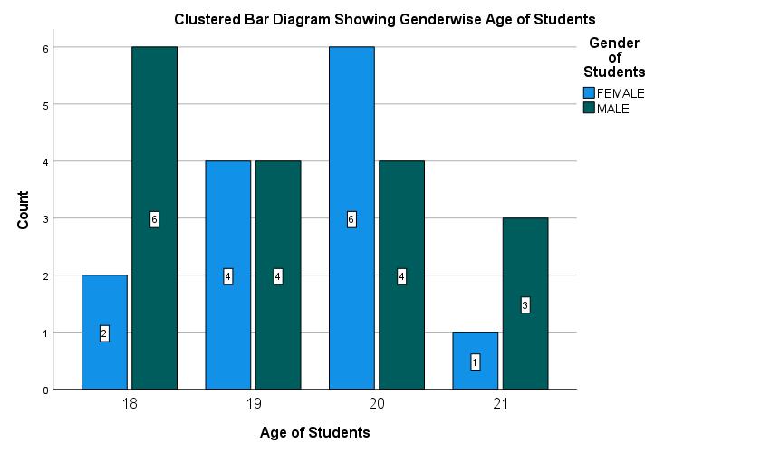
  - The range, maximum, minimum, mean, sum, standard deviation and variance of the age of the students are computed using descriptive statistics of SPSS software as follows.
Age of Students
N | Valid | 30
 | Missing | 0
Mean |  | 19.33
Median |  | 19.00
Std. Deviation |  | 1.028
Variance |  | 1.057
Range |  | 3
Minimum |  | 18
Maximum |  | 21
Sum |  | 580
  - Discreate frequency distribution for the age of the students is computed as follows:
    - Using SPSS:
Count | FEMALE | MALE
18 | 2 | 6
19 | 4 | 4
20 | 6 | 4
21 | 1 | 3
Grand Total | 13 | 17

    - Using SPSS
 |  | Gender of Students |  | Total
 |  | FEMALE | MALE
Age of Students | 18 | 2 | 6 | 8
 | 19 | 4 | 4 | 8
 | 20 | 6 | 4 | 10
 | 21 | 1 | 3 | 4
Total |  | 13 | 17 | 30

We can clearly observe that the minimum age of the students is 18 and the maximum value is 21. The average age of the students is 19.33 while most of the students are aged 20.
The standard deviation for the data set was obtained as 1.028. This means that most of the students are around 19-year-old. The clustering of the data around the mean value also implies that most of the students are on the same uniform level.

RESULT:
The minimum value, maximum value, range, mean, median, standard deviation, variance and total sum of the given marks are 18, 21, 3, 19.33, 19.00, 1.028, 1.057 and 580 respectively.

CONCLUSION:
In this way the gender wise bar diagram of age, discrete frequency distribution for the age of the student was constructed and the minimum value, maximum value, range, mean, median, standard deviation, variance and total sum of the given marks were computed using SPSS software.
19
STATEMENT:
THE FOLLOWING TABLE GIVES THE INFORTMATION ABOUT THE MARKS OBTAINED MARKS OBTAINED BY 10 STUDENTS IN MATHS AND STATISTICS.
MARKS IN MATHS | 25 | 28 | 35 | 32 | 31 | 36 | 29 | 38 | 34 | 32
MARKS IN STATISTICS | 43 | 46 | 49 | 41 | 36 | 32 | 31 | 30 | 33 | 39
BY USING APPROPRIATE SOFTWARE,
- PREDICT THE MOST LIKELY MARKS IN THE STATISTICS WHEN MARKS IN MATHS IS 30.
- THE COEFFICIENT OF CORRELATION BETWEEN THE MARKS IN MATHS AND STATISTICS.
- FIND THE COEFFICIENT OF DETERMINATION AND INTERPRETE THE RESULT
WORKING EXPRESSION:
- Regression analysis: Regression analysis is a statistical method that allows us to examine the relationship between two or more variables and predict the value of one based off the other. This deals with the influence of an independent variable on a dependent variable. The regression equation that we use for a dependent variable Y and an independent variable X, also called the regression equation of Y on X is:
$$Y=a+b.X$$
where, Y: Dependent variable
X: Independent variable
a: Y-intercept (y at x = 0)
b: coefficient of regression or regression coefficient
- Coefficient of correlation (r): The coefficient correlation ‘r’ is the measure of the relationship between two or more variables. It ranges from -1 to 1.
The Karl Pearson’s correlation coefficient is given by:
$$r= \frac{\sum{(X-\overline{X})(Y-\overline{Y})}}{\sqrt{\sum{{\left(X-\overline{X}\right)}^{2} \sum{{(Y-\overline{Y})}^{2}}}}}$$
This is also called the product moment formula.
- Coefficient of determination: The coefficient of determination is the proportion of the variance in the dependent variable that is explained by the independent variable(s) in a regression model. It is denoted by ‘R²’ and given by:
R² = $\frac{SSR}{TSS}= \frac{TSS-SSE}{TSS}=1- \frac{SSE}{TSS}$ , where
SSR = Sum of square due to regression or Explained variation
SSE = Sum of square due to error or Unexplained variation
TSS = Total sum of square or Total variation
CALCULATION:
- To predict the most likely marks in the statistics when marks in maths is 30, the regression equation is computed as follows:
  - Using SPSS:
LINEST
Slope | Y-intercept
-0.6642857 | 59.2571429
  - Using SPSS:
 | Unstandardized Coefficients
 | B
(Constant) | 59.257
MARKS IN MATHS | -.664

Hence if the mark in math is 30, then the marks in statistics would approximately be:
𝑦 = −0.664 × 30 + 59.248
𝑦 = 39.328
- The coefficient of correlation between the marks in maths and statistics is computed as follows:
  - Using SPSS:
Regression Statistics
Multiple R | 0.39398292
  - Using SPSS:
R
.394ª
- The coefficient of determination is computed as follows:
  - Using SPSS:
Regression Statistics
R Square | 0.155222541
  - Using SPSS:
R Square
.155
INTERPRETATION:
The slope of the linear regression equation -0.6642857 indicates that there is a negative linear relationship between the two data sets. For every unit increase in the independent variable (X), the dependent variable (Y) decreases by approximately 0.6642857 units.
The y-intercept of the linear regression equation 59.2571429 represents the value of the dependent variable (Y) when the independent variable (X) is zero. In this case, it suggests that when X is zero, Y is expected to be around 59.2571429.
The correlation coefficient of 0.39398292 indicates a weak positive linear relationship between the two data sets. This value ranges between -1 and 1, with 1 representing a perfect positive correlation, 0 representing no correlation, and -1 representing a perfect negative correlation. Therefore, a value of 0.39398292 suggests a weak positive relationship between the two variables.
The coefficient of determination, also known as R-squared, is a measure of how well the regression line fits the data. In this case, the coefficient of determination of 0.155222541 indicates that approximately 15.5% of the variation in the dependent variable (Y) can be explained by the independent variable (X). The remaining 84.5% of the variation is unaccounted for and may be attributed to other factors or random variation.
RESULT
The regression equation, marks of statistics when marks of maths is 30, correlation coefficient and the coefficient of determination was obtained as y = −0.664 × x+ 59.248, 39.328, 0.39398292 and 0.155222541 respectively.
CONCLUSION:
In this way the regression equation, correlation coefficient and the coefficient of determination was computed using MS SPSS and SPSS software.

20
STATEMENT:
FROM A POPULATION OF MARRIED COUPLES, A SAMPLE OF 12 COUPLE IS TAKEN. THE PAIRS OF AGES FOR THE SAMPLE OF MARRIED COUPLE ARE GIVEN BELOW.
HUSBAND’S AGE (YEARS) | 30 | 29 | 36 | 72 | 37 | 36 | 51 | 48 | 37 | 50 | 51 | 36
WIFE’S AGE  (YEARS) | 27 | 20 | 34 | 67 | 35 | 37 | 50 | 46 | 36 | 42 | 46 | 35
BY USING THE APPROPRIATE SOFTWARE,
- CONSTRUCT A SCATTER DIAGRAM OF AGES FOR THE SAMPLE OF MARRIED COUPLE.
- COMPUTE THE CORRELATION COEFFICIENT AND INTERPRETE THE RESULT.
WORKING EXPRESSION
- Scatter diagram: A scatter diagram, also known as a scatter plot, is a type of data visualization tool used in statistics to display the relationship between two variables. It shows the individual data points as a set of coordinates on a two-dimensional graph. In a scatter diagram, the two variables being studied are represented by the x-axis and y-axis. Each data point in the set is plotted as a point on the graph, with its x and y values corresponding to the values of the two variables being studied. The resulting pattern of points can reveal the nature and strength of the relationship between the two variables.
- Correlation coefficient (and interpretation): The correlation coefficient is a statistical measure that indicates the strength and direction of the linear relationship between two variables. It is denoted by the symbol "r" and ranges from -1 to +1. A correlation coefficient of +1 indicates a perfect positive correlation, which means that as one variable increases, the other variable increases in a perfectly linear manner. A correlation coefficient of -1 indicates a perfect negative correlation, which means that as one variable increases, the other variable decreases in a perfectly linear manner. A correlation coefficient of 0 indicates no linear correlation between the two variables.
CALCULATION
The scatter diagram, correlation coefficient is obtained as follows:
- Using SPSS:

Correlation Coefficient | 0.969031
- Using SPSS:
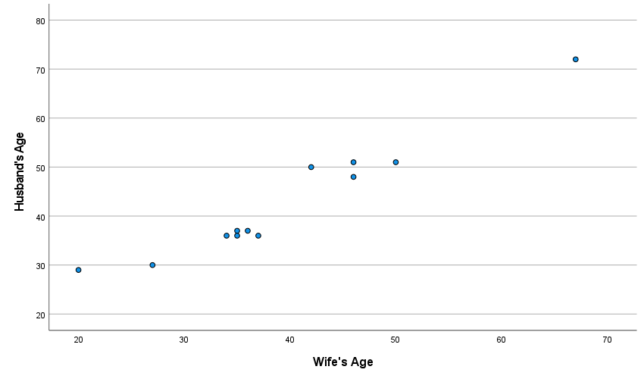

Correlations
 |  | Wife's Age | Husband's Age
Wife's Age | Pearson Correlation | 1 | .969
 | Sig. (2-tailed) |  | .000
 | N | 12 | 12
Husband's Age | Pearson Correlation | .969 | 1
 | Sig. (2-tailed) | .000
 | N | 12 | 12

INTERPRETATION
We obtained the values of correlation coefficient as 0.969 between Husband’s age and Wife’s age translates to a very strong positive correlation between the two variables. This means that the values of the variables are linearly proportional to each other.
We can clearly observe that in the scatter plot as well. As we move along the X-axis or the Wife’s age there is a linear increase in the value in Y-axis or the Husband’s age as well.
Hence, we can conclude that people tend to marry partners of similar age.
RESULT
The correlation coefficient between the variables was obtained as 0.969 which is a very high degree of positive correlation.
CONCLUSION: In this way the scatter diagram of ages for the sample of married couple was plotted and the correlation coefficient was computed using MS SPSS and SPSS software.

