**Microsoft Dynamics 365 for Finance & Operations  
Functional Design Document – Quotation**

Revision History

|  |  |  |  |
| --- | --- | --- | --- |
| Version | Date | Initials | Description of Changes Made |
| 1.0 | 5/16 | MV | Initial Draft |
| 1.1 | 5/18 | JF | Approved and Signed Off |
|  |  |  |  |

|  |  |
| --- | --- |
| Enhancement: |  |
| Business Area/  AX module | Procurement |
| Project Phase: | D365 Implementation |
| Version/SP/Add-ons: |  |
| Consultant: |  |
| Lead Dev.: |  |
| Development layer |  |
| Modification Type | Enhancement  Report  Interface  Conversion |

Functional Design Document – **Quotation**

# Purpose of functionality and business need

The document represents Quotation report with all the requirements for the specific entity 3PL.

# Proposed Solution

# Assumptions

# Detailed Design

1. **Desired view of the report**:

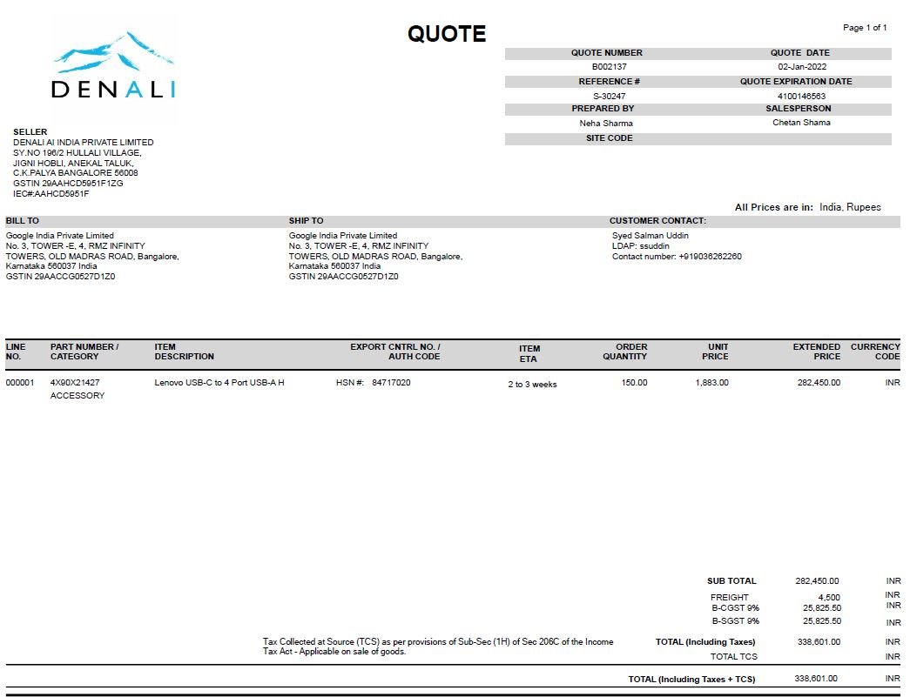Path: Sales and Marketing -> Sales quotations -> All Quotations

1. **Field description and sources**

**Example used to describe the example is located in Config environment, 3PL-000001**

|  |  |  |  |  |
| --- | --- | --- | --- | --- |
| **Section** | **Field Name** | **Example** | **Source** | **FO365 Field Name** |
| Header | Quote Number | 3PL-000001 | SalesQuotationTable_QuotationID | Quotation |
| Header | Quote Date | 3/6/2022 05:15:47 PM | SalesQuotationTable_Quotation_createdDateTime | Created date and time |
| Header | Reference | SO-000004 | SalesQuotationTable_SalesID | Sales order |
| Header | Quote Expiration Date | 4/5/2022 | SalesQuotationTable_QuotationStatus_QuotationExpiryDate | Expiration date |
| Header | Prepared By |  | SalesQuotationTable_Administration_Worker_salesTaker_DirPerson_FK_Name | Sales taker |
| Header | SALES PERSON |  | SalesQuotationTable_editContactPersonName2 | Contact |
| Header | SELLER | E-34 JANGPURA EXTENSION  Delhi - 110014  Delhi  IND | Legal entities -> Address Entity |  |
| Header | Bill To | AMAZON DEVELOPMENT CENTRE INDIA PVT LTD | SalesQuotationTable_HeaderDelivetAddress_DeliveryName |  |
| Header | Ship To | Divyasree Holdings Pvt Ltd 1st Floor, Plot no.6, Hi-Tech City.  500081  Hyderabad -  Telangana  IND | SalesQuotationTable_Logistics_PostalAddress-Address |  |
| Header | Customer Contact |  | SalesQuotationTable_editContactPersonName2 | Contact |
| Header | All Prices are in | INR | SalesQuotationTable_Curency_CurrencyCode | Currency |
| Lines | Line No: |  | SalesQuotationTable_SalesQuotationLine_LineNumber | Line Number |
| Lines | PART NUMBER /CATEGORY | 01EN019 | SalesQuotationTable_SalesQuotationLine_ItemID | Item |
| Lines | ITEM  DESCRIPTION | Lenovo ORG Lcd Panel L490 Thin | SalesQuotationTable_ ItemName | Product Name |
| Lines | EXPORT CNTRL NO. /  AUTH CODE | Not Standard Field | 3PL (Indian related field) TBD |  |
| Lines | ITEM  ETA | 3/18/2022 | SalesQuotationTable_ DeliveryReciptDateRequested | Requested receipt date |
| Lines | ORDER  QUANTITY | 20 | SalesQuotationTable_SalesQuotationLine_SalesQty | Quantity |
| Lines | UNIT  PRICE | 50000 | SalesQuotationTable_SalesQuotationLine_SalesPrice | Unit Price |
| Lines | EXTENDED  PRICE | Not Standard Field | SalesQuotationTable_ SalesQuotationLine_LineAmount | Net Amount |
| Lines | Currency  Code | INR | SalesQuotationTable_Curency_CurrencyCode | Currency |
| Footer | Sub Total |  | CustQuotationConfirmationJournal_QuotationSalesAmount | Sales amount |
| Footer | Freight |  | SalesQuotationTable_SalesQuotationLine_DlvMode | Mode of delivery |
| Footer | B-CGST 9% | Not Standard Field | 3PL (Indian related field) TBD |  |
| Footer | B-SGST 9% | Not Standard Field | 3PL (Indian related field) TBD |  |
| Footer | TOTAL (Including Taxes) | 1,000,000 | CustQuotationConfirmationJournal_QuotationTotalAmount | Total amount |
| Footer | TOTAL TCS | Not Standard Field | 3PL (Indian related field) TBD |  |
| Footer | TOTAL (Including Taxes + TCS) | Not Standard Field |  |  |

# Risks/Considerations

N/A

# Test Scenarios

Additional cases can be added by the client during FDD review.

|  |  |  |  |
| --- | --- | --- | --- |
| **Scenario** | **Steps** | **Test Data** | **Expected Outcome** |
|  |  |  |  |
|  |  |  |  |
|  |  |  |  |