**Class:** Final Year (Computer Science and Engineering)

**Year:** 2023-24 **Semester:** 1

**Course:** High Performance Computing Lab

**Practical No. 3**

**Exam Seat No: 2020BTECS00085**

**Title of practical: Study and implementation of basic OpenMP clauses**

**Q1. Differentiate between Software and Hardware Threads**

**Hardware Thread:**

Hardware threads, also known as hardware-level threads or physical threads, are managed by the computer's central processing unit (CPU). They are actual physical or logical cores on the CPU chip. Hardware threads are closely tied to the hardware architecture and are limited by the number of physical or logical cores available.

So, a 4 core CPU can genuinely support 4 hardware threads at once - the CPU really is doing 4 things at the same time. One hardware thread can run many software threads. In

modern operating systems, this is often done by time-slicing - each thread gets a

few milliseconds to execute before the OS schedules another thread to run on

that CPU. Since the OS switches back and forth between the threads quickly, it

appears as if one CPU is doing more than one thing at once, but in reality, a core

is still running only one hardware thread, which switches between many software

Threads.

**Software Thread:**

Software threads, also known as user-level threads or lightweight threads, are managed entirely by the operating system. They are created and controlled by software libraries or applications and don't require direct support from the hardware. Software threads are independent of hardware architecture and can be used on any computer system with a compatible operating system. Software threads are abstractions to the hardware to make

multi-processing possible. If you have multiple software threads but there are not

multiple resources then these software threads are a way to run all tasks in

parallel by allocating resources for limited time(or using some other strategy) so

that it appears that all threads are running in parallel. These are managed by the

operating system.

**Q2. Which type of threads are supported by the processor?**

Generally the Hardware Threads are supported by the processor. The

hardware threads are mostly based on the muti-core architecture which is latest

architecture to achieve high performance.

A multi-threaded application running on a traditional single-core chip

would have to interleave the threads. On a multi-corechip, however, the threads could be spread across the available cores, allowing

true parallel processing.

**Problem Statement:**

**Program to print Hello World!**

Source Code:

#include<stdio.h>

#include<omp.h>

void PrintMes(){

    int temp = omp_get_thread_num();

    printf("Hellow World by thread no %d \n", temp);

}

int main(){

    // call omp for creating threads

    #pragma omp parallel num_threads(10)

    PrintMes();

    return 0;

}

**Output:**

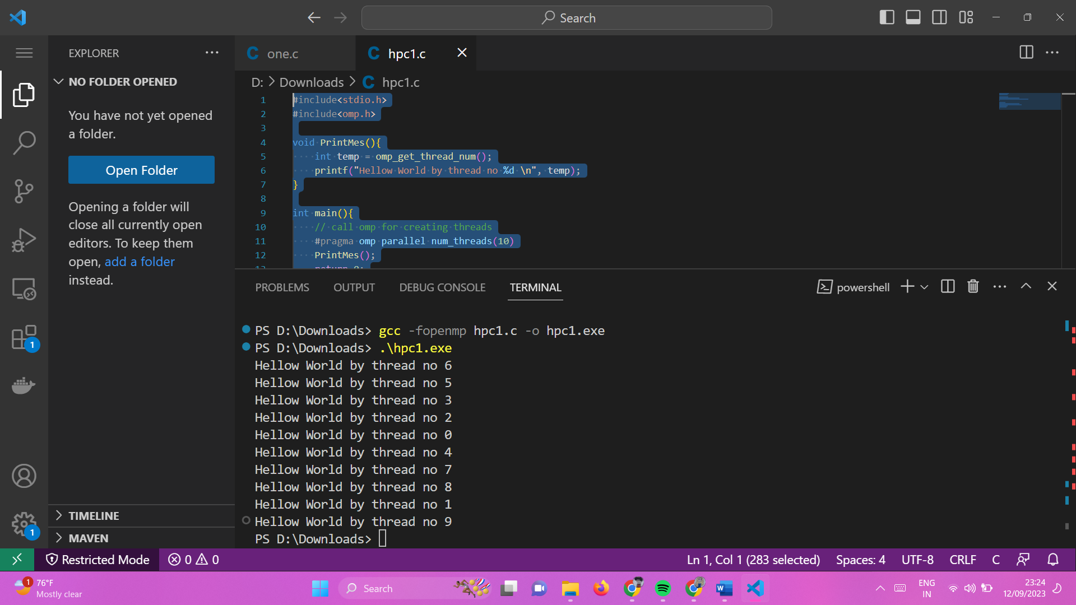

**Information:**

This is a simple example of using OpenMP (Open Multi-Processing) to create a parallel section of code that will be executed by multiple threads. OpenMP is a popular API for parallel programming in C and C++ that allows you to take advantage of multiple CPU cores to perform parallel computations.

Here's some information about the code:

* “#include<omp.h>”: This line includes the OpenMP header file, which provides the necessary functions and directives for parallel programming.
* “#pragma omp parallel num_threads(10)”: This line begins a parallel section of code using OpenMP. It specifies that we want to create a parallel region with 10 threads. Each thread will execute the code within the parallel region concurrently.
* “temp = omp_get_thread_num()”: “omp_get_thread_num()” is an OpenMP function that retrieves the unique ID of the calling thread. It assigns this ID to the”temp” variable.
* “printf("Hello World! by thread no \n", temp)”: This line uses “printf” to print a message indicating the thread number (“temp”). Each thread will print its own thread number, allowing you to see which thread is executing which part of the code.
* When we run this program, we'll observe that the "Hello World!" message is printed multiple times, with each message indicating the thread number. The number of times the message is printed depends on the number of threads specified in the “num_threads()” clause of the “#pragma omp parallel directive (in this case, 10 times). Each thread executes the “PrintMes” function concurrently, making it a simple parallel program.

**Analysis:**

The code demonstrates the use of OpenMP for parallel programming in C. Here's a short analysis of the code:

* The code utilizes OpenMP directives to create a parallel region with 10 threads.
* Within the parallel region, the `PrintMes()` function is called by each thread.
* The `PrintMes()` function retrieves and prints the thread's unique identifier.
* As a result, the "Hello World!" message is printed multiple times, each time indicating the thread number.
* This code serves as a basic example of parallelism, allowing multiple threads to execute the same function concurrently. It highlights the simplicity of using OpenMP to parallelize code in C.

**Github Link:** [**https://github.com/manjiri-chandure/HPC**](https://github.com/manjiri-chandure/HPC)