

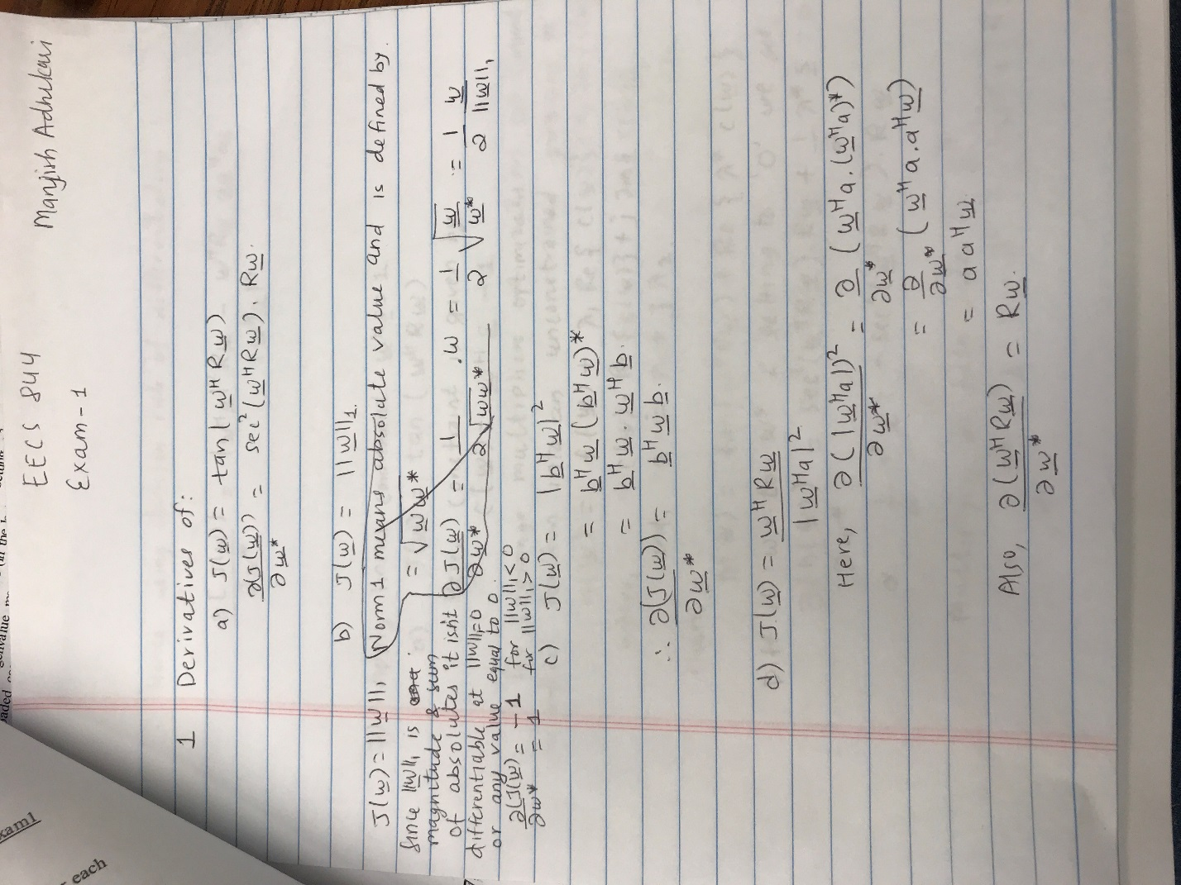

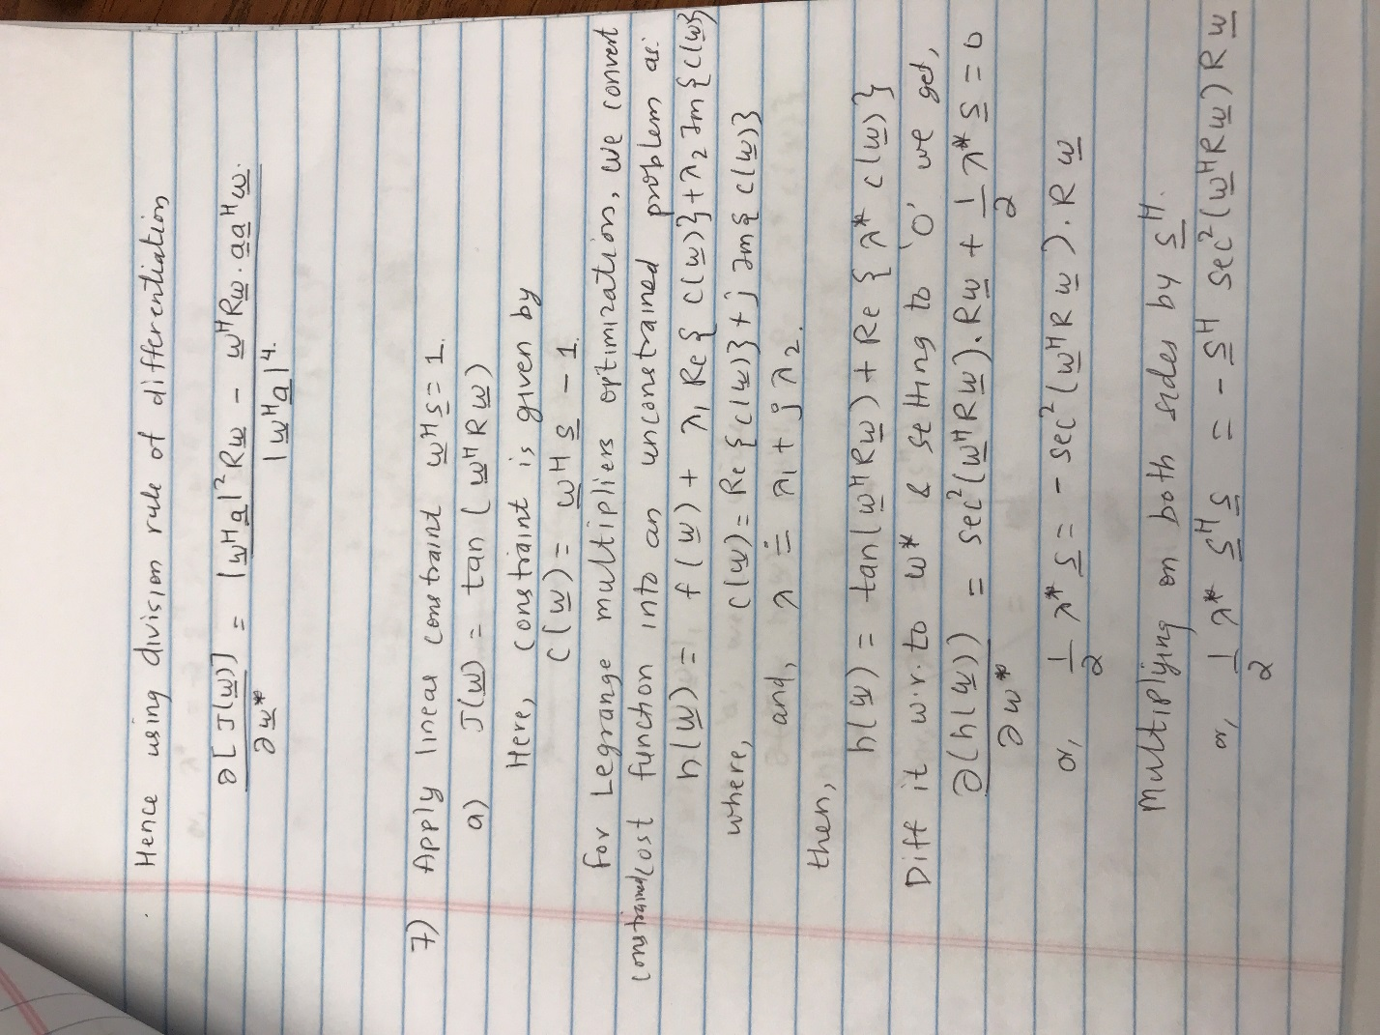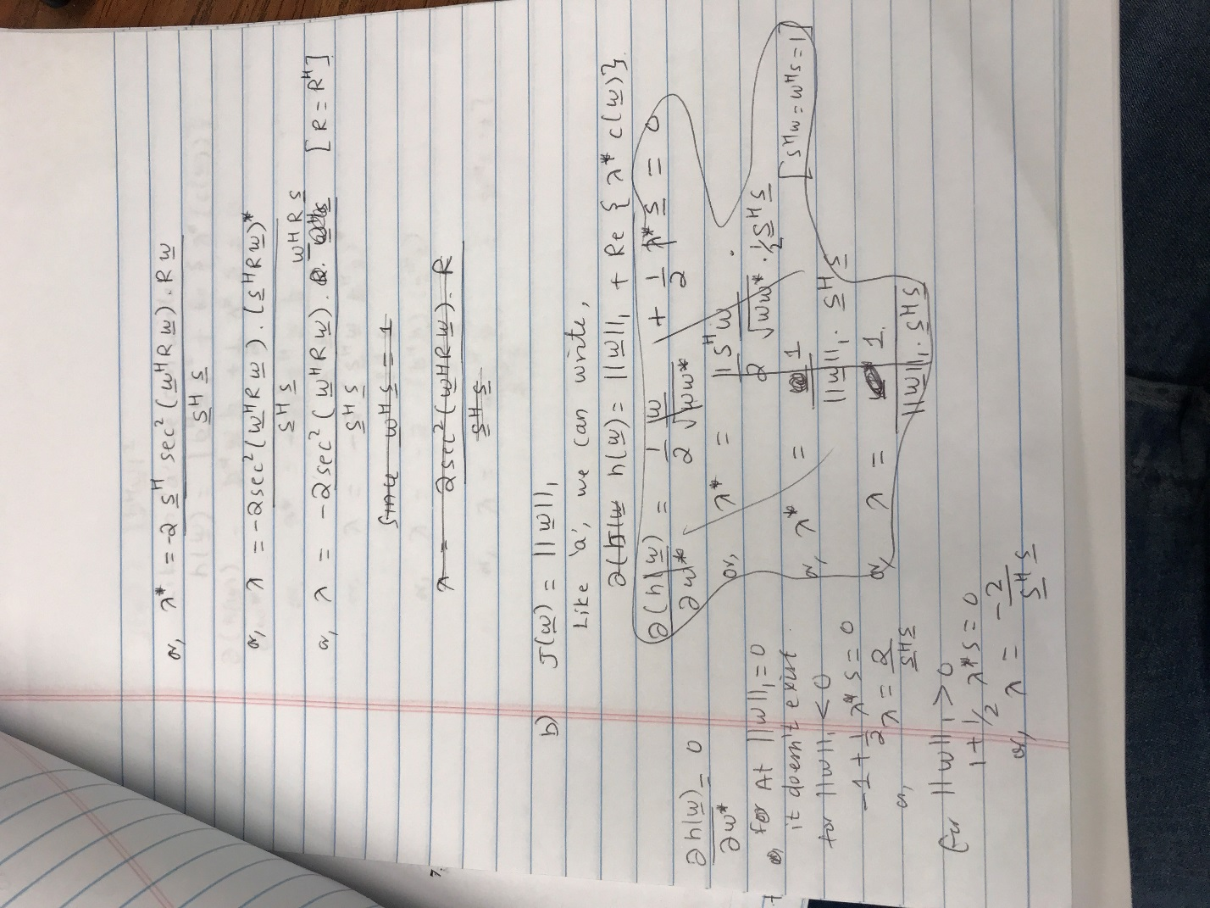

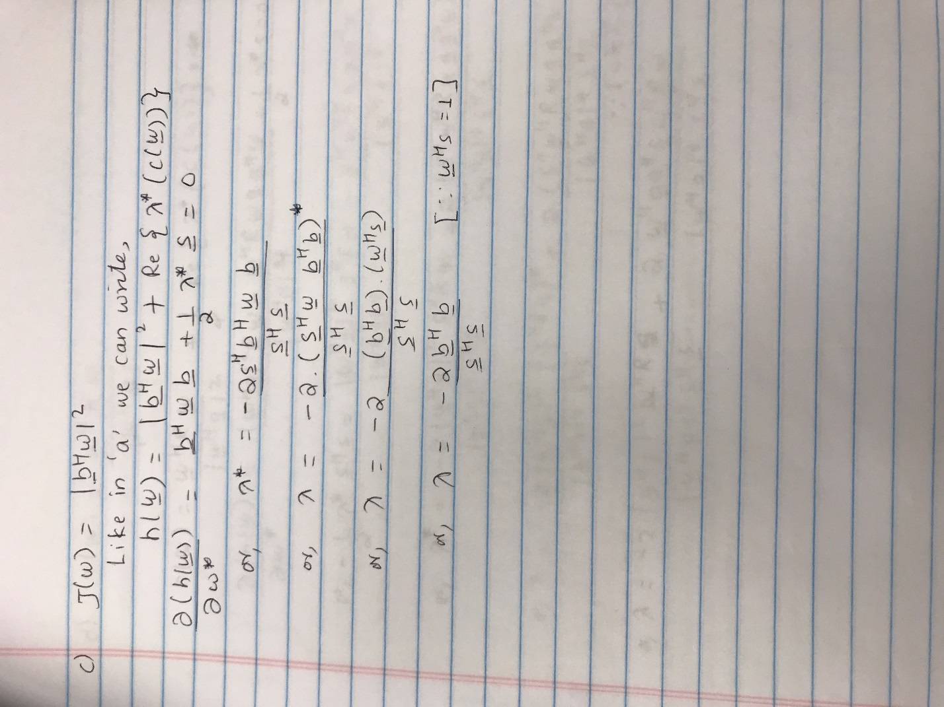

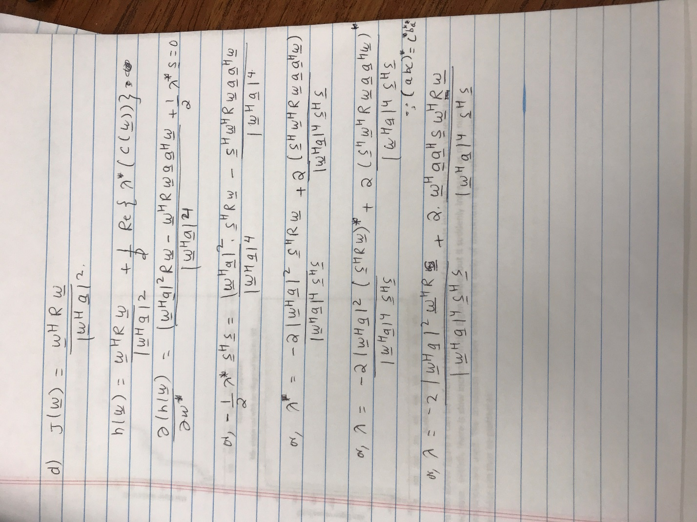

Q2. The time series matrix ‘**X**’ was formed and correlation matrix **R** was calculated. The Eigen values calculated for each snapshot can be shown by figures below.

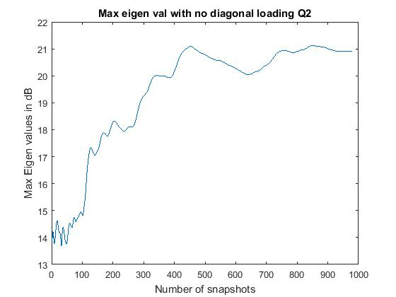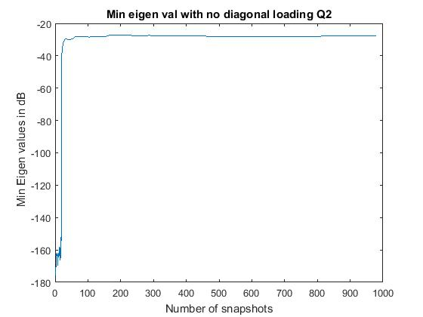

From the above figure it can be inferred that as the number of snapshots increase, the Eigen values start to increase. Initially there is slow increase in the Eigen values but it suddenly increases as more number of snapshots are used. The condition number which is the ratio of maximum Eigen value to minimum Eigen value can thus be plotted as:

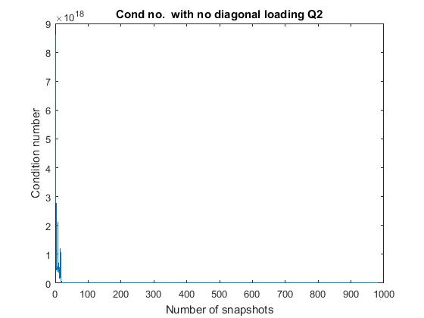

From the above figure it can be inferred that with the increase in snapshots the condition number decreases. So initially the correlation matrix has large condition number (i.e. is ill conditioned) and is prone to more errors when inverse is calculated. As snapshots increase, the condition number becomes smaller and there is less error in calculation of the inverse of the matrix. Thus the correlation matrix becomes more and more invertible. So more number of observations yield better results.

Q.3 With diagonal loading for different values of variance, the plot can be shown as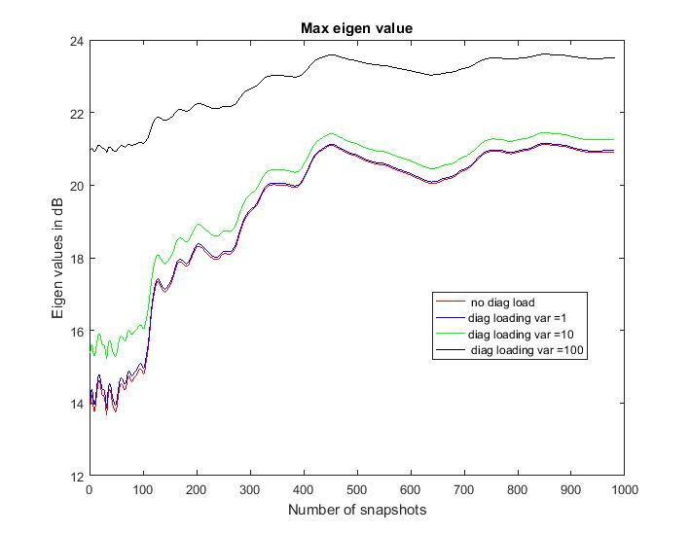

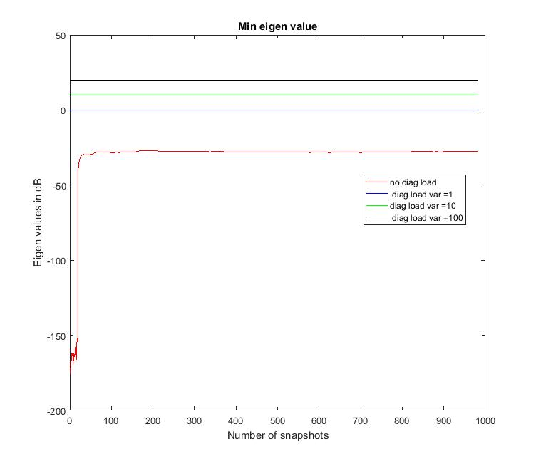

Compared to the previous case with no diagonal loading, the Eigen values have increased with the increase in the loading factor. There is increase in both the maximum and minimum eigenvalues.

Similarly, the condition number can be plotted as:

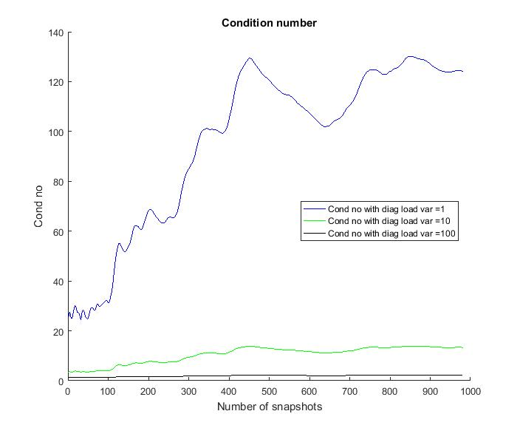

It is clear that with increase in diagonal loading, the condition number goes on decreasing i.e. better conditioned hence the inverse of the correlation matrix becomes more accurate.

But on the other hand in case of diagonal loading, the increase in number of snapshots also increases the condition number i.e. matrix becomes more and more ill conditioned hence inverse becomes prone to more error.

Hence higher loading factor betters the condition number for same number of snapshots but degrades with increasing number of snapshots for constant loading factor. So less snapshots with higher loading factor yields better matrix inverse.

Q.4 For constant number of observations (n=N) the Eigen values for different conditions can be plotted as

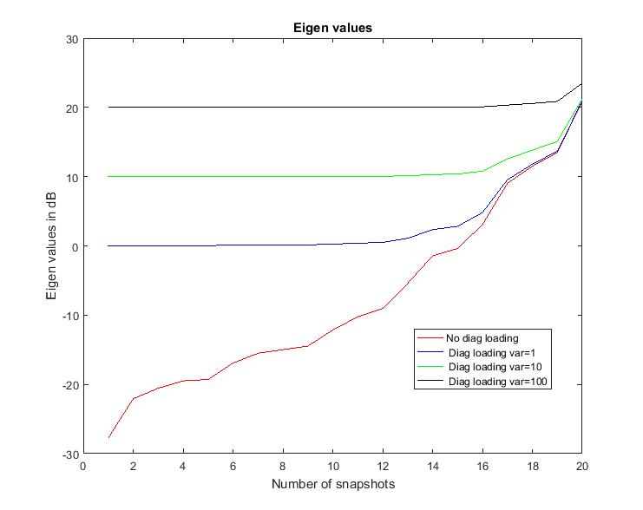

It can be clearly seen from the figure that with the increase in the diagonal loading factor there is increase in the Eigen values. The minimum Eigen values increases very fast but maximum Eigen value increases slowly thus the condition number gets better with increased loading factor. This means the inverse of the correlation matrix calculated will have less error with increased loading.

Q. 5. For the spatial data the correlation matrix **R** (15*15) is calculated which is Toeplitz and the Eigen values were calculated which is plotted as:

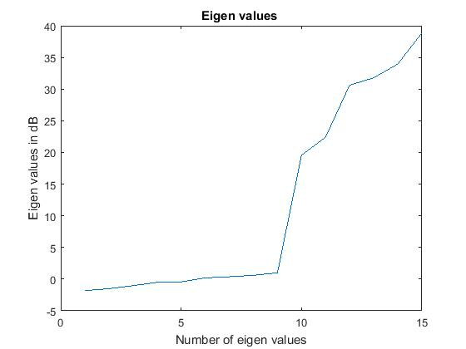

The Eigen values increase as we move farther from the reference antenna. Hence the data collected from the farther array element starts to become more and more uncorrelated. With the increase in antenna elements the condition number also starts to grow larger and hence the correlation matrix becomes more ill conditioned and inverse of correlation matrix more prone to errors.

Q. 6 The beam pattern for the adaptive and non-adaptive cases can be plotted as:

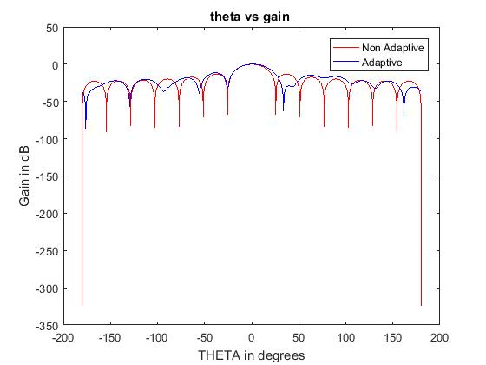

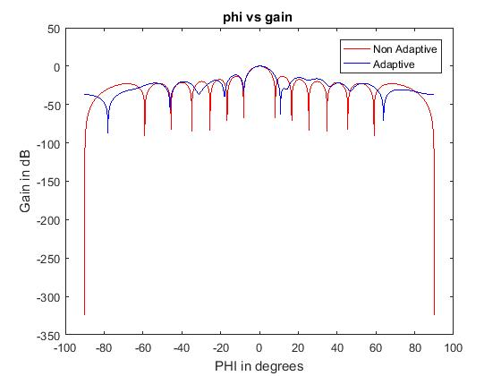

From the results we can see that the non-adaptive filter coefficients generate a sinc shaped beam with sidelobes. So if filter is applied to the direction of arrival of signal, it also generates sidelobes i.e. some energy from other non-desired directions will pass through. It is desired that the sidelobes are suppressed so that it won’t corrupt the desired signal.

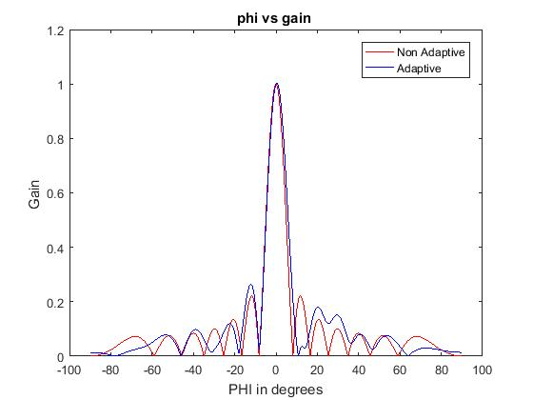

The adaptive filter has better sidelobes suppression compared to the non-adaptive filter but it can be seen that the main beam is wider compared to the non-adaptive form so this affects the spatial resolution which is degraded in adaptive filtering.

Since spatial angle (phi) and electrical angle(theta) are related by we can see similar beam pattern but the beam is narrow for the spatial angle as small spatial angle translates into larger electrical angle.