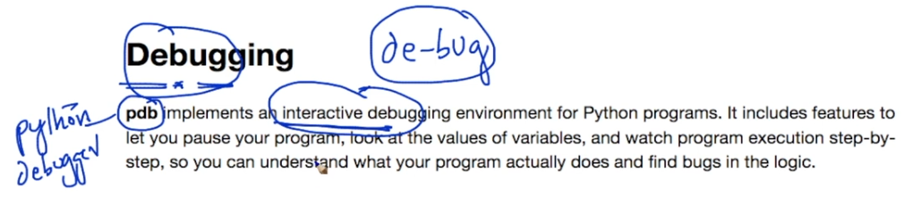

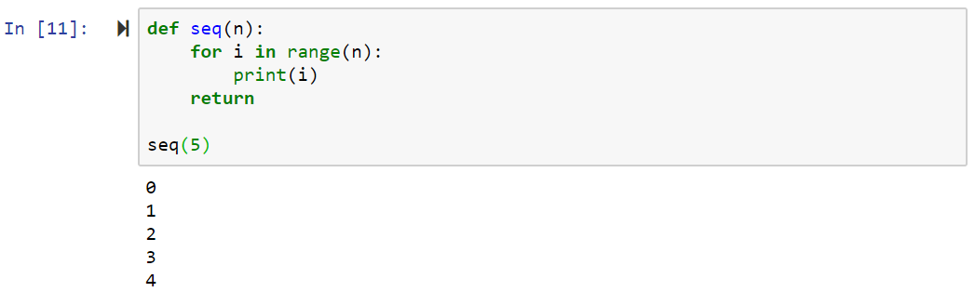

Apply Stop OR BreakPoint at print(i)

I want to see step by step

Need to declare

List 🡪 means where actual debug going on

To print I value

P i

To Print n value

P n

To print all local variables

P locals()

To continue

C

To print next all local variables

P locals()

When We declare (help) ::we find all debug help

h

To quit Debug

q

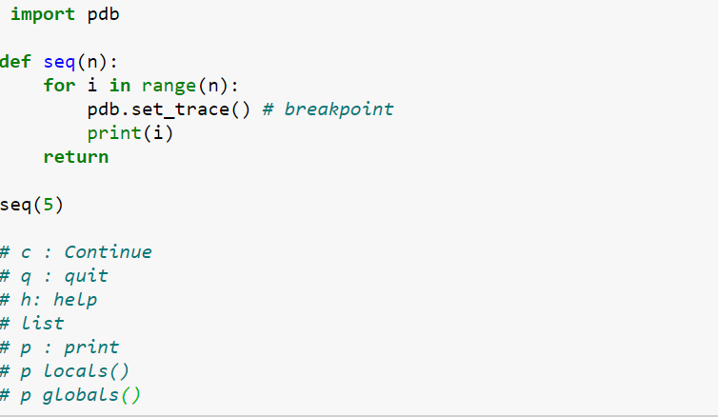

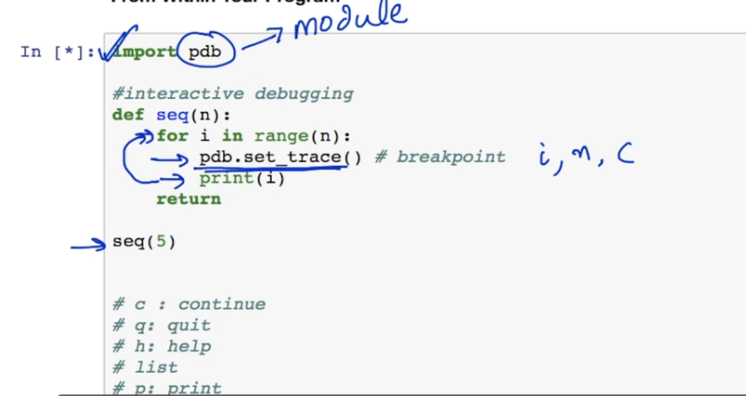

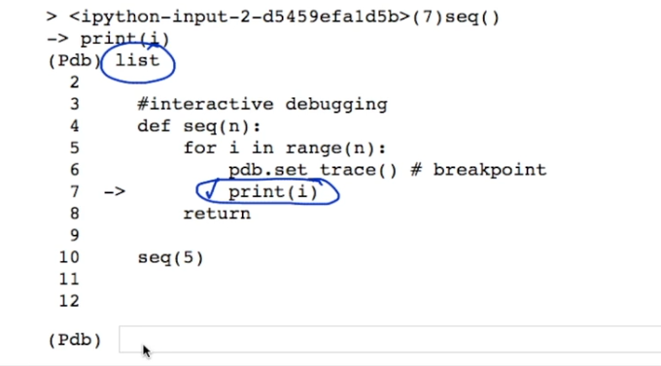

**Train**

**Model**

**ModelFit**

**Accuracy Testing**

**Deployment**

**What is ML?**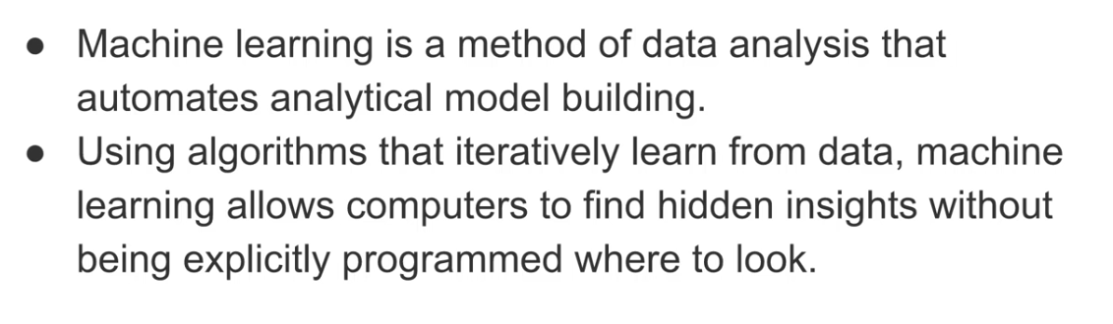

Where ML Used ?

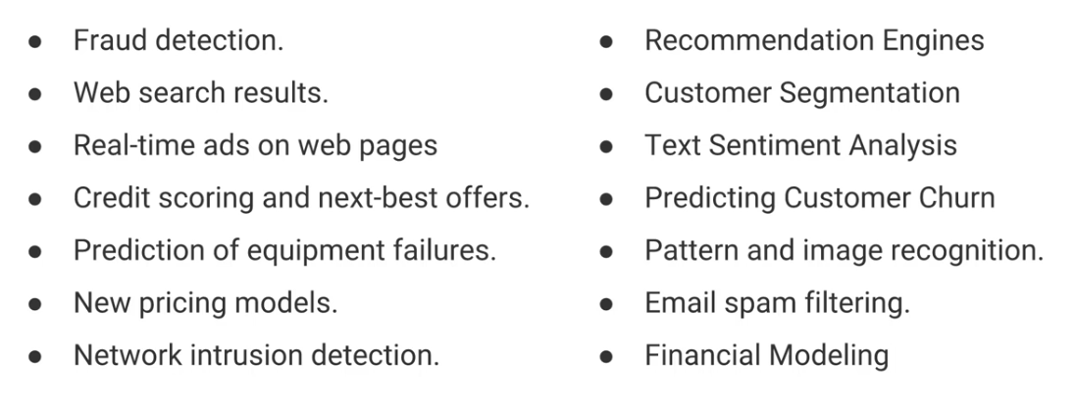

**Introdution To Machine Learning**

**ML is an approach, to train mathematical models.**

**We Deploy Knowledge acquired by model..**

**We don’t deploy models into application …**

**Knowledge Acquired by the model from Data Is called AS ::model fit:::**

**What Model Learns :::**

**Patterns from Data towards target classifier /target value**

**Once ModelFit produced, that has to be tested :::**

**Accuracy test == 97*100/100 = 97%**

**Once Model-Fit deployed into application will become smart application…**

**Difference Between Instruction Based Applition And Smart Application:::**

**Smart Application Intelligent based and Normal Application instruction based**

**Smart Application Ex::**

