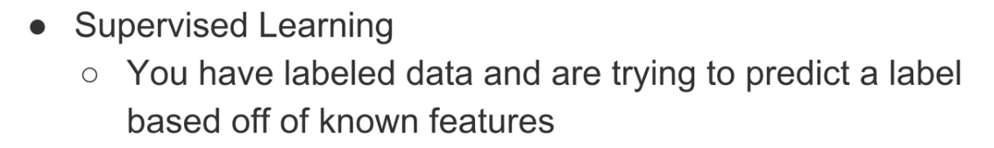

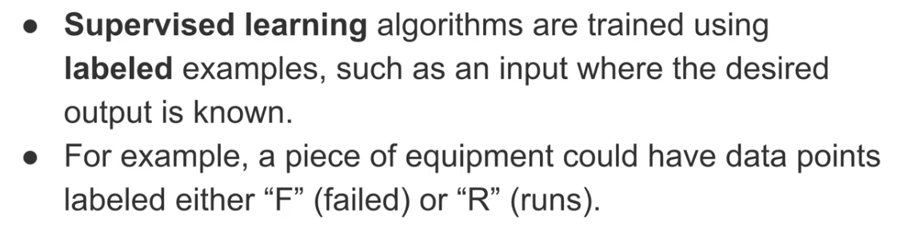

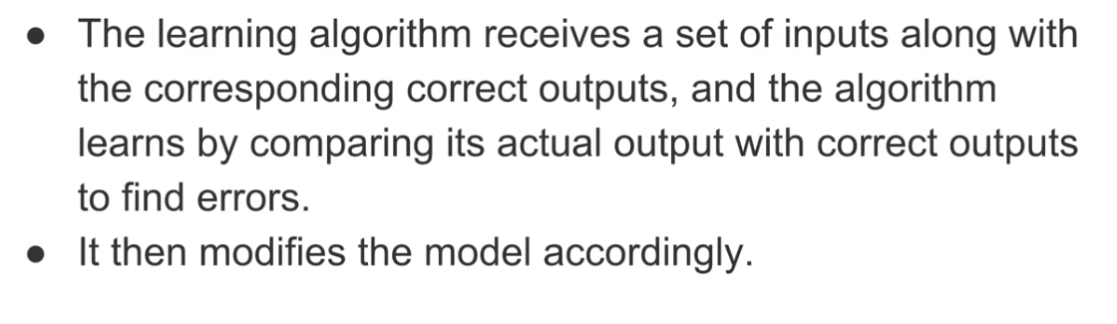

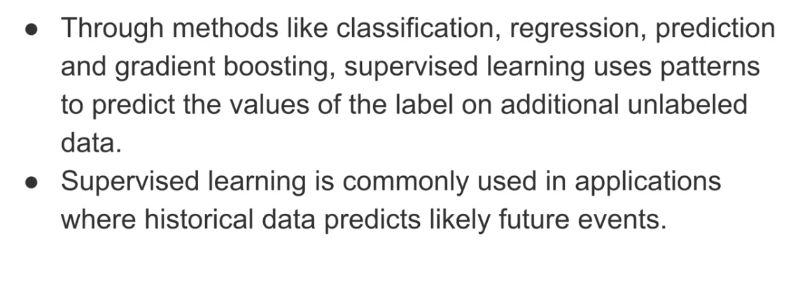

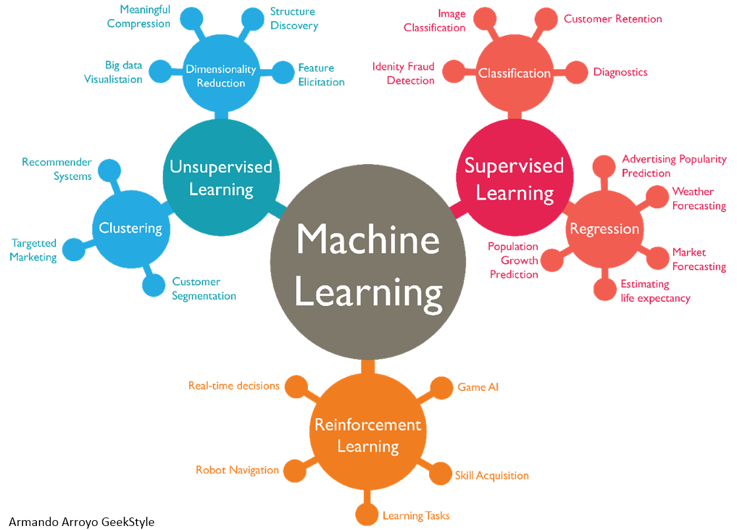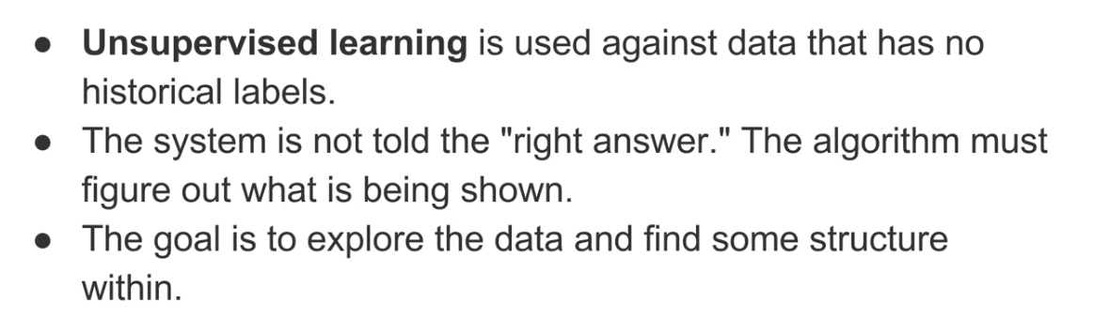

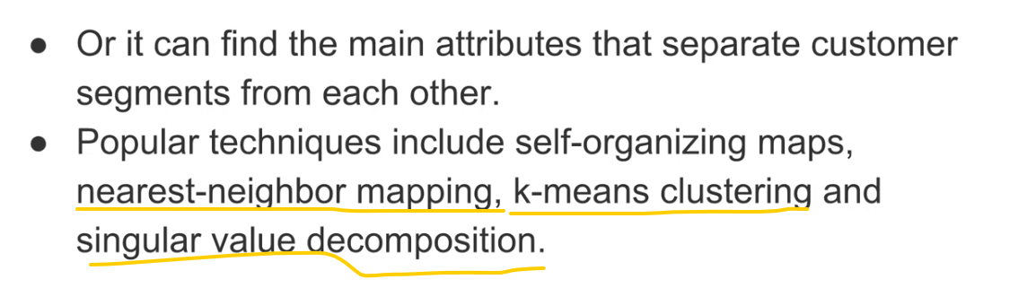

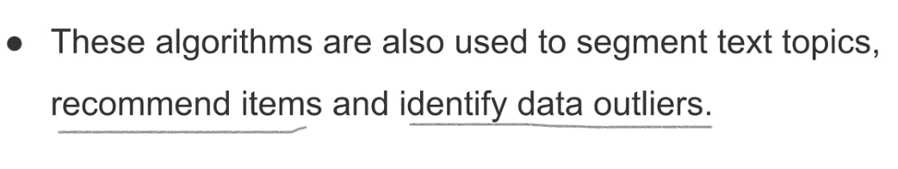

Reinforcement Learning:::

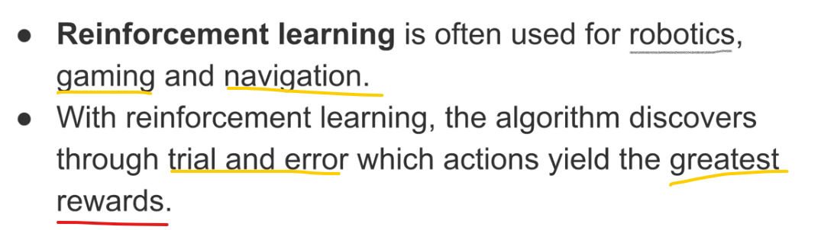

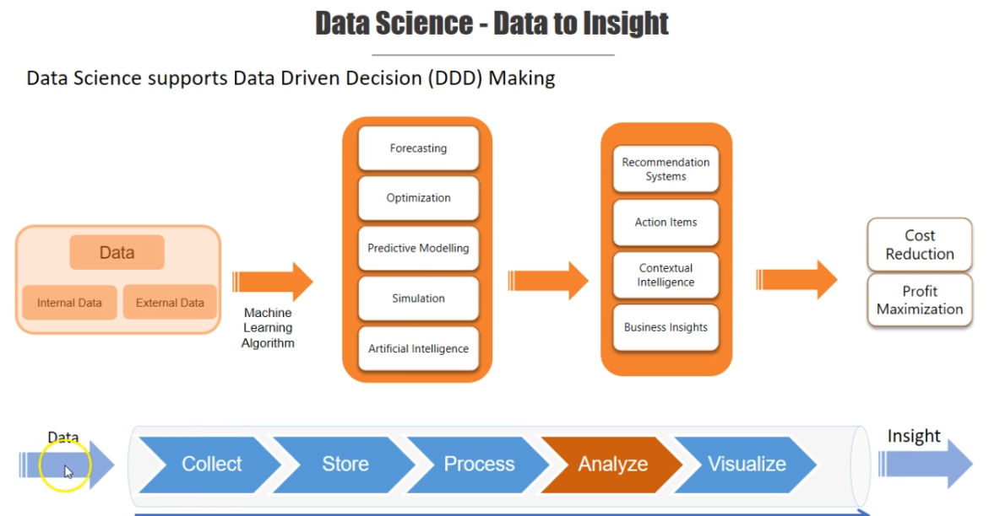

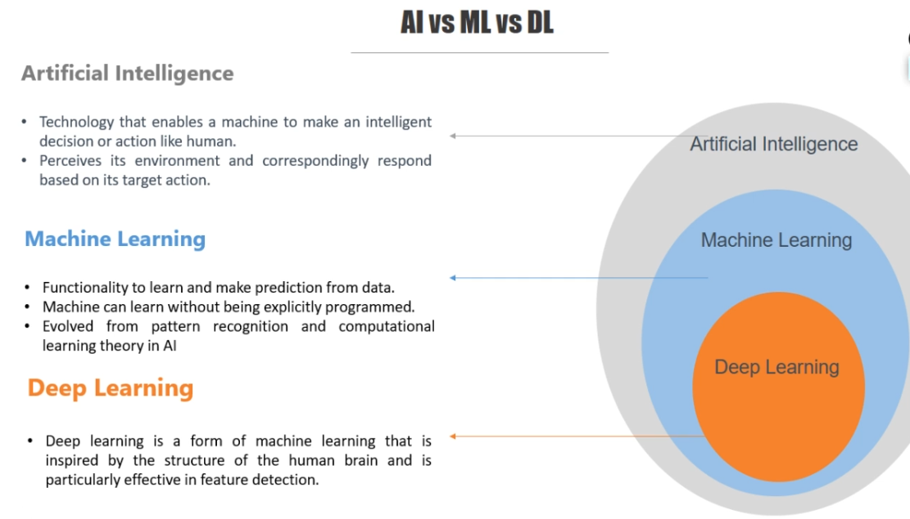

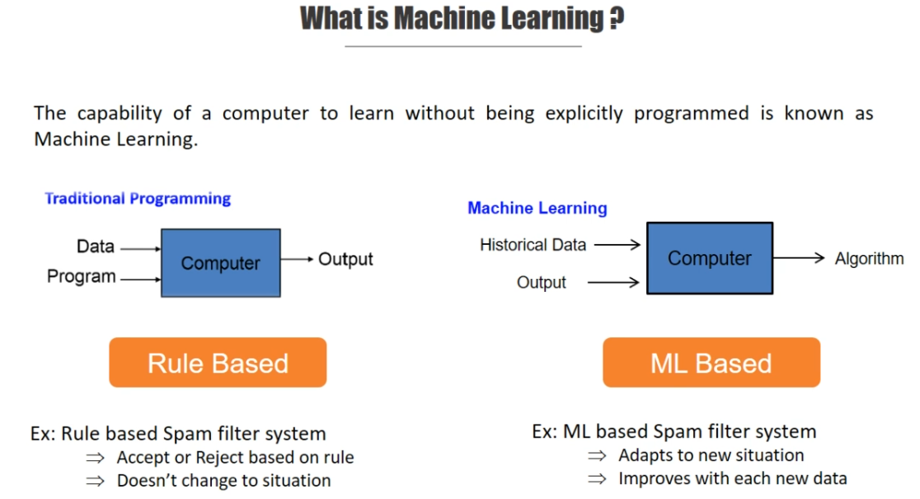

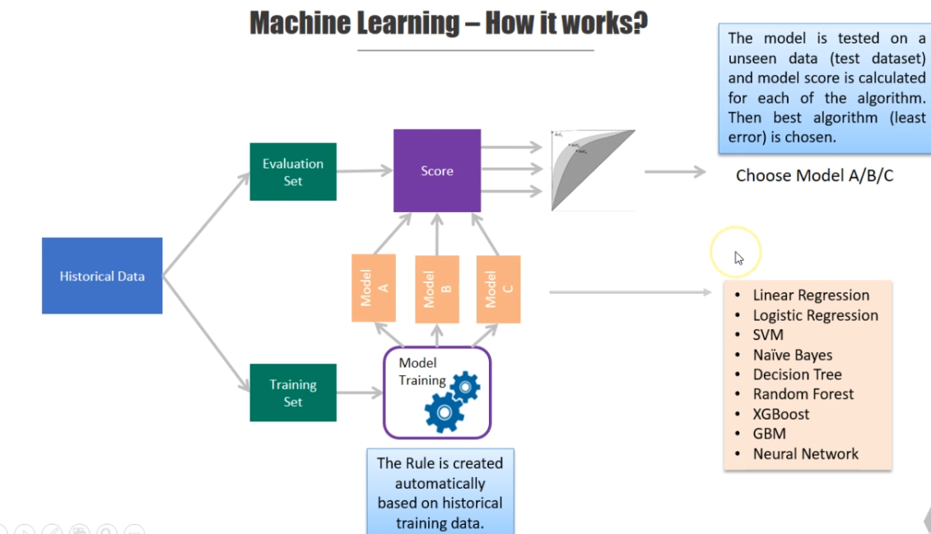

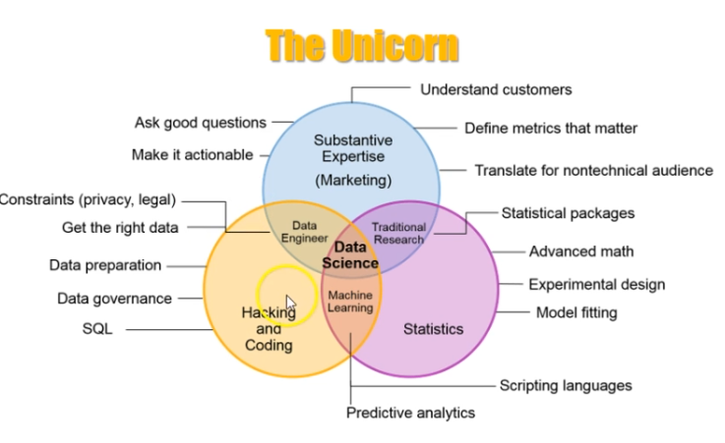

Python essential For Machine:

* The Libraries Essential for DataScience:::
* Pyhton Has Huge Libraries, But we required Only Few for Data-Science.
* Python has many Open Source Libraries .

They are:

1. Numpy – (Numerical Python)
2. Pandas
3. Scipy – (Scientify Python)
4. Scikit-Learn.
5. Scikit-Image
6. Matplotlib
7. Theano.
8. Tensorflow
9. Keras.
10. Caffe
11. Open AI Gym
12. NLTK – (Natural Language Tool Kit)
13. Textblob
14. Rasa
15. Pytorch – (NLP)

* Numpy:

Purpose🡪 Used For Linear Algebra.

🡪Entire Machine Learning models depends on this linear Alzebra.

* In Alzebra Operation related to matrix and vector.

Here we need to just import numpy as np or numpy.’

Numpy is Pre-Defind Function

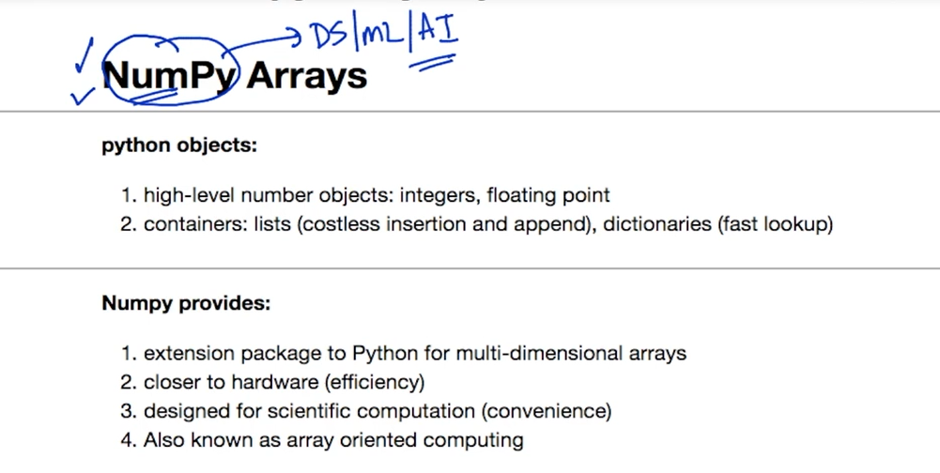

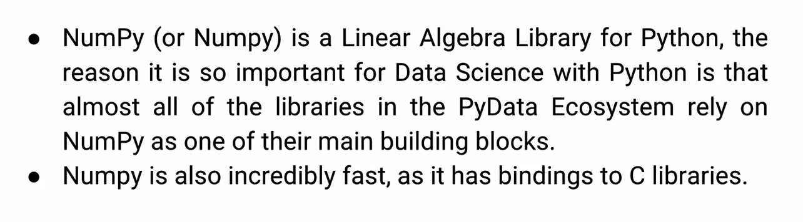

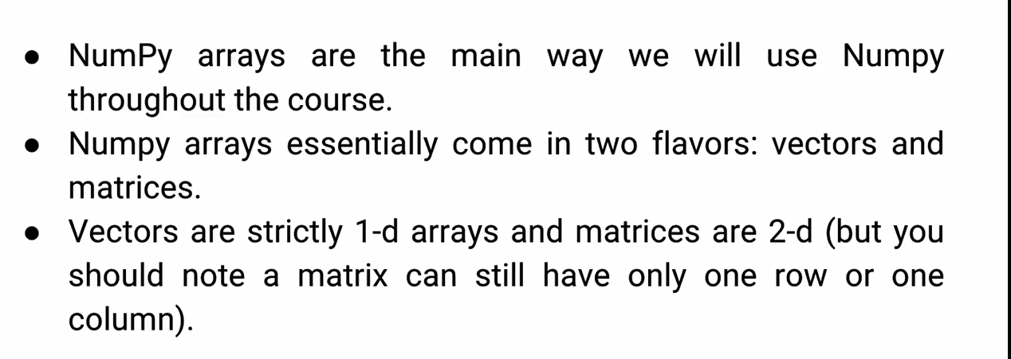

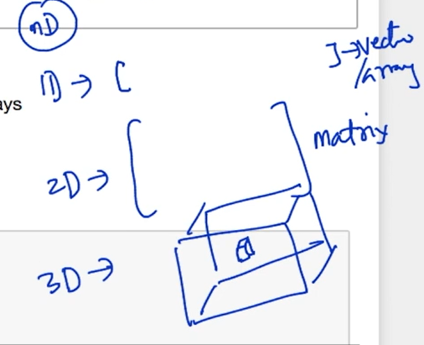

Views

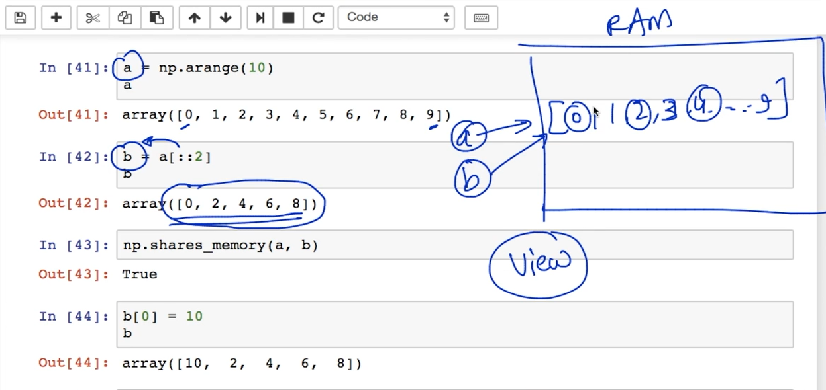

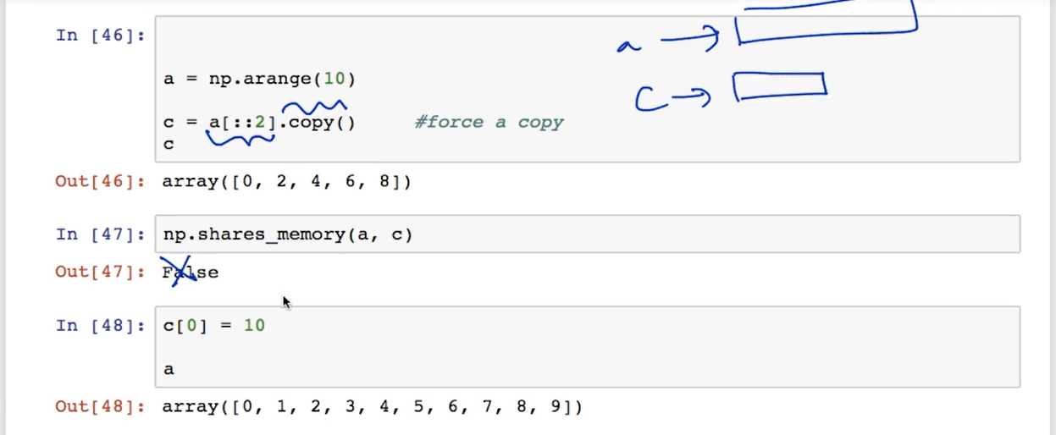

Masking

