Due To Technical Issue ::Recording Not Available::

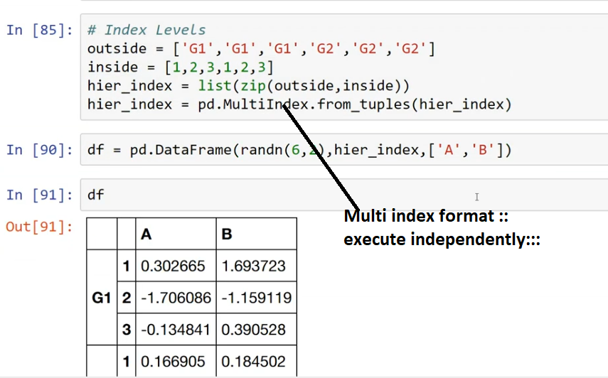

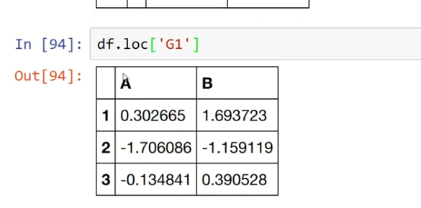

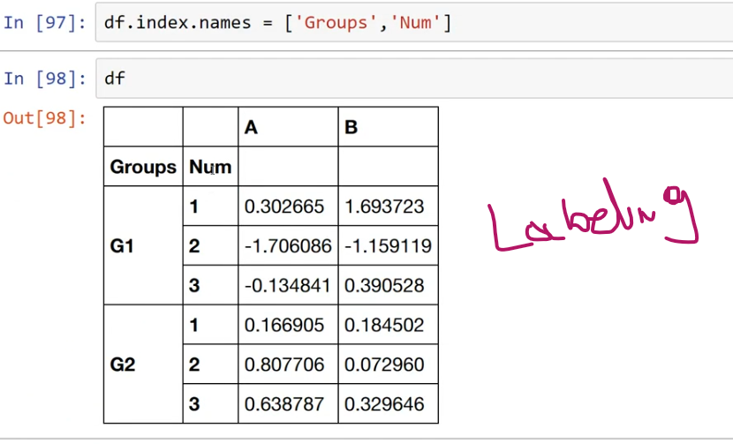

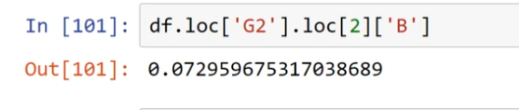

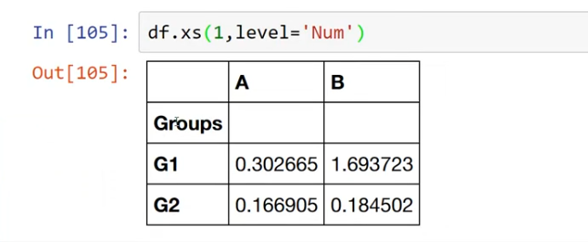

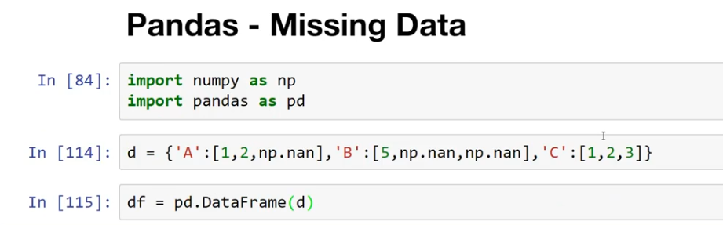

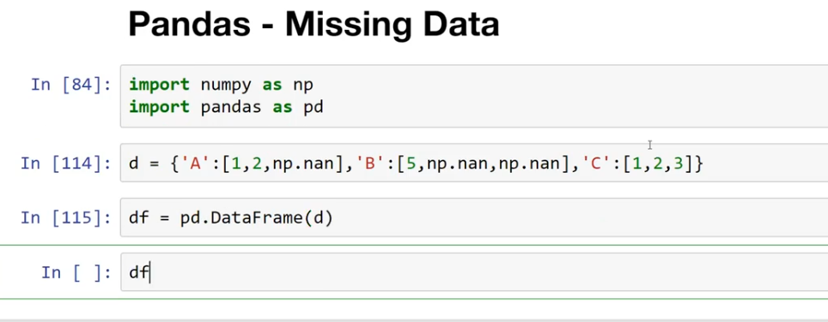

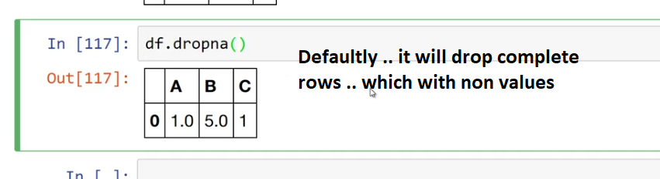

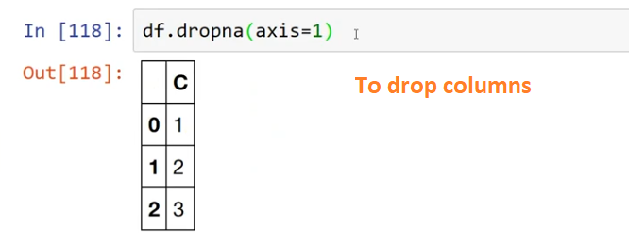

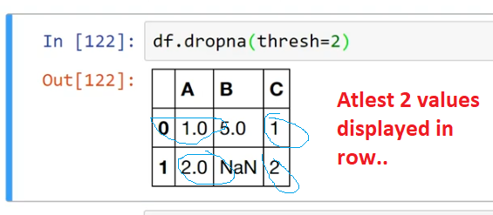

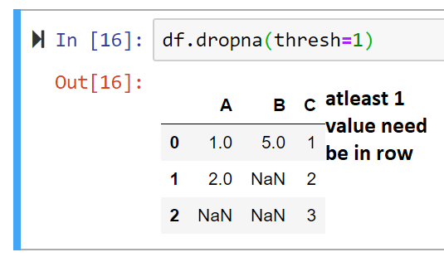

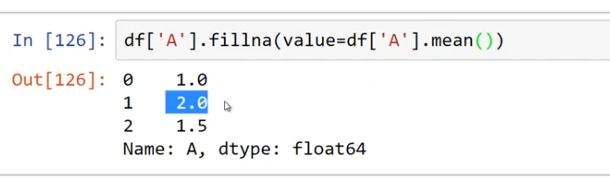



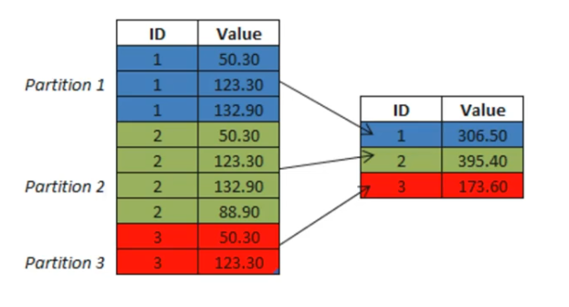

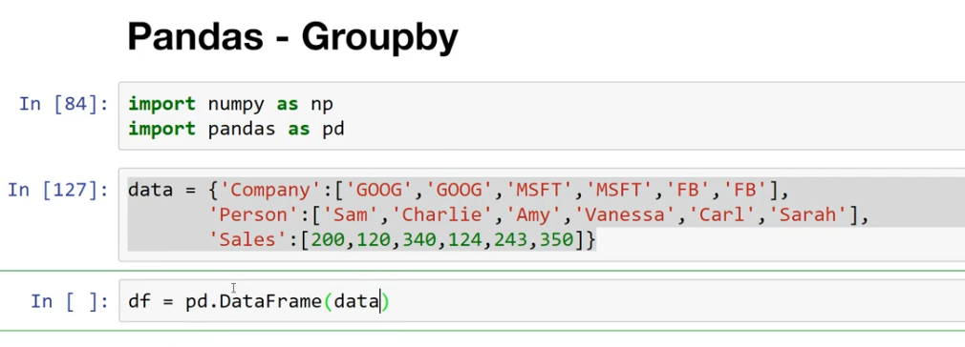

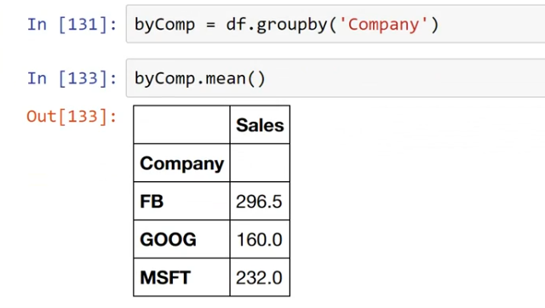

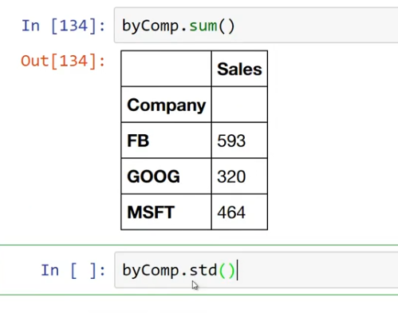

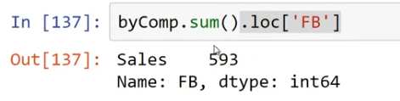

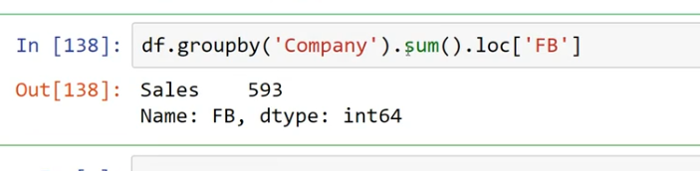

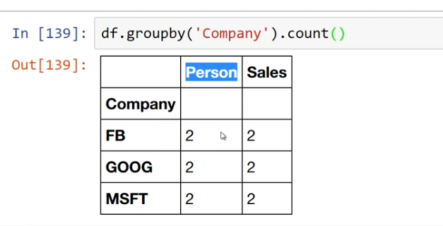

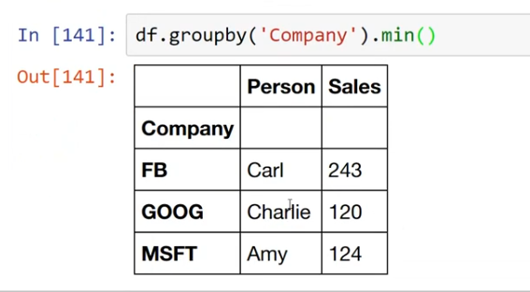

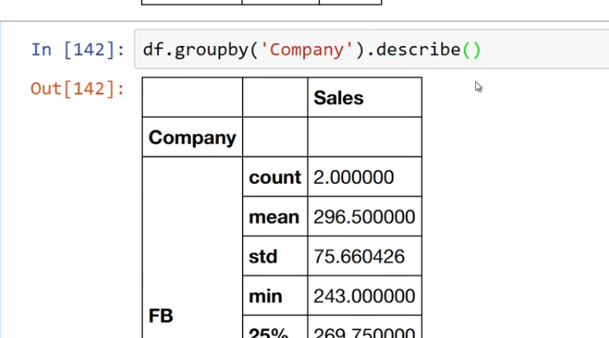

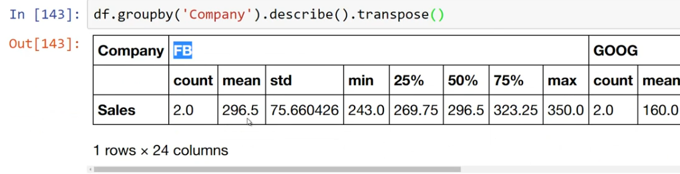

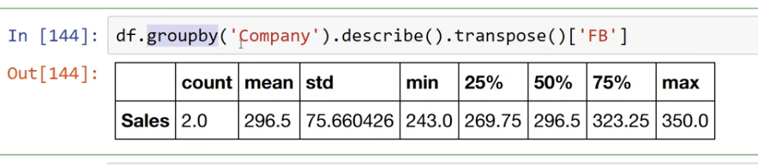



#Merging :::

df1 = pd.DataFrame({"A":["A0","A1","A2","A3"],

"B":["B0","B1","B2","B3"],

"C":["C0","C1","C2","C3"],

"D":["D0","D1","D2","D3"]})

df2 = pd.DataFrame({"A":["A4","A5","A6","A7"],

"B":["B4","B5","B6","B7"],

"C":["C4","C5","C6","C7"],

"D":["D4","D5","D6","D7"]})

df3 = pd.DataFrame({"A":["A8","A9","A10","A11"],

"B":["B8","B9","B10","B11"],

"C":["C8","C9","C10","C11"],

"D":["D8","D9","D10","D11"]})

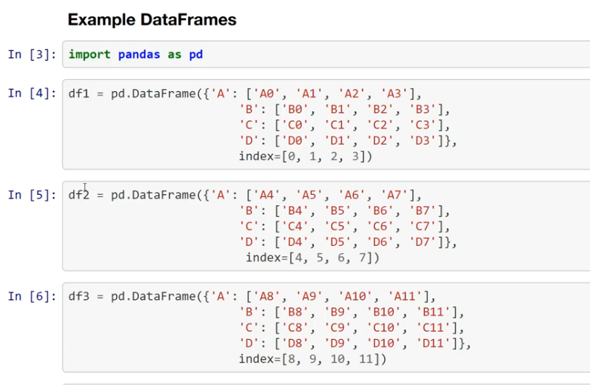

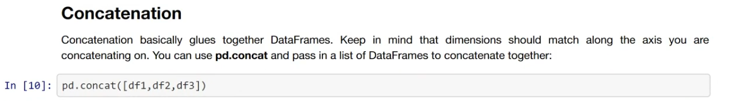

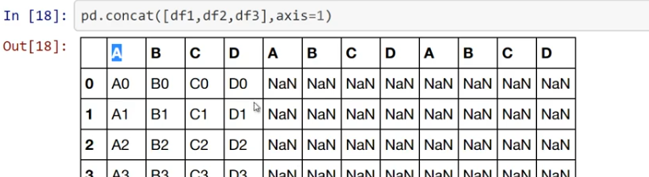

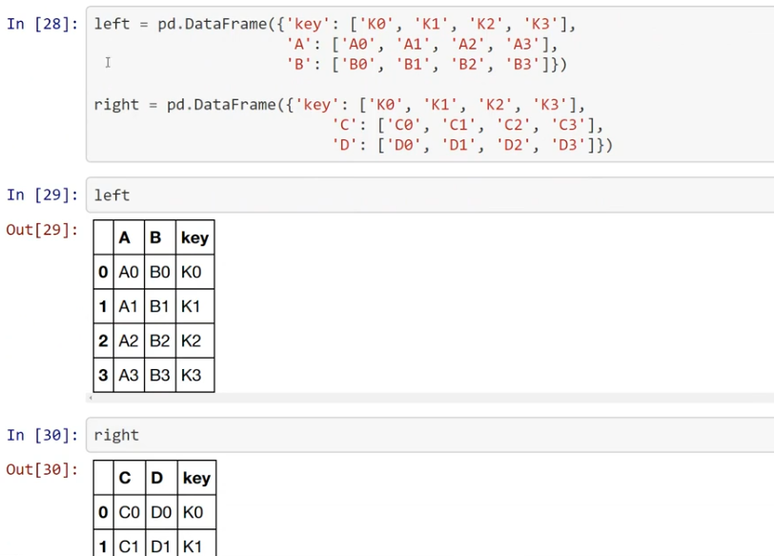

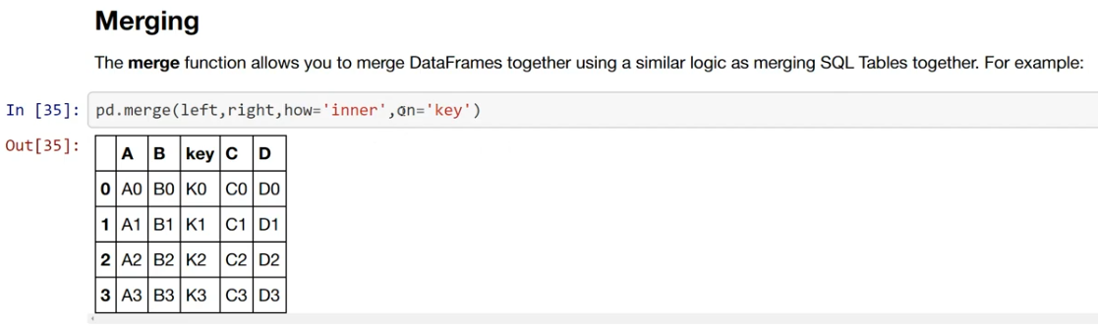



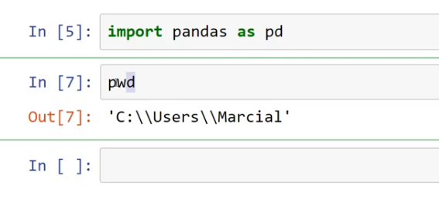

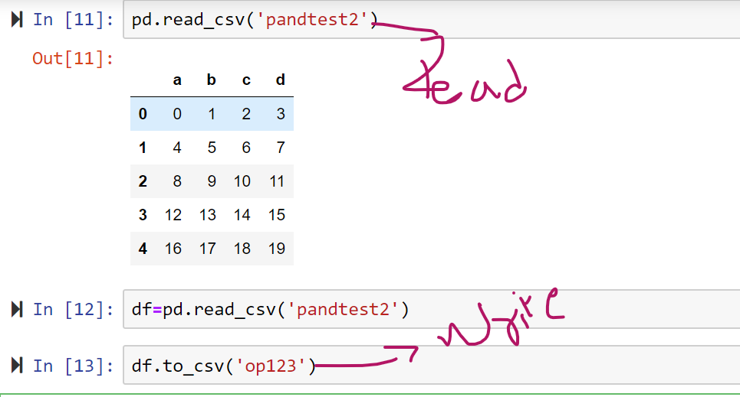

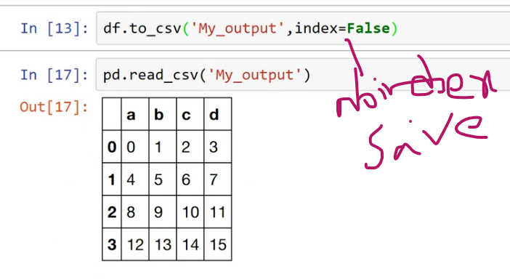

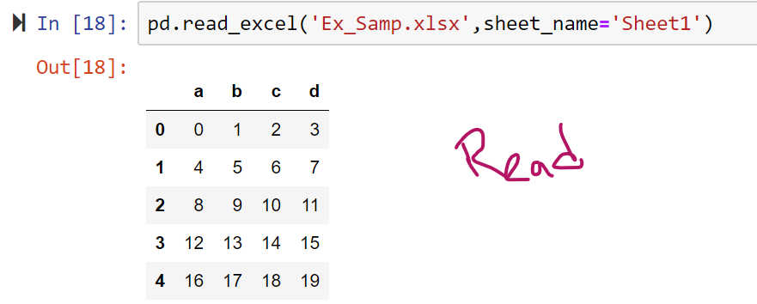

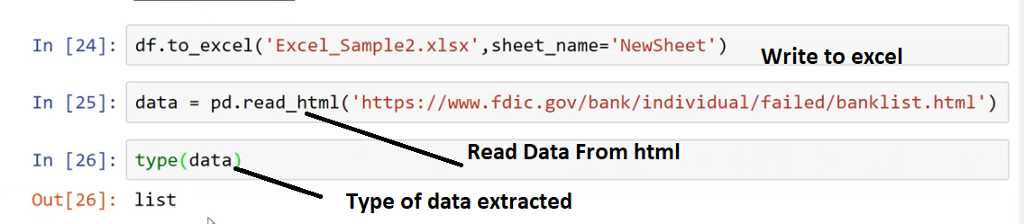

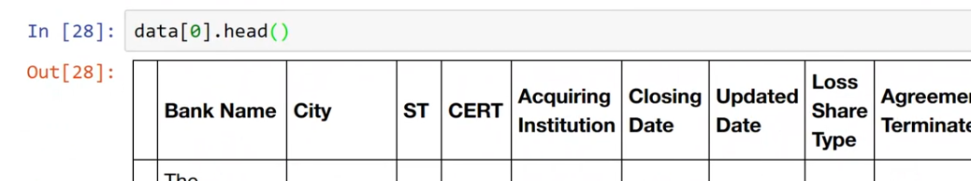

<https://www.fdic.gov/bank/individual/failed/banklist.html>