SF Salarie Exercise On Pandas :::UseCase

Sea Born On Matplotlib



Seaborn is a library for making statistical graphics in Python. It is built on top of [matplotlib](https://matplotlib.org/) and closely integrated with [pandas](https://pandas.pydata.org/) data structures.

* A dataset-oriented API for examining [relationships](https://seaborn.pydata.org/examples/scatter_bubbles.html#scatter-bubbles) between [multiple variables](https://seaborn.pydata.org/examples/faceted_lineplot.html#faceted-lineplot)
* Specialized support for using categorical variables to show [observations](https://seaborn.pydata.org/examples/jitter_stripplot.html#jitter-stripplot) or [aggregate statistics](https://seaborn.pydata.org/examples/pointplot_anova.html#pointplot-anova)
* Options for visualizing [univariate](https://seaborn.pydata.org/examples/distplot_options.html" \l "distplot-options) or [bivariate](https://seaborn.pydata.org/examples/joint_kde.html" \l "joint-kde) distributions and for [comparing](https://seaborn.pydata.org/examples/horizontal_boxplot.html#horizontal-boxplot) them between subsets of data
* Automatic estimation and plotting of [linear regression](https://seaborn.pydata.org/examples/anscombes_quartet.html#anscombes-quartet) models for different kinds [dependent](https://seaborn.pydata.org/examples/logistic_regression.html#logistic-regression) variables
* Convenient views onto the overall [structure](https://seaborn.pydata.org/examples/scatterplot_matrix.html#scatterplot-matrix) of complex datasets
* High-level abstractions for structuring [multi-plot grids](https://seaborn.pydata.org/examples/faceted_histogram.html#faceted-histogram) that let you easily build [complex](https://seaborn.pydata.org/examples/pair_grid_with_kde.html#pair-grid-with-kde) visualizations
* Concise control over matplotlib figure styling with several [built-in themes](https://seaborn.pydata.org/tutorial/aesthetics.html#aesthetics-tutorial)
* Tools for choosing [color palettes](https://seaborn.pydata.org/tutorial/color_palettes.html#palette-tutorial) that faithfully reveal patterns in your data

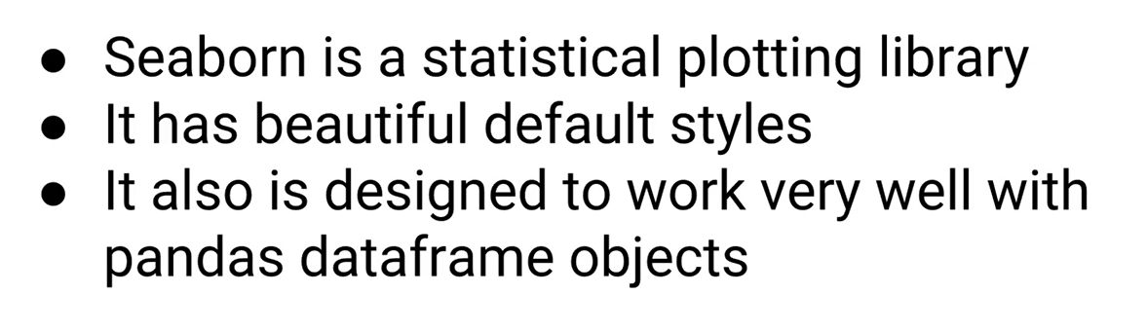



Tips is Inbuilt Dataset

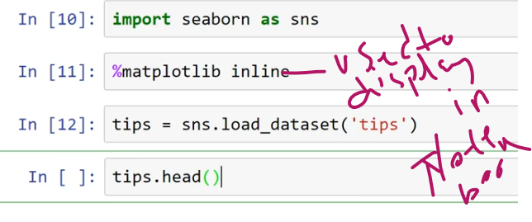

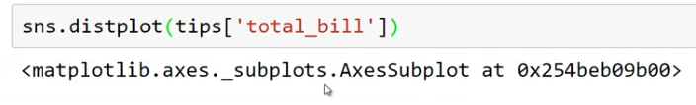

Line:::KDE<<Kernel Density Estimation>>

Distributed Plot

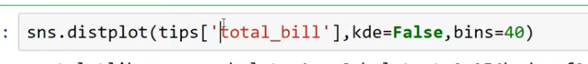



JointPlots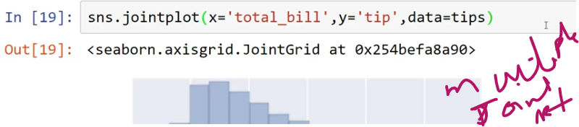

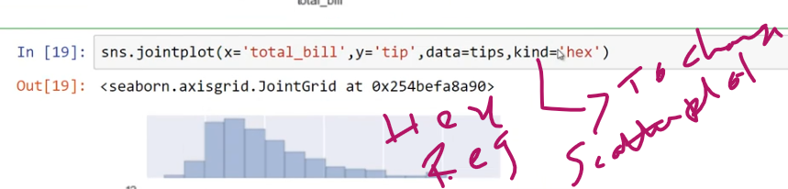

Kind = hex,reg,kde (default = scatter)

Pairplot

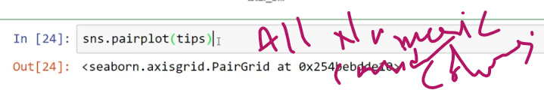

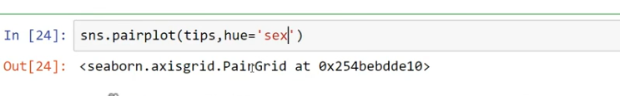

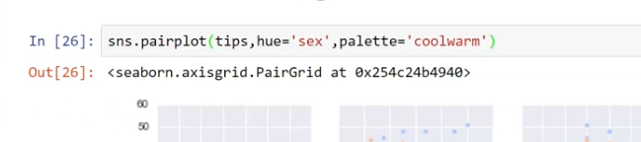

Rugplots:::

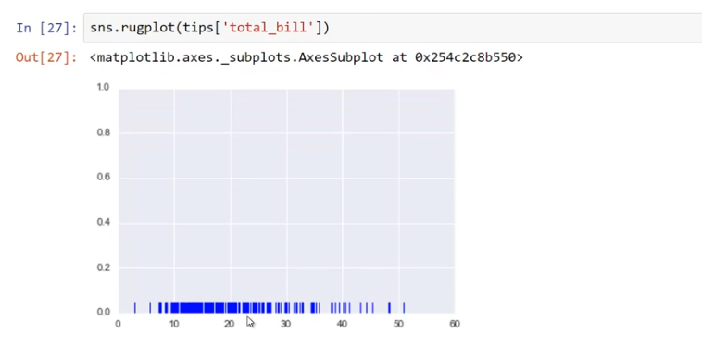



It will Calculate AVG

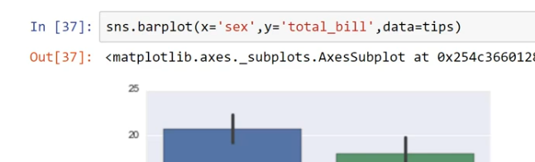

Here Count Number Of occurrence <records>

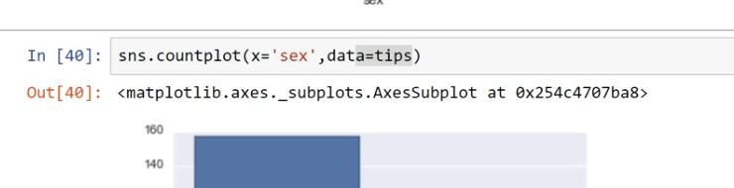

Here we get day wise <male/female>

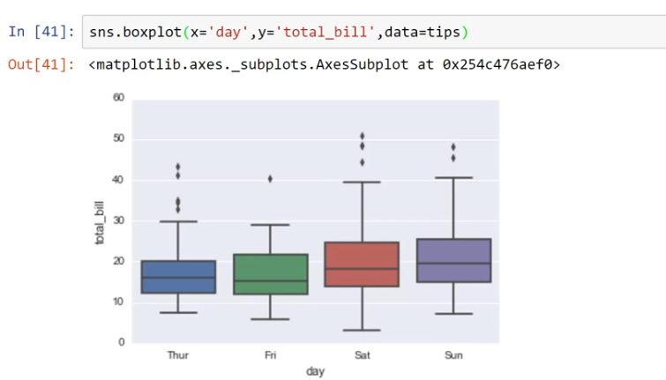

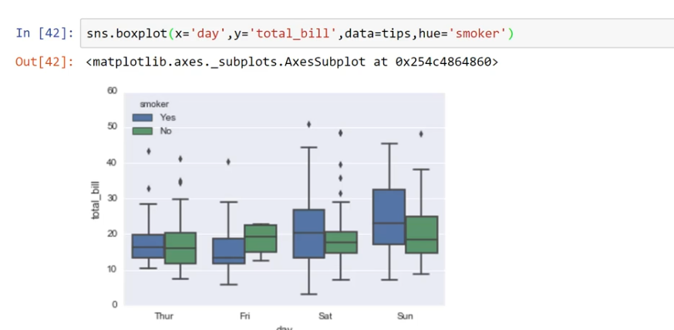

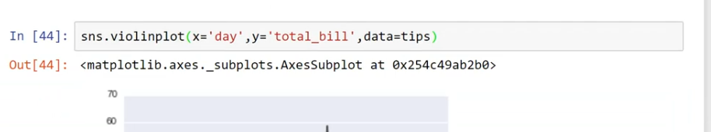

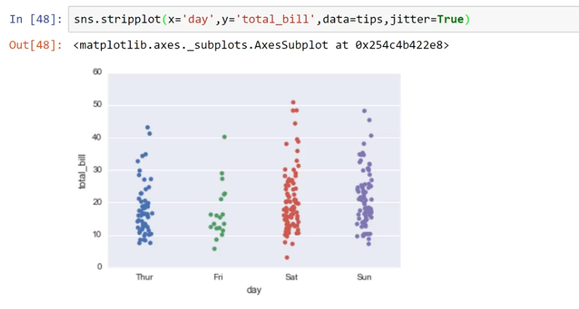

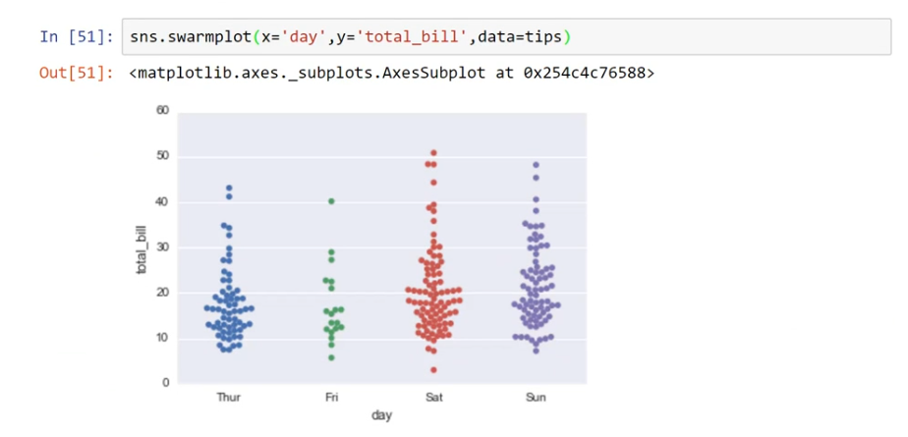

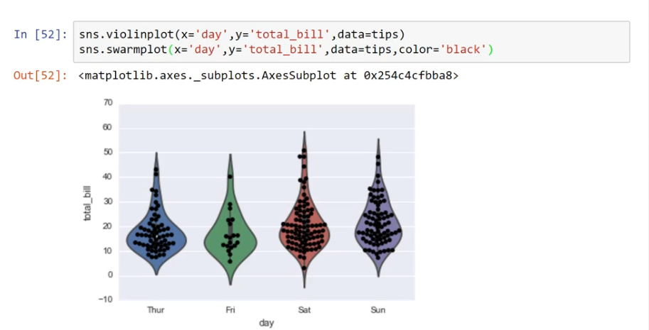

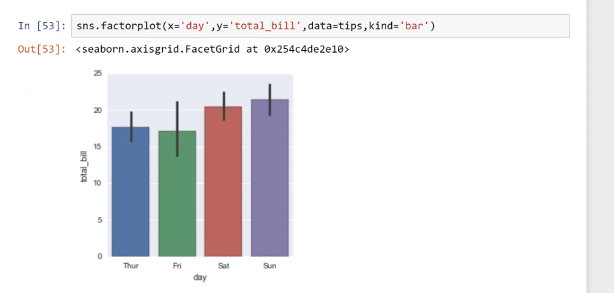

Matrix Plot

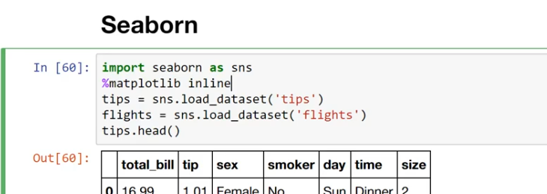

Matrix Plot utilize for Heat Maps :::

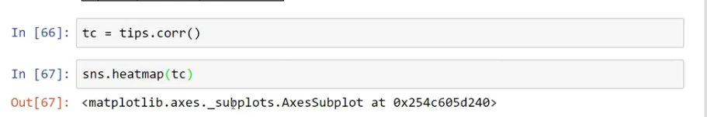

Annot === declare values in each pix

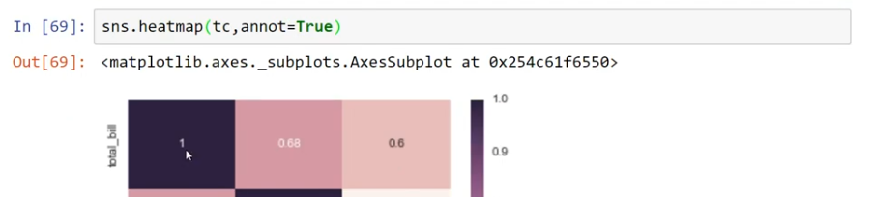

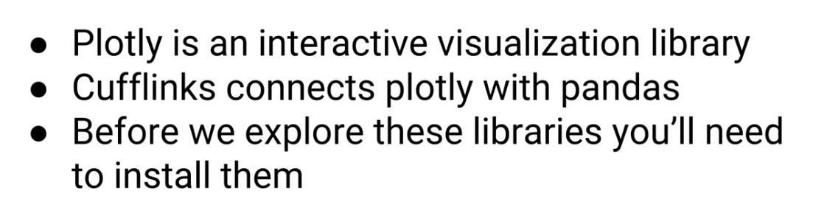

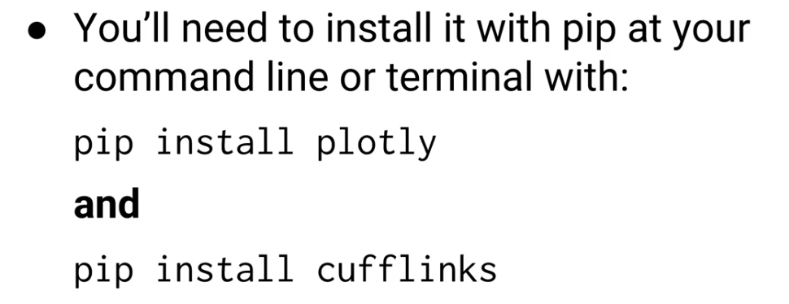

First Install Cufflinks