**Due to Technical Isse :: Recorded Session Not Available::**

**Introdution To Machine Learning**

**What is ML?**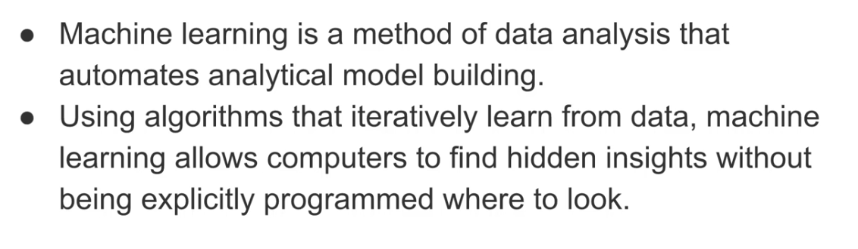

Where ML Used ?

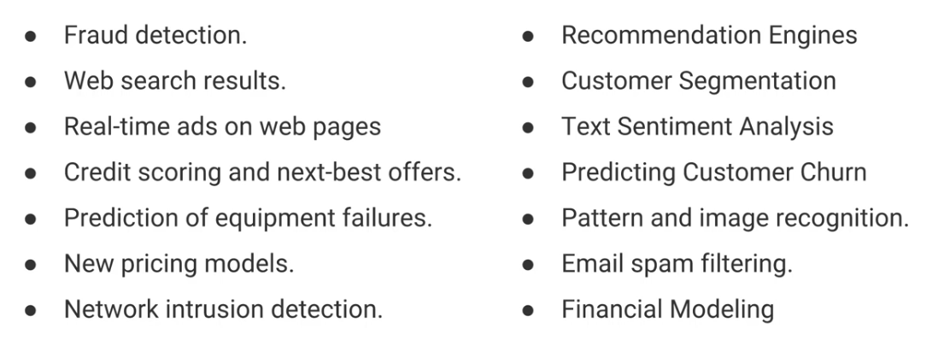

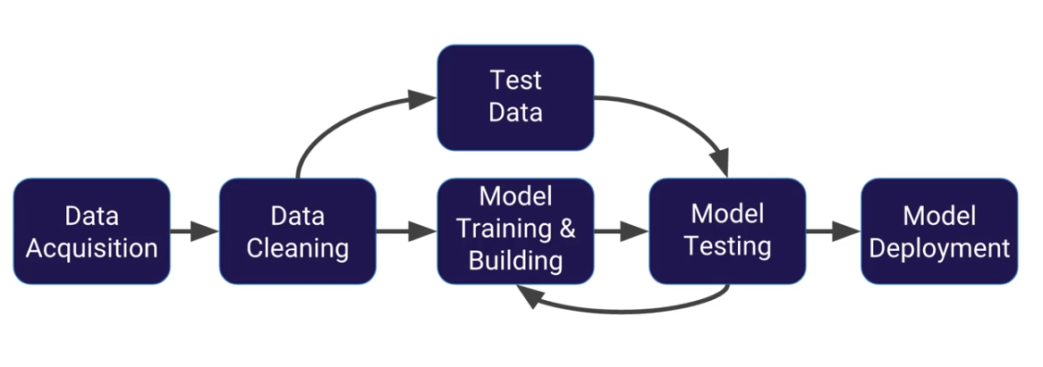

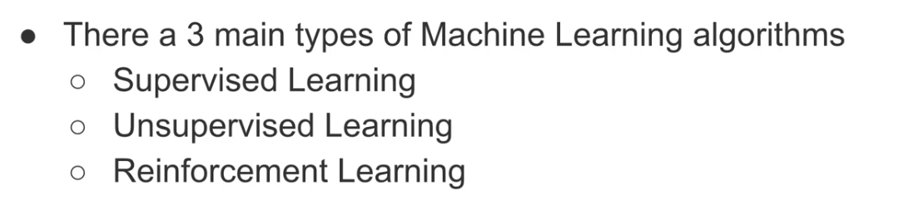

**Introdution To Machine Learning**

**ML is an approach, to train mathematical models.**

**We Deploy Knowledge acquired by model..**

**We don’t deploy models into application …**

**Knowledge Acquired by the model from Data Is called AS ::model fit:::**

**What Model Learns :::**

**Patterns from Data towards target classifier /target value**

**Once ModelFit produced, that has to be tested :::**

**Accuracy test == 97*100/100 = 97%**

**Once Model-Fit deployed into application will become smart application…**

**Difference Between Instruction Based Applition And Smart Application:::**

**Smart Application Intelligent based and Normal Application instruction based**

**Smart Application Ex::**

**Gmail Detection ::**

**Train**

**Model**

**ModelFit**

**Accuracy Testing**

**Deployment**

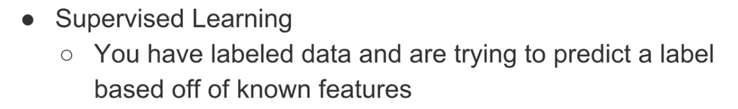

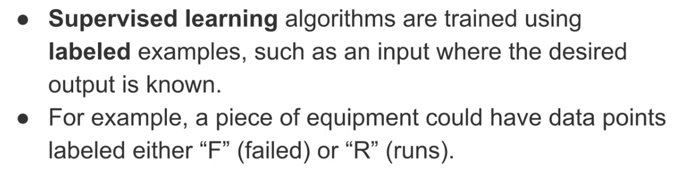

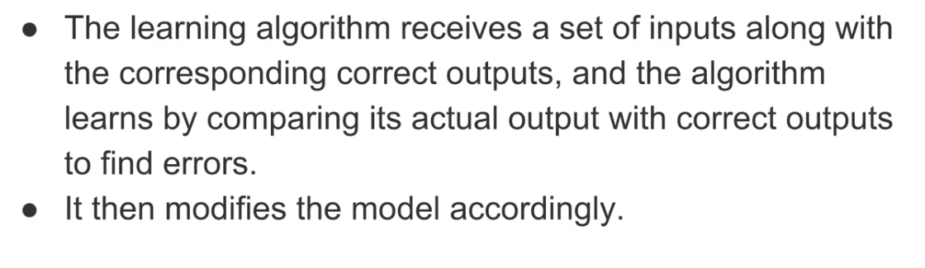

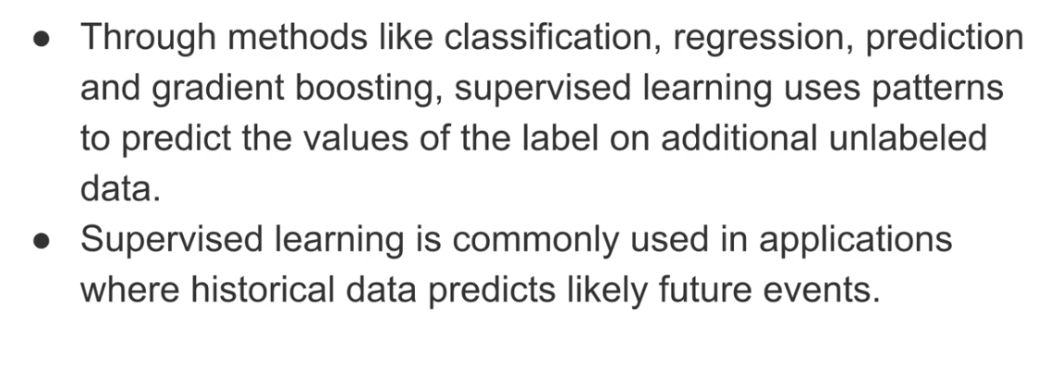

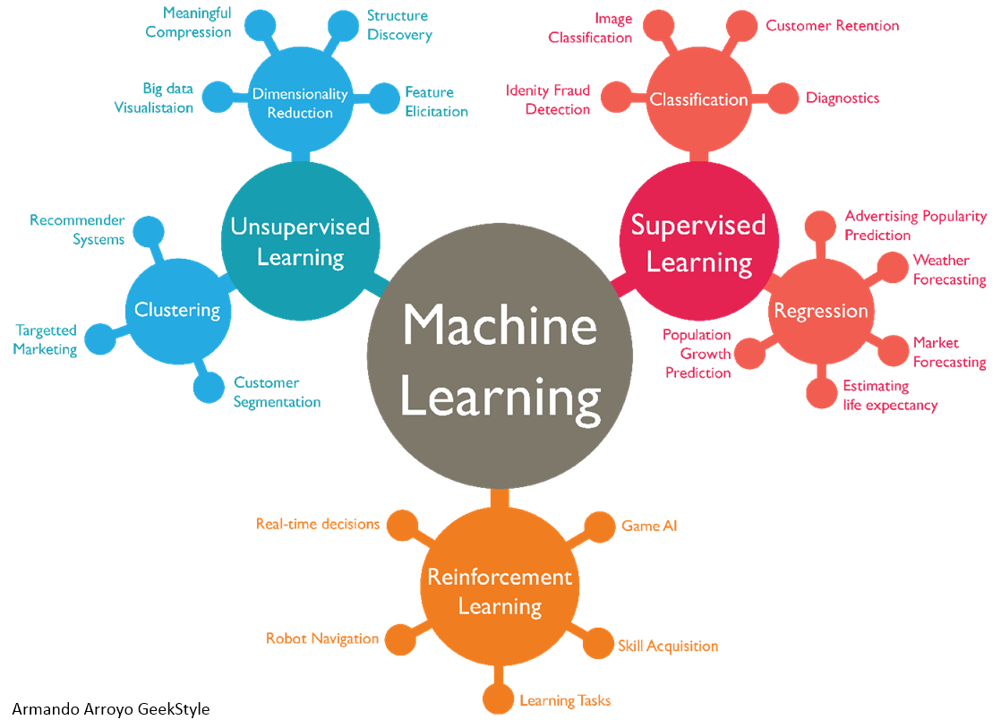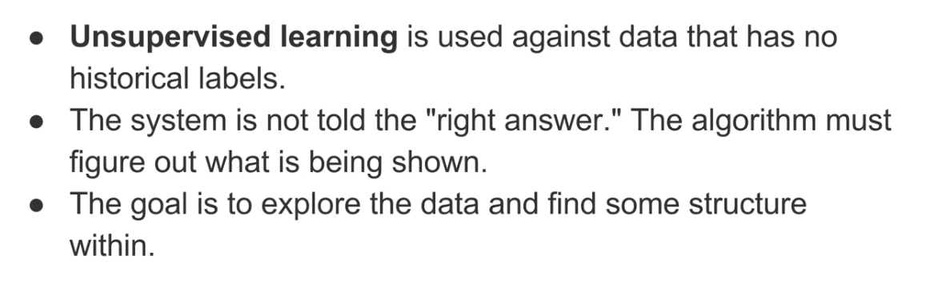

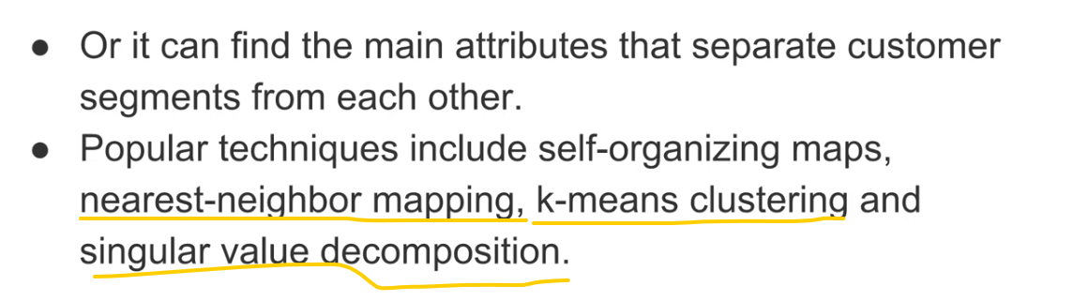

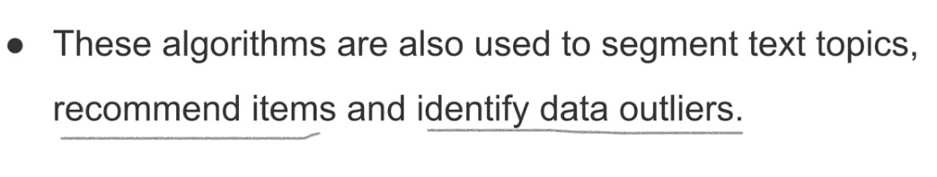

Reinforcement Learning:::

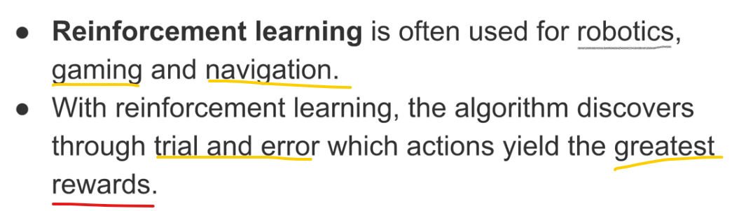

Data Preparation steps for Machine Learning:

There are 3 kinds of DataSet:

1.Trainset.

2.Validate Set(Optional)

3.Test-set.

Train set used to train models .

Test-set is utilized to evaluate model<Accuracy Test>

Validate set used for validating extact data.

In supervised learning … we have Inpur features and

Labels .

In unsupervised Learning only Input features available.. we find labels :::

There Are 3 Approaches to prepare dataset::

Approachg – 1

Keep 100% data in train set.

20%- 30 data in test-set.

Approach – 2

Keep 70% - 80% data train-set.

20%-30% data in test-set

Approach -3

Shuffle data keep 70 – 80% in train-set.

20-30% data in train set.

Over Fitting On model:::

Where Model feel learn everything :: but didn’t learn any pattern::becoz ::fraud trans and genuine trans are mostly equal::Accuracy high as 95%

Underfit on models::Accuracy wil be low…

To Over come ::: Overfit of models::: we go shuffle process to train :::

Shuffling data :::

Shuffle Data as below :::

Life Cycle OF Machine Learning: