

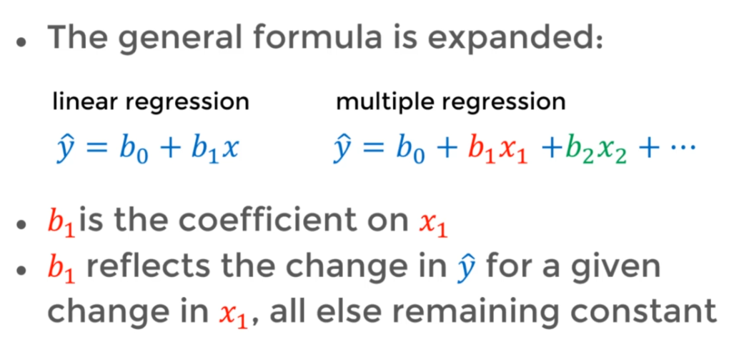

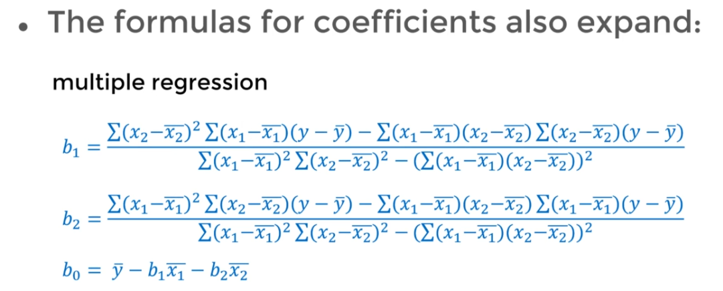

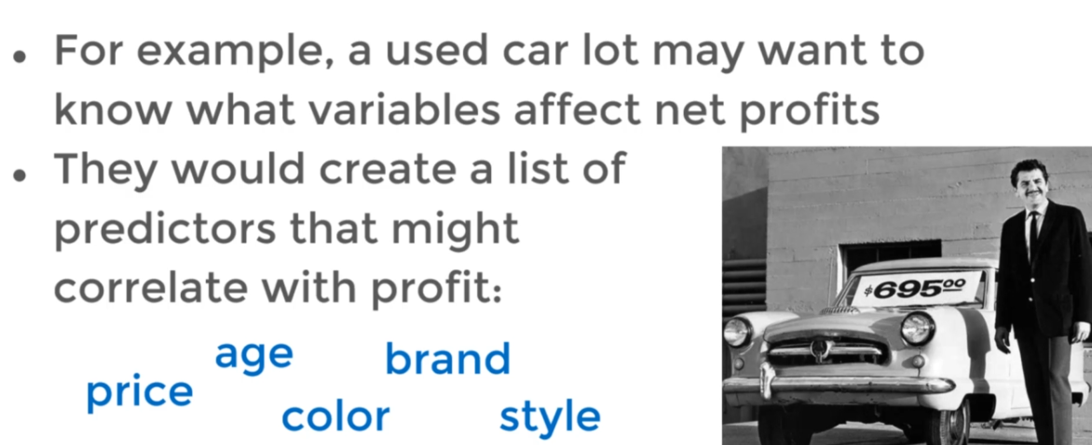

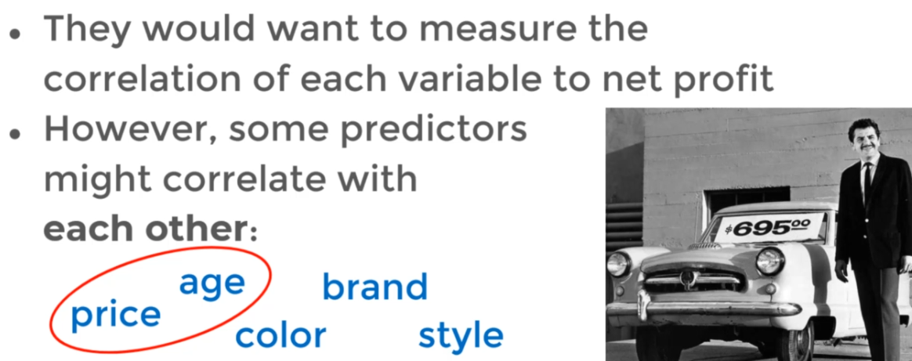

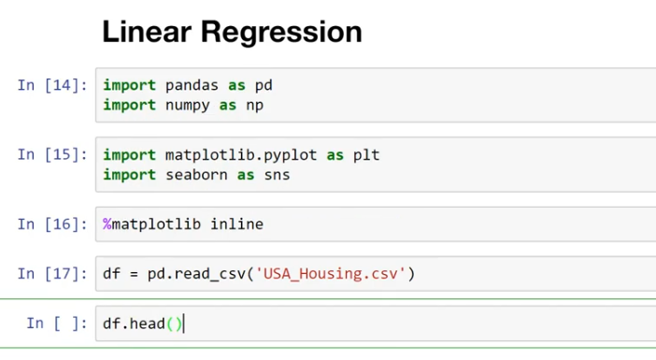

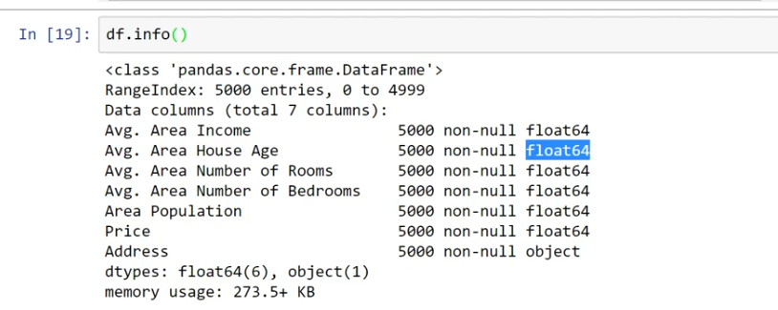

Correllation between objects :::

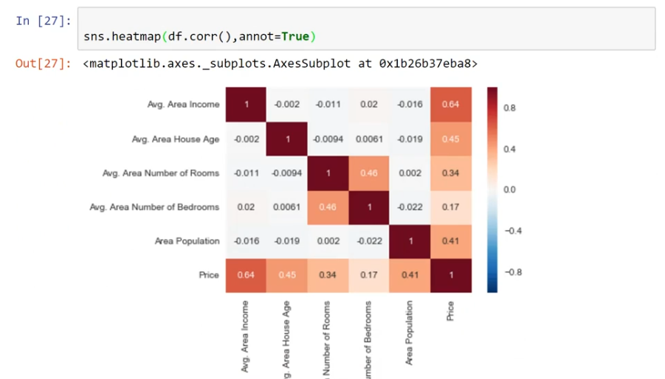

By Above Data :::

Condsider

X –axis = features to train :::[All Features]

Y-axis as Target Variable::::Price column we predict:::

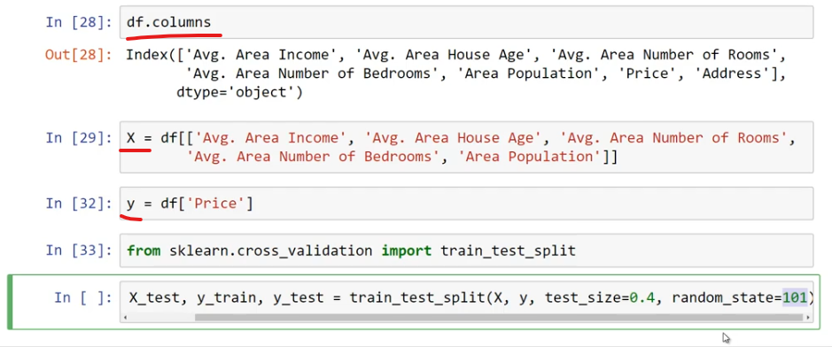

from sklearn.model_selection import train_test_split

\Allocating test_size::::is ::Persentage of test_size::0.4::

In Below ::

Lm.fit(X_tarin,Y_train))🡪 Will train data

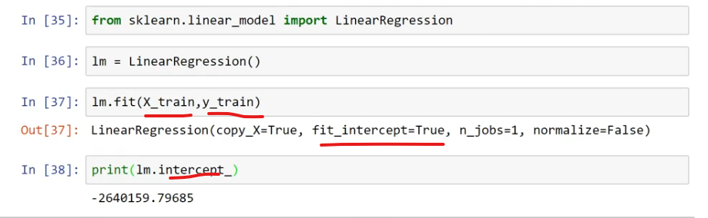

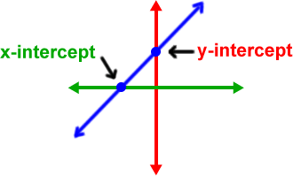

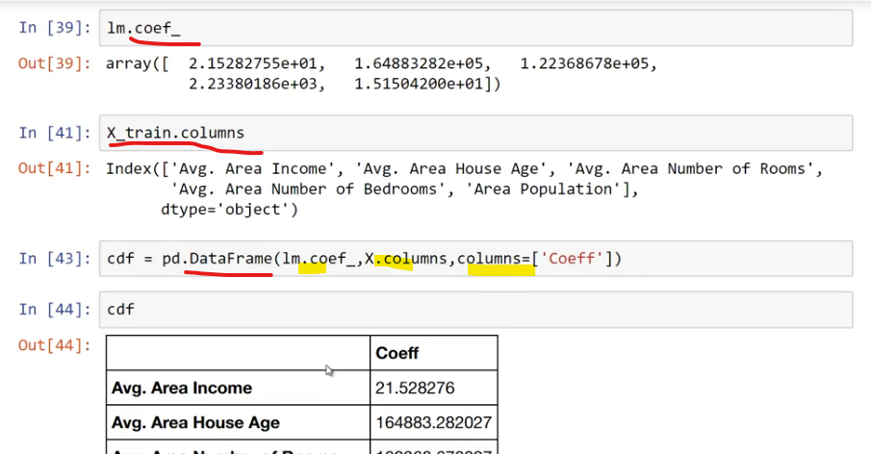

In above cdf:::

If One Unit Increase in avg.area income::is associate with increase in 21.

If avg area house age increa :::price will increa

