Due to Technical Issue:: Video Not Recording not available:

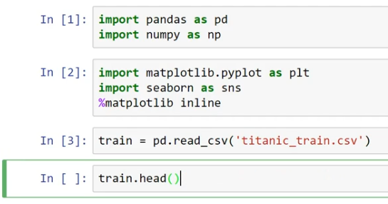





HOW MANY PEOPLE SURVIED ;;;

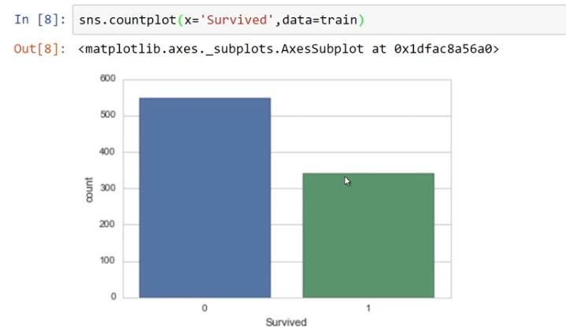

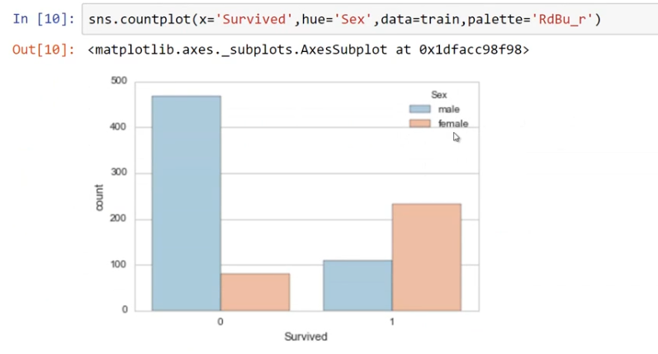

MISSSING DATA ;;;

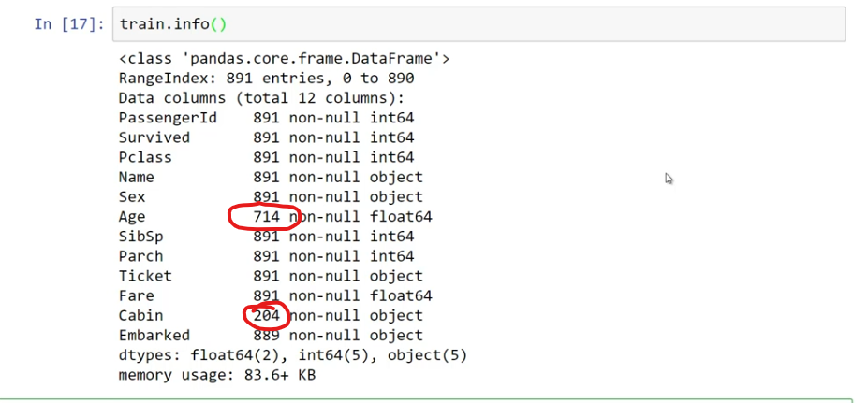

DATA CLEANING PROCESS

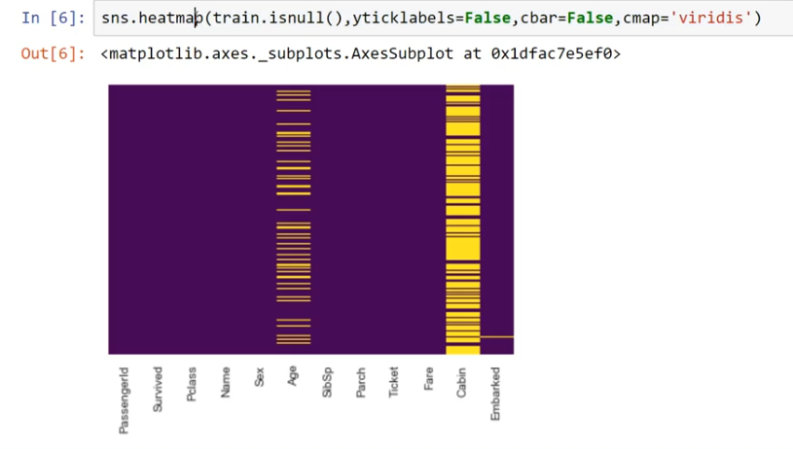

MISSING DATA FILLED WIT AVARAGE AGE ///BASED ON CLASS ///

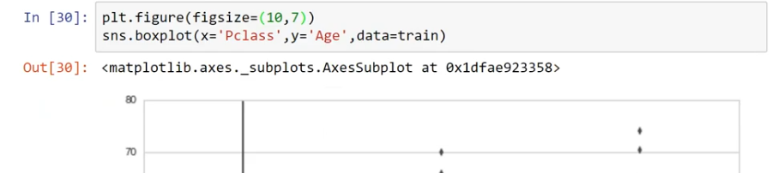

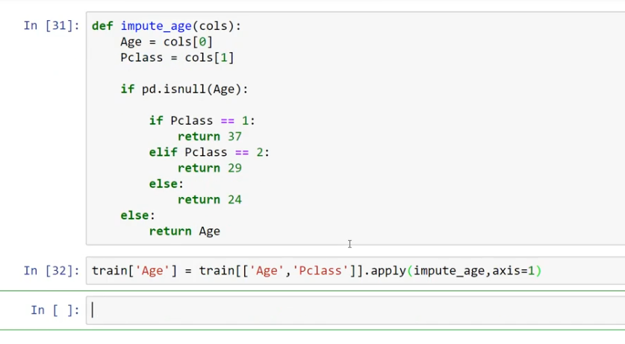

AGE COLUMN MISSING DATA AS ERADICATED ;;;IN BELOW IMAGE

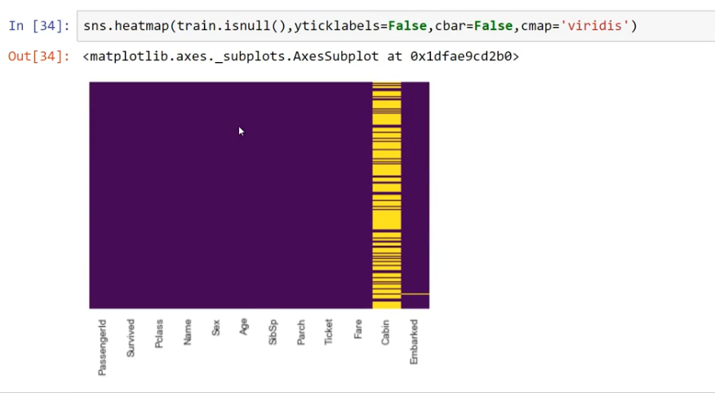

NEXT DROPING CABIN COLUMN’’’’’

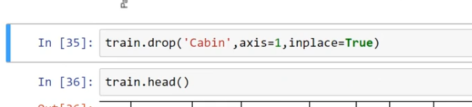

NO CABIN COLUMN BELOW

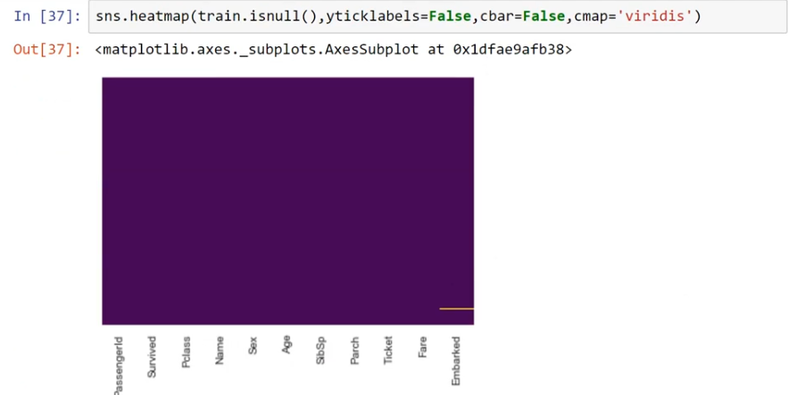

FINDING AND REMOVING MISSING COLUMNS

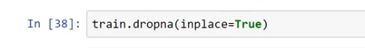

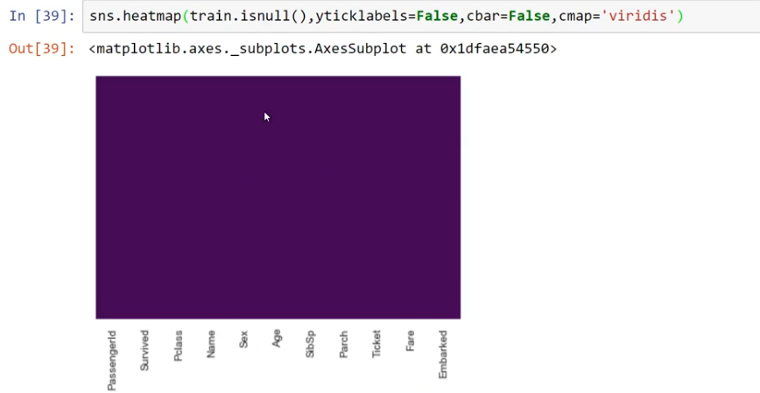

CONVERTING ‘’’’’SEX COLUMN ‘’’’AND ‘’’’EMBARKEDCOLUMN ‘’’INTO ‘’’NUMERIC PATERN FORANALYSIS

BY USING DUMMIESMETOD

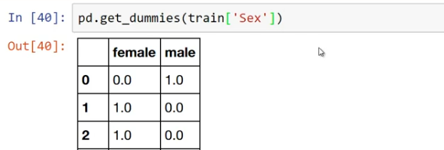

WE AVE ISSUE WIT ABOVE

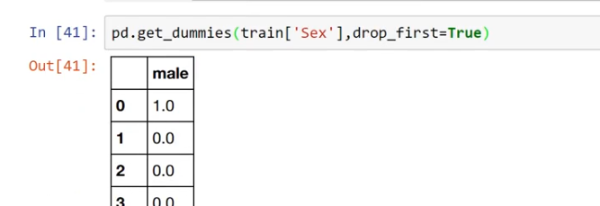

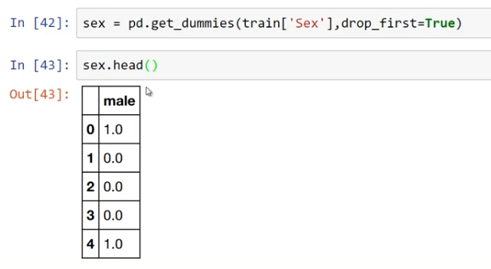

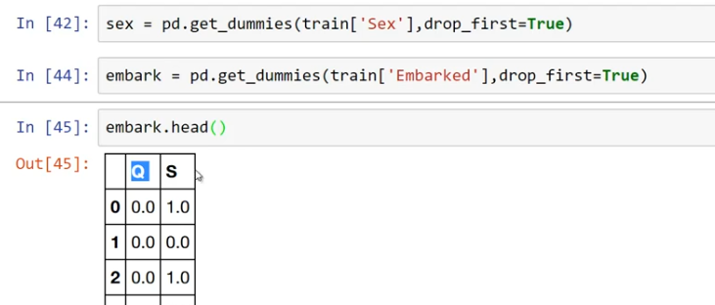

ADDING NEW COLUMNS FOR DATAFRAMES ‘’’SEX’’’EMBARKED

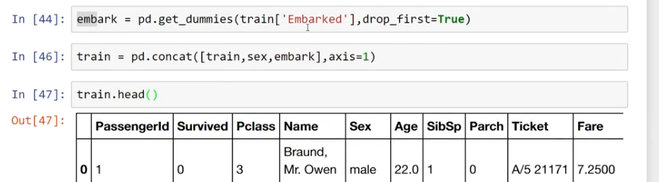

REMOVE TEXTED DATA COLUMNS ‘’’’’’’’’’BELOW

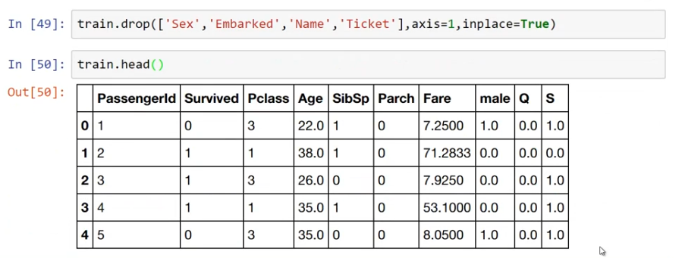

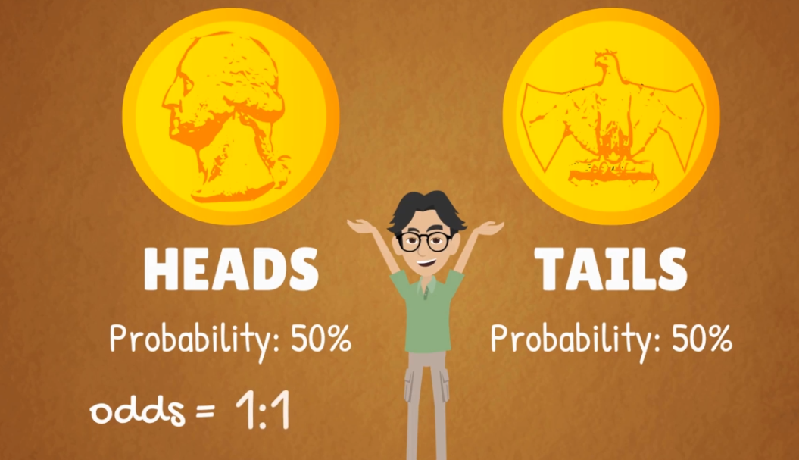



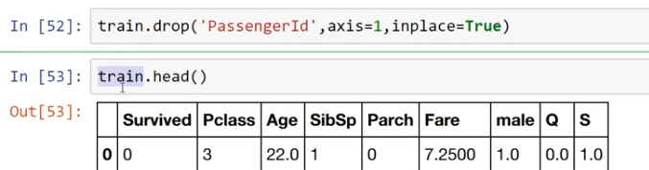

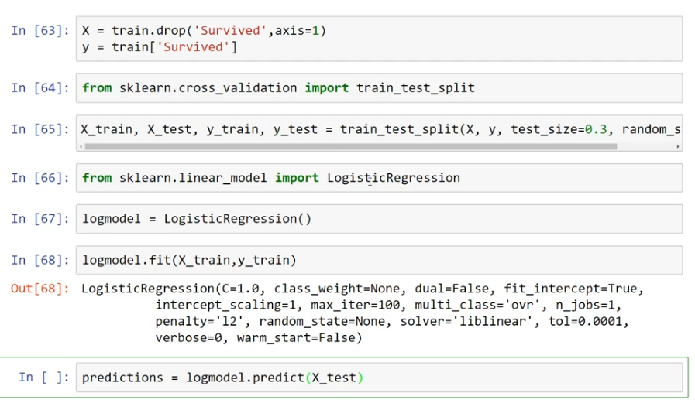

Confusion matrix

