DataSet : 50_StartUps

Description for mUlti linear regression :::

50 Companies :::Total

Columns :::

|  |  |  |  |  |
| --- | --- | --- | --- | --- |
| R&D Spend | Administration | Marketing Spend | State | Profit |

Profit Is Dependend Variable:::

All other are independent variables :::

Challenge ::: Which is best company ::: Prepare a model that should say best To Invest :::

In Take R&D Spend :::Marketing spend ::: for analysis

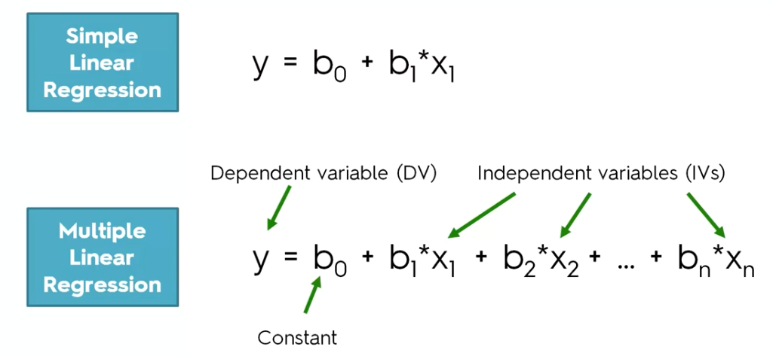

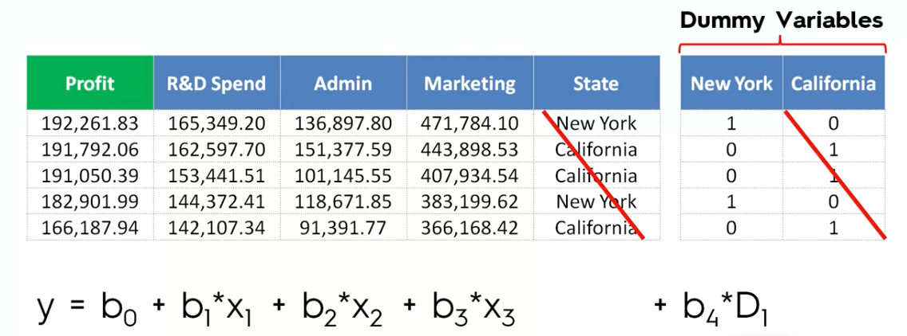

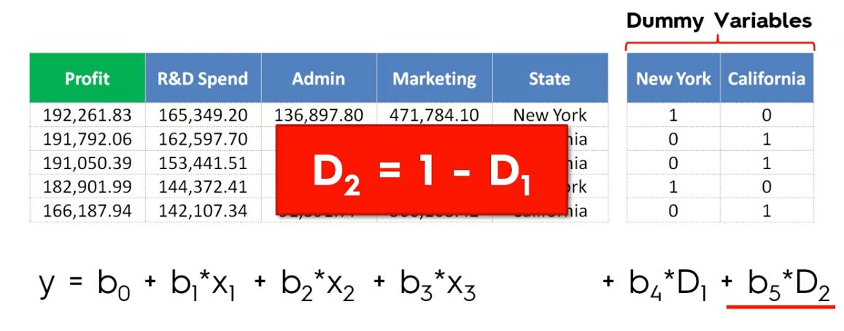

If you have 100 Dummy variables---Declare 99 –only

If you have 50 Dummy variables --- Declare 49—only

If you have 2 Dummy variables – Declare 1—Only

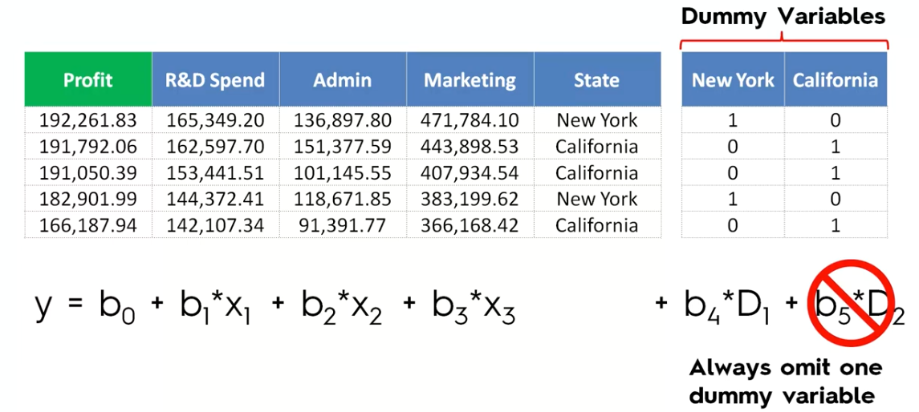

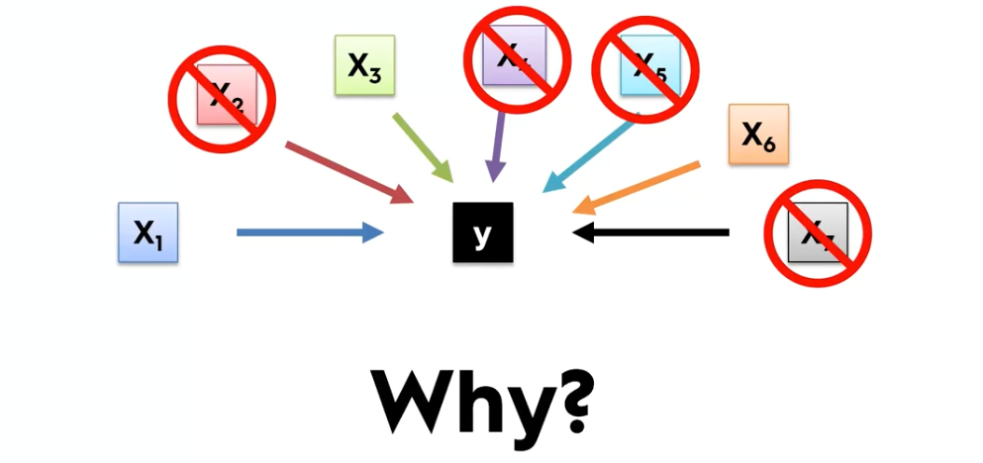

================================================================

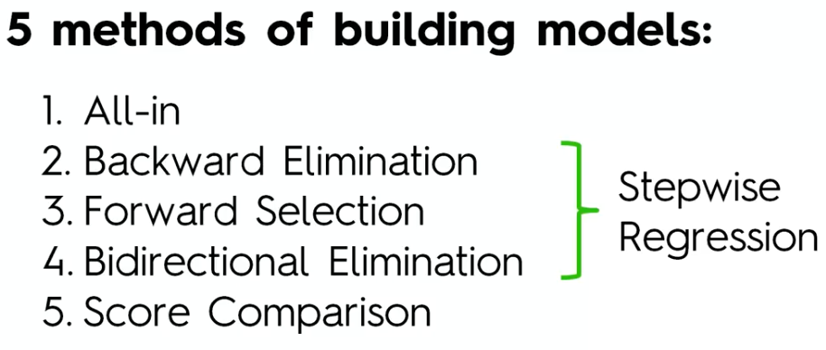

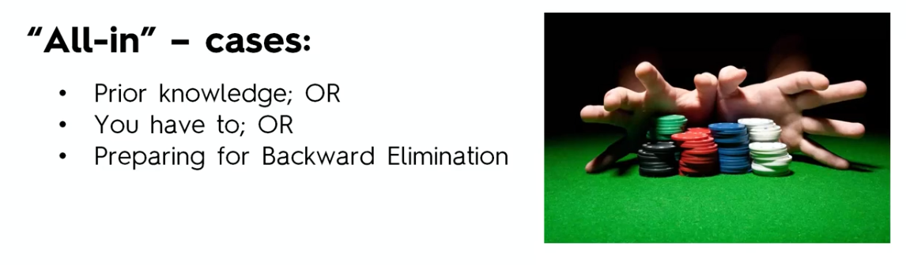

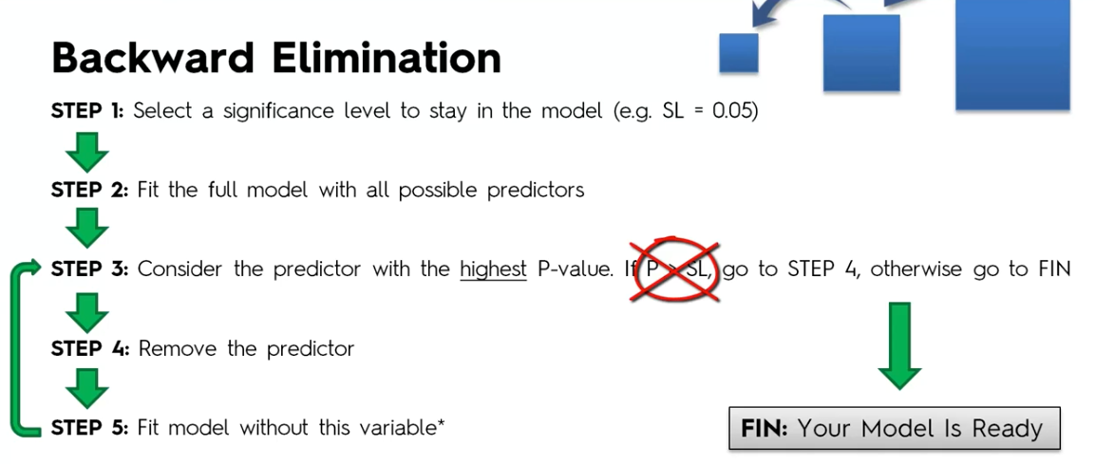

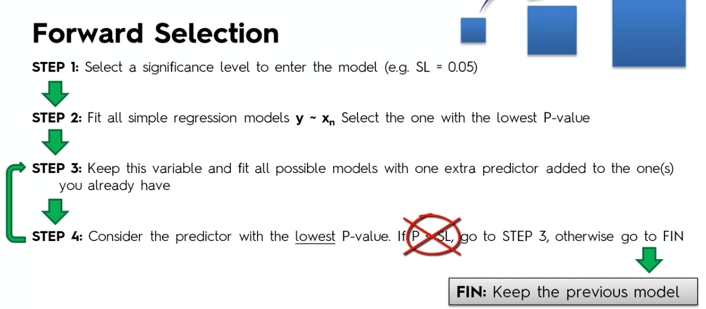

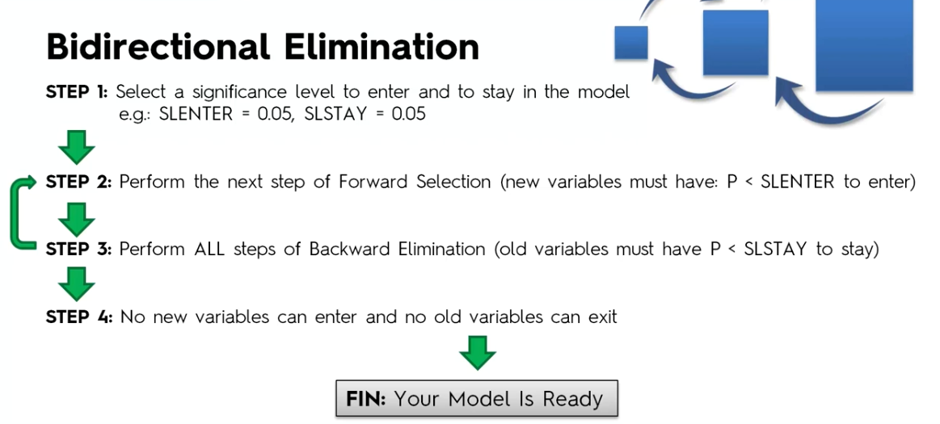

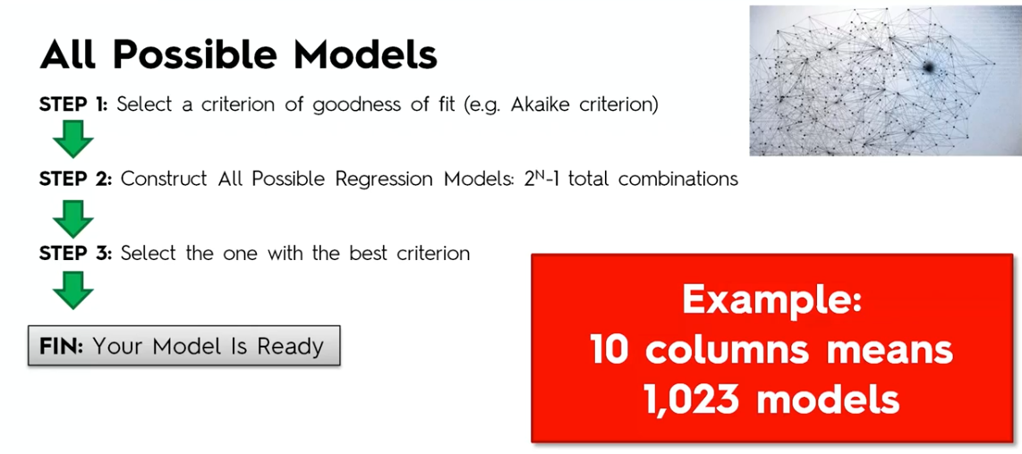

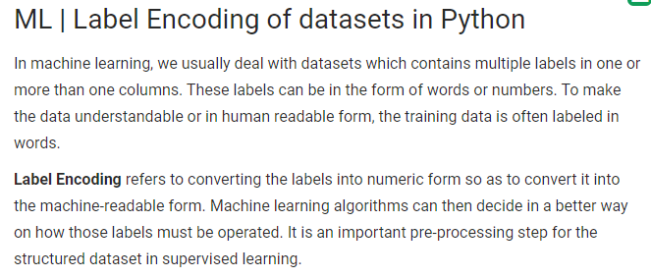

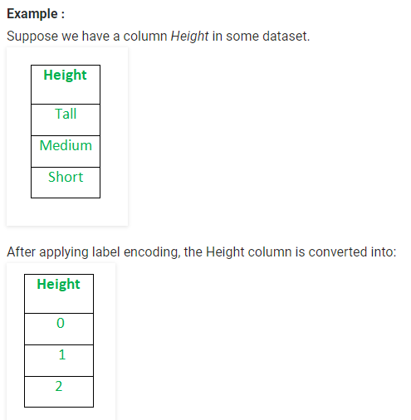

Label Encoder Example 2:::

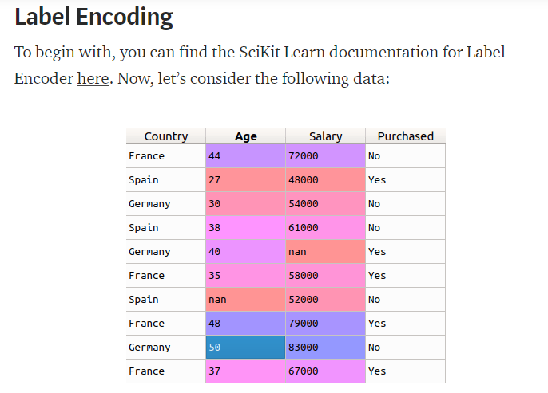

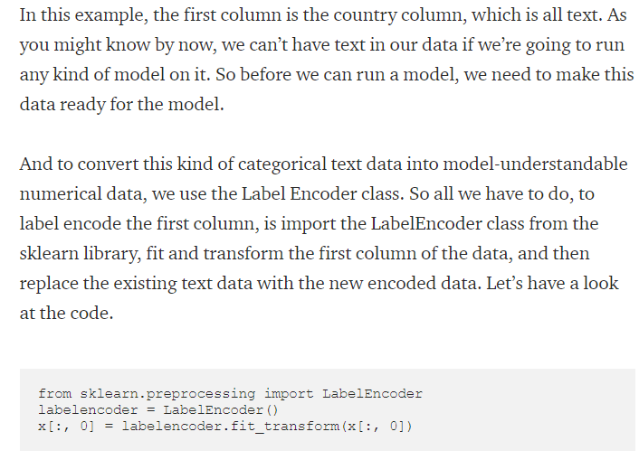

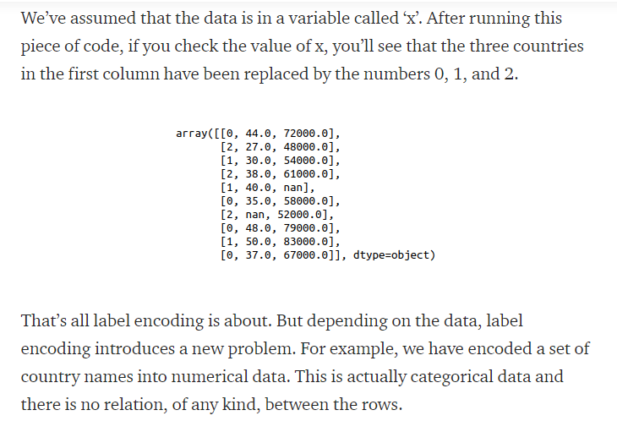

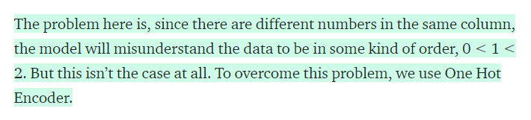

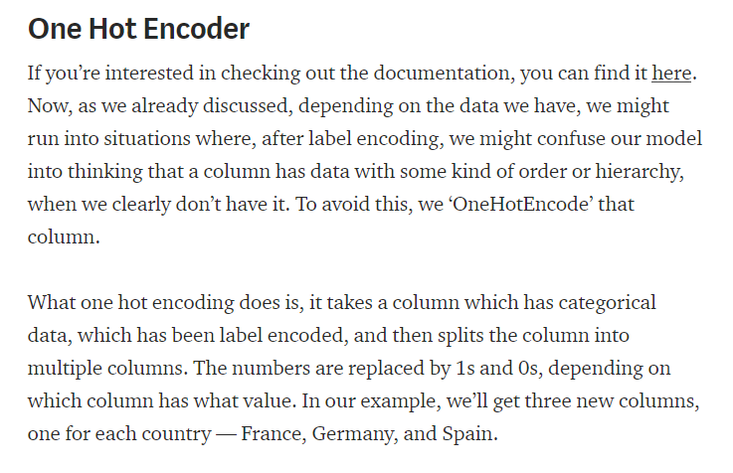

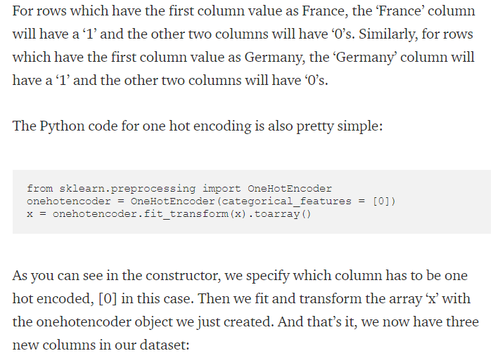

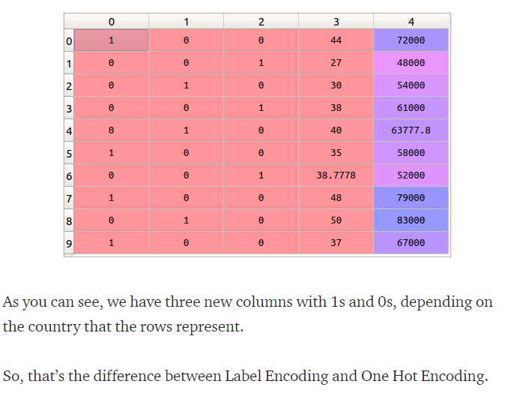

Avoiding

# Importing the libraries

import numpy as np

import matplotlib.pyplot as plt

import pandas as pd

# Importing the dataset

dataset = pd.read_csv('50_Startups.csv')

X = dataset.iloc[:, :-1].values

y = dataset.iloc[:, 4].values

X

# Encoding categorical data

from sklearn.preprocessing import LabelEncoder, OneHotEncoder

labelencoder = LabelEncoder()

X[:, 3] = labelencoder.fit_transform(X[:, 3])

onehotencoder = OneHotEncoder(categorical_features = [3])

X = onehotencoder.fit_transform(X).toarray()

# Avoiding the Dummy Variable Trap

X = X[:, 1:]

X

# Splitting the dataset into the Training set and Test set

from sklearn.model_selection import train_test_split

X_train, X_test, y_train, y_test = train_test_split(X, y, test_size = 0.2, random_state = 0)

# Feature Scaling

"""from sklearn.preprocessing import StandardScaler

sc_X = StandardScaler()

X_train = sc_X.fit_transform(X_train)

X_test = sc_X.transform(X_test)

sc_y = StandardScaler()

y_train = sc_y.fit_transform(y_train)"""

# Fitting Multiple Linear Regression to the Training set

from sklearn.linear_model import LinearRegression

regressor = LinearRegression()

regressor.fit(X_train, y_train)

# Predicting the Test set results

y_pred = regressor.predict(X_test)