if-else Statements Elseif

age = 22

>>> if age <4:

print("your age is uder 4")

elif age<18:

print("under 18")

else:

print("valid")

FOR LOOP + IF CONDITION:::

cars = ['audi',"bmw","maruti","baleno"]

for car in cars:

if car == "bmw":

print(car.upper())

else:

print(car.title())

A Dictionary in a Dictionary

users = {

'aeinstein': {

'first': 'albert',

'last': 'einstein',

'location': 'princeton',

},

'mcurie': {

'first': 'marie',

'last': 'curie',

'location': 'paris',

},

}

u for username, user_info in users.items():

v print("\nUsername: " + username)

w full_name = user_info['first'] + " " + user_info['last']

location = user_info['location']

x print("\tFull name: " + full_name.title())

print("\tLocation: " + location.title())

while Loops :::For APPLIED/PDF/Journal

the while in python used to iterateover a block of code as long as condition true.

while loop to count up through a series of numbers

Syntax :::

While test_expression:

Body of while

Print Number From while

cnt = 2

while cnt <6:

print(cnt)

print("this is inside loop")

cnt +=1; Infinite loop <<<if we remove>>>

Example 2::

cnt = 9

while cnt <5:

print(cnt)

print("this is inside loop")

cnt +=1;

else:

print(cnt)

print("this is out side loop")

While with length STR

word = "9aisolutions"

pos = 0

while pos<len(word):

print(word[pos])

pos+=1

remove Obj from list ::By Using While Loop::

pets = ['dog', 'cat', 'dog', 'goldfish', 'cat', 'rabbit', 'cat']

print(pets)

while 'cat' in pets:

pets.remove('cat')

print(pets)

While Loop With List Condition’s

Finding the product of all number in lst

lst = [2,3,4,5,6,7]

product = 1

index = 0

while index < len(lst):

product *= lst[index]

index += 1

print("product is: {}".format(product))

While Loop with including if-else

Implement a logic , weather declared number is prime or not

num = int(input("enter number:"))

isDivivded = False;

i = 2;

while i < num:

if num % i == 0:

isDivivded = True

print("{} is divisible by {}".format(num,i))

i += 1

if isDivivded:

print("{} is NOT a Prime Number".format(num))

else:

print("{} is a Prime Number".format(num))

Set ::

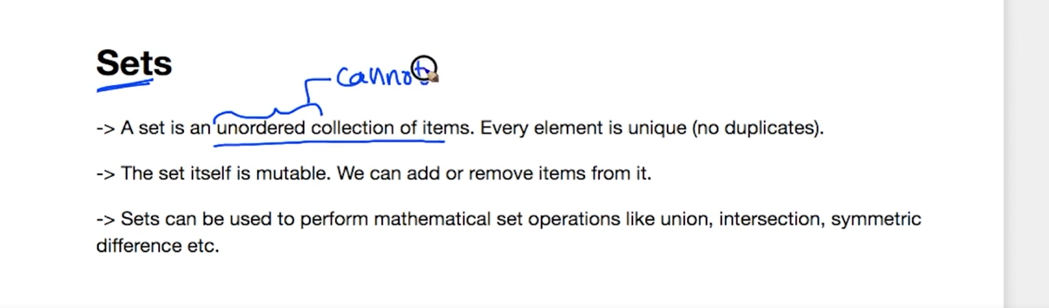

dt ={1,2,3,3,2,1}

print(dt)

type(dt)

str = {"ram","john","ram"}

print(str)

Set is mutable::

#set of list

sg = set([1,2,3,4,1])

print(sg)

Set is Unordered , soo we cant index::

ADD element to a set ::

S = {1,2}

Print(s[1])🡪 Error Becoz set wont allow indexing::

Add to the Set

s= {1,2,3}

s.add(5)

print(s)

#Adding Multiple obj into set using List:

s.update([2,6,7])

print(s)

#Adding Multiples like set and list at once:

s.update([45,55],{54,67})

print(s)

Remove elements from set

s.discard(67) -🡪 remove

print(s)

s.remove(55)

print(s)

#we can remove element using pop() also ::

#it removes random from set mostly first element

s.pop()

print(s)

Clear set:::

s.clear()

print(s)

Set Operations

set1 ={1,2,3,4,5,6,7}

set2 ={3,4,5,6,7,8,9}

# union

print(set1 | set2)

#union

print(set1.union(set2))

#set intersection

print(set1 & set2)

#set intersection

print(set1.intersection(set2))

#set difference :::Set of elements that only from set1 but not from set2

set1 = {1,2,3,4,5}

set2 = {4,5,6,7,8}

print(set1 -set2)

print(set1.difference(set2))

#set symmetric _difference function

#mathematical expression

#(A U B) - (A intersetion B)

set1 = {1,2,3,4,5}

set2 = {4,5,6,7,8}

print(set1.symmetric_difference(set2))

print(set1^set2) # method 2

print(set1.difference(set2))

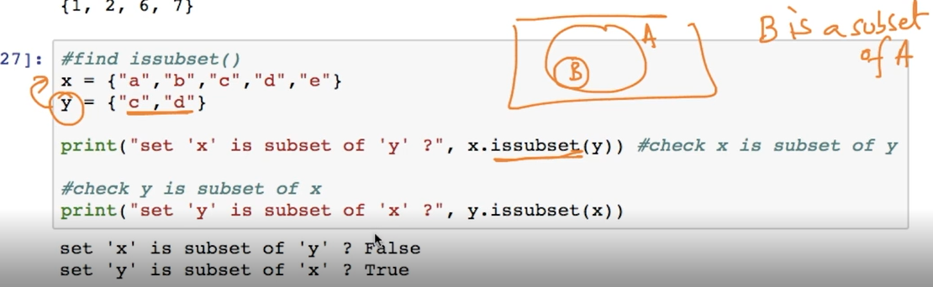

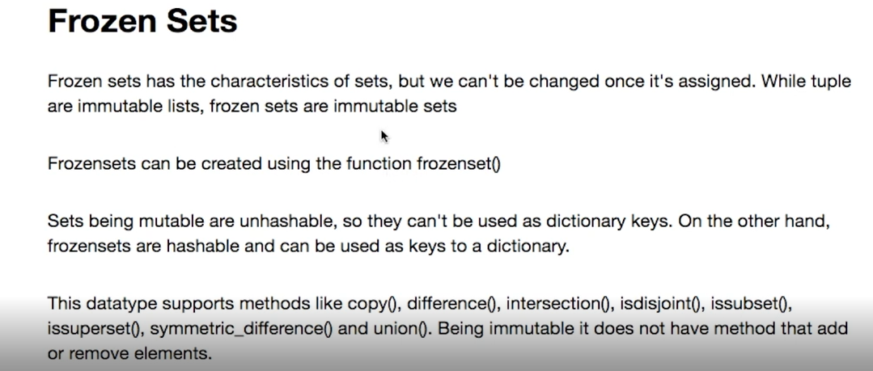

fset1 =([1,2,3,4,5,6])

fset2 =([4,5,6,7,8,9])

#Support all set operations

Functions:

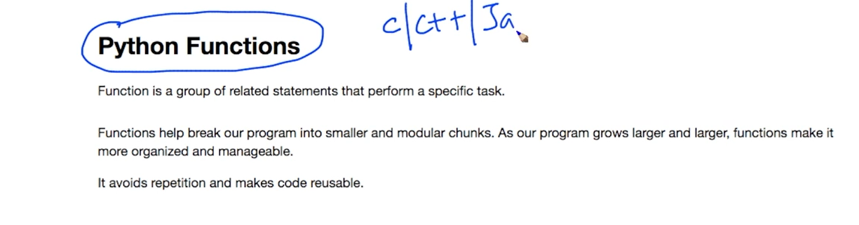

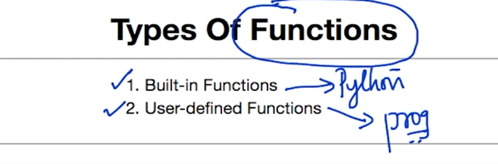

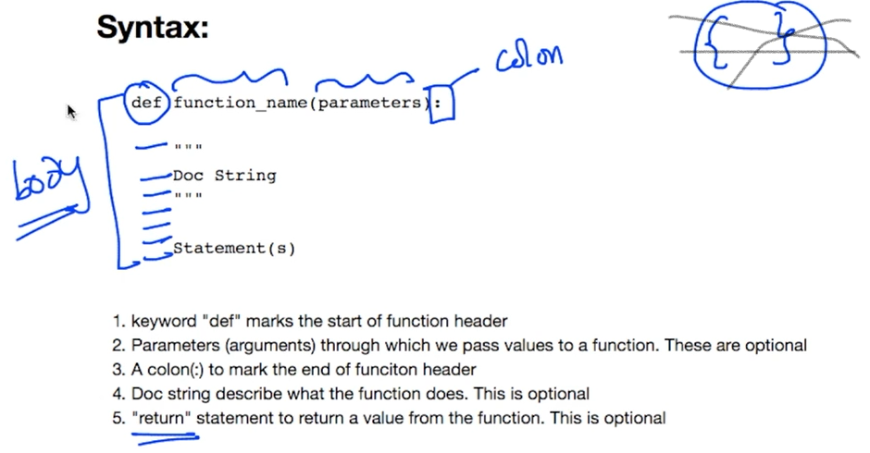

Doc Strg wll give explanation about :::function::

