8a. Evaluation of the Programming Language Used:
In this section of the computer science project, I will be evaluating my computer science project in terms of functionality, structure and needs/requirements.
For the project, I used the programming language VB.net, via the IDE Visual Studio 2013. VB.net is a unique and easy to learn language based on Microsoft’s .NET framework. The .NET framework is a software framework that includes a large collection of libraries, which helps in development of more robust applications. It includes a virtual machine (CLR) that manages the execution of programs. Furthermore, the .NET framework supports many languages – and crucially, it allows language interoperability, whereby each language can use code written in other languages. VB.net was also considered a viable option as it supports object-oriented constructs such as abstraction, encapsulation, inheritance and polymorphism.
I obtained visual studio from our school computers, via their remote network; which contains the free version of Visual Studio 2013, including C# and VB.net. Running the IDE was relatively simple and loaded successfully in sufficient time, which would present you with a starting screen, which would enable you to select a dark theme or light theme. I selected a dark theme which would make viewing and typing code less stressful on the eyes. You would then be presented by this page:
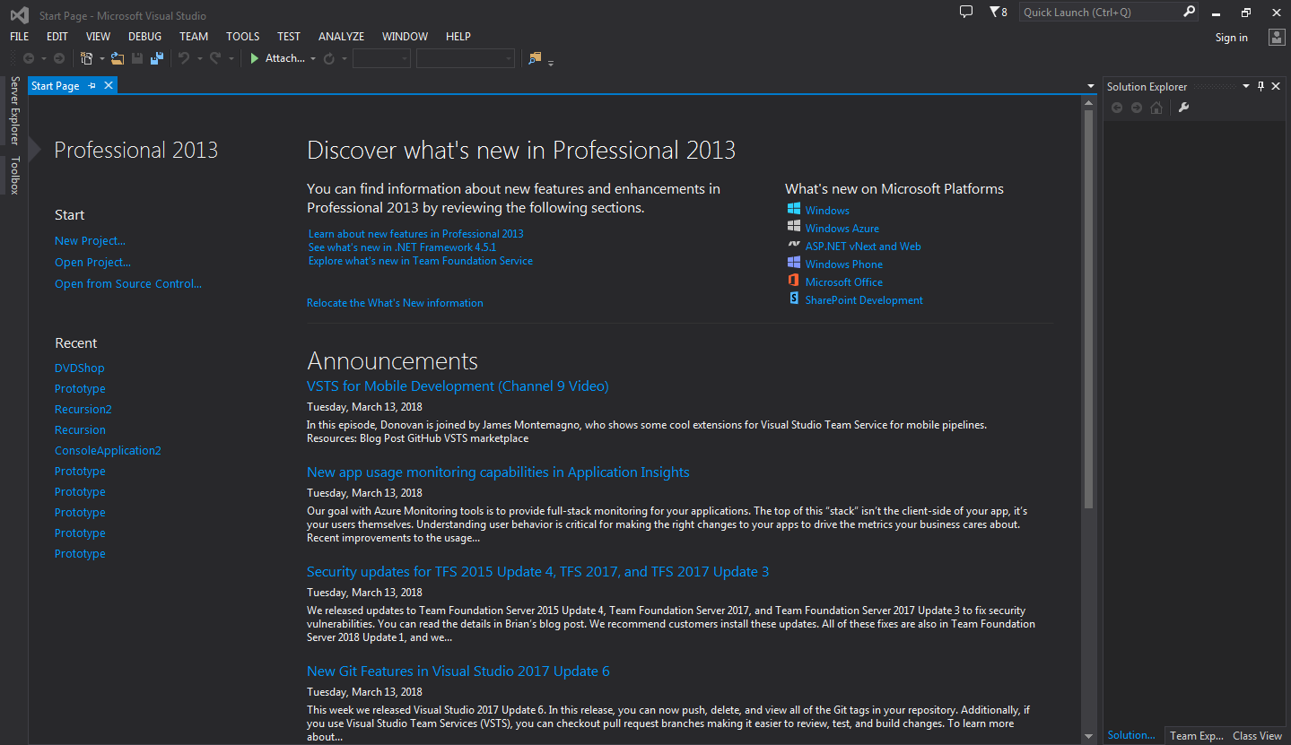
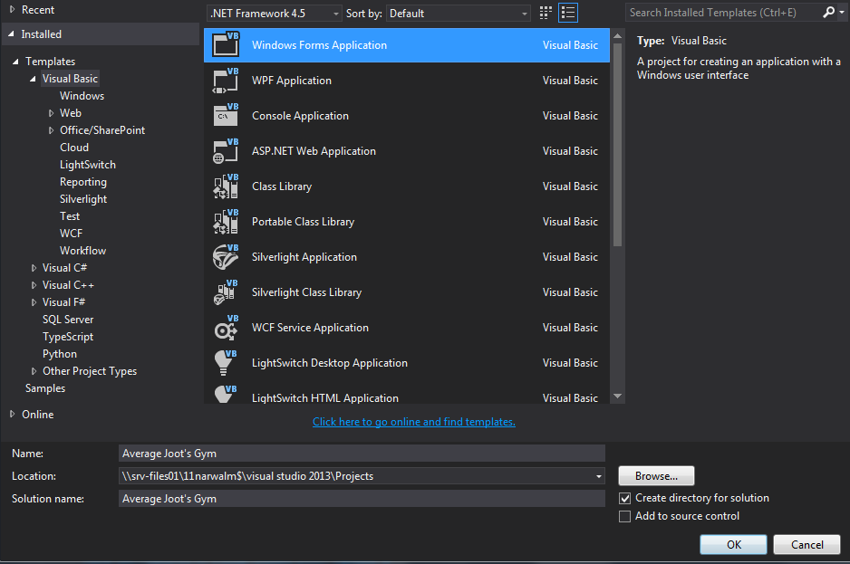
To begin the creation of the project, you’d click ‘New Project’ and then you’d be presented with this screen:

You’d then be able to select your desired language from the templates. In this instance: I’d select Visual Basic, followed by the ‘windows form application’, you can then select the .NET Framework you wish to use (in this instance, I kept the default option), the save location and the name of the solution. I then would click ‘OK’ and then development could begin.
In the IDE Visual Studio 2013, many of the navigation options are available on the top area of the window, which correlates with the theme of general Microsoft applications (e.g. Office).

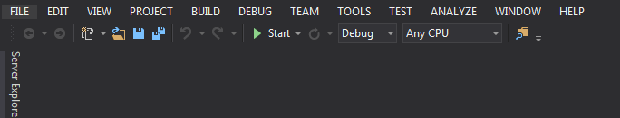
In this area of the window, there are various tools which can be used within development. The ‘FILE’ section included these options:
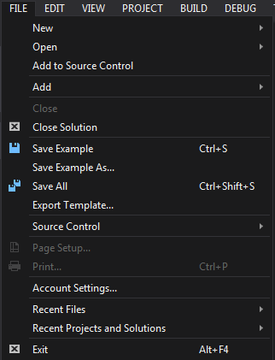
The ‘New’ option enables you to create a new project of various types, including websites, team projects, files etc. The open option enables you to open up existing projects and the add option lets you add other projects to the current one. You then have the standard ‘FILE options on windows applications such as Exit, Save. Close, Recent etc. These tools came of extreme use to me as expected. For example, the save function was extremely helpful in ensuring data was not lost, as sometimes Visual Studio would crash on the school system, and with the inclusion of the macro ‘Ctrl+S’, saving was quick and easy.
The ‘EDIT’ section consists of the general edit functions found within windows applications. This includes: Copy, Paste, Undo, Redo, Delete, Select All and Find and Replace. These options posed beneficial in circumstances where algorithms were repeated, from there: I could copy and paste code using the macros ‘Ctrl+C’ + ‘Ctrl+V’ and then use the Find and Replace function to replace variable names with the correct ones which correspond to the current form.
The ‘VIEW’ section is present to enable the user to various explorers and visual modules such as the solution explorer and the error list, this is useful for when you wish to customise your workspace to your liking. For example, if I accidentally closed the error menu; I can go the view section and find the error menu; upon click you can re-open it.
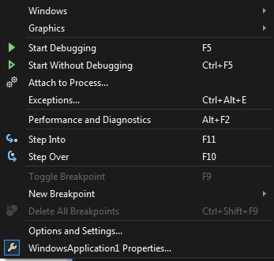
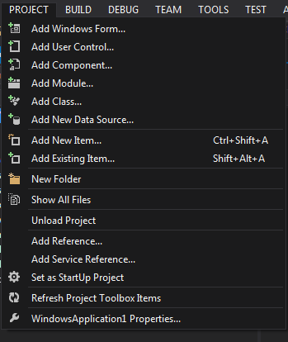
In the debug tab, you will have various options in terms of debugging the application. To debug, there was the options to start the application with debugging on and an option to start the application without debugging. These also had the macros ‘F5’ for start debugging and ‘CTRL+F5’ for start without debugging.
The ‘PROJECT’ option is purposed to enable the user to add and set properties for the project itself. This includes various aspects such as adding a new form, a user control and a class. This area can be beneficial due to the convenience, as you don’t have to go to the project explorer itself to add a new form, module or class. Also, you can view the properties of the project itself on this menu via the bottom option. There are also macros for adding an item.

The ‘BUILD’ section of the navigation menu is used or building an executable version of the code. This section has the capability of building and rebuilding the solution of the computer system. You can also clean the solution from this option and well as publish the solution from this option. This option has been very pivotal towards the development of the program, this is because when I would make some changes to the code, there would be discrepancies and sometimes the changes would not apply with differing forms, in which I would then clean the solution, so when it ran in the ide it would run with the changes in effect.

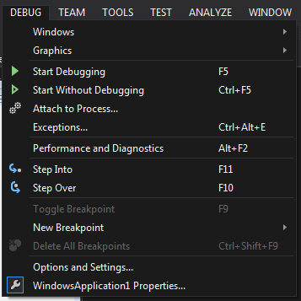
The ‘DEBUG’ section of the navigation menu was purposed to enable debug mode to occur, this mode enables users to debug the program during runtime, in hopes of finding various errors. From
The “TEST” section is then purposed to be able to test the code, run it in debug mode or make breakpoints. This section enabled me to test my program as if I was a user running the program, which would give me a strong indication into how to programs.
Object oriented programming was extremely vital towards the development of Average Joot’s Gym. This is because objects created for Object Oriented Programs can easily be reused in other programs, which can enable re-use of assets for any updates or modified version of Average Joot’s Gym. Objects have the ability to hide certain parts of themselves from developers, which can prevent devs from accidentally tampering with values they shouldn't. Also, Object Oriented Programs forces developers to go through an extensive planning phase, which makes for better designs with less flaws. Hence, the presence of the design section within the project, In which I outline the designs of each form, file structure and even include pseudocode of the fundamental algorithms.
In addition, once a program reaches a certain size, Object Oriented Programs are actually easier to program than non-Object-Oriented ones. An Object Oriented Program is significantly easier to modify and maintain than a non-Object Oriented Program. So although a lot of work is spent before the program is written, less work is needed to maintain it over time. This can be beneficial for me and Average Joots, as updates can be made and released more frequently and changes can be made without a significant inconvenience.
Furthermore, VB.net is an extremely easy-to-use IDE, it has many pre-built libraries from the .net framework which makes developing within VB.net easy and convenient compared to other languages such as Python and Java. Features such as the ability to debug, make breakpoints, create forms has been pivotal in the development of average joot’s gym.
The namespaces included in the .NET framework are:
- System
- System.Collections
- System.Data
- System.Drawing
- System.IO
- System.Text
- System.Threading
- System.Timers
- System.Web
- System.Web.Services
- System.Windows.Forms
- System.Xml
The most notable and used frameworks were System.IO to be able to import the .csv files, and System.Windows.Forms for creating the forms. This library reduced the inconvenience of creating the forms from scratch, by providing me with both the foundations and the options to customise these forms, which enabled me to create both an intiuitive and aesthetically pleasing product.
This is because forms enable me to create the form without coding from scratch, as well as change its name and add controllers. The library of controllers were extensive and included many useful tools such as Tab Controls, Buttons, Labels and Graphs. These all being pivotal towards the development of the database. For example, buttons were required for both navigation and completing tasks (e.g. adding a new member, closing a form) and the system would not function without it, and labels are required to make the software clear and easy to interpret, as labelling text boxes and forms can give the user a clear indication of the form/text box’s purpose as well as the tasks it can complete.
Being able to debug on visual basic was also extremely convenient due to being able to see the contents within lists and arrays, as well as identifying any errors with code. This including syntax errors; which saved a lot of time and effort identifying these errors and making the amendments. Also, I was able to see runtime and logical errors with the debug menu, which helped in terms of adding records to the lists, in which I encountered some errors early into development. For example, when the list was empty and a loop tried to deduct 0 from the count, there would be errors from there, which I would then address.
Furthermore, using VB.net enables you to create installable packages. This can be useful for distribution of the software to other computer systems, and making it easier for the software to be installed on computer systems.
Therefore, I believe that VB.net was the perfect IDE and language to use for this project due to both its extensive library, as well as the reduction in syntax knowledge which reduces both error frequency as well time. Also, the inclusion of debugging tools and breakpoints make VB.net excellent in the development stage, as well as the language being tailored for the windows operating system.

8b. Commercially Available Systems
In this section of the evaluation I will be comparing my project to other commercially available systems. This will give me an indication of the capabilities of my software in comparison to competitiors, and see how close or far Average Joot’s Gym is from that level.
An important aspect to consider is that despite the advancements and the complexity of the tables and forms, my system is indeed less sophisticated than the commercially available systems by a fairly wide margin, this most likely due to the scale and budgets of these systems, which are usually made for large organisations such as chain gyms (e.g. puregym) rather than a newer gym like Average Joot’s Gym.
The fundamental difference between my system and the commercial systems is the scale of operations. This is because Mr Joot’s gym, despite popularity: is small in comparison to competitors such as NRG and PureGym, therefore not requiring power diagnostic or analytic tools, or large data management tactics.
My system provides the facilities to complete the following:
- Member Management
- Trainer Management
- Program Management
- Booking Management
- Other Staff Management
- Progress Management
- Salary Management
- Facility Management
- User Management
- Member Analysis
- Trainer Analysis
- Program Analysis
Despite the lack of features in comparison to the more advance features of competition or larger database software, the fundamental requirements expected of Mr Joot were met successfully, therefore making my current system feasible.
Via research, I have found a commercially available system for gyms called “ActiveLinxx”, and I have conducted research on them.

ActiveL inxx
ActiveLinxx is a database management system provided by ActiveLinx LLC, this system is used for gyms to enable their members to track and monitor their gym activity. This includes the ability to actively track repetitions and sets whilst doing a specific exercise as well as tracking lifetime stats. Furthermore, users are able to access and modify information using a mobile app, which is available on both Android and iOS devices.
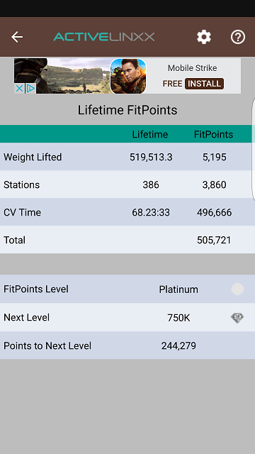
Activelinxx also works with gym devices such as weight lifting machines, and can actively track user data and progress. From here, users can access this data via the online client or via the app which is available on iOS and Android. The user can then download the application and from there,.

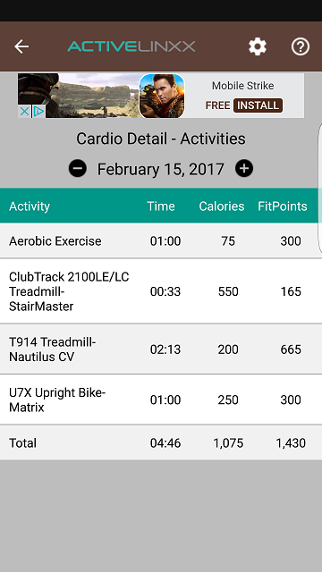
According to their website:
“ActiveLinxx, LLC is the only solution provider for operating the FitLinxx System. As you may have heard FitLinxx has exited the fitness facility market and ActiveLinxx is the new technology powering your facility. The ActiveLinxx team is a group of former FitLinxx employees who remain passionate in the development of the FitLinxx System to improve and encourage healthy lifestyles by providing reliable system performance, excellent customer experience, and innovative solutions.”

Below are the various packages which ActiveLinxx provide:
Services | Basic Package | Full Package | Premium Package
Email Technical Support | Y | Y | Y
Continuous system stability | Y | Y | Y
Replacement parts and remote PC support/diagnostics | Y | Y | Y
ActiveLinxx website access (w-intuitive device language translation) | N | Y | Y
ActiveLinxx Mobile App for android and iOS devices | N | Y | Y
Multi-site continuing support | N | Y | Y
Satellite Management Station (SMS) support | N | Y | Y
Multi-language support | N | Y | Y
On-demand Management Reports and Member Progress Reports | N | Y | Y
Software updates and secure data backups | N | Y | Y
Remote PC support/diagnostics (no charge) | N | Y | Y
No charge for replacement parts | N | N | Y
Priority status telephone support | N | N | Y
ActiveLinxx proactive monitoring system | N | N | Y
Comparison with my system
- ActiveLinxx have email tech support, which can also be provided by myself. Hence, making us similar in that respect.
- ActiveLinxx have website access with language translation, something which my software in unable to provide, most likely due to the smaller scale of my system.
- ActiveLinxx also has multi-language support, something my project does not have.
- They also provide secure data backups, something I could potentially provide in the future but do not have integrated with my database.
- ActiveLinxx also have telephone support and provide replacement parts, something we cannot match.
- Although, we do have member progress reports via the progress table in my database, which can show the progress a member has made in a specific period of time.
- ActiveLinxx also has an android app as well as an iPhone app, which can be used by members, trainers and management. This is something we don’t provide: once again, due to our smaller scale as well as smaller timeframe.
- Also, activelinxx’s data is cloud-based, whereas our data is stored locally in the debug folder of the project.
- ActiveLinxx is run by a development team, whereas I’m one single individual. Therefore, I lack the expertise or the advantage of being able to work within a team to complete tasks more efficiently and with ease.

eFit Financial
eFit Financial is a cloud-based gym and fitness center management solution that allows clients to automate tasks and track payments in real time. This software caters to clubs of all sizes and types, including aerobics, personal training, boxing and martial arts facilities.
This software lets users manage memberships, schedule personal trainers, generate trainer payroll and manage invoices. It provides gym members with online scheduling, registrations and bill payment options.
Primary features of the solution include :
- Billing and payment collection
- Membership management, time
- Attendance management
- Online portal management,
- Inventory control
- Scheduling

The solution is compatible with various browsers across a range of devices such as desktops, smartphones and tablets; and can be integrated with a third-party Full-Service Advantage solution, allowing clubs to access cloud-based applications and outsource all payment processing, billing and collections.

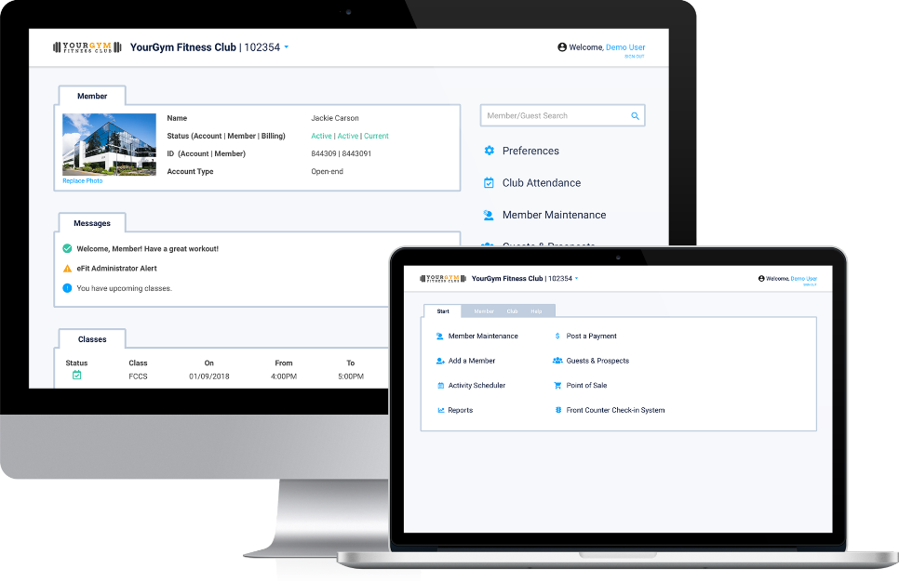

Comparison with my system
- eFit’s data is cloud-based, whereas our data is stored locally in the debug folder of the project.
- They have a billing and POS system, whereas our software does not
- eFit financial has a member check in service, where members can check in and staff can be alerted when they check in, whereas we lack this feature.
- Efit also has automatic reminders and email systems, something our system does not provide.
- Furthermore, eFit financial can provide inventory control; whereas Average Joot’s Gym does not handle inventory or stock. However, this wasn’t in Mr Joot’s needs/requirements so does not matter.
- eFit also provide specialist sports software: for example, personal training, mma, boxing and rockclimbing. Average Joot’s does not have tailored software.
- Average Joot’s does not provide an attendance system for programs or bookings, whereas eFit does.

Overall, my system is not as advance as commercially available systems by a wide margin: however despite this: I am able to meet Mr Joot’s needs/requirements successfully, although these features within the commercially available systems can be used as inspiration for future updates or another database program.
This could be done by me providing cloud-based storage: either by Microsoft storage or by google drive, which can reduce storage space on local systems and keep all systems using the software in-sync in terms of data. I could maybe also implement a schedule system, which can view programs on during a day and ensure there aren’t clashes, although this feature wasn’t on the requirements.

8c. Successful features and suggested improvements
In this section of the evaluation I will be determining the successful features and suggesting features to improve the final product. To do this, I will use my requirements specification I derived from the investigation section and comparing each point to my final product. I will then bold the bullet points in which I believe I didn’t meet and suggest improvements to ensure in the future these can be met.
Requirements Specification
- Create a professional, intuitive and user friendly system that appeals to the users and stakeholders. A system which is not too complicated but does not lack essential features.
- Create a login form, where staff can have various logins, and in which there are different levels of access.
- New Members can be added
- Existing Members can be modified
- Members can be deleted
- Members can be viewed and searched from via different search refinements
- New Trainers can be added
- Existing Trainers can be modified
- Trainers can be deleted
- Trainers can be viewed and searched from via different search refinements
- New Programs can be added
- Existing Programs can be modified
- Programs can be deleted
- Programs can be viewed and searched from via different search refinements
- New Staff Members can be added
- Existing Staff can be modified
- Staff Members can be deleted
- Staff can be viewed and searched from via different search refinements
- Bookings can be added
- Existing Bookings can be modified
- Bookings can be deleted
- Bookings can be viewed and searched from via different search refinements
- New Progress Goals can be added
- Existing Goals can be modified
- Goals can be deleted
- Goals can be viewed and searched from via different search refinements
- New Facilities can be added
- Existing Facilities can be modified
- Facilities can be deleted
- Facilities can be viewed and searched from via different search refinements
- New Salaries can be added
- Existing Salaries can be modified
- Salaries can be deleted
- Salaries can be viewed and searched from via different search refinements
- New Users can be added
- Users can be deleted
- Users can be viewed and searched from via different search refinements
- There is a section of basic analysis, which includes graphs for at least 3 different tables.
- The program must be able to maintain all of the data above and complete all functions accurately and correctly.
- The program must run with speed and efficiency, and be able to handle basic multitasking.
- The program must have compatibility in mind in terms of file storage.
- To ensure success, the project must be completed within the adequate time frame.

Successful Features
Login
- The login feature is now fully functional and works as intended. The user can input various usernames and passwords which correlate to the UserFile and then gain access to the main form. There is also different levels of access, as only the ‘admin’ can see the passwords on the datagridview.
- The user can input the username, password and then click the enter button to go into the program.
- If the password is incorrect, then the user cannot get into the program.
- The login has adequate aesthetics and text effects within the boxes saying the box’s purpose (e.g. “password”), this gives the program a modern aesthetic, making it more welcoming for the user.

Adding Records
- Records can be added for all the tables, including users. Each record can be set specifically and accurately.
- There is validation when adding records for all tables, this includes: presence check, type check and length check. These validation types work as intended for each form and are tailored to the data sets and datatypes it correlates to (E.g. date ranges, text length ranges).
- Each record addition is separated into forms based on what table the record is being added to and has the according input boxes.
- Dates can be entered via a date/time picker for the corresponding forms and ID’s can be selected via a drop-down menu.
- There is also a “clear button” to clear all the text boxes as well as a “return to home” button on each form, to close the form itself.

Modifying Records
- Records can be searched for and refined by various parameters (e.g. by their ID, First Name, Capacity, etc.)
- Multiple datasets on records can be changed at once (e.g. First Name and Home address can both be changed simultaneously).
- Modifying records works as intended.

Deleting Records
- Records can be deleted promptly and effectively.
- The record can be selected via a drop down which shows a parameter such as a full name or a name (e.g. John Smith or Swimming Pool) to make identification easier and more user-friendly.
- There is a messagebox which asks if the user is sure, which prevents mistakes from occurring or accidental deletion.
- The amount of records within the list is shown after deletion.

Basic Analysis
- Analysis has been implemented into the program and works,
- However, there are still issues with the grouping of the bars, which I failed to address in development in feasible time, this can be one of my improvements.

Aesthetics
- I successfully created an intuitive and user-friendly interface which is both aesthetically pleasing and effective in use. Based upon feedback from the post-prototype refinement:
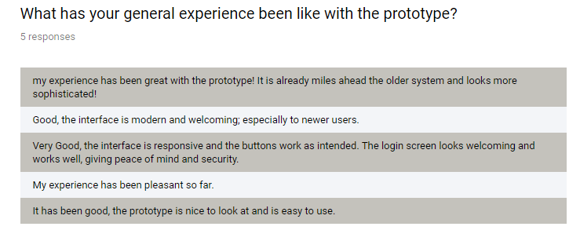
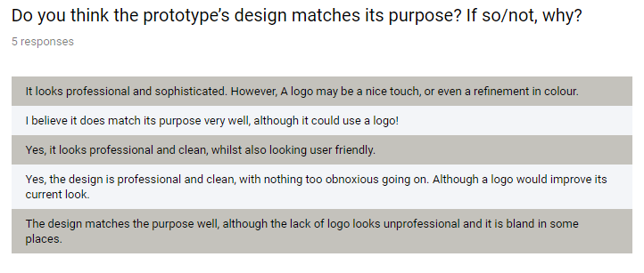
- The user interface is both modern, friendly and approachable; and combines usability with professionalism. Based upon feedback:

- From the feedback, I ended up adding the logo which improves both the user friendliness as well as its presentation. This directly combats the criticism of the lack of logo.

Improvements
Basic Analysis
- For the analysis, I would attempt to address the multiple bar issue, this via changing the format of the list, which is a radical change, hence my inability to complete this change within the time range.
- I would also consider including more methods of analysis which covers more tables, for more in-depth analysis. As well as different types of tables other than bar charts (e.g. pie charts, line graphs etc.)
Aesthetics
- For aesthetics, I would try to experiment with colours in the future. This is because despite the colour difference in tab controls, the buttons and the outside of the tab control both use the control colour, which is a bland grey colour. Maybe as an improvement, I can experiment with something more welcoming such as yellow to match to logo or light blue to have both a sporty theme and a professional set.
- Also, I may consider changing the shape of the form or making it slightly larger. This is because most of the grid views have too much data, meaning you have the scroll to find some records, which may be inconvenient. To combat this, I could make the forms larger to accommodate this, or even potentially fullscreen.
Layout
- For layout, I may change the layout of the buttons on each tab, by making the buttons smaller or increasing the gap. This is because the gap is slightly small, which can potentially lead to accidental clicks on the wrong button. Whilst this is a minimal-non issue, the change could make the program that little bit more intuitivie
- I may also experiment with font changes to improve the aesthetics of the program, this could be by using a wider range of fonts, or more bolder fonts to magnify buttons or labels. This can distinguish the program, as many could argue it looks fairly generic, like a default windows application. Which is complimentary of my layout, but then fails to distinguish itself as proprietary software.

Storage
- For the requirements, I stated I wanted to keep compatibility in mind by using .csv files; however, when looking at commercially available systems. I question if using cloud-based storage would’ve been more efficient.
- This is because cloud-based storage can be accessed from many systems, and a local .csv file may not have the same data on each computer system e.g. there may be more members on one system than another. Therefore, cloud based storage may combat this issue. I could use a cloud service such as google drive or OneDrive from Microsoft.

8d. Strengths and weaknesses of my personal performance.
In this section of the evaluation, I will be evaluating my own performance during this project. These attributes include management, coding ability and well as work completed.
One of the fundamental strengths in my personal performance during the development was my sole interest on the user experience. kept a steady focus on the end user experience from the discussion all the way to post-prototype refinement. Therefore, any change, aesthetics or features would endeavour towards enhancing the final solution and ensuring that the final product was the best it possibly could be in its circumstances. By keeping the user experience as my strongest interest, I was able to put myself in the perspective of the user, which was extremely supportive in ensuring that the final product was a success.
Also, during earlier stages: I identified information as well as planned my interviews before conducting them. I wrote the questions for the face-to-face interview with Mr Joot and wrote down the responses. I managed my time via table, giving me specific deadlines for specific sections; to ensure I don’t fall behind.
The development of the prototype was extremely helpful towards the final product as there was no incredibly significant change required for the required product other than cosmetic or minor changes, this decreased the time making changes for software development and enabled me to focus on the writeup. For example, the cosmetic changes made included a logo as well as minor design tweaks.
Furthermore, having the designs and requirements specifications outlined and available during the development process ensured that I was following the right track to making the product as excellent as possible and ensuring it met all requirements and needs. I also instilled good habits by regularly saving my work using the CTRL + S macro. I also used the spellcheck function in word to check for spelling and grammatical errors. For example, in the investigation section I used spellcheck to ensure there were no spelling mistakes.
One negative aspect of my performance is that I selected an extremely ambitious project, whilst I completed the fundamentals, for example: I was unable to get analysis fully working as well as have many analysis types due to both time and facility constraints. Also, I had issues with making trivial mistakes in code, these including: missing an ending of a letter, wrong variable name, missing piece of code etc. These issues made the development stage cumbersome and longer than it needed to be.
Overall, I believe I succeeded in my personal performance, however: looming issues such as time constraints and over ambitiousness potentially hindered a high potential of a product, despite meeting the vast majority of the requirements.
8e. Changes of approach for future projects.
In this section of the evaluation, I will be thinking about what I would do differently in the future. I will be considering both new features and changes in the process of development and design. These changes include:
- The use of cloud storage instead of .csv files. This is because cloud-based storage can be accessed from many systems, and a local .csv file may not have the same data on each computer system e.g. there may be more members on one system than another. The use of cloud storage can address this looming issue, and I could use a cloud service such as google drive or OneDrive from Microsoft, which is free to use. This can reduce costs for Mr Joot as well as myself in the development process. This will also reduce time in the saving process.
- I would be less ambitious with the project itself. For example, I would use less tables. Whilst this would decrease the complexity of the product, it would reduce time of development and I could focus the extra time on improving features on existing tables (e.g. more sophisticated searching algorithms such as bubble sort, which can improve efficiency). Or I could add useful features such as a “forgot password” button which could enable users to change their password if they forgot it, or to implement an email system; which could be extremely useful to Mr Joot.
- I would plan my code with more depth to prevent unnecessary mistakes made during development, this can reduce the time coding and identifying trivial errors and the time can be devoted to other stages of development. For example, I had issues with making trivial mistakes in code, these including: missing an ending of a letter, wrong variable name, missing piece of code etc. These issues were time consuming and made the development time longer. If I planned the development with more depth, this could’ve been minimised.
- I would focus on being more experimental with my designs and distinguishing them rather than focusing on professionalism. This is because in my program; despite the colour difference in tab controls- the buttons and the outside of the tab control both use the control colour, which is a bland grey colour. If I perhaps was a bit more risky and ambitious with the colour scheme, I can make my products more vibrant and distinguishing, which can increase friendliness to new users as well as reduce the generic standard windows application look.
- I would also obtain feedback in different means than surveys, this may be by conducting more interviews; especially considering the success and usefulness of Mr Joot’s interview. Whilst interviews may take longer and be more expensive, you are able to get a more detailed and in-depth response face-to-face or via video, rather than a text response, and you can have responses tailored via follow ups, which can provide invaluable information.

