## Introduction

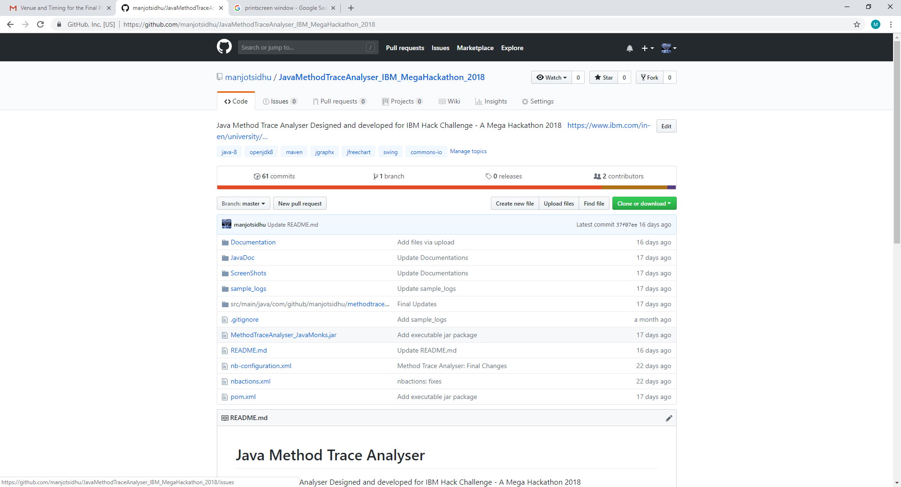

Good Morning everyone, I am Manjot Singh Sidhu, Project Leader of my team JavaMonks and it consists of 2 members, me and my sister Harsimran Kaur Sidhu whose role was to assist in GUI and docs.

## Problem

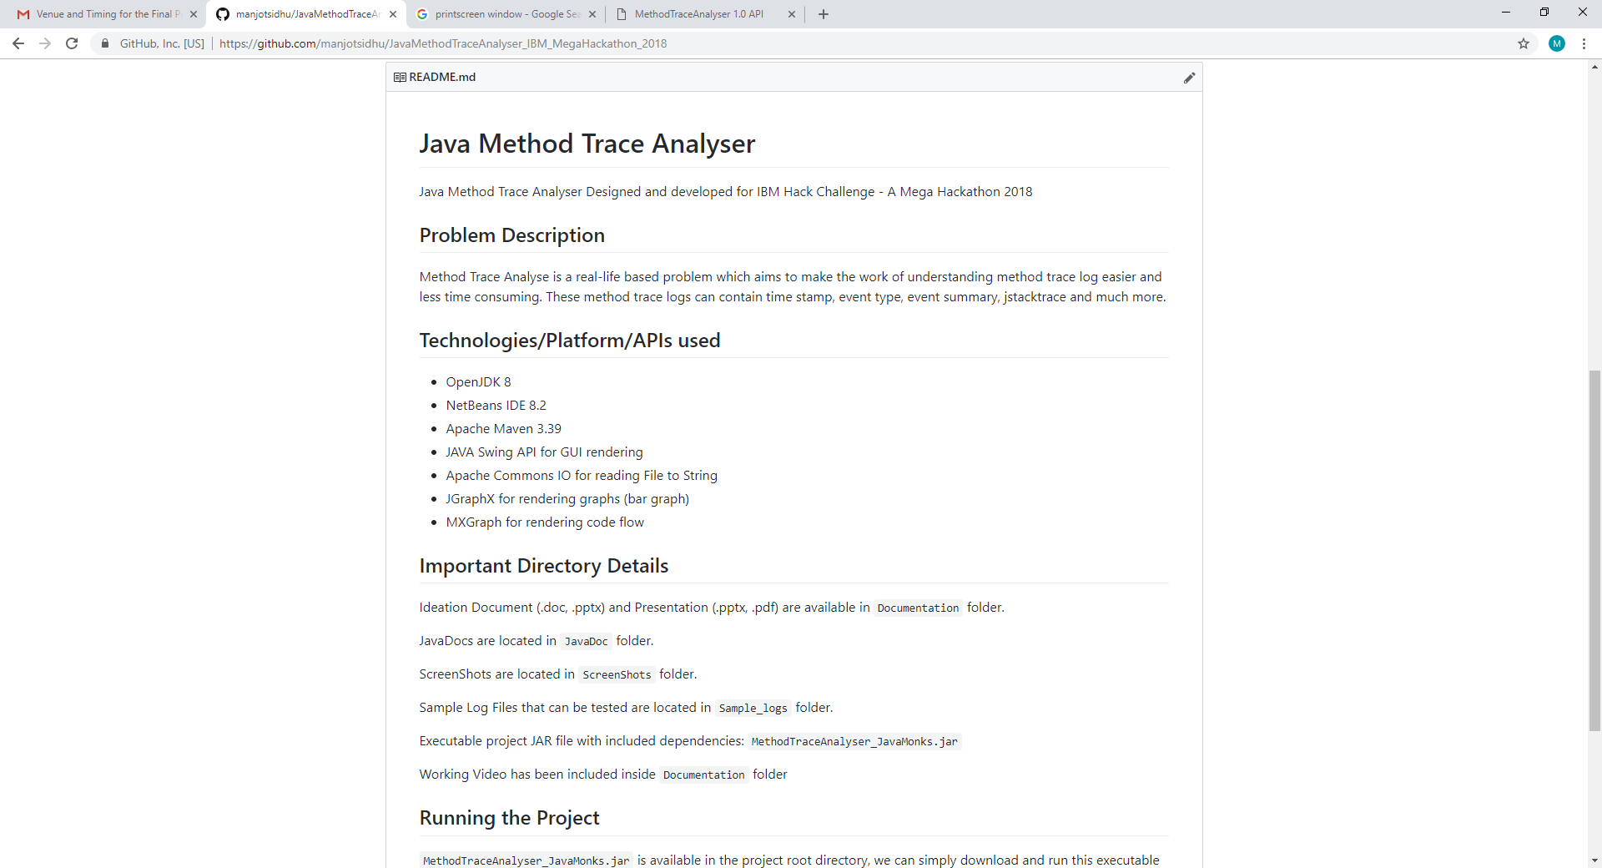

Analyzing method trace logs manually is actually a real-life based problem which often developers feel is time consuming and lengthy process. Its like understanding thousands of lines of logs just to find abnormality in the methods and specially those logs which contain jstacktrace.

## Idea

In order to solve this problem, our main aim is to create a basic Graphical User Interface program which parses more than one method trace log files and analysis the data of all the files and then represents the data in such a way which is easy to compare and representable in graphs and flow charts.

The architecture of the program mainly consists of 3 components, Parser, Analyser and the main GUI component.

## Parser

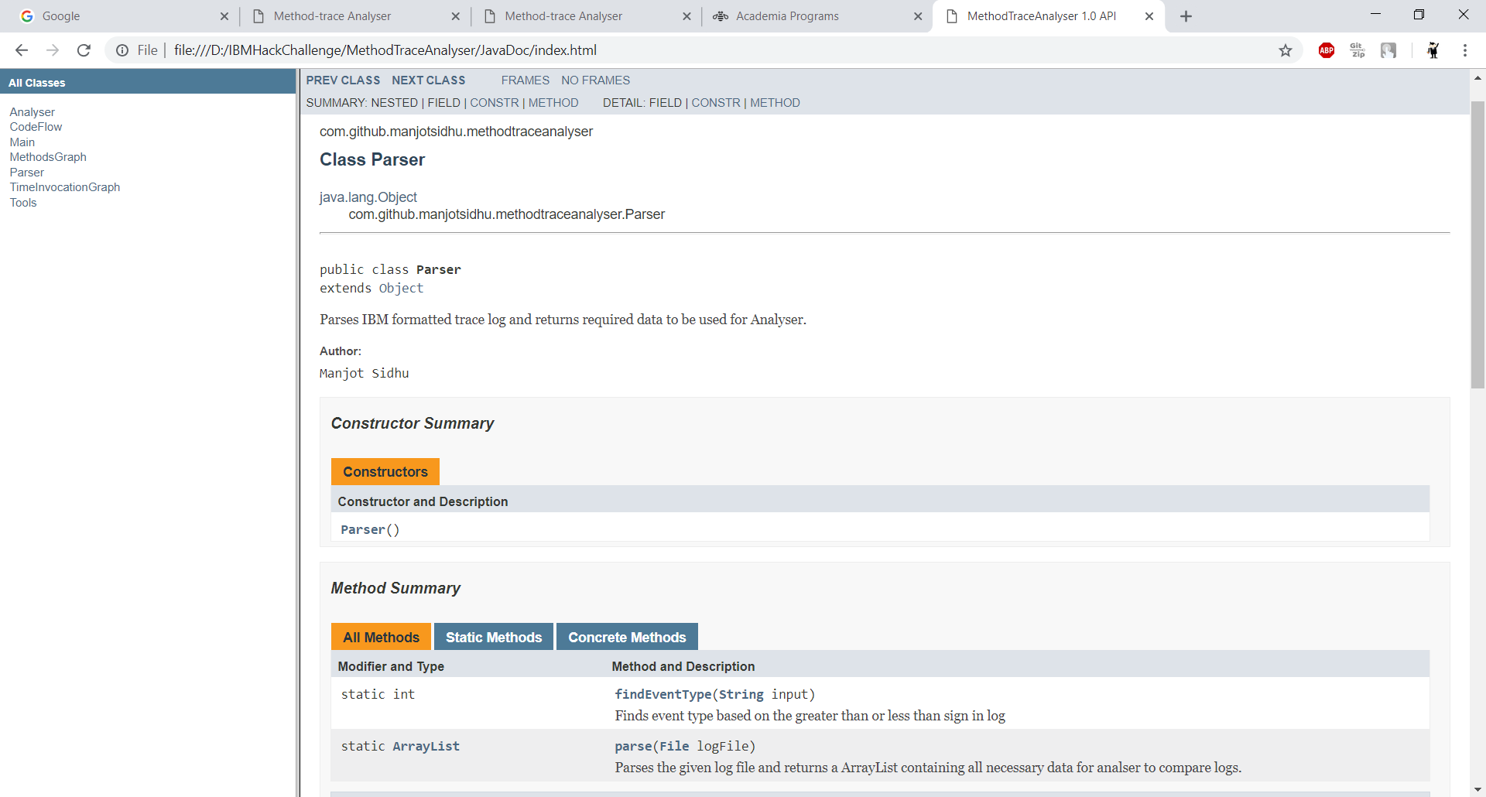

Parser consists of a static method named parse which parses the given log file as an argument. Our first challenge was how to parse the thousand lines of log files within low cost of time. So, we used regex to make this possible. Using a single regex pattern, we successfully extracted all the necessary data from log file and thus a nested 2-D Array List which contains all this data is returned.

## Analyzer

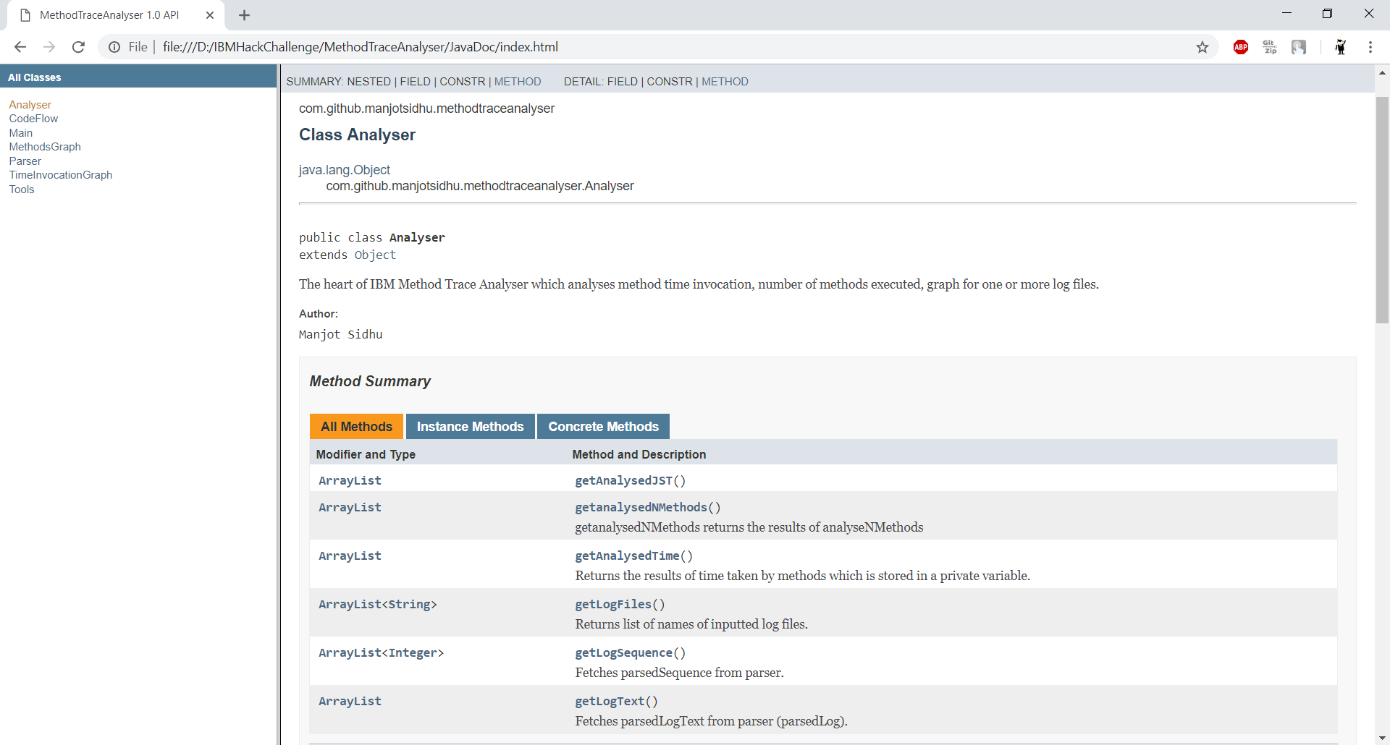

Analyzer uses this parsed data to feed to our 3 methods namely analyseTime, analyseNMethods and analyseJStackTrace.

AnalyseTime method calculates difference between the time stamps at entry and exit points for each method in milliseconds and puts them in a new ArrayList.