Student Name: Manjot Singh

This assignment is based on chapter 9 of the textbook, and involves configuring switches with VLANs, and enabling inter-VLAN communication on a router.

Submission Details

1. Assignment is due in the assignment dropbox in Slate by the end of class in week 11.

2. Submit the following documents as part of your submission:

* This document – complete with requested screenshots
* the FIVE configuration files (FOUR SWITCHES PLUS THE ROUTER). In Packet Tracer click on the device, click on “config” and click “export” beside the running-config file. CLEARLY LABEL EACH CONFIG FILE TO INDICATE THE SWITCH OR ROUTER

3. You will be configuring the following network:

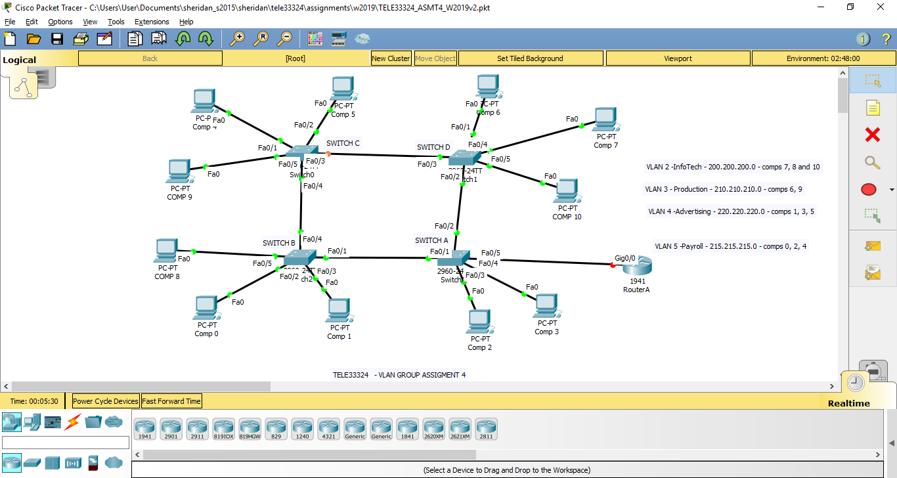

- Figure 1 -

4. Please note that the FOUR switches are 2960 (each with 16 FastEthernet ports) and the Routers are Router-PT. Use the PC-PT for the 11 computers. PLEASE NOTE THAT YOUR INTERFACE NUMBERS DON’T HAVE TO MATCH MINE.

5. Assign ip addresses and default gateways to each of the ELEVEN PCs according to the networks in figure 1. Use the text tool to indicate what ip address you are assigning to each of the eleven PCs. [3]

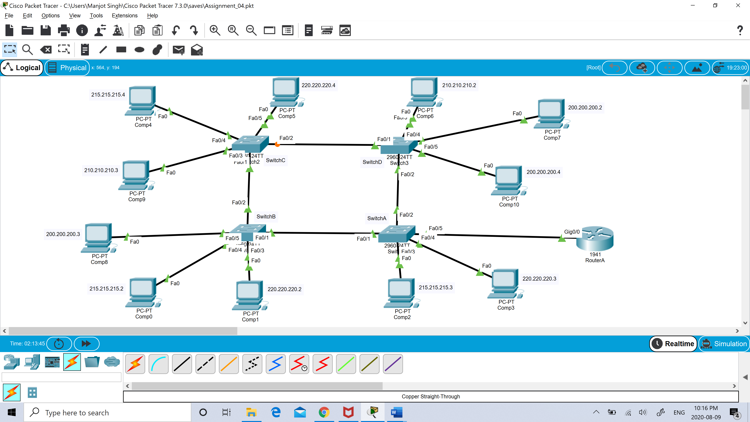

The marks for points 6 – 10 will be ascertained from the config files for the FOUR switches and the Router. Be sure to label each config file

6. Create the four VLANs on switch A, with the names given in figure 1. Set the domain name to TELE33324v2. This will be your VTP server. [2]

Screenshot of “show vlan brief”:

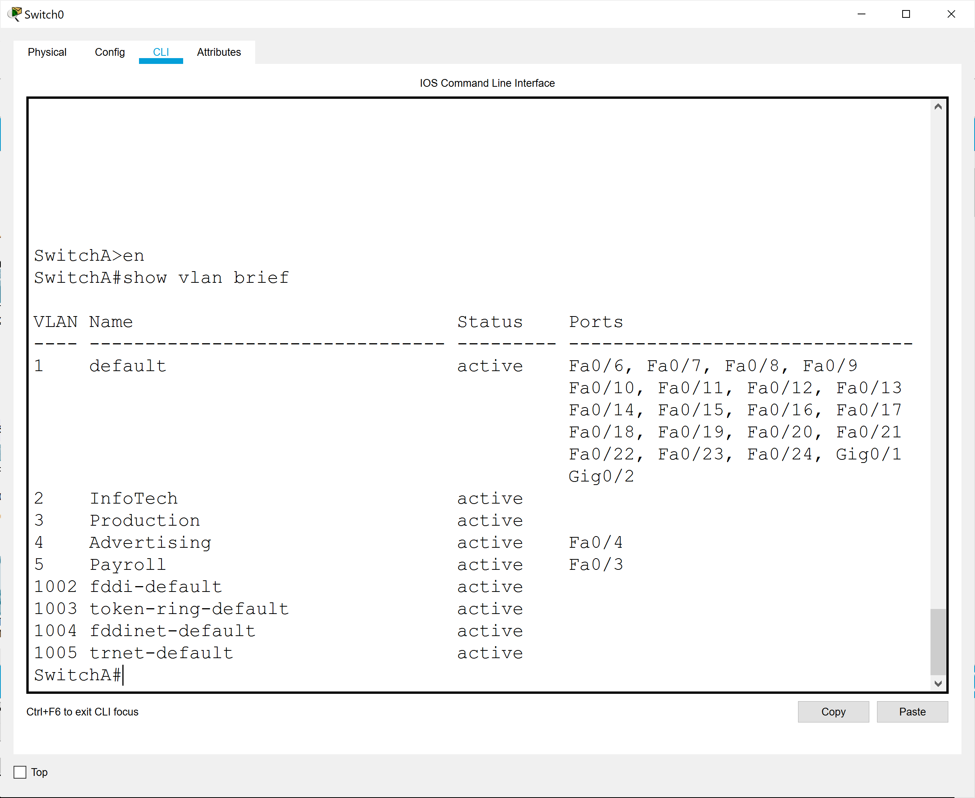

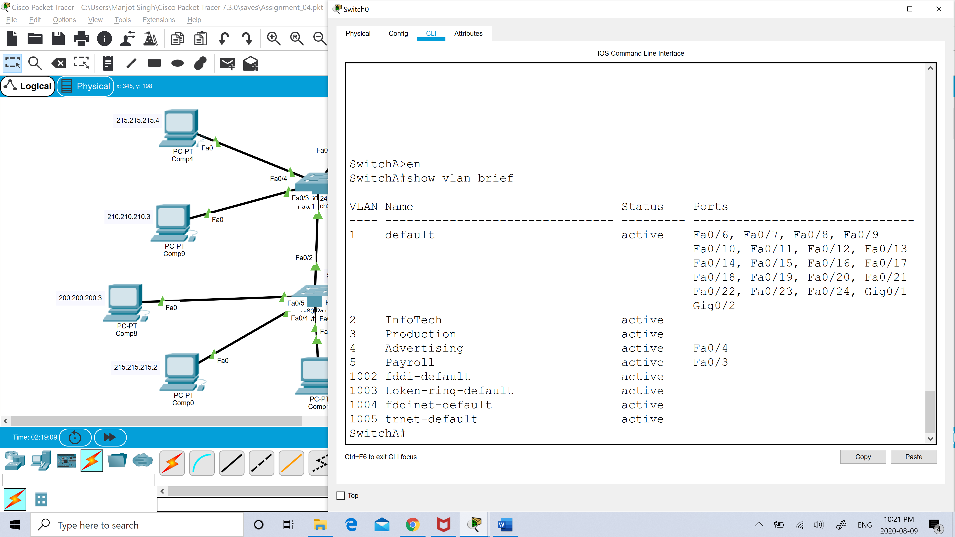

Screenshot of “show vtp status”:

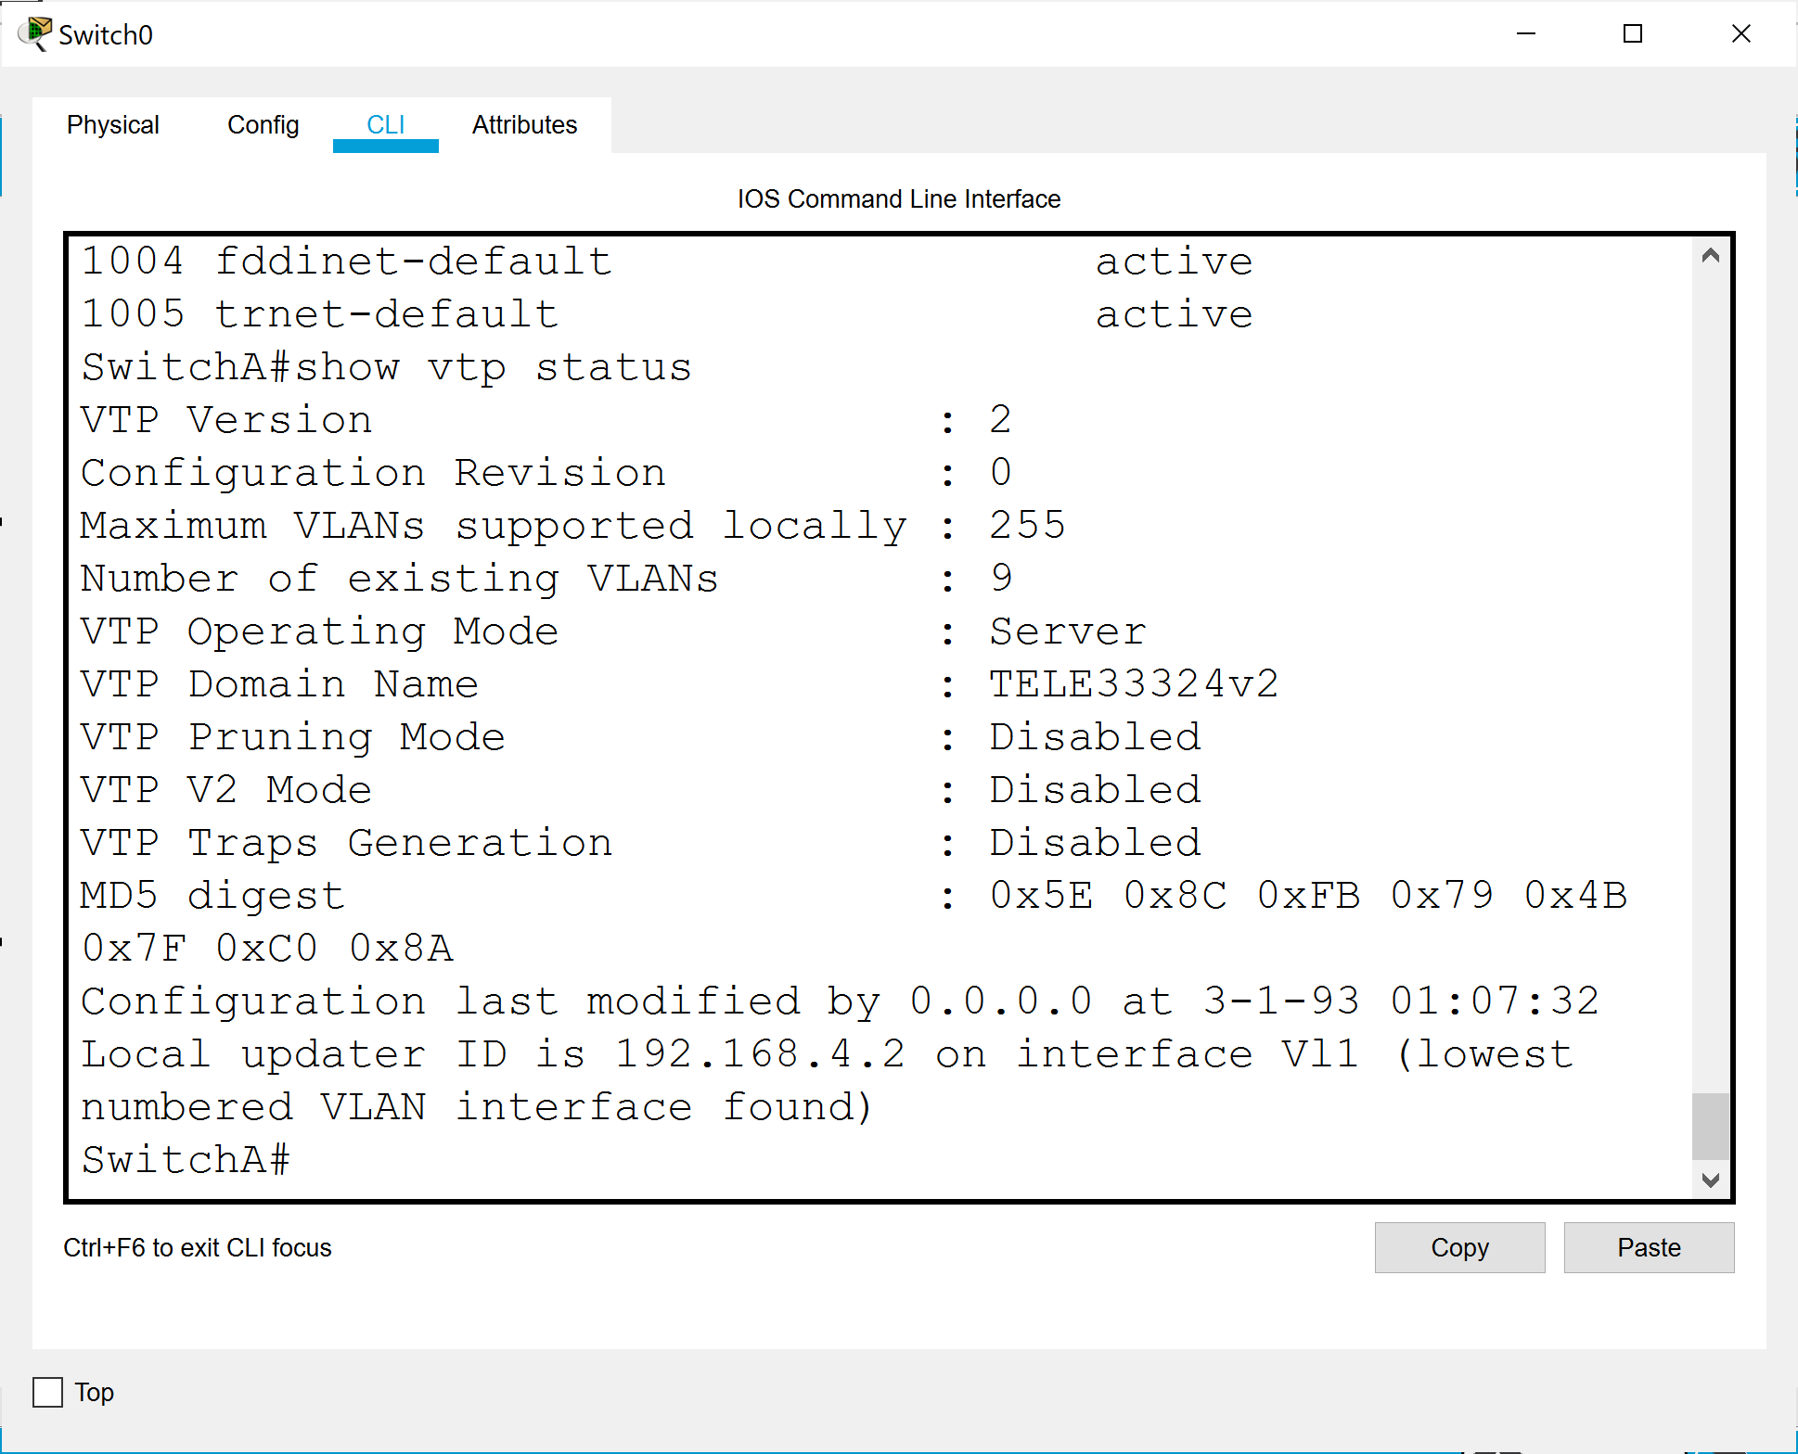

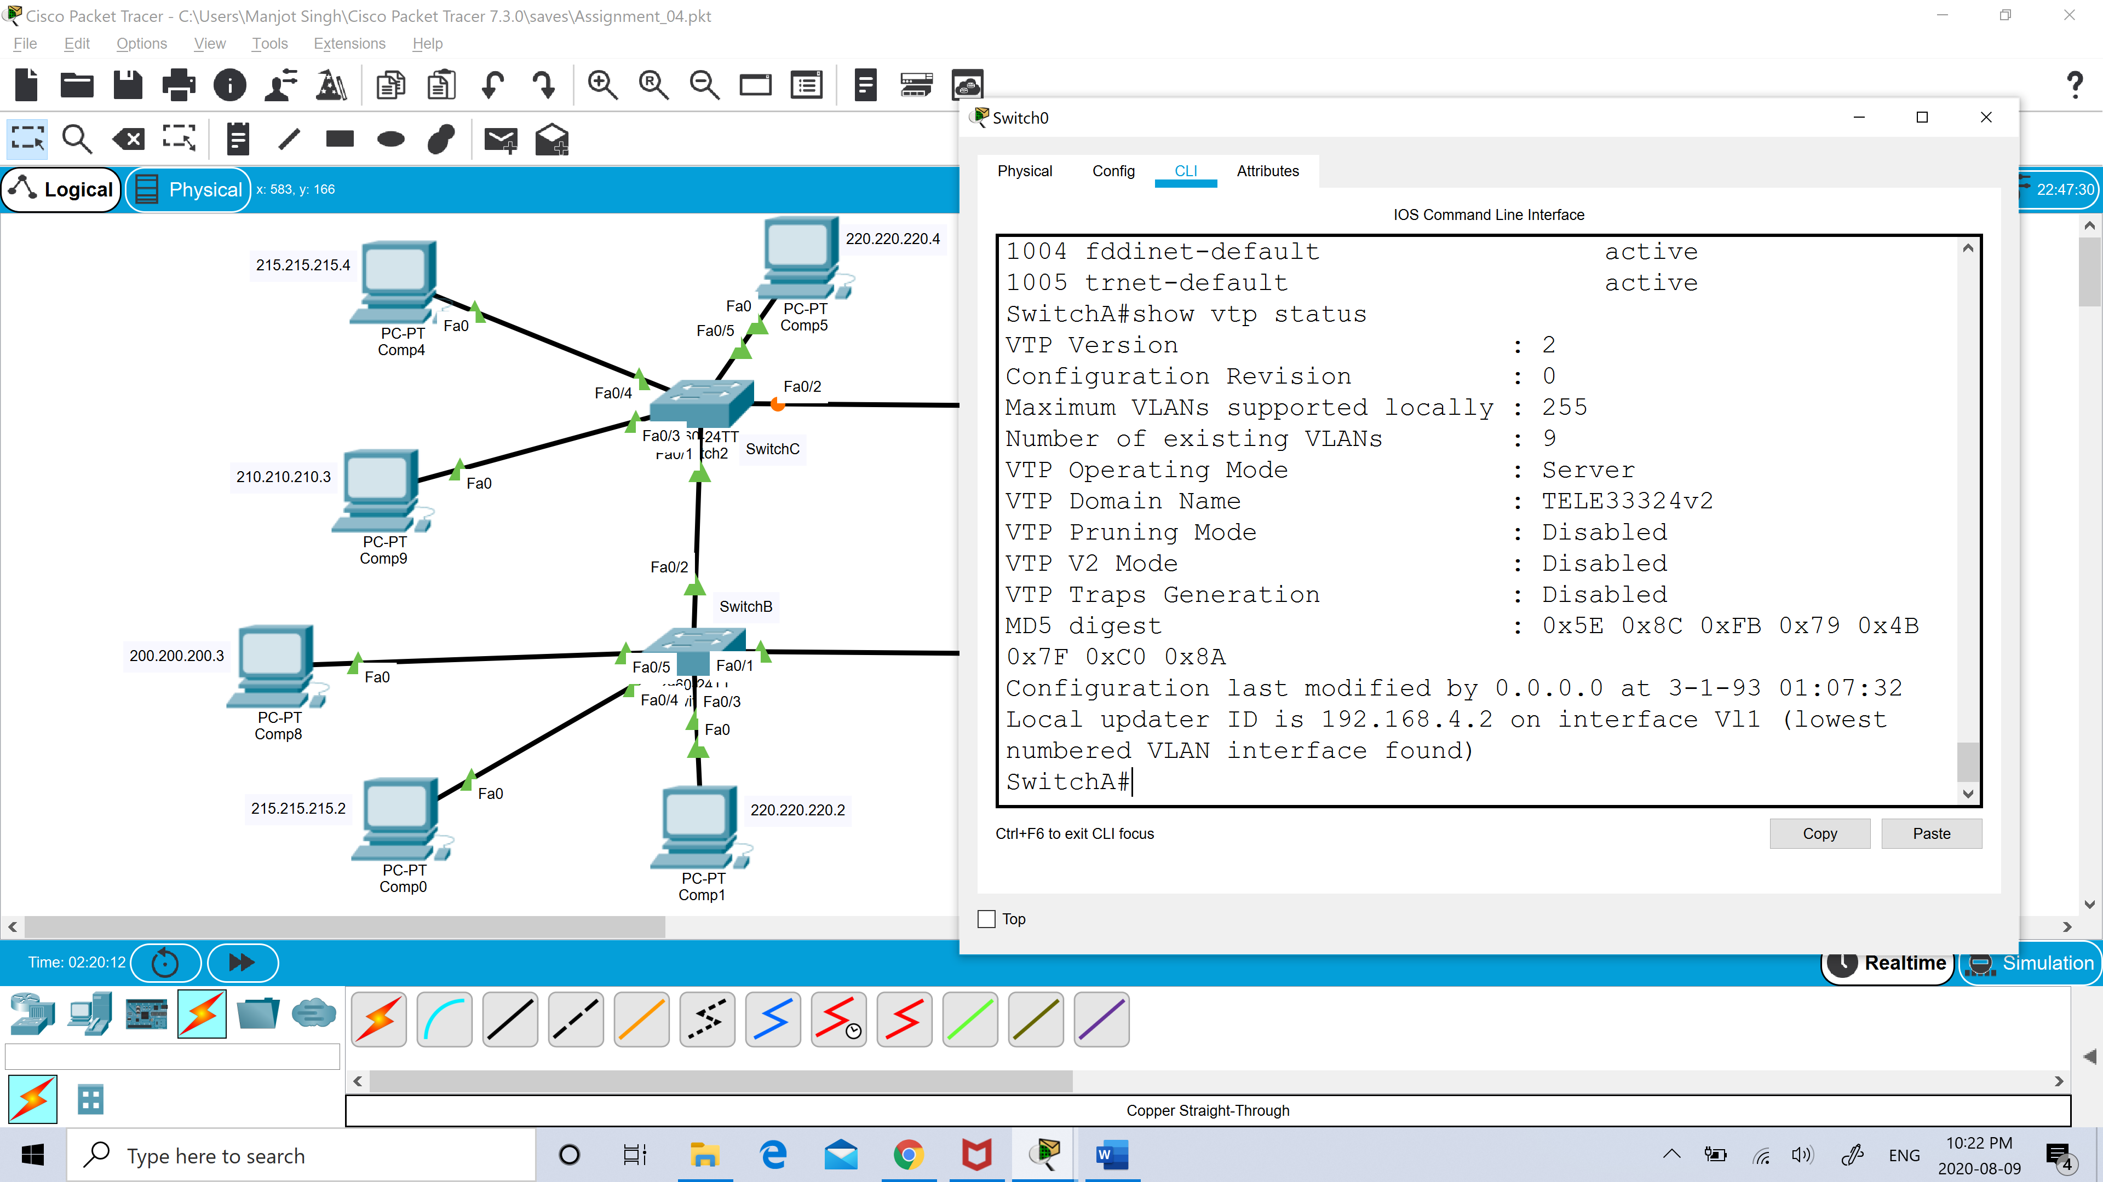

7. Set the required ports on switch A to either ACCESS or TRUNK, as appropriate [2]

8. Set switches B, C and D to VTP clients, AFTER setting the domain name to

TELE33324v2. [2]

Screenshot of SwitchB “show vlan brief”:

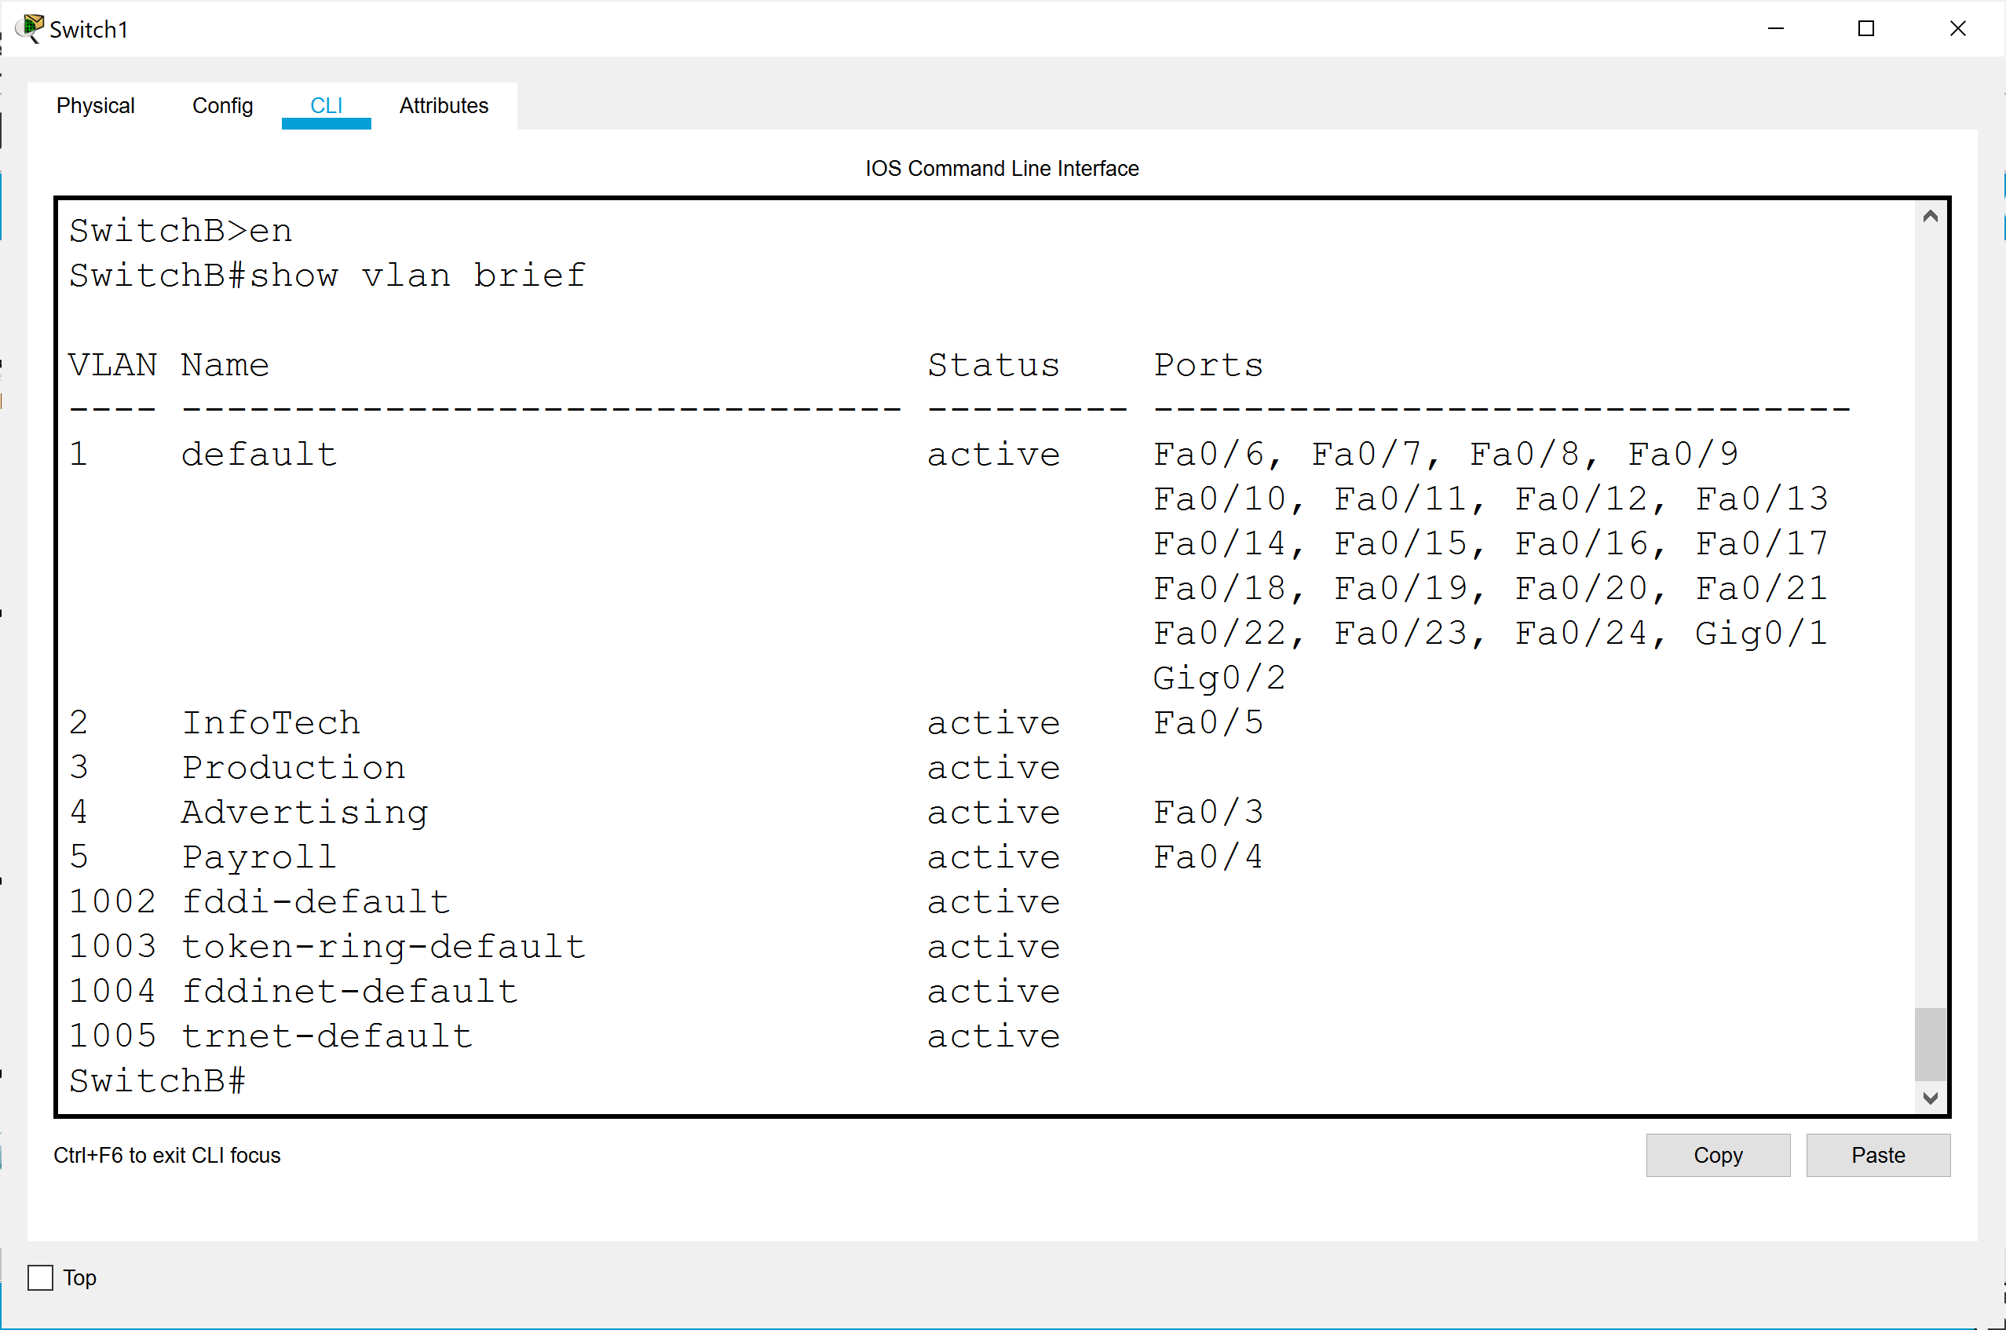

Screenshot of SwitchB “show vtp status”:

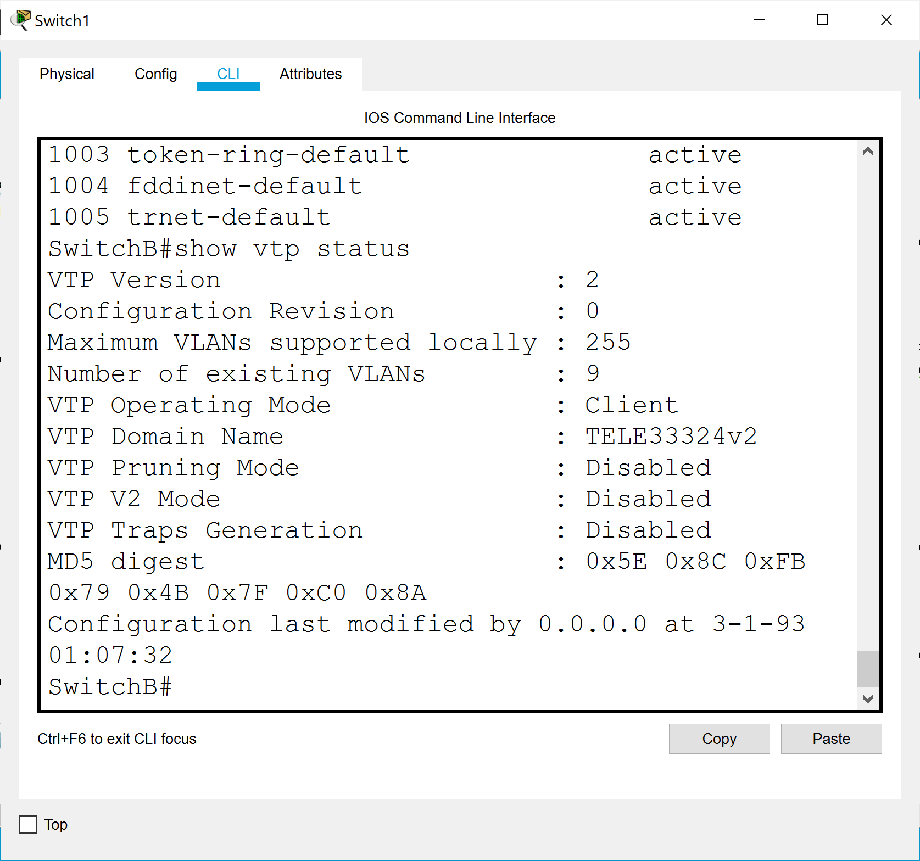

Screenshot of SwitchC “show vlan brief”:

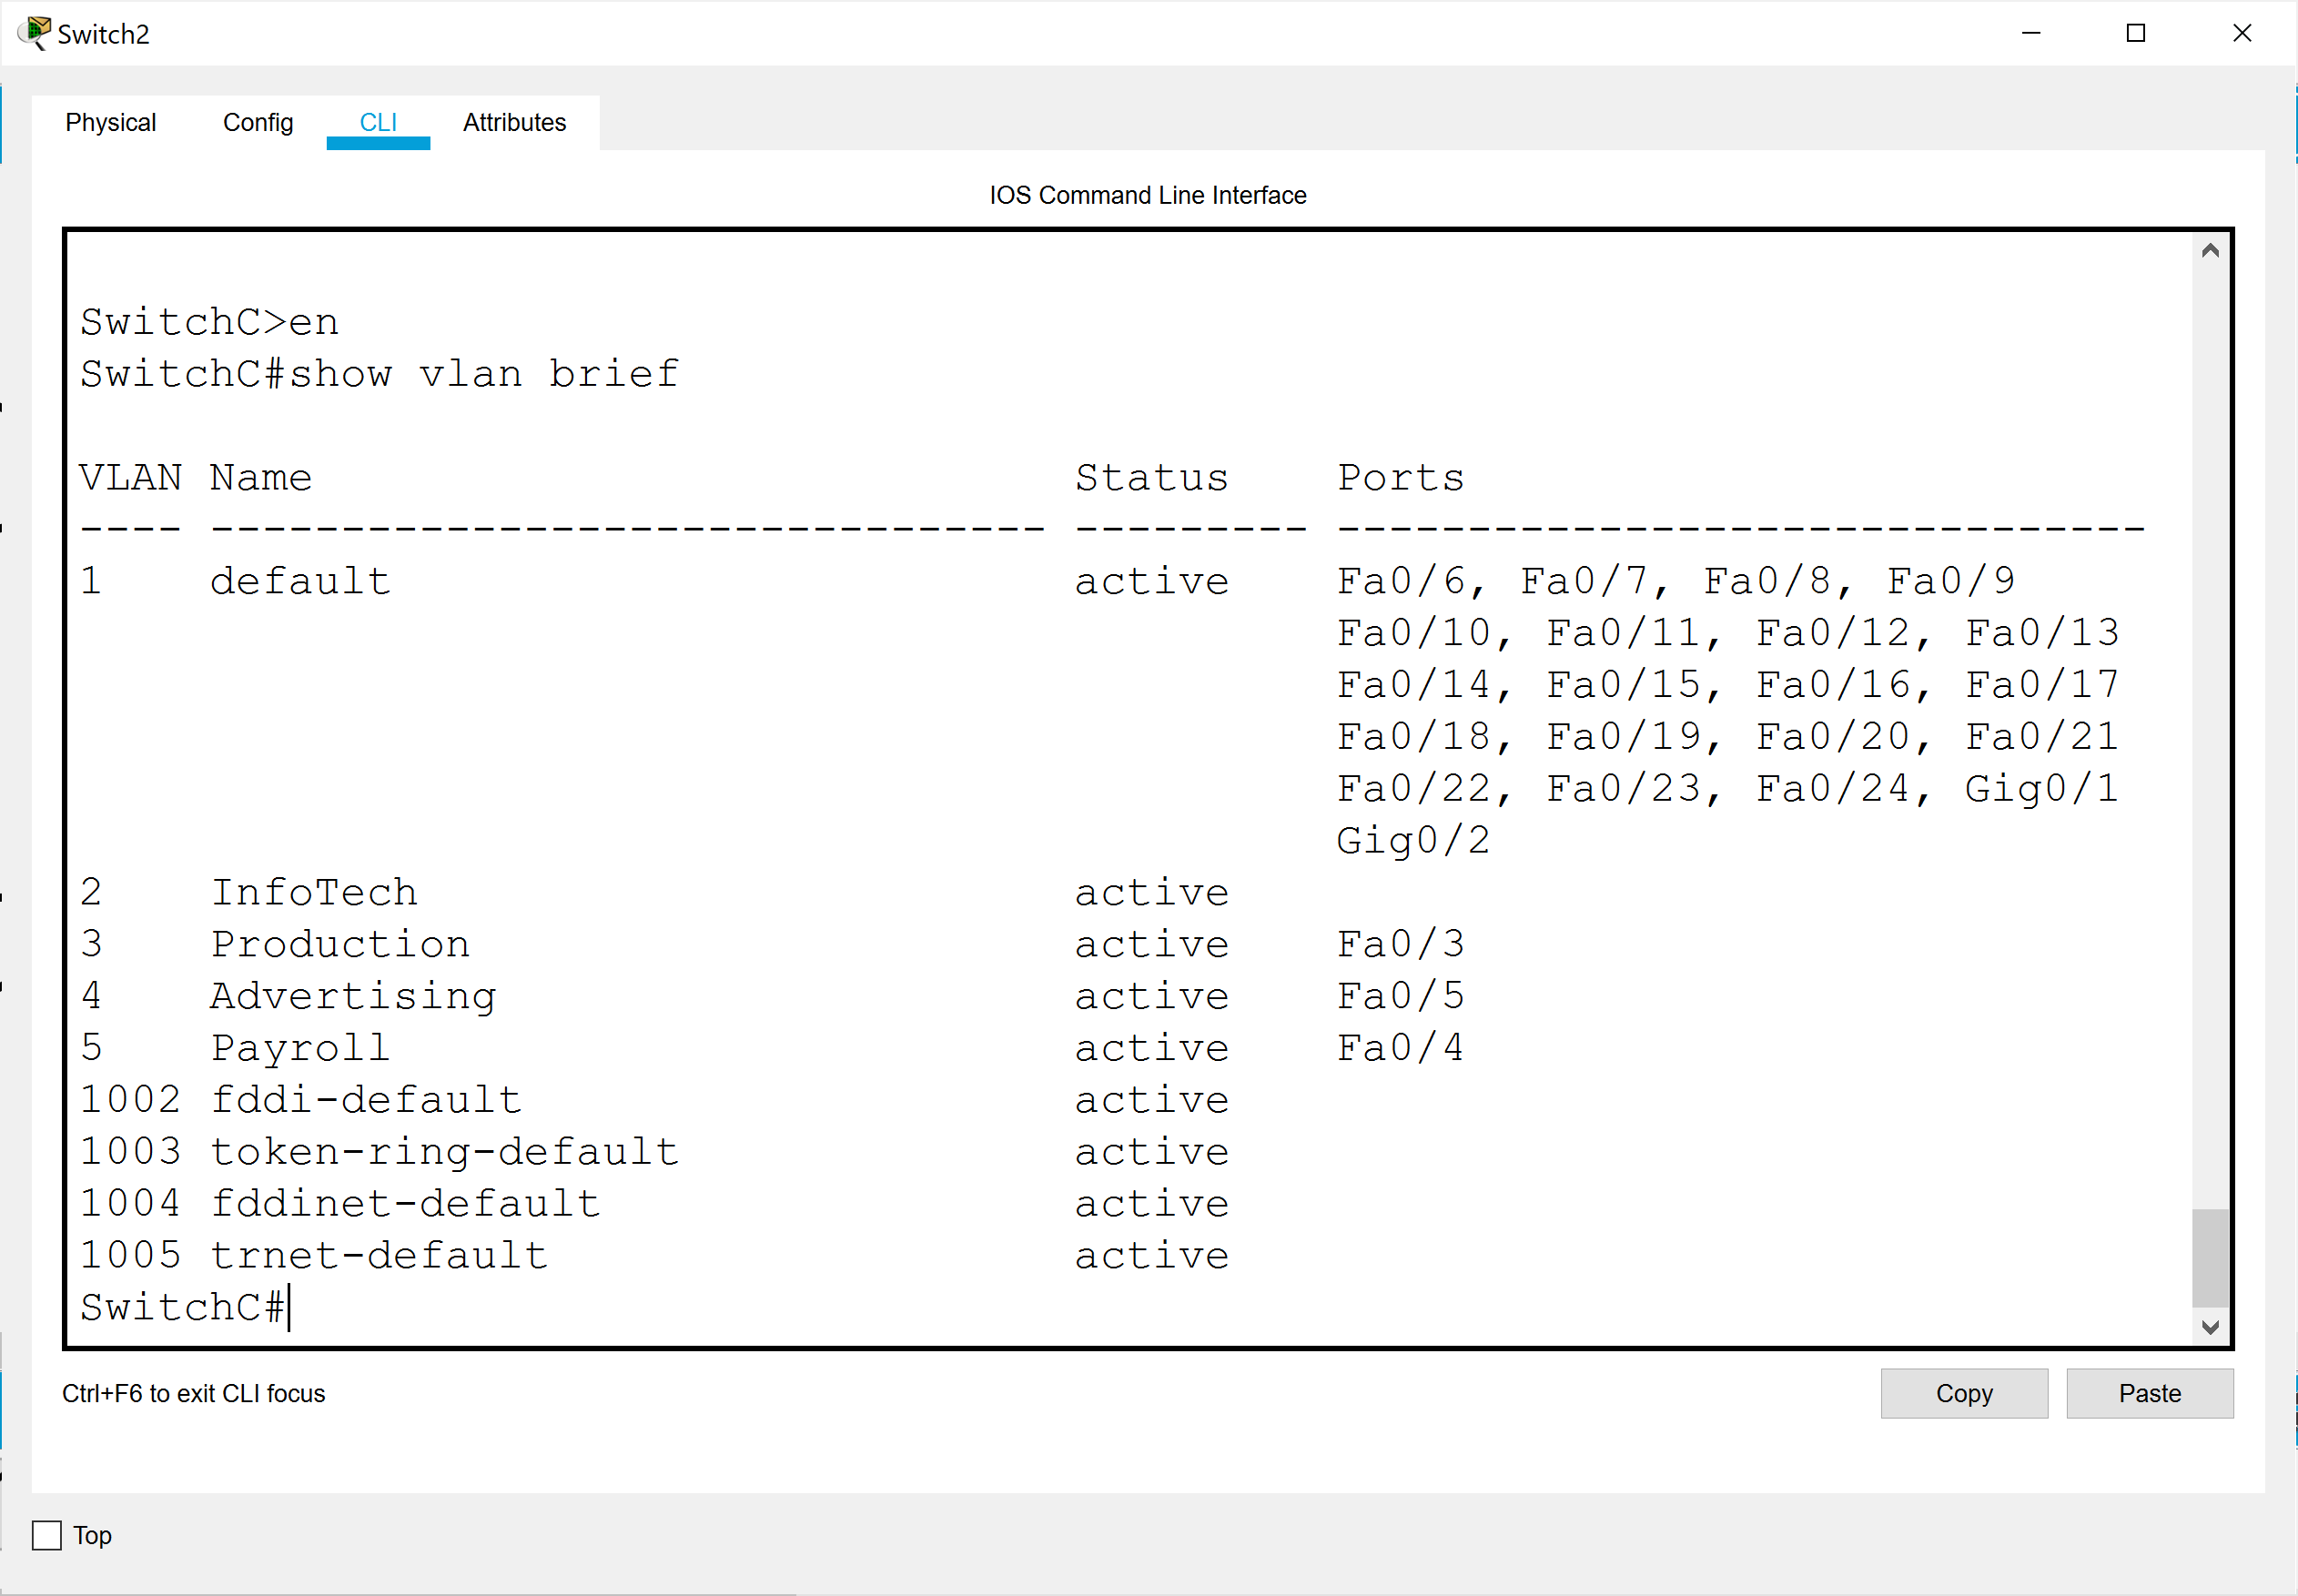

Screenshot of SwitchC “show vtp status”:

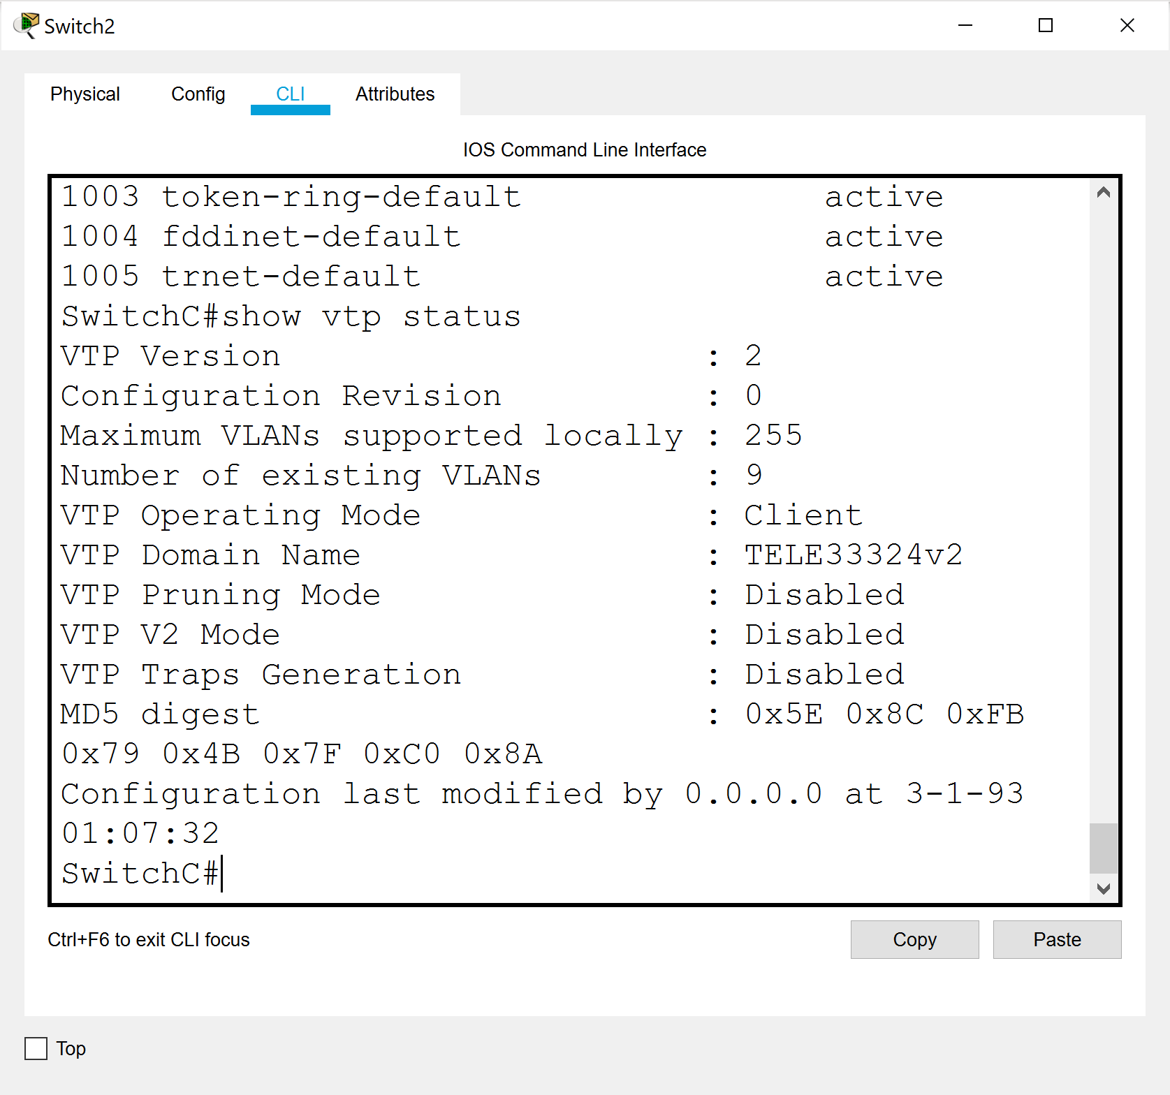

Screenshot of SwitchD “show vlan brief”:

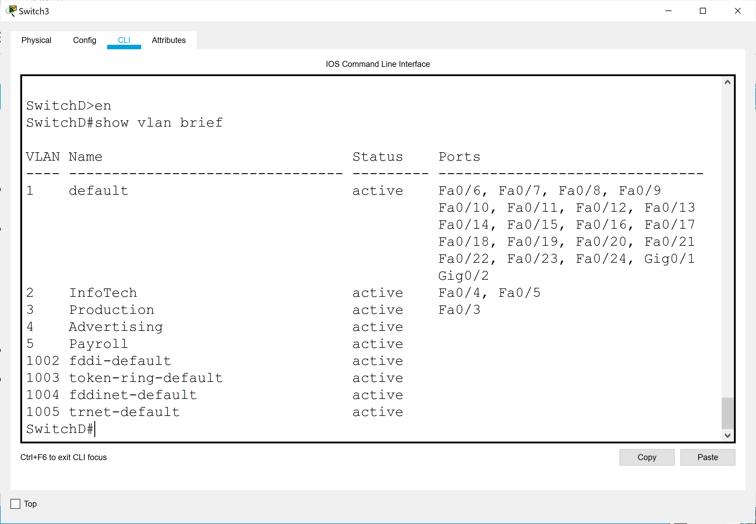

Screenshot of SwitchD “show vtp status”:

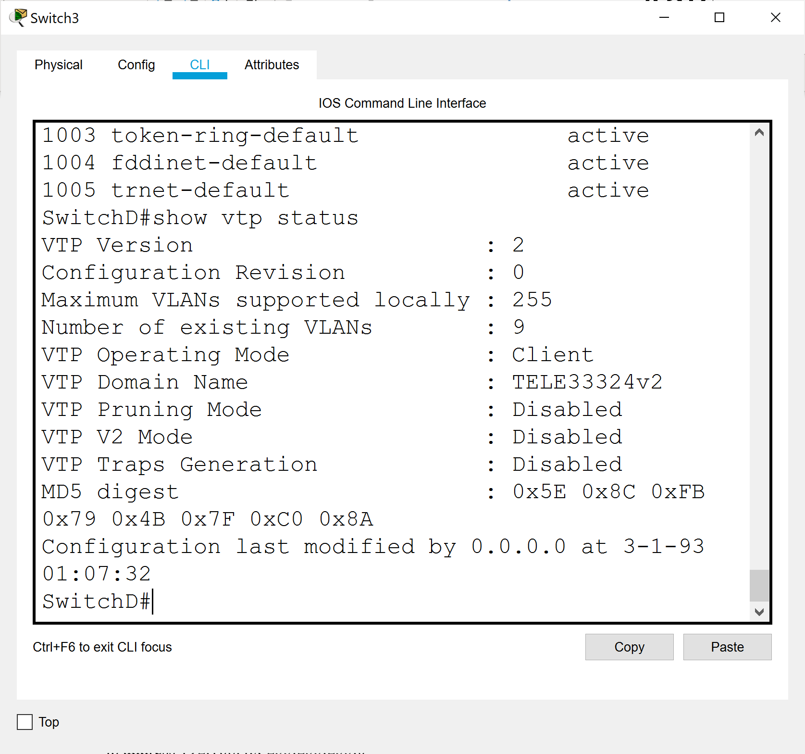

9. Set the required ports on switches B, C, and D to either ACCESS or TRUNK [4]

10. Assign addresses from network 192.168.4.0 to the VLAN 1 interface on each switch, and specify the default gateway as follows:

Int vlan 1

ip address 192.168.4.x 255.255.255.0

no shut

exit

ip default-gateway 192.168.4.1

11. Enable inter-vlan communication between VLANs 3 and 4 by creating appropriate

subinterfaces on Router A on the connection to Switch A. Also, assign ip address 192.168.4.1 to the main interface leaving router A going to Switch A [3]

11. Do screenshots of the following and LABEL THEM:

Any PC on Vlan 3, successfully pinging all the PCs on Vlan 3 and Vlan 4 [2]

Pinging Comp9 from Comp6:

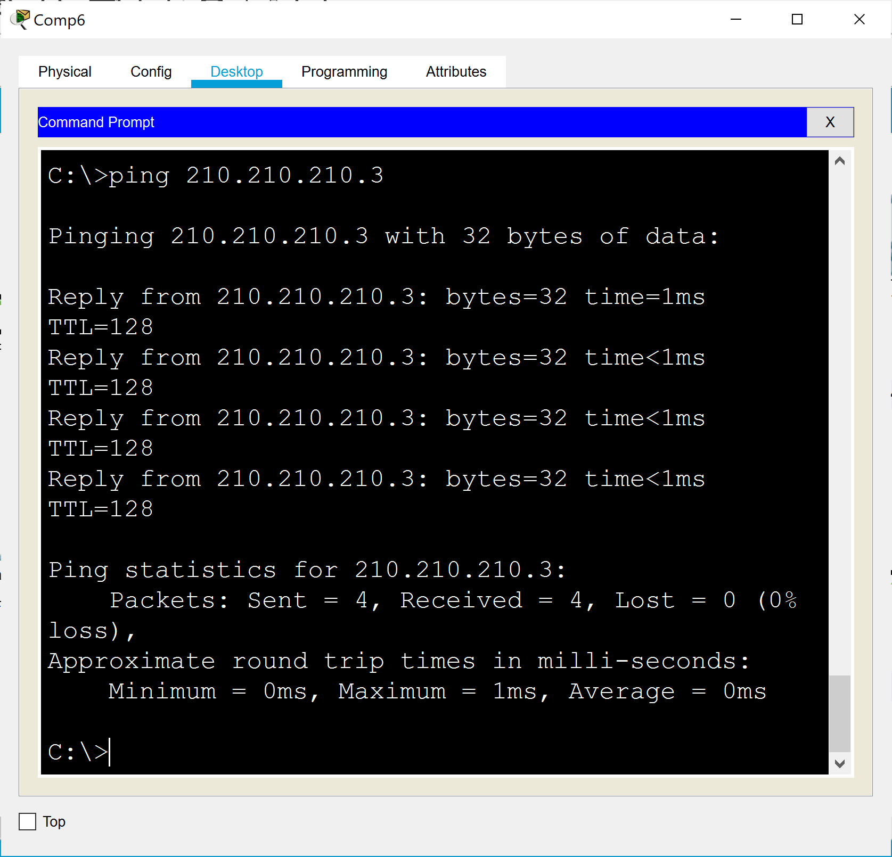

Pinging Comp1 from Comp6:

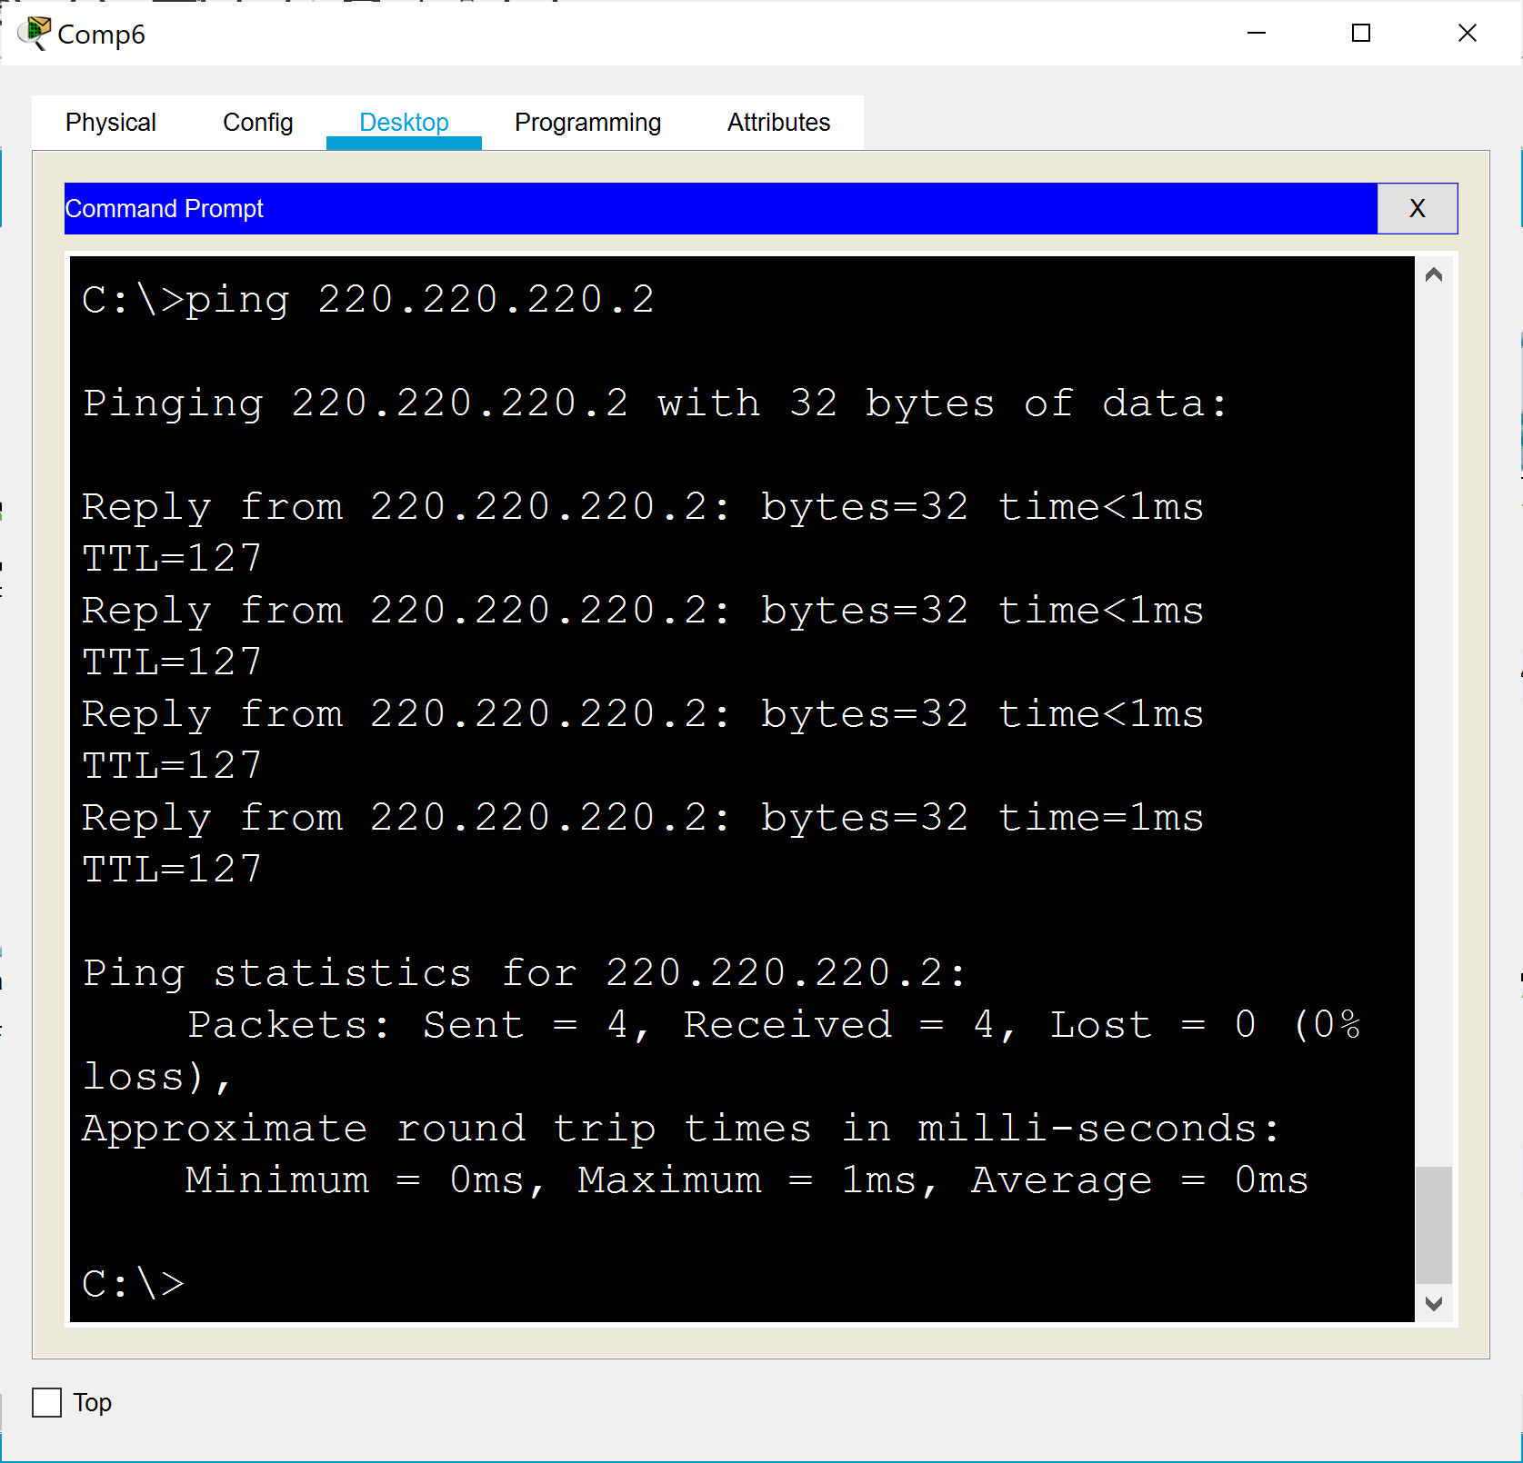

Pinging Comp3 from Comp6:

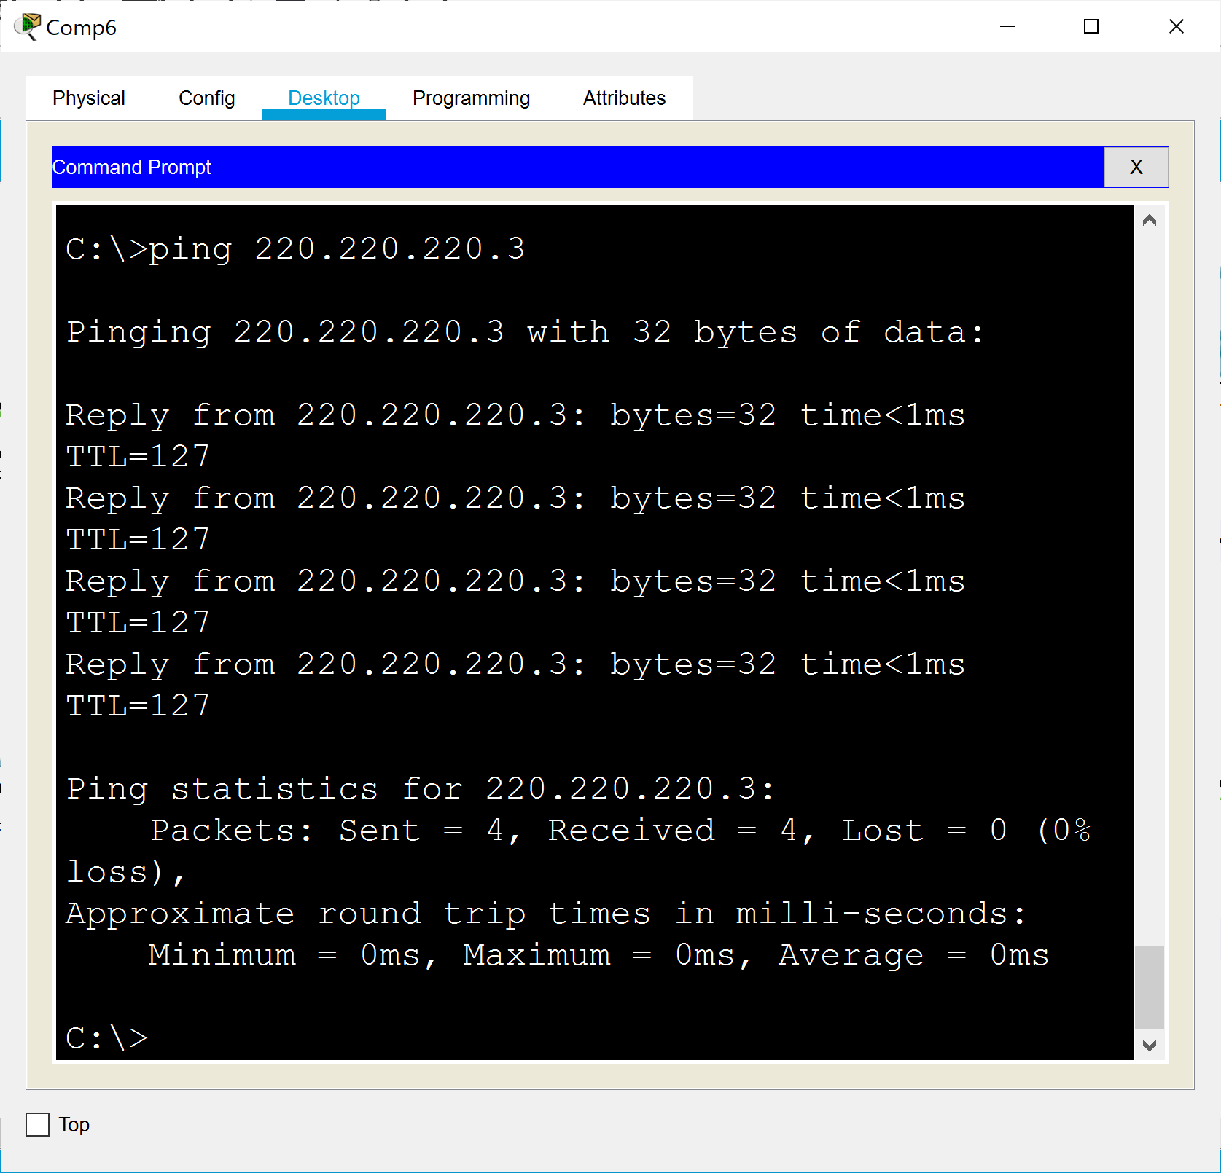

Pinging Comp5 from Comp6:

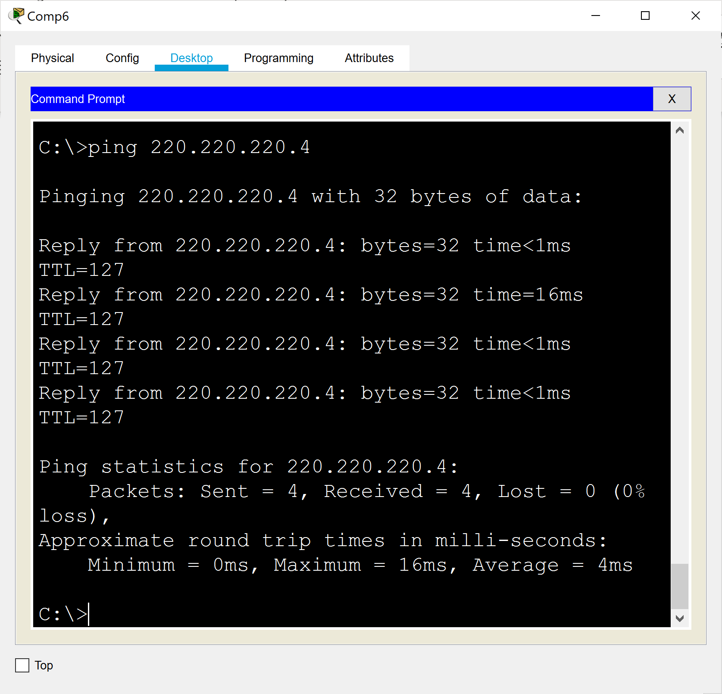

Any PC on Vlan 4, successfully pinging all the PCs on Vlan 4 and Vlan 3. [2]

Pinging Comp3 from Comp1:

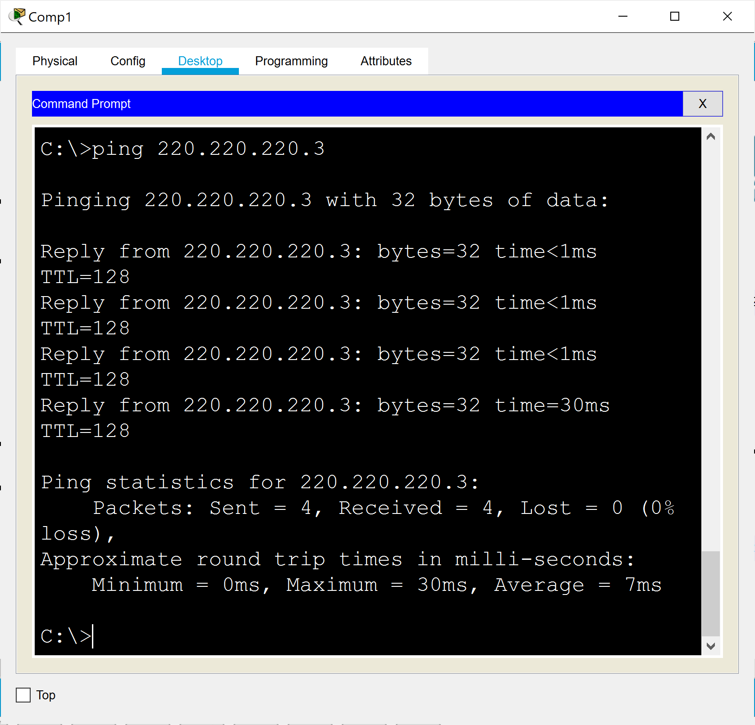

Pinging Comp5 from Comp1:

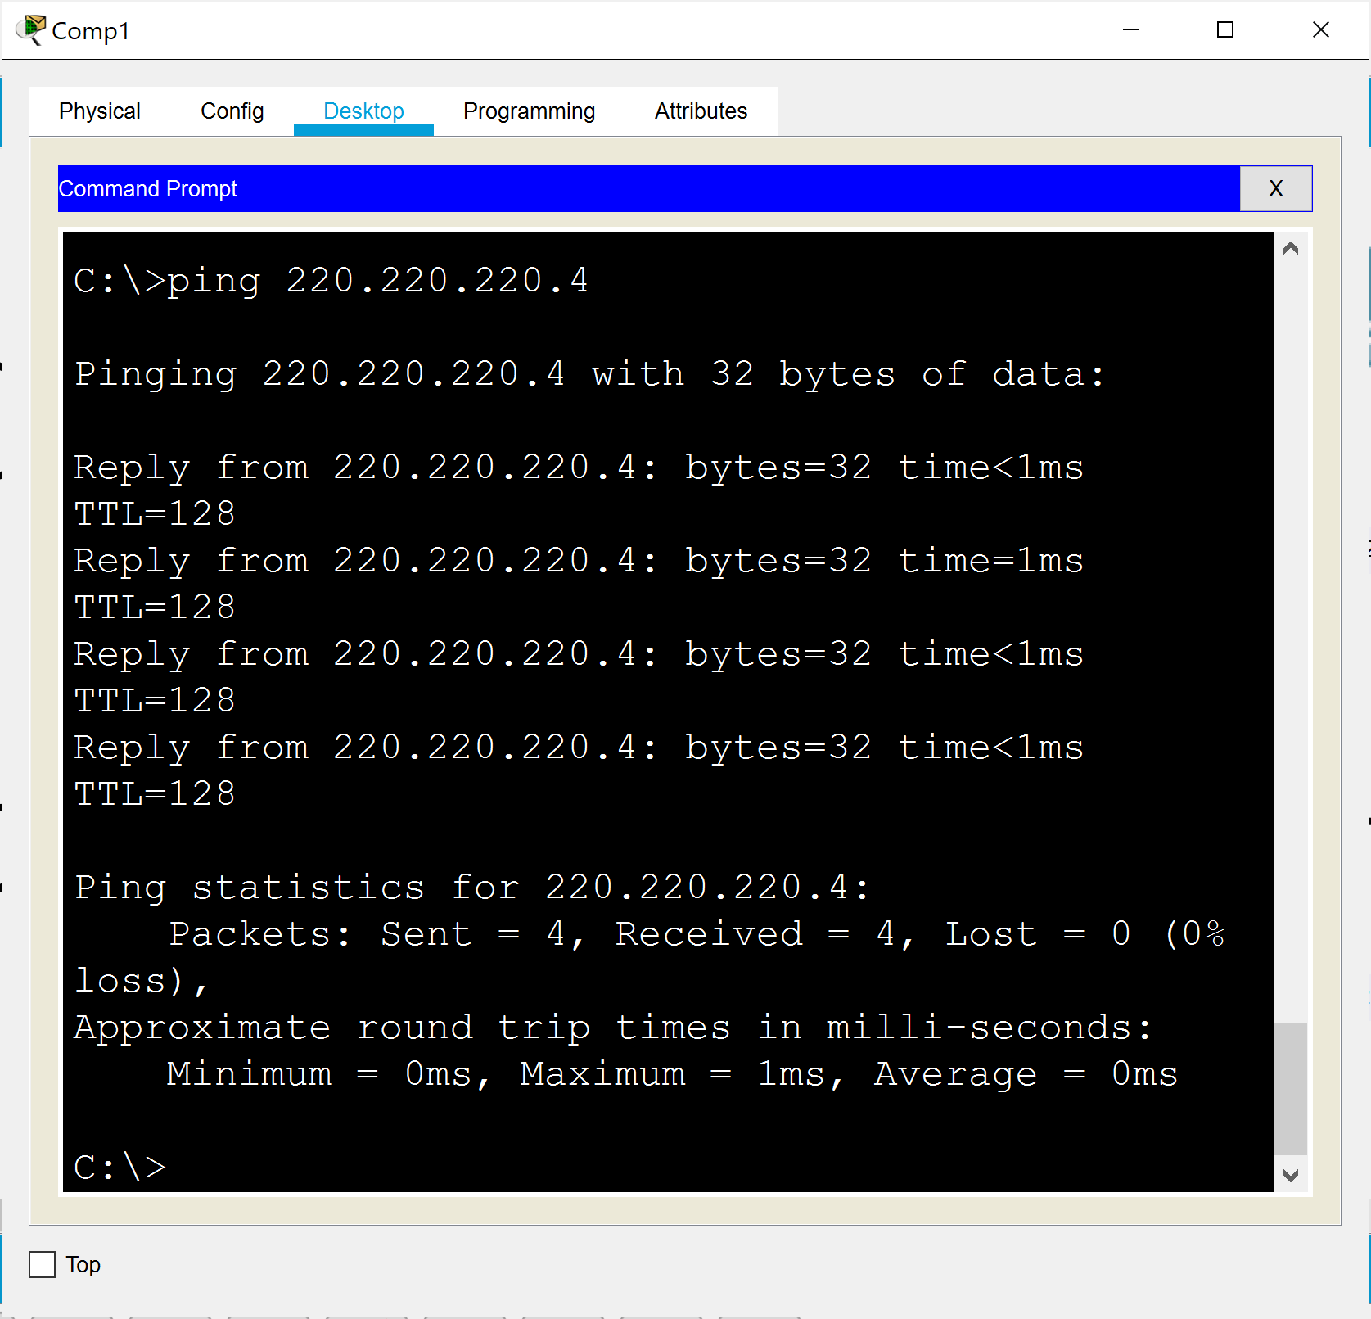

Pinging Comp6 from Comp1:

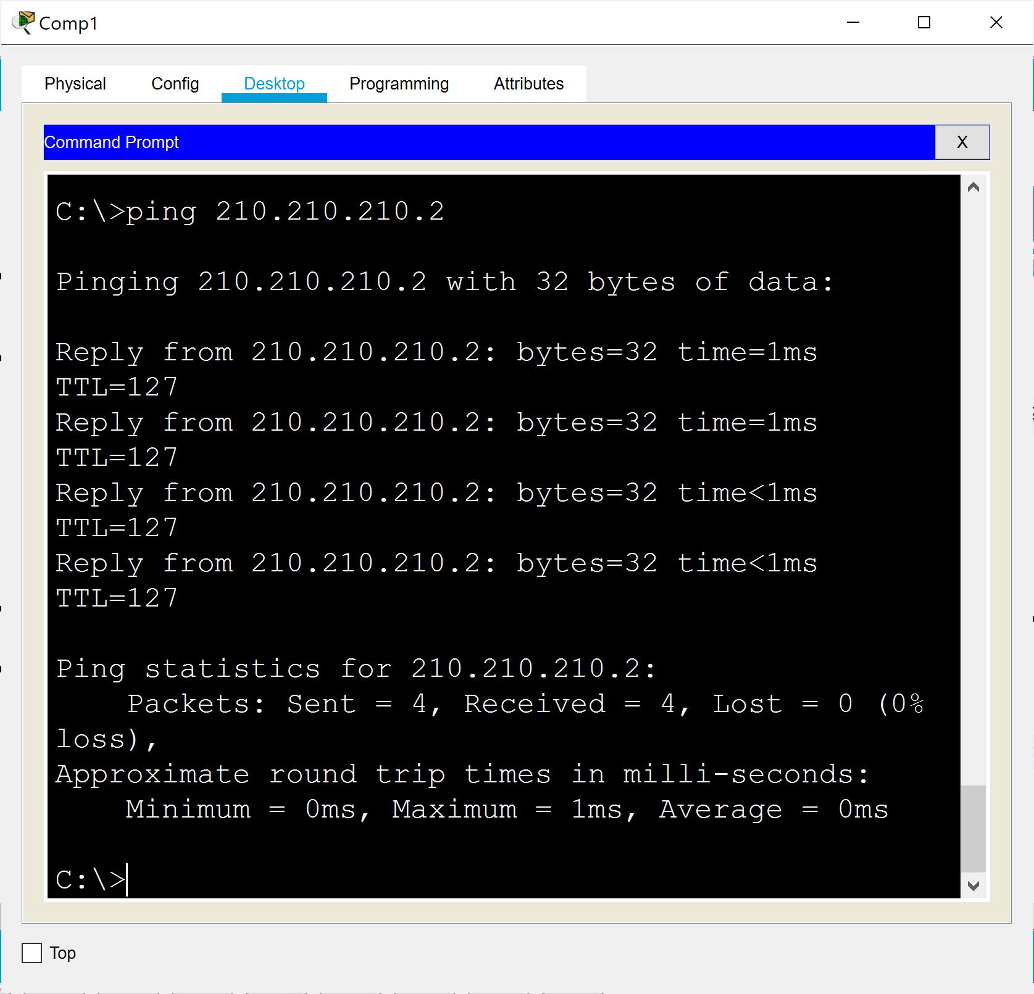

Pinging Comp9 from Comp1:

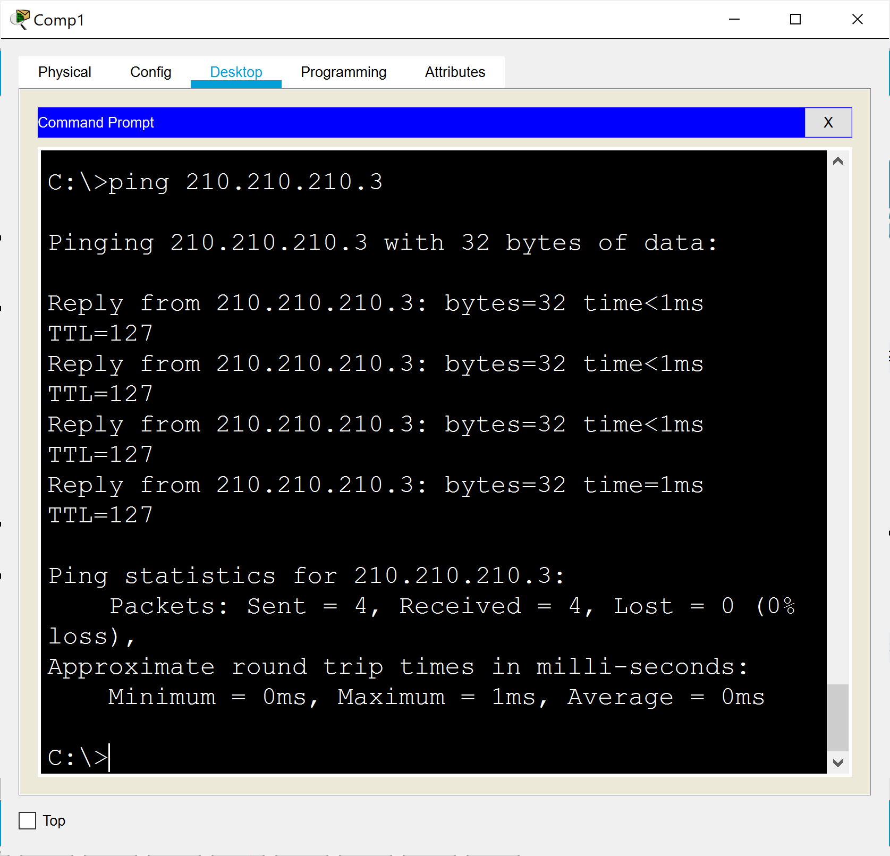

End of assignment!