WC26 TERMINAL
Live 2026 FIFA World Cup dashboard · wc26.krmank.com · Author: Keshav Manjrekar

BLUF
WC26 Terminal is a fast, information-dense, real-data dashboard for the 2026 FIFA World Cup, built as a Bloomberg-style "terminal" (black & gold) and served from the edge. It pulls live scores from ESPN and live prediction-market odds from Polymarket, computes group standings and the knockout bracket in the browser, and presents everything — live matches, upcoming fixtures, results, top scorers, title odds, bracket, and standings — in a single glanceable view. It is live at wc26.krmank.com, deployed on Cloudflare Workers.

Mission
Give fans and analysts a single, trustworthy, glanceable source of truth for the World Cup — fast, honest, always-on, and beautiful on any device.

Problem It Solves
Following a World Cup today means juggling several tabs, each with a different weakness:
- Fragmentation: scores live on one site, the bracket on another, betting odds on a third. No single dense view.
- Clutter and latency: mainstream sports sites are ad-heavy and slow; hard to scan at a glance.
- Unreliable standings: public standings endpoints are flaky for group stages, so tables and "who is advancing" are often wrong.
- Opaque probabilities: win/title odds are rarely shown with an honest source, mixing model guesses and market prices without saying which.
WC26 Terminal consolidates all of this into one edge-served page: computed-from-results standings and bracket (so they are always internally consistent), live scores, and prediction-market title odds — with the data source labelled so the numbers can be trusted. As a portfolio project, it also demonstrates end-to-end product and engineering judgement.

User Persona
Persona | Who they are | What they need | How WC26 serves them
The Engaged Fan (primary) | Follows the tournament closely; checks in many times a day on mobile and desktop. | Live scores, who is advancing, and odds — fast, at a glance, without ads. | Happening Now + Title Odds up top, live auto-refresh, one dense scannable page.
The Analyst / Bracket-watcher | Cares about standings, tiebreakers, the R32 picture, and upsets. | Accurate, internally-consistent standings and bracket, computed from actual results. | Client-side standings, computed bracket "as it stands", 3rd-place race, shocker detection.

Features
Feature | What it does
Happening Now | Live match cards (score, clock, scorers, win% bar, match stats). Fixtures appear 30 min pre-kickoff and drop out of Upcoming; a green live dot shows only while a match is in progress; Delayed badge for postponements.
Title Odds | Live outright "who wins the tournament" odds from Polymarket’s World Cup Winner market, renormalized across teams still alive. Desktop sidebar next to Happening Now; stacks below on mobile.
Upcoming | Day-grouped fixtures with local kickoff times, countdowns, colour-coded round tags, and two-nation win% bars.
Recent Results | Final-score cards with goal scorers + cards on hover/tap, a Penalties tag + shootout score, a round tag, and a "Shocker" highlight for big upsets.
Golden Boot + All-time | Top scorers computed live from events, with per-goal hover detail and an "Active only" toggle; a companion all-time World Cup scorers table (pre-2026 + live) with its own Active-only toggle.
Knockout Bracket | Computed "as it stands" from real knockout fixtures; winners advance automatically (penalties included), with live dots, FIFA-rank superscripts, and Penalties/Shocker tags.
Group Standings + 3rd-Place Race | All 12 groups computed client-side (points, GD, qualification/elimination) plus the 8-of-12 best third-place ranking by FIFA tiebreakers.
Win probabilities | Per-match FIFA-ranking Elo model on Upcoming/live cards, with no draw in knockouts; Polymarket match markets attach automatically when they exist (matched by FIFA code).
Cross-cutting | Team/location filters, dark + light themes (contrast-tuned), fully responsive with a sticky mobile top bar, viewer-timezone footer clock, and a graceful offline fallback.

System Design Diagram
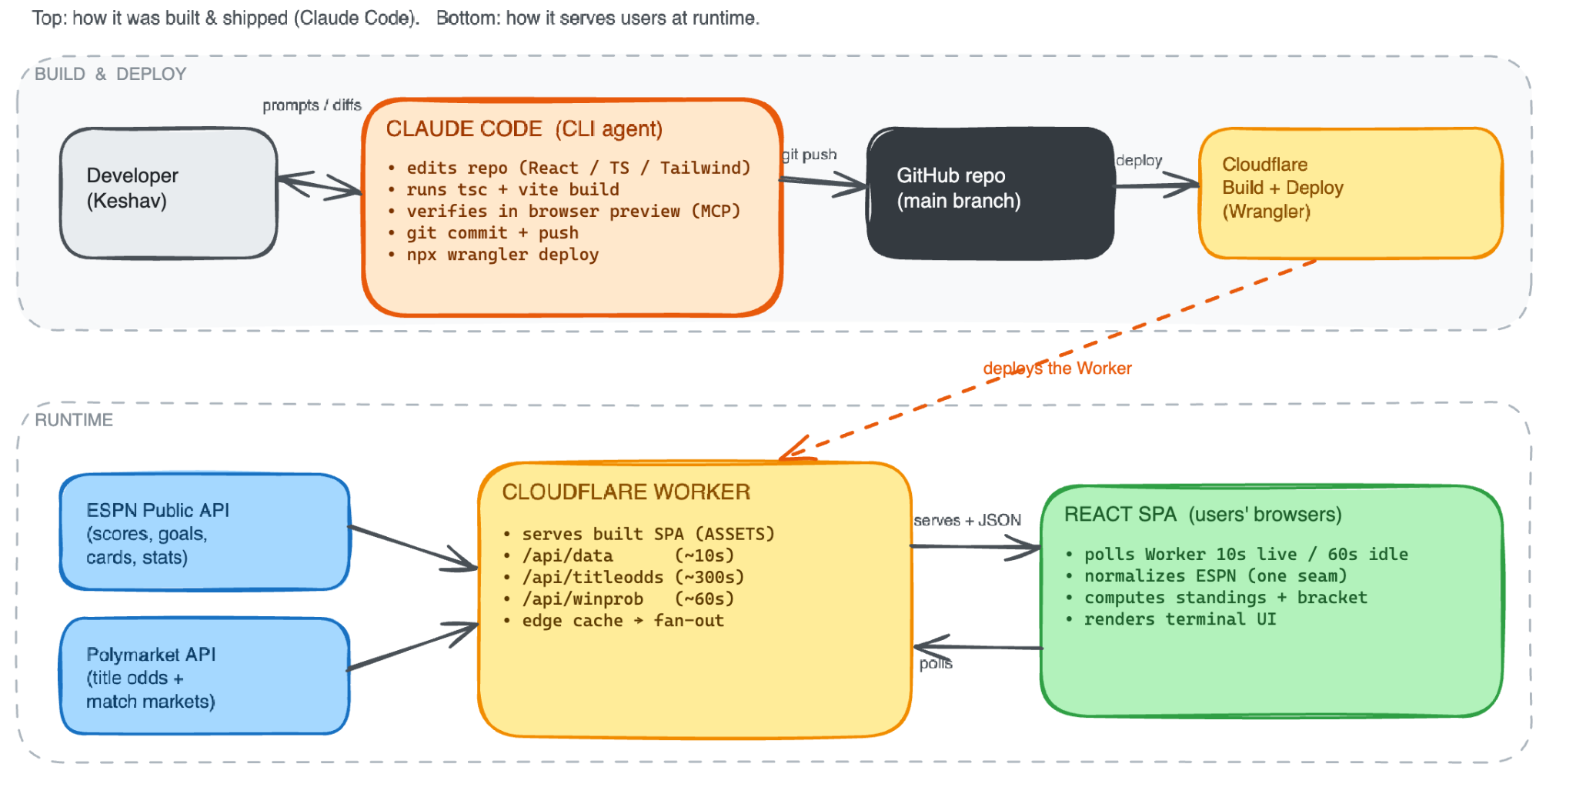
Component | Responsibility
ESPN public API | Source of truth for fixtures, live scores, events (goals/cards), and match stats.
Polymarket Gamma API | Source of live prediction-market prices (outright title odds; match markets when available).
Cloudflare Worker | Serves the SPA (ASSETS binding) and proxies/caches the /api/* routes; one upstream fetch fans out to all users.
React SPA | Polls the Worker, normalizes ESPN data, computes standings/bracket/scorers/upsets, and renders the terminal UI.
Shared parsers | Pure TS modules (espn, titleOdds, teamCodes, winprob) reused by Worker + a Vite dev middleware so preview matches production.

Engineering Requirements

Functional
- Aggregate ESPN scoreboard for the full tournament window and refresh during live play.
- Compute group standings, the knockout bracket, top scorers, and the 3rd-place race entirely client-side from results.
- Surface live prediction-market title odds and attach per-match markets when they exist, matched by FIFA 3-letter code.
- Label every probability with its source; never present a model number as a market price.
- Filters (team OR location), dark/light themes, and a bundled schedule fallback when live data is unavailable.

Non-functional
Requirement | Target / Approach
Performance | Edge-served SPA; ~10s edge cache on ESPN; poll 10s during live matches, 60s when idle.
Scalability | One upstream fetch per cache window fans out to all users via the Worker cache (no per-user upstream calls).
Reliability | Graceful degradation: stale banner + bundled schedule.json fallback; sections hide cleanly when a data source is empty.
Accuracy / trust | Standings & bracket computed from results (internally consistent); source-tagged probabilities.
Responsiveness / a11y | Mobile-first; sticky top bar, wrapped nav, tap-to-open hover panels; ARIA roles on toggles/switches; reduced-motion support.
Security | Public, no-auth upstreams only; no secrets in the client or repo; permissive read-only proxy.
Dev/prod parity | Shared parsers + a dev middleware serve the same /api/titleodds locally as in production.

Data Flow
- The browser polls the Worker (every ~10s during live matches, ~60s when idle) for /api/data, /api/titleodds, and /api/winprob.
- The Worker checks its edge cache. On a miss it fetches the upstream (ESPN or Polymarket), caches the response for its TTL, and returns it — so one upstream call serves every user in that window.
- /api/data returns the raw ESPN scoreboard. The SPA normalizes it in a single seam (src/lib/espn.ts) into a clean Match model (status, scores, clock, goals, cards, stats, round, venue).
- From those normalized matches the client computes: group standings, the knockout bracket "as it stands", top scorers, the 3rd-place race, and upset ("shocker") detection.
- /api/titleodds parses Polymarket’s "World Cup Winner" event: each team’s Yes price becomes a title probability, names resolve to FIFA codes, eliminated teams drop out, and survivors renormalize to 100%.
- Per-match win% uses a FIFA-ranking Elo model (no draw in knockouts); a real Polymarket match market overrides it when one exists, matched by FIFA code.
- React renders the terminal UI; the whole loop repeats on the polling interval, keeping the view live without page reloads.

How We Built It

Stack
- Vite + React + TypeScript + Tailwind for the SPA;
- A single Cloudflare Worker (static assets via the ASSETS binding + /api/* routes) for hosting and the cached proxy;
- Deployed with Wrangler;
- Custom domain wc26.krmank.com on Cloudflare DNS.

Key architectural decisions
- One normalization seam — all ESPN parsing lives in src/lib/espn.ts, so the rest of the app is source-agnostic (and could be repointed at another feed).
- Compute in the browser — standings and the bracket are derived from results rather than trusting ESPN’s unreliable standings endpoint, guaranteeing internal consistency.
- Edge cache fan-out — the Worker polls upstreams once per short cache window and serves all users from cache, keeping it fast and within free limits.
- Robust market matching — Polymarket names are resolved to FIFA 3-letter codes (with alias + diacritic handling) instead of brittle string matching, so real markets attach reliably.
- Honesty pass — removed an unimplemented "DraftKings" tier, labelled per-match bars as model-based, and added real live Title Odds from Polymarket as the genuine market feature.
- Dev/prod parity — the same pure parsers power both the Worker and a Vite dev middleware, so the local preview renders identical data to production.

Process
- Built data-layer-first (types, normalization, polling) before UI,
- then shipped the MVP end-to-end against live ESPN data,
- and iterated feature-by-feature (bracket, win%, title odds, upsets, all-time scorers) with a type-check and a browser verification after each change.
- Throughout, the guiding rule was to match the locked visual prototype, keep changes minimal, and never look broken when data is down.

