what is nodejs

1.It is js runtime build on chrome v8 js engine.

2.nodejs is a open source nd cross-platform.

3.client and server side lang.

4.Node runs on a server not in a browser(backend not frontend)

5.The console is the terminal window

Console.log(“hello world”)

6.server.js file

Run cmd- node server

7.console.log(global)- Shows the timing

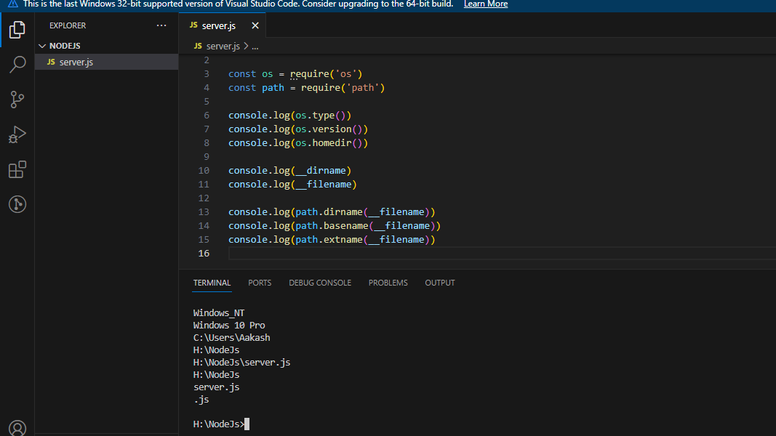

Ex-

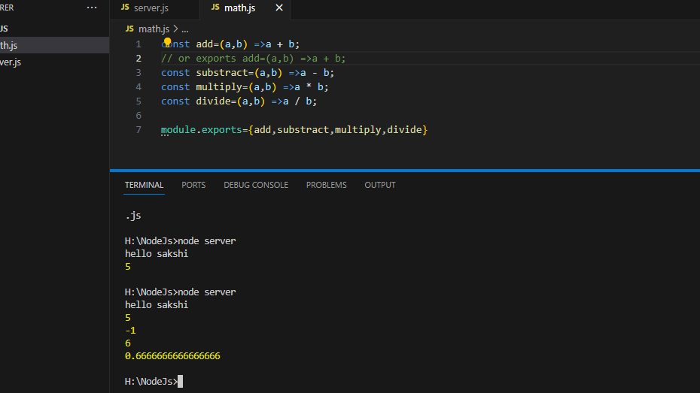

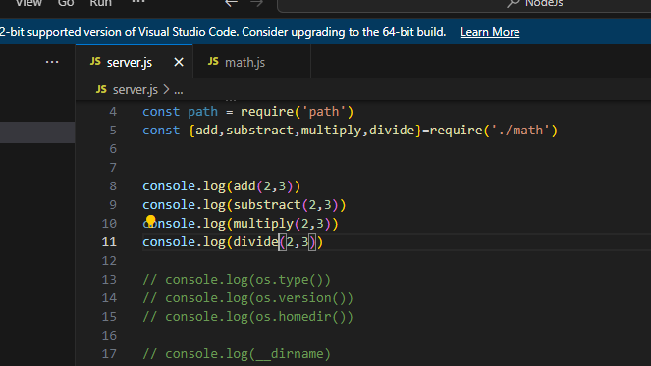

Chapter 2-Creating a new file-Read and write file

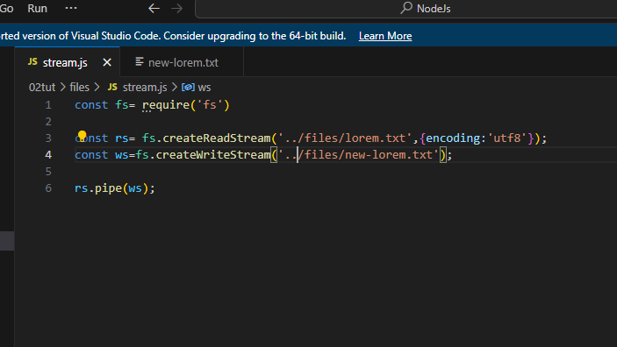

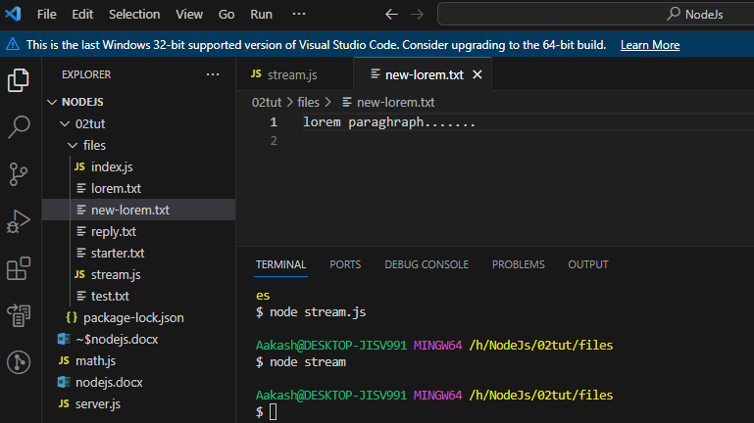

Chapter 3-NPM module

1.run cmd->npm i nodemon –g

2.nodemon

3.npm init

4. npm i date -fns🡪Install this pckg as a dependency

5.add this dependency🡪npm i uuid

6.npm rm nodemon –D 🡪 use for uninstall dependency