ConnectHub Contact Manager
Project Documentation
Because let's be honest—finding a client's phone number shouldn't feel like an archaeological dig.
ConnectHub is a robust backend solution designed to unify your scattered professional and personal networks into one secure, searchable space.
Project Overview
ConnectHub is a Node.js-based RESTful API that solves the chaos of fragmented contact data. It allows users to store, categorize, and retrieve contact information with a focus on privacy, speed, and organization.
Key Objectives
- Provide secure user authentication and data isolation
- Enable efficient contact management through CRUD operations
- Implement flexible categorization using tags
- Offer fast search and filtering capabilities
- Deliver a responsive, cross-device user experience
Target Users
- Freelancers and consultants managing client relationships
- Small business owners tracking vendor and customer contacts
- Students and young professionals building their network
- Event organizers managing attendee and volunteer information
- Anyone seeking a simple, privacy-focused contact management solution
Project Architecture
ConnectHub follows the MVC (Model-View-Controller) pattern to ensure the code is scalable and easy to maintain.
Backend Layer (Node.js + Express)
- Routes: Defines API endpoints (e.g., /api/contacts)
- Controllers: The "brains" where business logic lives
- Middleware: Handles security (JWT) and data validation
Database Layer (MongoDB + Mongoose)
- NoSQL Storage: Perfect for flexible contact fields
- Mongoose ODM: Provides structure to the data through Schemas
Technical Architecture
Backend Architecture (Node.js + Express)
- Controllers: Business logic for authentication and CRUD operations
- Models: Mongoose schemas defining data structure
- Routes: API endpoint definitions with HTTP methods
- Middleware: JWT verification, error handling, validation
- Configuration: Database connection and environment variables
Database Architecture (MongoDB)
- Users Collection: _id, name, email, password (hashed), timestamps
- Contacts Collection: _id, userId (FK), name, email, phone, notes, tags[], timestamps
- Relationships: Many-to-One (Contacts → User)
- Indexes: email (unique), userId, name, tags (for search)
Database Design
The relationship between Users and Contacts is One-to-Many (1:N). One user can own many contacts, but each contact belongs to exactly one user.
Data Schemas
Collection | Fields | Indexes
Users | name, email (unique), password (hashed), timestamps | Email
Contacts | userId (FK), name, email, phone, tags[], notes, isFavorite, timestamps | userId, name, tags
Updated Contact Schema (Mongoose)
const contactSchema = new mongoose.Schema({
userId: { type: mongoose.Schema.Types.ObjectId, ref: 'User', required: true },
name: { type: String, required: true },
email: { type: String },
phone: { type: String },
notes: { type: String },
tags: [{ type: String }],
isFavorite: { type: Boolean, default: false },
}, { timestamps: true });
Features
Core Functionality
# | Feature | Description
1 | 🔒 JWT Authentication | Secure login using JSON Web Tokens and bcrypt for password hashing. No one sees your password—not even the database admin.
2 | 📋 Full CRUD Operations | Create, read, update, and delete contacts with full validation and error handling
3 | 🏷 Smart Tagging | Organize contacts with multiple tags (Work, Family, Friends, etc.) and filter by category
4 | 🔍 Power Search | Debounced search across name, email, and tags with instant results using MongoDB regex queries
Developer Features
- Environment Variables: Secure configuration using .env files
- ES Modules: Modern JavaScript syntax (import/export) for cleaner code
- Error Handling: Centralized middleware to catch and report errors without crashing the server
Advanced & Bulk Operations
Because clicking "Delete" fifty times is a workout nobody asked for, these features handle high-volume changes in a single request.
- Bulk Delete: DELETE /api/contacts/bulk
  - Body: { "ids": ["id1", "id2", "id3"] }
  - Benefit: Efficiently cleans up your database using MongoDB's deleteMany() operation
- Bulk Tags: PATCH /api/contacts/bulk-tags
  - Body: { "ids": [...], "tags": ["Work", "2024-Conference"], "action": "add" }
  - Logic: Allows users to add or remove specific tags from a group of contacts at once
- Toggle Favorite: PATCH /api/contacts/:id/favorite
  - Logic: A simple boolean flip (true/false). Marking a contact as a "Favorite" allows for a dedicated "VIP" filter
Pre-requisites
Software Requirements
Software | Purpose
Node.js | JavaScript runtime for backend
MongoDB | NoSQL database for data storage
npm | Package manager
Git | Version control system
VS Code | Recommended Code Editor
Knowledge Requirements
- JavaScript ES6+ syntax and concepts
- Node.js and Express.js for RESTful API development
- MongoDB and Mongoose ODM
- JWT authentication and bcrypt password hashing
- Git version control workflow
Project Setup & Installation
Installation Steps
- Create Project Structure
mkdir server or cd server
npm init -y
- Install Dependencies
install express mongoose dotenv cors jsonwebtoken bcryptjs
npm install --save-dev nodemon
- Enable ES Modules
Add "type": "module" to your package.json
- Configuration
Create a .env file in the root:
PORT=5000
MONGO_URI=your_mongodb_connection_string
JWT_SECRET=your_super_secret_key
Folder Structure
server/
├── models/
│ ├── User.js
│ └── Contact.js
├── routes/
│ ├── auth.js
│ └── contacts.js
├── middleware/
│ └── auth.js
├── controllers/
│ ├── authController.js
│ └── contactController.js
├── config/
│ └── db.js
├── .env
├── server.js
└── package.json
API Endpoints
User Authentication
Feature | Endpoint | Description
Registration | POST /api/auth/register | Accepts name, email, and password. Hashes the password via bcrypt before storage.
Login | POST /api/auth/login | Verifies credentials and returns a JWT. This token must be included in the header of all subsequent requests.
Contact Management (CRUD)
- Create Contact: POST /api/contacts
  - Input: name, email, phone, notes, tags[]
  - Logic: Automatically assigns the logged-in user's ID to the new contact
- Get All Contacts: GET /api/contacts
  - Returns all contacts belonging to the authenticated user
- Update Contact: PUT /api/contacts/:id
  - Input: Any fields requiring changes
  - Security: The backend verifies that the contact id actually belongs to the requesting userId
- Delete Contact: DELETE /api/contacts/:id
  - Removes a single entry
- Search Contacts: GET /api/contacts/search?q=searchterm
  - Searches across name, email, and tags fields
User Roles and Responsibilities
User Capabilities
- Registration - Register on the application using name, email, password
- Login - Login on the application using email and registered password
- Search - Search for a contact using name, email or tags
- Add Contact - Add new contact with name, email, phone, notes, tags
- Edit Contact - Edit existing contact information
- Delete Contact - Delete any contact
- Bulk Operations - Perform bulk delete and tag operations
- Favorites - Mark contacts as favorites for quick access
Logical Workflow
- Auth: User logs in → Receives Token
- Organization: User selects 10 contacts → Applies "Client" tag using Bulk Tags
- Prioritization: User clicks the star icon on their top 5 clients → Toggle Favorite sets isFavorite: true
- Cleanup: User selects old leads → Bulk Delete removes them in one click
Execution Guide
Starting the Server
- Start the Server:
npm run dev
- Verify Connection:
  - You should see: Server running on port 5000
  - You should see: MongoDB Connected Successfully
- Test Endpoints:
Use Postman or Thunder Client to test the POST /api/auth/register and GET /api/contacts routes
Testing the Application
Open your browser and navigate to: http://localhost:5000
You should see: Backend is running
Future Enhancements
The current build is a strong MVP, but we can take it further:
- vCard/CSV Support: Allow users to bulk-import contacts from Google or Outlook
- Image Uploads: Use Cloudinary to store profile pictures for contacts
- Activity Logs: Track when a contact was last edited or contacted
- Email Integration: A "Send Email" trigger directly from the contact dashboard
- Recycle Bin: Instead of permanent Delete, implement a deletedAt timestamp to allow recovery for 30 days
- Export to CSV: A "Bulk Export" feature to download selected contacts for use in email marketing tools
Known Limitations
- No Trash Bin: Deleting a contact is currently permanent. There is no "Soft Delete" or recovery feature yet
- Rate Limiting: The API does not currently have protection against brute-force login attempts (needs express-rate-limit)
- Real-time Updates: If a user has two tabs open, changes in one won't reflect in the other without a refresh (requires WebSockets/Socket.io)
This application provides a complete backend solution for contact management with secure authentication, efficient CRUD operations, and advanced search capabilities. Users can organize their contacts using flexible tagging systems and perform bulk operations for better productivity.

Output Screenshots

1.Register Api

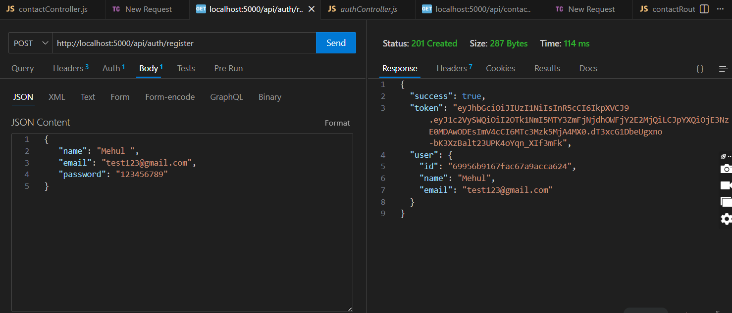

- Login Api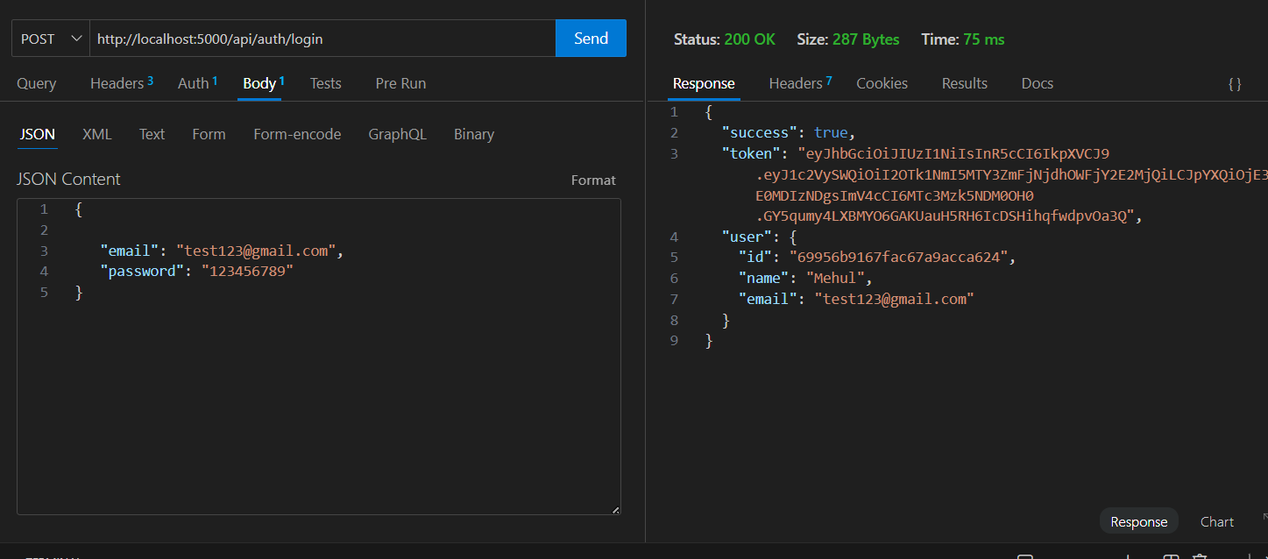

- Create New Contact
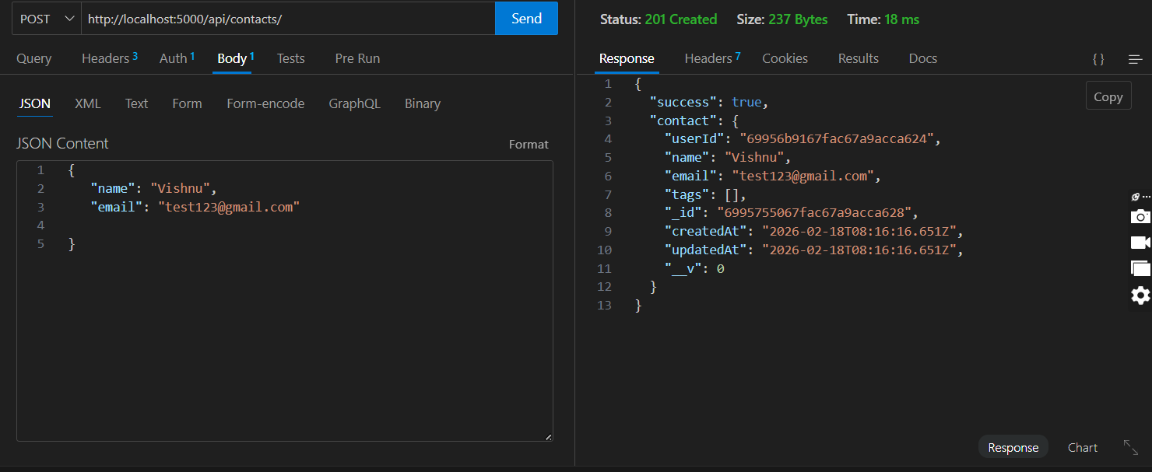

- Update Contact
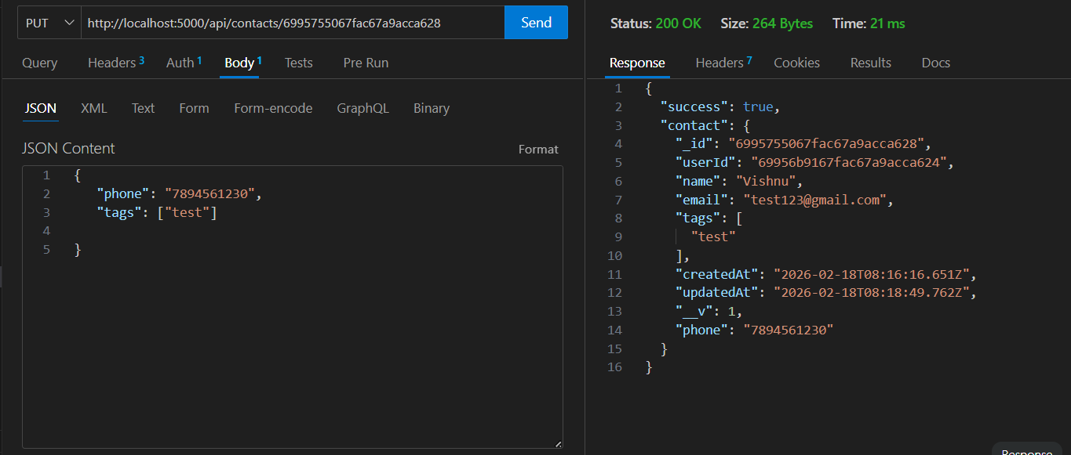

- Delete Contact
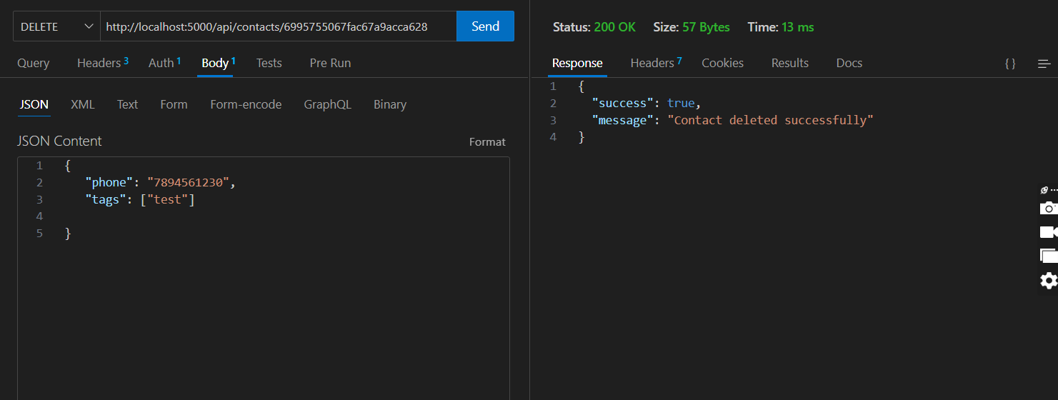

- Search Contact
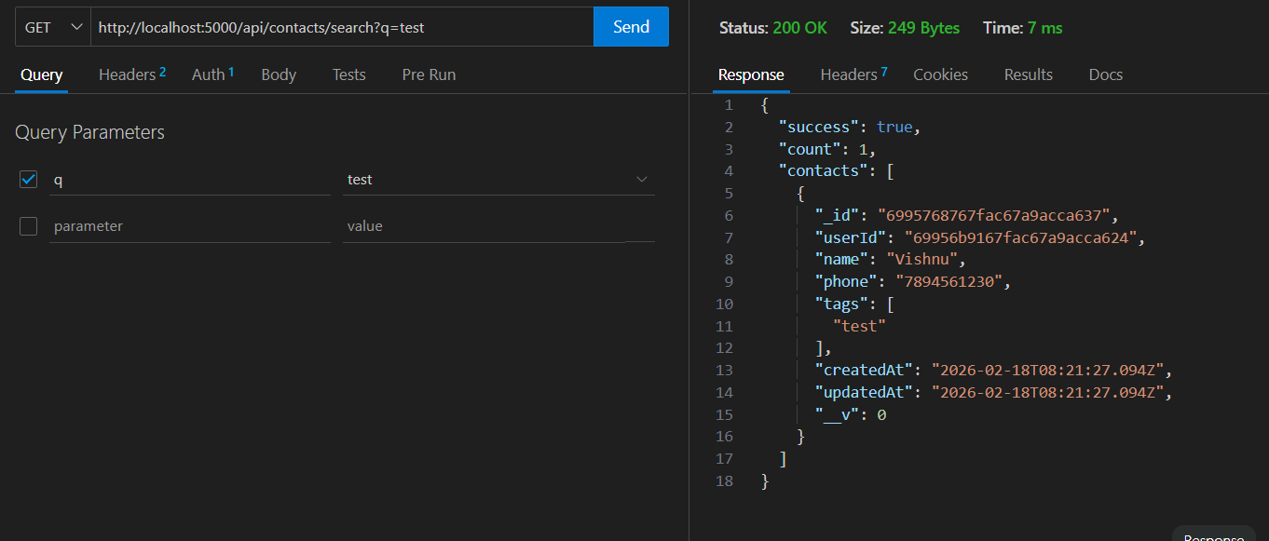

- Get The Current User
