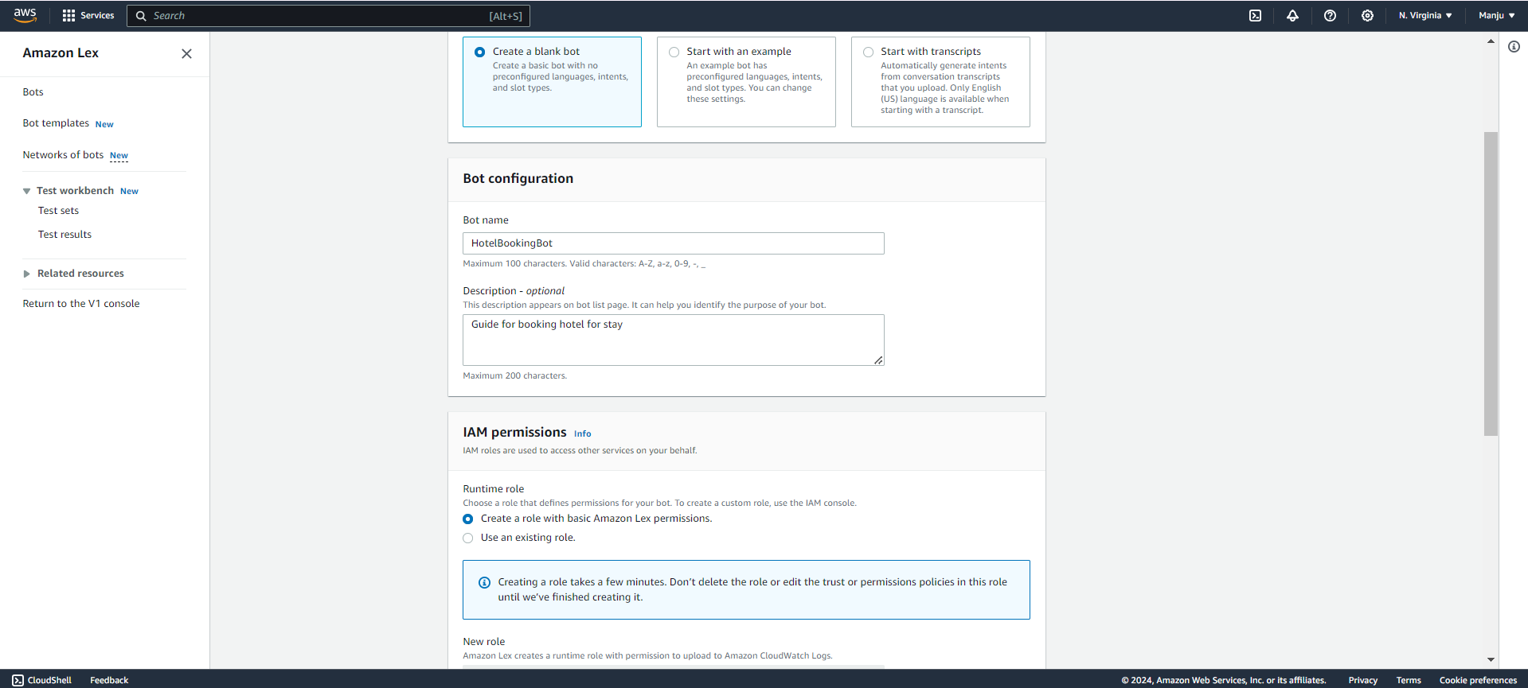

Developing a chatbot using Amazon Lex in AWS involves several steps, including designing the chatbot, configuring it in Amazon Lex, and integrating it with other services or platforms. Below is a comprehensive guide to chatbot development using Amazon Lex, from initial setup to deployment.

**1. Introduction to Amazon Lex:**

Amazon Lex is a service for building conversational interfaces into applications using voice and text. It provides natural language understanding (NLU) and automatic speech recognition (ASR) capabilities, making it easier to create chatbots and virtual assistants.

**2.Prerequisites:**

- An AWS account.

- Basic knowledge of AWS services.

- Familiarity with programming languages like Python (for Lambda functions) or JavaScript (for integrating with web applications).

**3. Creating a New Bot in Amazon Lex:**

**Step 1: Sign in to AWS Management Console**

1. Go to the [AWS Management Console](https://aws.amazon.com/console/).

2. Navigate to the Amazon Lex service.

**Step 2: Create a New Bot:**

1. Click on "Create bot".

2. Choose "Custom bot" or "Create a bot from a template" based on your preference.

3. Enter basic bot information:

- Bot name: Give your bot a name.

- Language: Choose the language for the bot.

- Output Voice (optional): Select a voice if you are creating a voice-enabled bot.

- Session Timeout: Set the timeout duration for user sessions.



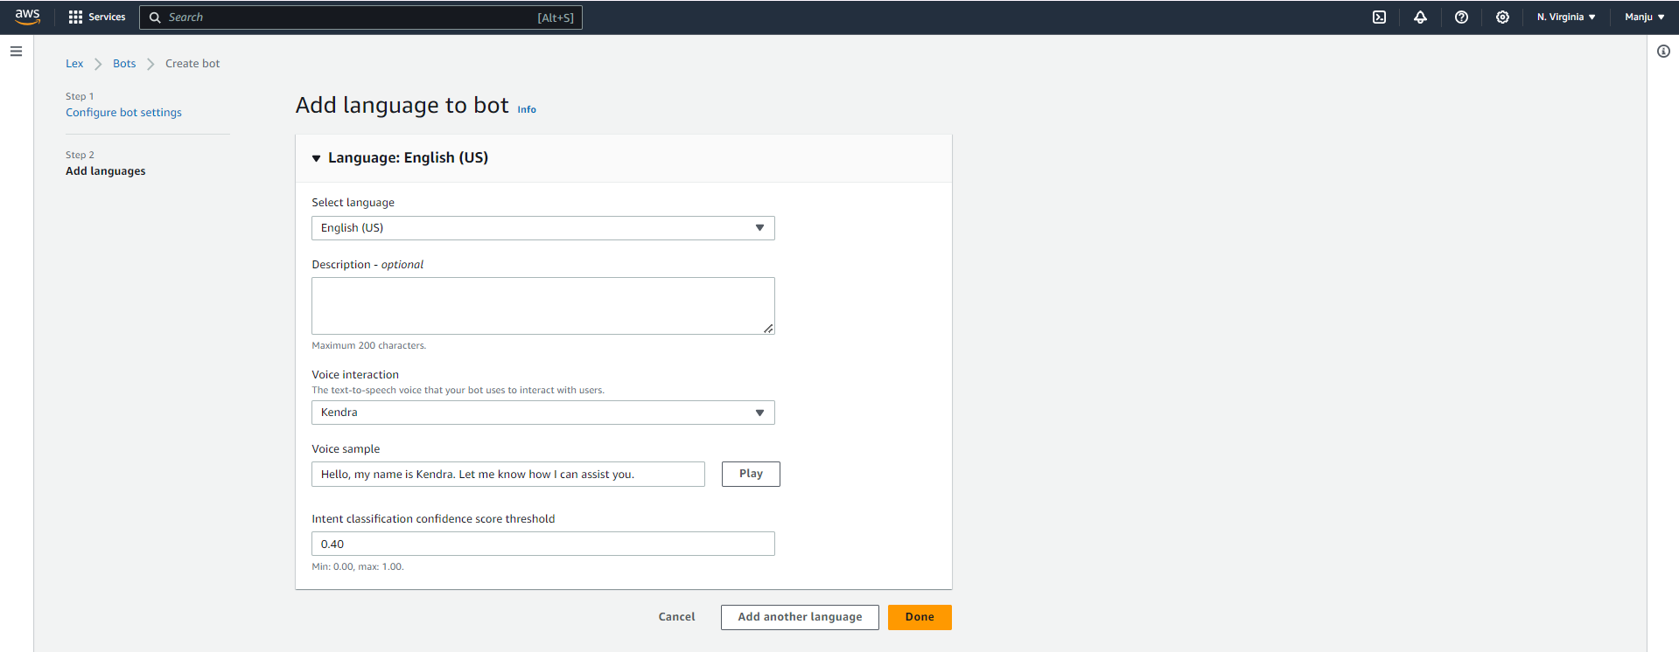

**Step 3: Configure Bot:**

1. IntentsDefine what the bot should do. Intents are actions the bot can perform, like booking a hotel or answering a question.

2. Slots: These are parameters that the bot collects from users to fulfill an intent (e.g., hotel name, check-in date).

3. Utterances: Define how users might express their intent (e.g., "I want to book a hotel").

**Step 4: Create Intents:**

1. Click on "Create intent".

2. Provide a name for the intent (e.g., `HotelBookingIntent`).

3. Define sample utterances that users might use to invoke this intent.

4. Add slots needed for the intent, such as `HotelName`, `CheckInDate`, etc.

5. Set up slot types if using custom slot types or use built-in slot types.

6. Add confirmation prompts and fulfillment options:

- Confirmation Prompt: Ask users to confirm their choice.

- Fulfillment: Define how the bot fulfills the intent (e.g., using an AWS Lambda function).

**Step 5: Set Up Fulfillment:**

1. Choose how the intent should be fulfilled. You can use:

- AWS Lambda function: For custom backend logic.

- Return parameters to client: For simpler interactions.

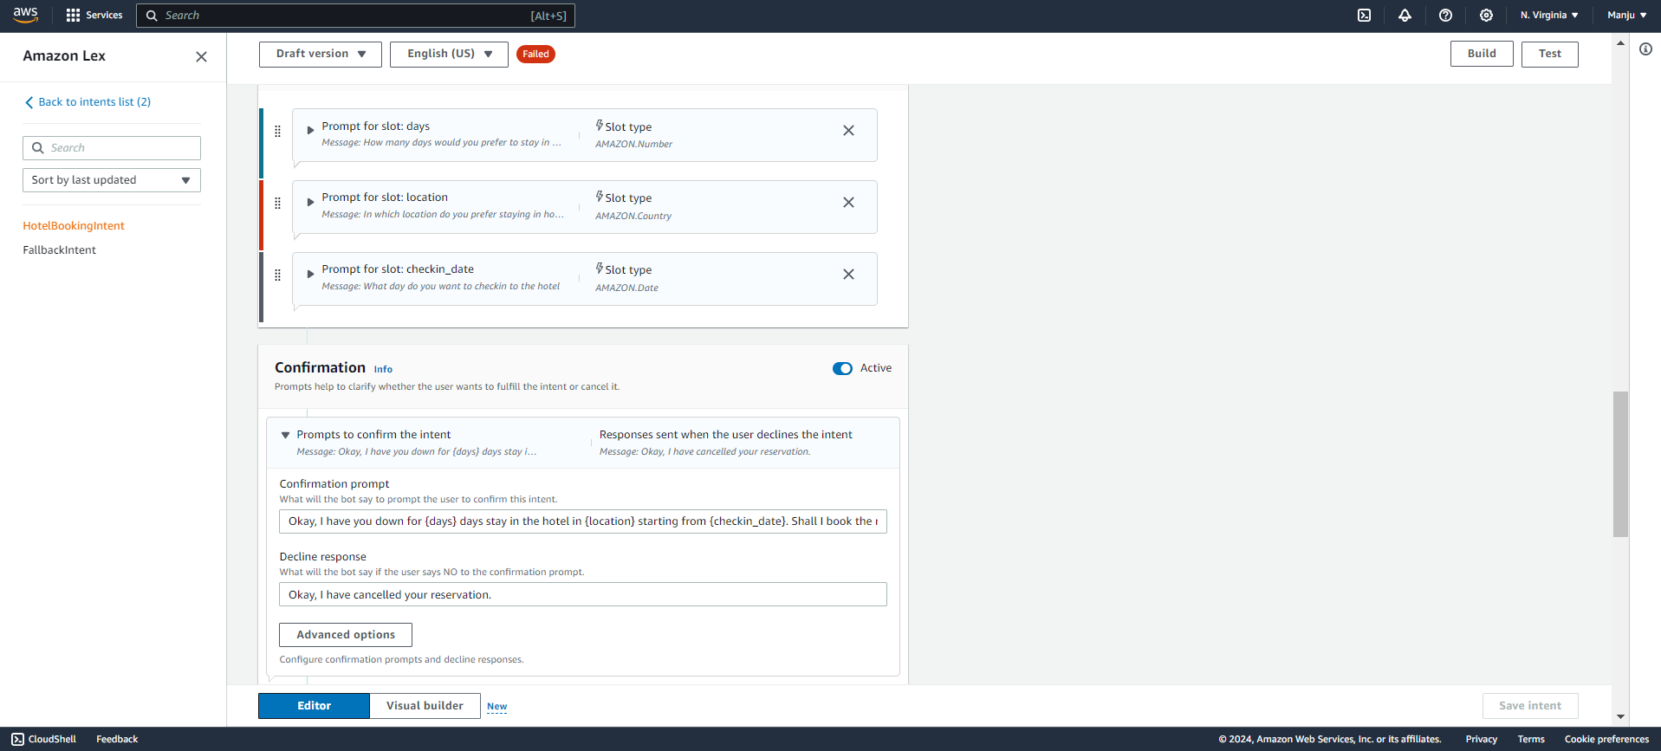

**4. Implementing Lambda Functions for Fulfillment:**

AWS Lambda functions can be used to process user requests and provide responses.

**Step 1: Create a Lambda Function:**

1. Go to the AWS Lambda console.

2. Click “Create function".

3. Choose "Author from scratch".

4. Configure function details:

- Function name: Enter a name for the function.

- Runtime: Choose the runtime (e.g., Python, Node.js)-

-Role: Select or create an execution role with the necessary permissions.

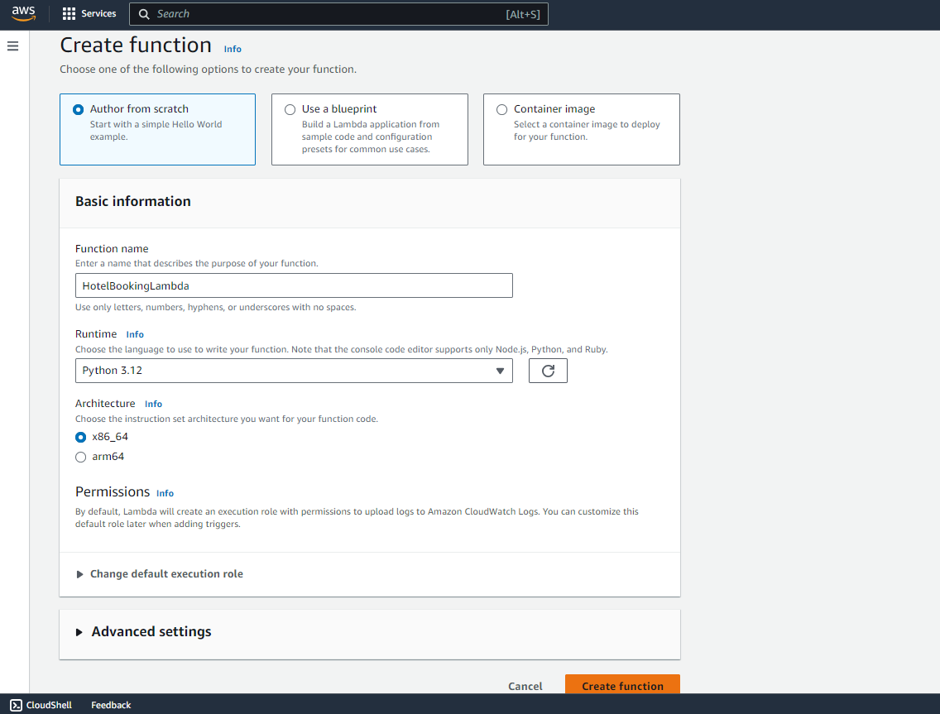

**Step 2: Implement Lambda Function Code:**

1. Write the code for your Lambda function. It should handle the intents from Amazon Lex and return responses.

2. Use the Lambda function to perform actions like querying a database or interacting with other AWS services.

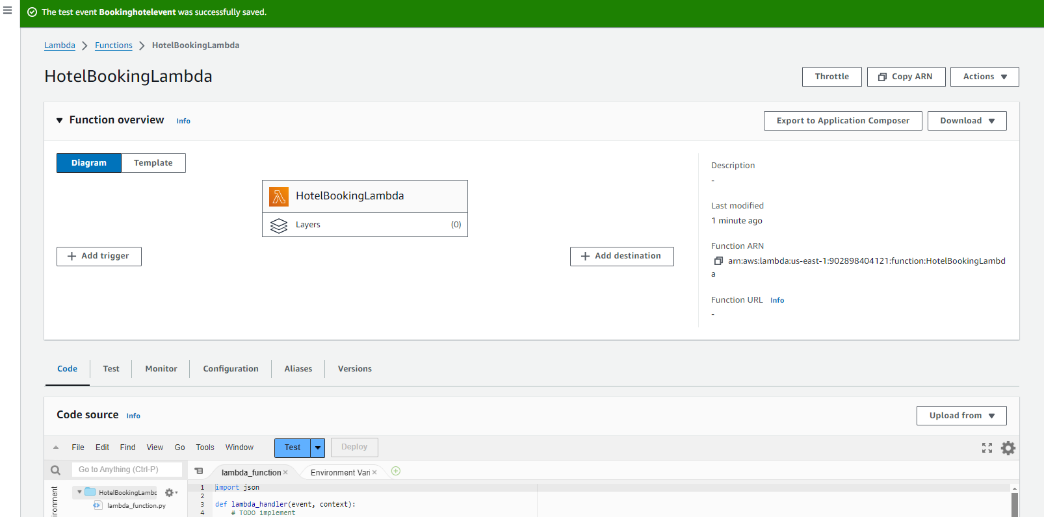

**Step 3: Link Lambda Function to Lex Intent**:

1. Go back to the Amazon Lex console.

2. Open your bot and navigate to the “Intents” section.

3. Select the intent you want to fulfill using Lambda.

4. In the "Fulfillment" section, select "AWS Lambda function" and choose your function.

**5. Testing and Debugging:**

**Step 1: Test in Lex Console**

1. Use the “Test” tab in the Amazon Lex console to interact with your bot.

2. Provide sample inputs and observe the bot's responses.

**Step 2: Debug Lambda Functions**

1. Use Amazon CloudWatch Logs to monitor and debug your Lambda function.

2. Ensure proper logging and error handling in your Lambda code.

**6. Deploying Your Bot**

Step 1: Publish Your Bot

1. Go to the "Alias" tab in the Amazon Lex console.

2. Create an alias for your bot (e.g., `production`).

3. Publish the bot version.

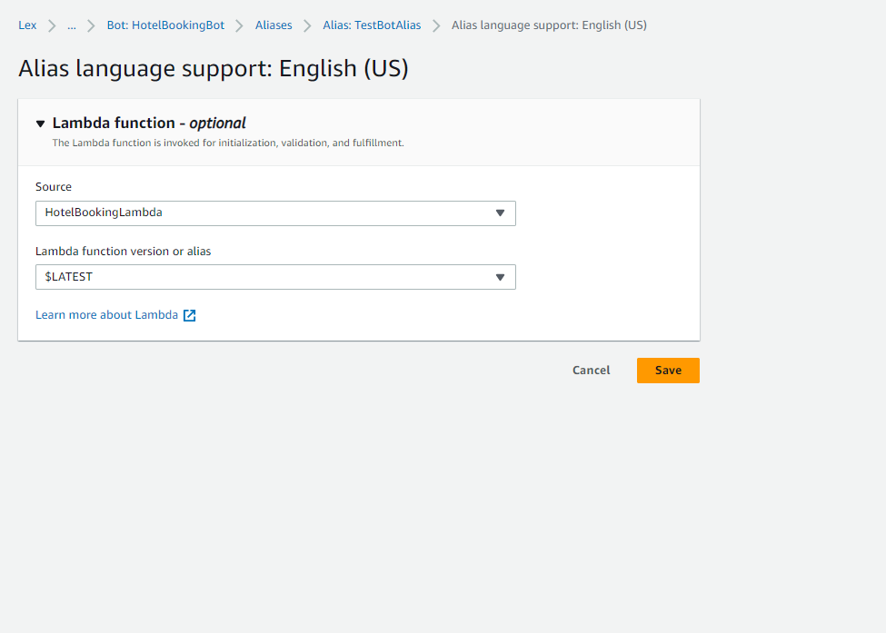

**Step 2: Integrate with Applications**

1. Web Interface: Use the AWS Lex SDKs to integrate your bot into a web application.

2. Third-Party Platforms: Connect your bot to platforms like Kommunicate, or Twilio using their respective integration settings.

**7. Monitoring and Analytics**

1. Amazon CloudWatch: Monitor Lambda function performance and errors.

2. Lex Metrics: View metrics related to bot usage, such as the number of requests and user interactions.

**8. Best Practices**

1. Design for Conversational Flow: Ensure that your bot can handle different user inputs gracefully.

2. Error Handling: Implement robust error handling and logging.

3. User Experience: Continuously test and improve the user experience based on feedback.

**9. Additional Resources**

- AWS Lex Documentation: [Amazon Lex Developer Guide](https://docs.aws.amazon.com/lex/latest/dg/what-is.html)

- AWS Lambda Documentation: [AWS Lambda Developer Guide](https://docs.aws.amazon.com/lambda/latest/dg/welcome.html)

-ChatGPT

-GitHub

This setup allows you to leverage AWS's powerful services to build sophisticated conversational interfaces.

