A Project Report

On

# RAILWAY MANAGEMENT SYSTEM

**Course: Database Management Systems**

B.E-.IT Sem: IV

By

**R.MANJULA**

**1602-20-737-144**

**&**

**J.ARUNA**

**1602-20-737-125**

Under Guidance of S.Sreelakshmi



**Department of Information Technology**

# Vasavi College of Engineering(Autonomous) Ibrahimbagh,Hyderabad-31 BONAFIDECERTIFICATE

This to certify that the project report titled “**RAILWAY MANAGEMENT SYSTEM”** project work of

R.Manjula and J.Aruna bearing the roll numbers of 1602-20-737-144&1602-20-737-125 who carried out this project unser my super visison in the 4rth semester for the academic year 2021-2022.

*Singnature*

*Internal Examiner*

*Signature*

*External examiner*

**ABSTRACT**

This project “RAILWAY MANAGEMENTSYSTEM” deals with the railway reservation system facilitates the passengers to enquiry about the trains available on the basis of source and destination, booking and cancellation of tickets, enquiry about the status of the booked ticket, etc. The aim of case study is to design and develop a data base maintaining records of different trains, train status and passengers.This project contains introduction to the railways reservation system. It is the computerized system of reserving the seats of train seats in advance. It is mainly used for a long route.

We have extracted the details of the events from the internet and we have inserted in the corresponding tables.

Roll Number: 1602-20-737-144

1602-20-737-125

**INTRODUCTION:**

**REQUIREMENT ANALYSIS:**

***List of Tables:***

*EMPLOYEE

*PASSENGER

*STATION

*TRAIN

*ANNOUNCE

*BOOK_TICKET

*CANCEL_TICKET

***List of Attributes with Domain Types:***

***\**Employee**

EID :number

ENAME:number

DOJ number

GENDER varchar

PHONE varchar

SALARY:varchar

\***Passenger**

PNO number

PNAME:varchar

PHONE:number

RES_STATUS: varchar

GENDER: varchar

SEATNO:number

AGE:number

\***Station**

SID: number

SNAME:varchar

PLATFORMNO: number

\***Book_ticket**

TID number

RES_Q: varchar

TNAME varchar

JFROM: varchar

JTO: varchar

DAY:varchar

BERTH:varchar

PNAME:varchar

AGE: number

GENDER:varchar

PHONE:number

\***Cancel_ticket**

TNO:number

TID:number

PID:number

\***Train**

TNO:number

TNAME: varchar

SID:number

ARRTIME:number

DEPTIME: number

\***Announce**

TNO number

TNAME: varchar

SNO: number

SNAME:varchar

PLATFORMNO:number

DEPTIME:number

ARRTIME:number

**THROUGH THE PROJECT:**

In this project we try to educate viewers on how a reservation is done. Store and retrieve information about the various transactions related to rail travel. Keep track of all its passengers and thus schedule their journey accordingly. Maintains records of passengers travelling in the different trains on different dates reaching different destinations.

**ARCHITECTURE AND TECHNOLOGY USED:**

**SOFTWARE USED:**

Java Eclipse, Oracle 11g Database, Java SE version 8,SQL Plus.

**Java SWING:**

**Swing** is a GUI widget toolkit for Java. It is part of Oracle's Java Foundation Classes (JFC) – an API for providing a graphical user interface (GUI) for Java programs.

Swing was developed to provide a more sophisticated set of GUI components than the earlier AWT. Swing provides a look and feel that emulates the look and feel of several platforms, and also supports a pluggable look and feel that allows applications to have a look and feel unrelated to the underlying platform. It has more powerful and flexible components than AWT. In addition to familiar components such as buttons, check boxes and labels, Swing provides several advanced components such as tabbed panel, scroll panes, trees, tables, and lists.

**SQL:**

Structure Query Language (SQL) is a database query language used for storing and managing data in Relational DBMS. SQL was the first commercial language introduced for E.F Codd's**Relational** model of database. Today almost all RDBMS (MySql, Oracle, Infomix, Sybase, MS Access) use **SQL** as the standard database query language. SQL is used to perform all types of data operations in RDBMS.

**Java-SQL Connectivity using JDBC:**

**Java Database Connectivity** (**JDBC**) is an application programming interface (API) for the programming language Java, which defines how a client may access a database. It is a Java-based data access technology used for Java database connectivity. It is part of the Java Standard Edition platform, from Oracle Corporation. It provides methods to query and update data in a database and is orienttowards relational databases.

programming (JDBC API) as:

try{

Class.forName("oracle.jdbc.driver.OracleDriver");}

catch (Exception e){

System.err.println("Unable to find and load driver");

System.exit(1);}

public void connectToDB(){

try{

connection =

DriverManager.getConnection("jdbc:oracle:thin:@localhost:1522:xe","xe1","xe1"); statement = connection.createStatement();}

catch (SQLExceptionconnectException){

System.out.println(connectException.getMessage()); System.out.println(connectException.getSQLState());

System.out.println(connectException.getErrorCode());

System.exit(1);}

}

Thus, the connection from Java to Oracle database is performed and therefore, can be used for updating tables in the database directly.

**ER DIAGRAM:**

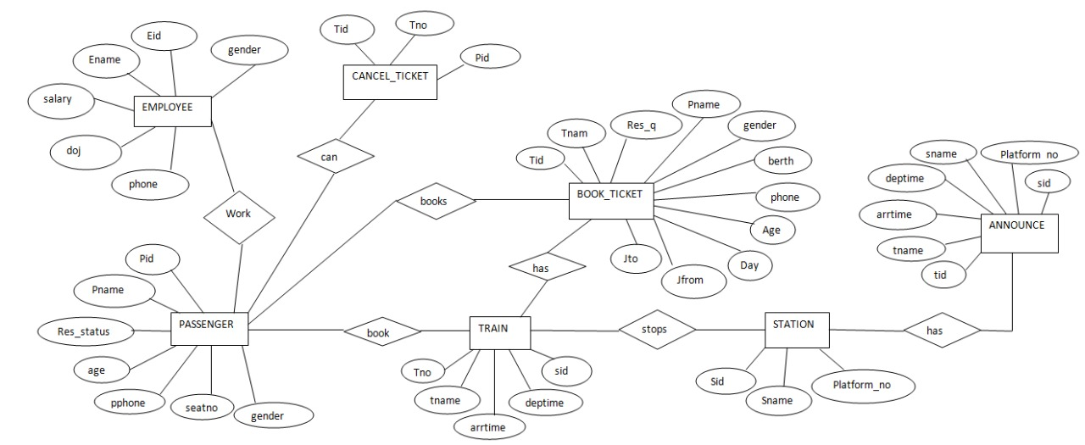

**RELATIONAL MODEL:**

**DDL OPERATIONS:**

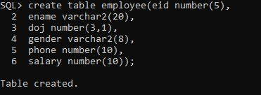**Employee:**

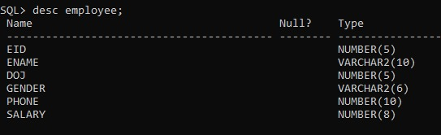

**Passenger:**

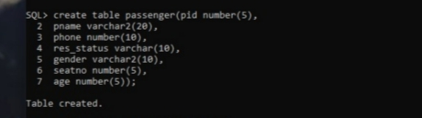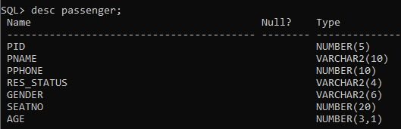

**Station:**

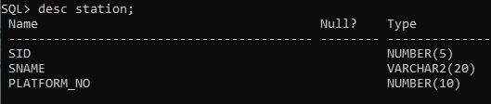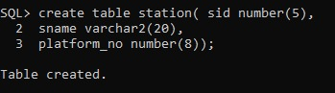

**Cancel_ticket:**

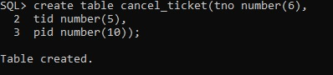

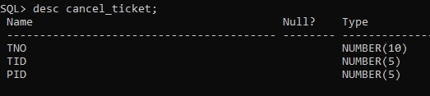

**Train:**

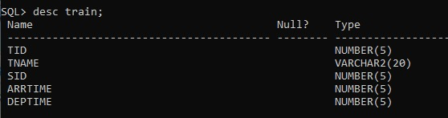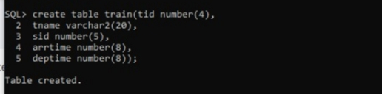

**Announce:**

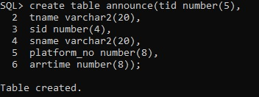

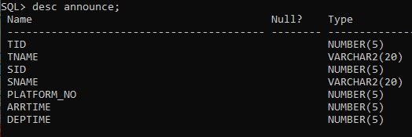

**Book_ticket:**

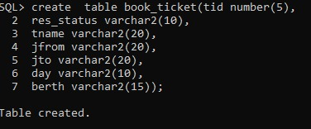

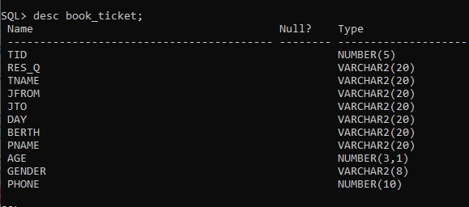

**DML OPERATIONS**:

**Employee:**

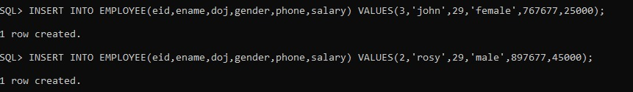

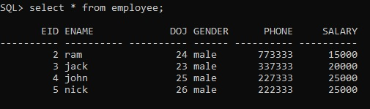

**Passenger:**

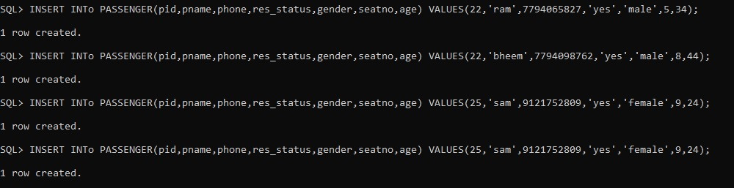

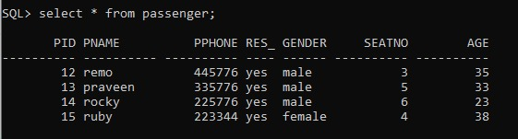

**Announce:**

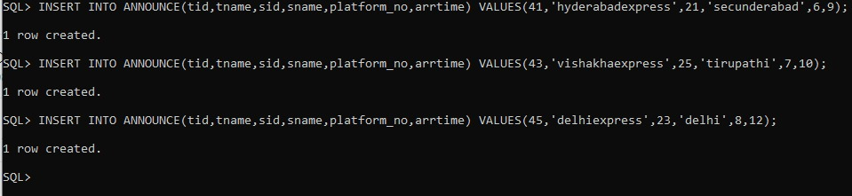

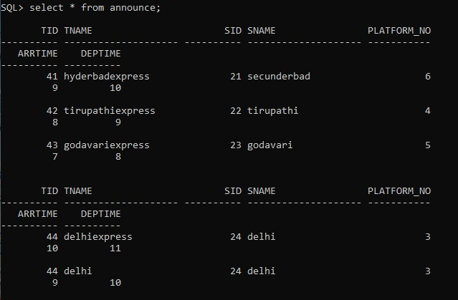

**Station:**

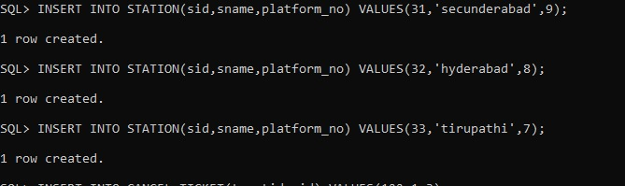

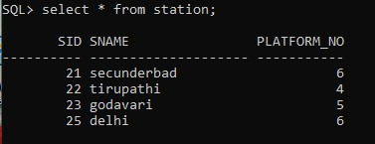

**TRAIN:**

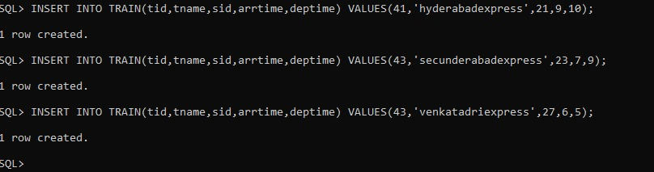

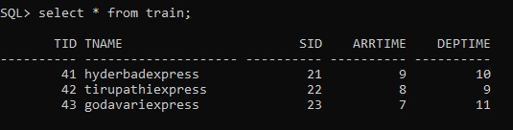

**Cancel_ticket:**

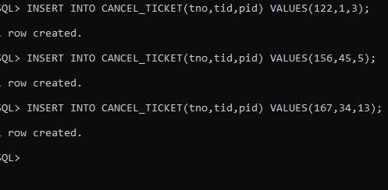

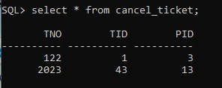

**Book_ticket:**

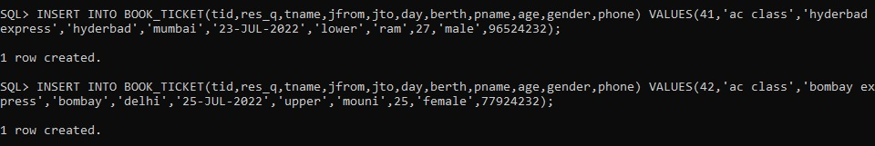

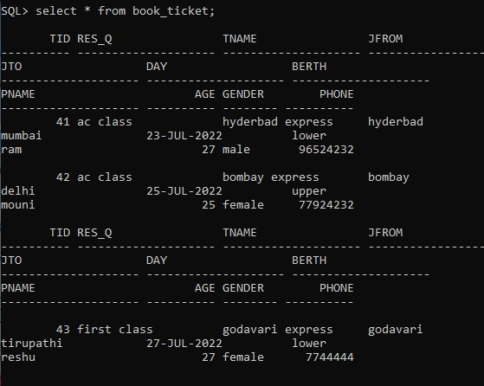

**Front End Implementation:**

Java SWING is a GUI widget toolkit for Java. It is part of Oracle's Java Foundation Classes (JFC) - an API for providing a graphical user interface (GUI) for Java programs. Swing was developed to provide a more sophisticated set of GUI components than the earlier AWT. Swing provides a look and feel that emulates the look and feel of several platforms and supports a pluggable look and feel that allows applications to have a look and feel unrelated to the underlying platform. It has more powerful and flexible components than AWT. In addition to familiar components such as buttons, check boxes and labels, Swing provides several advanced components such as tabbed panel, scroll panes, trees, tables, and lists.

**IMPLEMENTATION:**

//Railway.java

import javax.swing.*;

import java.awt.*;

import java.awt.event.*;

public class Railway extends JFrame{

private JFrame frame= new JFrame();

private JButton b1=new JButton("employee!!");

private JButton b2=new JButton("passenger!!");

private JButton b3=new JButton("station!!");

private JButton b4=new JButton("train!!");

private JButton b5=new JButton("announce!!");

private JButton b6=new JButton("book_ticket!!");

private JButton b7=new JButton("cancel_ticket!!");

private JLabel l1=new JLabel("VISIT TO");

private JMenuBarmBar;

private JMenumnuHelp;

private JMenuItemabt;

public Railway(){

frame.setTitle("HOME PAGE");

frame.setLayout(null);

frame.setDefaultCloseOperation(JFrame.EXIT_ON_CLOSE);

frame.setBounds(0,0,1400,1000);

Container c=frame.getContentPane();

frame.getContentPane().add(b1);

frame.getContentPane().add(b2);

frame.getContentPane().add(b3);

frame.getContentPane().add(b4);

frame.getContentPane().add(b5);

frame.getContentPane().add(b6);

frame.getContentPane().add(b7);

frame.getContentPane().add(l1);

initializeMenuBar();

frame.setJMenuBar(mBar);

abt.addActionListener(new HelpMenuActionListener());

JLabel label=new JLabel("RAILWAY MANAGEMENT SYSTEM!!");

JLabel label1=new JLabel();

label1.setIcon(new ImageIcon("C:/Users/admin/Downloads/rail.png"));

Dimension size = label1.getPreferredSize();

label.setBounds(300,5,700,50);

label.setFont(new Font("Serif",Font.PLAIN,20));

label.setForeground(Color.BLACK);

l1.setBounds(1130,5,700,50);

l1.setFont(new Font("Serif",Font.PLAIN,20));

l1.setForeground(Color.BLACK);

label1.setBounds(100,60, size.width,size.height);

b1.setBounds(1100,60,170,40);

b1.setFont(new Font("Times New Roman",Font.BOLD,17));

b2.setBounds(1100,110,170,40);

b2.setFont(new Font("Times New Roman",Font.BOLD,17));

b3.setBounds(1100,160,170,40);

b3.setFont(new Font("Times New Roman",Font.BOLD,17));

b4.setBounds(1100,210,170,40);

b4.setFont(new Font("Times New Roman",Font.BOLD,17));

b5.setBounds(1100,260,170,40);

b5.setFont(new Font("Times New Roman",Font.BOLD,17));

b6.setBounds(1100,310,170,40);

b6.setFont(new Font("Times New Roman",Font.BOLD,17));

b7.setBounds(1100,360,170,40);

b7.setFont(new Font("Times New Roman",Font.BOLD,17));

b1.addActionListener(new ActionListener() {

public void actionPerformed(ActionEvent ae) {

new employee();

}

});

b2.addActionListener(new ActionListener() {

public void actionPerformed(ActionEvent ae) {

new passenger();

}

});

b3.addActionListener(new ActionListener() {

public void actionPerformed(ActionEvent ae) {

new station();

}

});

b4.addActionListener(new ActionListener() {

public void actionPerformed(ActionEvent ae) {

new train();

}

});

b5.addActionListener(new ActionListener() {

public void actionPerformed(ActionEvent ae) {

new announce();

}

});

b6.addActionListener(new ActionListener() {

public void actionPerformed(ActionEvent ae) {

}

});

b7.addActionListener(new ActionListener() {

public void actionPerformed(ActionEvent ae) {

new cancel_ticket();

}

});

c.add(label);

c.add(label1);

frame.getContentPane().setBackground(Color. PINK);

frame.setVisible(true);

}

public void initializeMenuBar()

{

mBar=new JMenuBar();

mnuHelp=new JMenu("Help");

abt=new JMenuItem("About");

mnuHelp.add(abt);

mBar.add(mnuHelp);

}

private class HelpMenuActionListener implements ActionListener {

public void actionPerformed(ActionEvent ae) {

if(ae.getSource()==abt)

{

String details;

details = "This project is about the details of railway management system"+"\n"+

"It has 7 tables:"+"\n"+

"1.employee table with rows containing employee Id as eid, employee name as ename, employee date of join as doj,employee gender as gender, employee phone number as phone and employee salary as salary"+"\n"+

"2.passenger table with rows containing passenger Id as pid, name of the passenger as pname, passenger phone number as pphone, status of passengers reservation as res_status, gender of passenger as gender, passenger seatno as seatno and passenger age as age"+"\n"+

"3.station table with rows containing station Id as sid, station name as sname and platforms of station as no_of_platforms"+"\n"+

"4.train table with rows containing train Id as tid, train name as tname, station id as sid, train arrive time as arrtime and t"+"\n"+

"5.announce table with rows containing train Id as tid, train name as tname, station Id as sid, station name as sname, platform number as platform_no, arrive time as arrtime and departure time as deptime"+"\n"+

"6.ticket_booking table with rows containing ticket number as tno, train Id as tid,passenger Id as pid, train source as source, train destination as destination,train class as class,total seats booked asand ticket cost as cost"+"\n"+

"7.cancel_ticket table with rows containing ticket no as tno, train Id as tid and passenger Id as pid";

JOptionPane.showMessageDialog(null,details,"INFORMATION", JOptionPane.INFORMATION_MESSAGE);

}

}

}

public static void main(String args[]){

new Railway();

}

}

//employee.java

import javax.swing.*;

import java.awt.*;

import java.awt.event.*;

import java.sql.*;

import java.util.*;

public class employee implements ActionListener{

private JFrame f=new JFrame("employee!!");

private JLabel l=new JLabel("");

private JLabel l1=new JLabel("Enter employee Id,name,doj,gender,phone,salary");

private JLabel l2=new JLabel("Enter employee Id,salary to update");

private JLabel l3=new JLabel("Enter employee Id to delete");

private JLabel l4=new JLabel("Result");

private JLabel l5=new JLabel("EMPLOYEE");

private JButton b1=new JButton("Insert");

private JButton b2=new JButton("Update");

private JButton b3=new JButton("Delete");

private JButton b4=new JButton("View");

private JTextField t1=new JTextField();

private JTextField t2=new JTextField();

private JTextField t3=new JTextField();

private JTextField t=new JTextField();

private JTextArea t4=new JTextArea();

private JScrollPanescrollBar=new JScrollPane(t4,JScrollPane.VERTICAL_SCROLLBAR_ALWAYS,JScrollPane.HORIZONTAL_SCROLLBAR_ALWAYS);

public employee() {

f.setDefaultCloseOperation(JFrame.HIDE_ON_CLOSE);

f.setBounds(100,150,1000,400);

Container c=f.getContentPane();

f.getContentPane().add(l1);

f.getContentPane().add(l2);

f.getContentPane().add(l3);

f.getContentPane().add(l4);

f.getContentPane().add(l5);

f.getContentPane().add(b1);

f.getContentPane().add(b2);

f.getContentPane().add(b3);

f.getContentPane().add(b4);

f.getContentPane().add(t1);

f.getContentPane().add(t2);

f.getContentPane().add(t3);

f.getContentPane().add(t);

f.getContentPane().add(scrollBar);

scrollBar.setBounds(690,80,250,150);

l.setBounds(20,30,50,50);

l1.setBounds(20,80,280,30);

l1.setOpaque(true);

l1.setBackground(Color.WHITE);

l2.setBounds(20,120,280,30);

l2.setOpaque(true);

l2.setBackground(Color.WHITE);

l3.setBounds(20,160,280,30);

l3.setOpaque(true);

l3.setBackground(Color.WHITE);

l4.setBounds(20,200,280,30);

l4.setOpaque(true);

l4.setBackground(Color.WHITE);

l5.setBounds(430,5,700,50);

l5.setFont(new Font("Serif",Font.PLAIN,20));

l5.setForeground(Color.BLUE);

b1.setBounds(570,80,100,30);

b1.setFont(new Font("Times New Roman",Font.BOLD,17));

b2.setBounds(570,120,100,30);

b2.setFont(new Font("Times New Roman",Font.BOLD,17));

b3.setBounds(570,160,100,30);

b3.setFont(new Font("Times New Roman",Font.BOLD,17));

b4.setBounds(570,200,100,30);

b4.setFont(new Font("Times New Roman",Font.BOLD,17));

t1.setBounds(330,80,220,30);

t2.setBounds(330,120,220,30);

t3.setBounds(330,160,220,30);

t.setBounds(330,200,220,30);

t4.setEditable(false);

b1.addActionListener(this);

b2.addActionListener(this);

b3.addActionListener(this);

b4.addActionListener(this);

c.add(l);

f.getContentPane().setBackground(Color.WHITE );

f.setVisible(true);

}

public void actionPerformed(ActionEvent ae){

String s=new String(ae.getActionCommand());

if((s).equals("Insert")){

try{

t.setText("1 row Inserted "+t1.getText());

Class.forName("oracle.jdbc.OracleDriver");

Connection con=DriverManager.getConnection("jdbc:oracle:thin:@localhost:1521:xe","manju","vasavi");

Statement stmt=con.createStatement();

StringTokenizerst=new StringTokenizer(t1.getText(),",");

inteid=Integer.parseInt(st.nextToken());

String ename=st.nextToken();

intdoj=Integer.parseInt(st.nextToken());

String gender=st.nextToken();

int phone=Integer.parseInt(st.nextToken());

int salary=Integer.parseInt(st.nextToken());

stmt.executeUpdate("insert into employee values('"+eid+"','"+ename+"','"+doj+"','"+gender+"','"+phone+"',"+salary+")");

con.close();

}

catch (Exception e) {

t.setText("Error Occured!!");

}

t2.setText("");

t3.setText("");

t4.setText("");

}

else if((s).equals("Update")){

try{

t.setText("1 row Updated "+t2.getText());

Class.forName("oracle.jdbc.OracleDriver");

Connection con=DriverManager.getConnection("jdbc:oracle:thin:@localhost:1521:xe","manju","vasavi");

Statement stmt=con.createStatement();

StringTokenizerst=new StringTokenizer(t2.getText(),",");

inteid=Integer.parseInt(st.nextToken());

int salary=Integer.parseInt(st.nextToken());

stmt.executeUpdate("Update employee set salary='"+salary+"' where eid="+eid+"");

con.close();

}

catch(Exception e){

t.setText("Error Occured!!");

}

t1.setText("");

t3.setText("");

t4.setText("");

}

else if((s).equals("Delete")){

try{

t.setText("Deleted 1 row with eid "+t3.getText());

Class.forName("oracle.jdbc.OracleDriver");

Connection con=DriverManager.getConnection("jdbc:oracle:thin:@localhost:1521:xe","manju","vasavi");

Statement stmt=con.createStatement();

inteid=Integer.parseInt(t3.getText());

stmt.executeUpdate("delete from employee where eid="+eid+"");

con.close();

}

catch(Exception e){

t.setText("Error Occured!!");

}

t1.setText("");

t2.setText("");

t4.setText("");

}

else if((s).equals("View")){

try{

t.setText("Rows from employee table");

Class.forName("oracle.jdbc.OracleDriver");

Connection con=DriverManager.getConnection("jdbc:oracle:thin:@localhost:1521:xe","manju","vasavi");

Statement stmt=con.createStatement();

ResultSetrs=stmt.executeQuery("select * from employee");

String str=new String();

while(rs.next())

str=str+(rs.getInt(1)+" "+rs.getString(2)+" "+rs.getInt(3)+" "+rs.getString(4)+" "+rs.getInt(5)+" "+rs.getInt(6)+"\n");

t4.setText(str);

con.close();

}

catch(Exception e){

t.setText("Error Occured!!");

}

t1.setText("");

t2.setText("");

t3.setText("");

}

}

public static void main(String[] args){

new employee();

}

}

//Passenger.java

import javax.swing.*;

import java.awt.*;

import java.awt.event.*;

import java.sql.*;

import java.util.*;

public class passenger implements ActionListener{

private JFrame f=new JFrame("passenger Page");

private JLabel l=new JLabel("");

private JLabel l1=new JLabel("Enter passenger Id,name,pphone,res_status,gender,seatno,age");

private JLabel l2=new JLabel("Enter passenger Id,seatno to update");

private JLabel l3=new JLabel("Enter passenger Id to delete");

private JLabel l4=new JLabel("Result");

private JLabel l5=new JLabel("PASSENGER");

private JButton b1=new JButton("Insert");

private JButton b2=new JButton("Update");

private JButton b3=new JButton("Delete");

private JButton b4=new JButton("View");

private JTextField t1=new JTextField();

private JTextField t2=new JTextField();

private JTextField t3=new JTextField();

private JTextField t=new JTextField();

private JTextArea t4=new JTextArea();

private JScrollPanescrollBar=new JScrollPane(t4,JScrollPane.VERTICAL_SCROLLBAR_ALWAYS,JScrollPane.HORIZONTAL_SCROLLBAR_ALWAYS);

public passenger() {

f.setDefaultCloseOperation(JFrame.HIDE_ON_CLOSE);

f.setBounds(100,150,1000,400);

Container c=f.getContentPane();

f.getContentPane().add(l1);

f.getContentPane().add(l2);

f.getContentPane().add(l3);

f.getContentPane().add(l4);

f.getContentPane().add(l5);

f.getContentPane().add(b1);

f.getContentPane().add(b2);

f.getContentPane().add(b3);

f.getContentPane().add(b4);

f.getContentPane().add(t1);

f.getContentPane().add(t2);

f.getContentPane().add(t3);

f.getContentPane().add(t);

f.getContentPane().add(scrollBar);

scrollBar.setBounds(690,80,250,150);

l.setBounds(20,30,50,50);

l1.setBounds(20,80,300,30);

l1.setOpaque(true);

l1.setBackground(Color.WHITE);

l2.setBounds(20,120,300,30);

l2.setOpaque(true);

l2.setBackground(Color.WHITE);

l3.setBounds(20,160,300,30);

l3.setOpaque(true);

l3.setBackground(Color.WHITE);

l4.setBounds(20,200,300,30);

l4.setOpaque(true);

l4.setBackground(Color.WHITE);

l5.setBounds(430,5,700,50);

l5.setFont(new Font("Serif",Font.PLAIN,20));

l5.setForeground(Color.BLUE);

b1.setBounds(570,80,100,30);

b1.setFont(new Font("Times New Roman",Font.BOLD,17));

b2.setBounds(570,120,100,30);

b2.setFont(new Font("Times New Roman",Font.BOLD,17));

b3.setBounds(570,160,100,30);

b3.setFont(new Font("Times New Roman",Font.BOLD,17));

b4.setBounds(570,200,100,30);

b4.setFont(new Font("Times New Roman",Font.BOLD,17));

t1.setBounds(330,80,220,30);

t2.setBounds(330,120,220,30);

t3.setBounds(330,160,220,30);

t.setBounds(330,200,220,30);

t4.setEditable(false);

b1.addActionListener(this);

b2.addActionListener(this);

b3.addActionListener(this);

b4.addActionListener(this);

c.add(l);

f.getContentPane().setBackground(Color.WHITE );

f.setVisible(true);

}

public void actionPerformed(ActionEvent ae){

String s=new String(ae.getActionCommand());

if((s).equals("Insert")){

try{

t.setText("1 row Inserted "+t1.getText());

Class.forName("oracle.jdbc.OracleDriver");

Connection con=DriverManager.getConnection("jdbc:oracle:thin:@localhost:1521:xe","manju","vasavi");

Statement stmt=con.createStatement();

StringTokenizerst=new StringTokenizer(t1.getText(),",");

intpid=Integer.parseInt(st.nextToken());

String pname=st.nextToken();

intpphone=Integer.parseInt(st.nextToken());

String res_status=st.nextToken();

String gender=st.nextToken();

intseatno=Integer.parseInt(st.nextToken());

int age=Integer.parseInt(st.nextToken());

stmt.executeUpdate("insert into passenger values('"+pid+"','"+pname+"','"+pphone+"','"+res_status+"','"+gender+"','"+seatno+"',"+age+")");

con.close();

}

catch (Exception e) {

t.setText("Error Occured!!");

}

t2.setText("");

t3.setText("");

t4.setText("");

}

else if((s).equals("Update")){

try{

t.setText("1 row Updated "+t2.getText());

Class.forName("oracle.jdbc.OracleDriver");

Connection con=DriverManager.getConnection("jdbc:oracle:thin:@localhost:1521:xe","manju","vasavi");

Statement stmt=con.createStatement();

StringTokenizerst=new StringTokenizer(t2.getText(),",");

intpid=Integer.parseInt(st.nextToken());

intseatno=Integer.parseInt(st.nextToken());

stmt.executeUpdate("Update passenger set seatno='"+seatno+"' where pid="+pid+"");

con.close();

}

catch(Exception e){

t.setText("Error Occured!!");

}

t1.setText("");

t3.setText("");

t4.setText("");

}

else if((s).equals("Delete")){

try{

t.setText("Deleted 1 row with pid "+t3.getText());

Class.forName("oracle.jdbc.OracleDriver");

Connection con=DriverManager.getConnection("jdbc:oracle:thin:@localhost:1521:xe","manju","vasavi");

Statement stmt=con.createStatement();

intpid=Integer.parseInt(t3.getText());

stmt.executeUpdate("delete from passenger where pid="+pid+"");

con.close();

}

catch(Exception e){

t.setText("Error Occured!!");

}

t1.setText("");

t2.setText("");

t4.setText("");

}

else if((s).equals("View")){

try{

t.setText("Rows from passenger table");

Class.forName("oracle.jdbc.OracleDriver");

Connection con=DriverManager.getConnection("jdbc:oracle:thin:@localhost:1521:xe","manju","vasavi");

Statement stmt=con.createStatement();

ResultSetrs=stmt.executeQuery("select * from passenger");

String str=new String();

while(rs.next())

str=str+(rs.getInt(1)+" "+rs.getString(2)+" "+rs.getInt(3)+" "+rs.getString(4)+" "+rs.getString(5)+" "+rs.getInt(6)+" "+rs.getInt(7)+"\n");

t4.setText(str);

con.close();

}

catch(Exception e){

t.setText("Error Occured!!");

}

t1.setText("");

t2.setText("");

t3.setText("");

}

}

public static void main(String[] args){

new passenger();

}

}

//station.java

import javax.swing.*;

import java.awt.*;

import java.awt.event.*;

import java.sql.*;

import java.util.*;

public class station implements ActionListener{

private JFrame f=new JFrame("station!!");

private JLabel l=new JLabel("");

private JLabel l1=new JLabel("Enter sid,sname,platform_no to insert");

private JLabel l2=new JLabel("Enter sid,sname to update");

private JLabel l3=new JLabel("Enter sid to delete");

private JLabel l4=new JLabel("Result");

private JLabel l5=new JLabel("STATION");

private JButton b1=new JButton("Insert");

private JButton b2=new JButton("Update");

private JButton b3=new JButton("Delete");

private JButton b4=new JButton("View");

private JTextField t1=new JTextField();

private JTextField t2=new JTextField();

private JTextField t3=new JTextField();

private JTextField t=new JTextField();

private JTextArea t4=new JTextArea();

private JScrollPanescrollBar=new JScrollPane(t4,JScrollPane.VERTICAL_SCROLLBAR_ALWAYS,JScrollPane.HORIZONTAL_SCROLLBAR_ALWAYS);

public station() {

f.setDefaultCloseOperation(JFrame.HIDE_ON_CLOSE);

f.setBounds(100,150,1000,400);

Container c=f.getContentPane();

f.getContentPane().add(l1);

f.getContentPane().add(l2);

f.getContentPane().add(l3);

f.getContentPane().add(l4);

f.getContentPane().add(l5);

f.getContentPane().add(b1);

f.getContentPane().add(b2);

f.getContentPane().add(b3);

f.getContentPane().add(b4);

f.getContentPane().add(t1);

f.getContentPane().add(t2);

f.getContentPane().add(t3);

f.getContentPane().add(t);

f.getContentPane().add(scrollBar);

scrollBar.setBounds(690,80,250,150);

l.setBounds(20,30,50,50);

l1.setBounds(60,80,250,30);

l1.setOpaque(true);

l1.setBackground(Color.WHITE);

l2.setBounds(60,120,250,30);

l2.setOpaque(true);

l2.setBackground(Color.WHITE);

l3.setBounds(60,160,250,30);

l3.setOpaque(true);

l3.setBackground(Color.WHITE);

l4.setBounds(60,200,250,30);

l4.setOpaque(true);

l4.setBackground(Color.WHITE);

l5.setBounds(430,5,700,50);

l5.setFont(new Font("Serif",Font.PLAIN,20));

l5.setForeground(Color.BLUE);

b1.setBounds(570,80,100,30);

b1.setFont(new Font("Times New Roman",Font.BOLD,17));

b2.setBounds(570,120,100,30);

b2.setFont(new Font("Times New Roman",Font.BOLD,17));

b3.setBounds(570,160,100,30);

b3.setFont(new Font("Times New Roman",Font.BOLD,17));

b4.setBounds(570,200,100,30);

b4.setFont(new Font("Times New Roman",Font.BOLD,17));

t1.setBounds(330,80,220,30);

t2.setBounds(330,120,220,30);

t3.setBounds(330,160,220,30);

t.setBounds(330,200,220,30);

t4.setEditable(false);

b1.addActionListener(this);

b2.addActionListener(this);

b3.addActionListener(this);

b4.addActionListener(this);

c.add(l);

f.getContentPane().setBackground(Color.WHITE );

f.setVisible(true);

}

public void actionPerformed(ActionEvent ae){

String s=new String(ae.getActionCommand());

if((s).equals("Insert")){

try{

t.setText("1 row Inserted "+t1.getText());

Class.forName("oracle.jdbc.OracleDriver");

Connection con=DriverManager.getConnection("jdbc:oracle:thin:@localhost:1521:xe","manju","vasavi");

Statement stmt=con.createStatement();

StringTokenizerst=new StringTokenizer(t1.getText(),",");

intsid=Integer.parseInt(st.nextToken());

String sname=st.nextToken();

intplatform_no=Integer.parseInt(st.nextToken());

stmt.executeUpdate("insert into station values('"+sid+"','"+sname+"',"+platform_no+")");

con.close();

}

catch (Exception e) {

t.setText("Error Occured!!");

}

t2.setText("");

t3.setText("");

t4.setText("");

}

else if((s).equals("Update")){

try{

t.setText("1 row Updated "+t2.getText());

Class.forName("oracle.jdbc.OracleDriver");

Connection con=DriverManager.getConnection("jdbc:oracle:thin:@localhost:1521:xe","manju","vasavi");

Statement stmt=con.createStatement();

StringTokenizerst=new StringTokenizer(t2.getText(),",");

intsid=Integer.parseInt(st.nextToken());

String sname=st.nextToken();

stmt.executeUpdate("Update station set sname='"+sname+"' where sid="+sid+"");

con.close();

}

catch(Exception e){

t.setText("Error Occured!!");

}

t1.setText("");

t3.setText("");

t4.setText("");

}

else if((s).equals("Delete")){

try{

t.setText("Deleted 1 row with sid "+t3.getText());

Class.forName("oracle.jdbc.OracleDriver");

Connection con=DriverManager.getConnection("jdbc:oracle:thin:@localhost:1521:xe","manju","vasavi");

Statement stmt=con.createStatement();

intsid=Integer.parseInt(t3.getText());

stmt.executeUpdate("delete from station where sid="+sid+"");

con.close();

}

catch(Exception e){

t.setText("Error Occured!!");

}

t1.setText("");

t2.setText("");

t4.setText("");

}

else if((s).equals("View")){

try{

t.setText("Rows from station table");

Class.forName("oracle.jdbc.OracleDriver");

Connection con=DriverManager.getConnection("jdbc:oracle:thin:@localhost:1521:xe","manju","vasavi");

Statement stmt=con.createStatement();

ResultSetrs=stmt.executeQuery("select * from station");

String str=new String();

while(rs.next())

str=str+(rs.getInt(1)+" "+rs.getString(2)+" "+rs.getInt(3)+"\n");

t4.setText(str);

con.close();

}

catch(Exception e){

t.setText("Error Occured!!");

}

t1.setText("");

t2.setText("");

t3.setText("");

}

}

public static void main(String[] args){

new station();

}

}

//train.java

import javax.swing.*;

import java.awt.*;

import java.awt.event.*;

import java.sql.*;

import java.util.*;

public class train implements ActionListener{

private JFrame f=new JFrame("train!!");

private JLabel l=new JLabel("");

private JLabel l1=new JLabel("Enter train Id,name,sid,arrtime,deptime");

private JLabel l2=new JLabel("Enter train Id,deptime to update");

private JLabel l3=new JLabel("Enter train Id to delete");

private JLabel l4=new JLabel("Result");

private JLabel l5=new JLabel("TRAIN");

private JButton b1=new JButton("Insert");

private JButton b2=new JButton("Update");

private JButton b3=new JButton("Delete");

private JButton b4=new JButton("View");

private JTextField t1=new JTextField();

private JTextField t2=new JTextField();

private JTextField t3=new JTextField();

private JTextField t=new JTextField();

private JTextArea t4=new JTextArea();

private JScrollPanescrollBar=new JScrollPane(t4,JScrollPane.VERTICAL_SCROLLBAR_ALWAYS,JScrollPane.HORIZONTAL_SCROLLBAR_ALWAYS);

public train() {

f.setDefaultCloseOperation(JFrame.HIDE_ON_CLOSE);

f.setBounds(100,150,1000,400);

Container c=f.getContentPane();

f.getContentPane().add(l1);

f.getContentPane().add(l2);

f.getContentPane().add(l3);

f.getContentPane().add(l4);

f.getContentPane().add(l5);

f.getContentPane().add(b1);

f.getContentPane().add(b2);

f.getContentPane().add(b3);

f.getContentPane().add(b4);

f.getContentPane().add(t1);

f.getContentPane().add(t2);

f.getContentPane().add(t3);

f.getContentPane().add(t);

f.getContentPane().add(scrollBar);

scrollBar.setBounds(690,80,250,150);

l.setBounds(20,30,50,50);

l1.setBounds(20,80,270,30);

l1.setOpaque(true);

l1.setBackground(Color.WHITE);

l2.setBounds(20,120,270,30);

l2.setOpaque(true);

l2.setBackground(Color.WHITE);

l3.setBounds(20,160,270,30);

l3.setOpaque(true);

l3.setBackground(Color.WHITE);

l4.setBounds(20,200,270,30);

l4.setOpaque(true);

l4.setBackground(Color.WHITE);

l5.setBounds(430,5,700,50);

l5.setFont(new Font("Serif",Font.PLAIN,20));

l5.setForeground(Color.BLUE);

b1.setBounds(570,80,100,30);

b1.setFont(new Font("Times New Roman",Font.BOLD,17));

b2.setBounds(570,120,100,30);

b2.setFont(new Font("Times New Roman",Font.BOLD,17));

b3.setBounds(570,160,100,30);

b3.setFont(new Font("Times New Roman",Font.BOLD,17));

b4.setBounds(570,200,100,30);

b4.setFont(new Font("Times New Roman",Font.BOLD,17));

t1.setBounds(330,80,220,30);

t2.setBounds(330,120,220,30);

t3.setBounds(330,160,220,30);

t.setBounds(330,200,220,30);

t4.setEditable(false);

b1.addActionListener(this);

b2.addActionListener(this);

b3.addActionListener(this);

b4.addActionListener(this);

c.add(l);

f.getContentPane().setBackground(Color.WHITE );

f.setVisible(true);

}

public void actionPerformed(ActionEvent ae){

String s=new String(ae.getActionCommand());

if((s).equals("Insert")){

try{

t.setText("1 row Inserted "+t1.getText());

Class.forName("oracle.jdbc.OracleDriver");

Connection con=DriverManager.getConnection("jdbc:oracle:thin:@localhost:1521:xe","manju","vasavi");

Statement stmt=con.createStatement();

StringTokenizerst=new StringTokenizer(t1.getText(),",");

inttid=Integer.parseInt(st.nextToken());

String tname=st.nextToken();

intsid=Integer.parseInt(st.nextToken());

intarrtime=Integer.parseInt(st.nextToken());

intdeptime=Integer.parseInt(st.nextToken());

stmt.executeUpdate("insert into train values('"+tid+"','"+tname+"','"+sid+"','"+arrtime+"',"+deptime+")");

con.close();

}

catch (Exception e) {

t.setText("Error Occured!!");

}

t2.setText("");

t3.setText("");

t4.setText("");

}

else if((s).equals("Update")){

try{

t.setText("1 row Updated "+t2.getText());

Class.forName("oracle.jdbc.OracleDriver");

Connection con=DriverManager.getConnection("jdbc:oracle:thin:@localhost:1521:xe","manju","vasavi");

Statement stmt=con.createStatement();

StringTokenizerst=new StringTokenizer(t2.getText(),",");

inttid=Integer.parseInt(st.nextToken());

intdeptime=Integer.parseInt(st.nextToken());

stmt.executeUpdate("Update train set deptime="+deptime+" where tid="+tid+"");

con.close();

}

catch(Exception e){

t.setText("Error Occured!!");

}

t1.setText("");

t3.setText("");

t4.setText("");

}

else if((s).equals("Delete")){

try{

t.setText("Deleted 1 row with tid "+t3.getText());

Class.forName("oracle.jdbc.OracleDriver");

Connection con=DriverManager.getConnection("jdbc:oracle:thin:@localhost:1521:xe","manju","vasavi");

Statement stmt=con.createStatement();

inttid=Integer.parseInt(t3.getText());

stmt.executeUpdate("delete from train where tid="+tid+"");

con.close();

}

catch(Exception e){

t.setText("Error Occured!!");

}

t1.setText("");

t2.setText("");

t4.setText("");

}

else if((s).equals("View")){

try{

t.setText("Rows from train table");

Class.forName("oracle.jdbc.OracleDriver");

Connection con=DriverManager.getConnection("jdbc:oracle:thin:@localhost:1521:xe","manju","vasavi");

Statement stmt=con.createStatement();

ResultSetrs=stmt.executeQuery("select * from train");

String str=new String();

while(rs.next())

str=str+(rs.getInt(1)+" "+rs.getString(2)+" "+rs.getInt(3)+" "+rs.getInt(4)+" "+rs.getInt(5)+"\n");

t4.setText(str);

con.close();

}

catch(Exception e){

t.setText("Error Occured!!");

}

t1.setText("");

t2.setText("");

t3.setText("");

}

}

public static void main(String[] args){

new train();

}

}

//announce.java

Import javax.swing.*;

Import java.awt.*;

Import java.awt.event.*;

Import java.sql.*;

Import java.util.*;

Public class announce implements ActionListener{

Private JFrame f=new JFrame(“announce!!”);

Private JLabel l=new JLabel(“”);

Private JLabel l1=new JLabel(“Enter tid,tname,sid,sname,pt_no,arrtime,deptime”);

Private JLabel l2=new JLabel(“Enter train Id,arrtime to update”);

Private JLabel l3=new JLabel(“Result”);

Private JLabel l4=new JLabel(“ANNOUNCE”);

Private JButton b1=new JButton(“Insert”);

Private JButton b2=new JButton(“Update”);

Private JButton b3=new JButton(“View”);

Private JTextField t1=new JTextField();

Private JTextField t2=new JTextField();

Private JTextField t=new JTextField();

Private JTextArea t3=new JTextArea();

Private JScrollPanescrollBar=new JScrollPane(t3,JScrollPane.VERTICAL_SCROLLBAR_ALWAYS,JScrollPane.HORIZONTAL_SCROLLBAR_ALWAYS);

Public announce() {

f.setDefaultCloseOperation(JFrame.HIDE_ON_CLOSE);

f.setBounds(100,150,1000,400);

Container c=f.getContentPane();

f.getContentPane().add(l1);

f.getContentPane().add(l2);

f.getContentPane().add(l3);

f.getContentPane().add(l4);

f.getContentPane().add(b1);

f.getContentPane().add(b2);

f.getContentPane().add(b3);

f.getContentPane().add(t1);

f.getContentPane().add(t2);

f.getContentPane().add(t);

f.getContentPane().add(scrollBar);

scrollBar.setBounds(690,80,250,150);

l.setBounds(20,30,50,50);

l1.setBounds(20,80,270,30);

l1.setOpaque(true);

l1.setBackground(Color.WHITE);

l2.setBounds(20,120,270,30);

l2.setOpaque(true);

l2.setBackground(Color.WHITE);

l3.setBounds(20,160,270,30);

l3.setOpaque(true);

l3.setBackground(Color.WHITE);

l4.setBounds(430,5,700,50);

l4.setFont(new Font(“Serif”,Font.PLAIN,20));

l4.setForeground(Color.BLUE);

b1.setBounds(570,80,100,30);

b1.setFont(new Font(“Times New Roman”,Font.BOLD,17));

b2.setBounds(570,120,100,30);

b2.setFont(new Font(“Times New Roman”,Font.BOLD,17));

b3.setBounds(570,160,100,30);

b3.setFont(new Font(“Times New Roman”,Font.BOLD,17));

t1.setBounds(330,80,220,30);

t2.setBounds(330,120,220,30);

t.setBounds(330,160,220,30);

t3.setEditable(false);

b1.addActionListener(this);

b2.addActionListener(this);

b3.addActionListener(this);

c.add(l);

f.getContentPane().setBackground(Color.WHITE );

f.setVisible(true);

}

Public void actionPerformed(ActionEvent ae){

String s=new String(ae.getActionCommand());

If((s).equals(“Insert”)){

Try{

t.setText(“1 row Inserted “+t1.getText());

Class.forName(“oracle.jdbc.OracleDriver”);

Connection con=DriverManager.getConnection(“jdbc:oracle:thin:@localhost:1521:xe”,”manju”,”vasavi”);

Statement stmt=con.createStatement();

StringTokenizerst=new StringTokenizer(t1.getText(),”,”);

Inttid=Integer.parseInt(st.nextToken());

String tname=st.nextToken();

Intsid=Integer.parseInt(st.nextToken());

String sname=st.nextToken();

Intplatform_no=Integer.parseInt(st.nextToken());

Intarrtime=Integer.parseInt(st.nextToken());

Intdeptime=Integer.parseInt(st.nextToken());

Stmt.executeUpdate(“insert into announce values(‘”+tid+”’,’”+tname+”’,’”+sid+”’,’”+sname+”’,’”+platform_no+”’,’”+arrtime+”’,”+deptime+”)”);

Con.close();

}

Catch (Exception e) {

t.setText(“Error Occurred!!”);

}

T2.setText(“”);

T3.setText(“”);

}

Else if((s).equals(“Update”)){

Try{

t.setText(“1 row Updated “+t2.getText());

Class.forName(“oracle.jdbc.OracleDriver”);

Connection con=DriverManager.getConnection(“jdbc:oracle:thin:@localhost:1521:xe”,”manju”,”vasavi”);

Statement stmt=con.createStatement();

StringTokenizerst=new StringTokenizer(t2.getText(),”,”);

Intarrtime=Integer.parseInt(st.nextToken());

Inttid=Integer.parseInt(st.nextToken());

Stmt.executeUpdate(“Update announce set arrtime=”+arrtime+” where tid=”+tid+””);

Con.close();

}

Catch(Exception e){

t.setText(“Error Occurred!!”);

}

T1.setText(“”);

T3.setText(“”);

}

Else if((s).equals(“View”)){

Try{

t.setText(“Rows from announce table”);

Class.forName(“oracle.jdbc.OracleDriver”);

Connection con=DriverManager.getConnection(“jdbc:oracle:thin:@localhost:1521:xe”,”manju”,”vasavi”);

Statement stmt=con.createStatement();

ResultSetrs=stmt.executeQuery(“select * from announce”);

String str=new String();

While(rs.next())

Str=str+(rs.getInt(1)+” “+rs.getString(2)+” “+rs.getInt(3)+” “+rs.getString(4)+” “+rs.getInt(5)+” “+rs.getInt(6)+” “+rs.getInt(7)+”\n”);

T3.setText(str);

Con.close();

}

Catch(Exception e){

t.setText(“Error Occurred!!”);

}

T1.setText(“”);

T2.setText(“”);

}

}

Public static void main(String[] args){

New announce();

}

}

//book_ticket.java

import javax.swing.*;

import java.awt.*;

import java.awt.event.*;

import java.sql.*;

import java.util.*;

public class book_ticket implements ActionListener{

private JFrame f=new JFrame("book_ticket!!");

private JLabel l=new JLabel("");

private JLabel l1=new JLabel("Enter Train Id ");

private JLabel l2=new JLabel("Reservation Quota");

private JLabel l3=new JLabel("Train Name");

private JLabel l4=new JLabel("Journey From");

private JLabel l5=new JLabel("Journey To");

private JLabel l6=new JLabel("Journey Day");

private JLabel l7=new JLabel("Berth Choice");

private JLabel l8=new JLabel("Passenger Name");

private JLabel l9=new JLabel("Age");

private JLabel l10=new JLabel("Gender");

private JLabel l11=new JLabel("phone number");

private JLabel l12=new JLabel("Result");

private JButton b1=new JButton("BOOKTICKET");

private JTextField t1=new JTextField();

private JTextField t2=new JTextField();

private JTextField t3=new JTextField();

private JTextField t4=new JTextField();

private JTextField t5=new JTextField();

private JTextField t6=new JTextField();

private JTextField t7=new JTextField();

private JTextField t8=new JTextField();

private JTextField t9=new JTextField();

private JTextField t10=new JTextField();

private JTextField t11=new JTextField();

private JTextField t=new JTextField();

public book_ticket() {

f.setDefaultCloseOperation(JFrame.HIDE_ON_CLOSE);

f.setBounds(140,120,470,570);

Container c=f.getContentPane();

f.getContentPane().add(l1);

f.getContentPane().add(l2);

f.getContentPane().add(l3);

f.getContentPane().add(l4);

f.getContentPane().add(l5);

f.getContentPane().add(l6);

f.getContentPane().add(l7);

f.getContentPane().add(l8);

f.getContentPane().add(l9);

f.getContentPane().add(l10);

f.getContentPane().add(l11);

f.getContentPane().add(l12);

f.getContentPane().add(b1);

f.getContentPane().add(t1);

f.getContentPane().add(t2);

f.getContentPane().add(t3);

f.getContentPane().add(t4);

f.getContentPane().add(t5);

f.getContentPane().add(t6);

f.getContentPane().add(t7);

f.getContentPane().add(t8);

f.getContentPane().add(t9);

f.getContentPane().add(t10);

f.getContentPane().add(t11);

f.getContentPane().add(t);

l.setBounds(20,30,50,50);

l1.setBounds(20,20,150,30);

l1.setOpaque(true);

l1.setBackground(Color.PINK);

l2.setBounds(20,60,150,30);

l2.setOpaque(true);

l2.setBackground(Color.PINK);

l3.setBounds(20,100,150,30);

l3.setOpaque(true);

l3.setBackground(Color.PINK);

l4.setBounds(20,140,150,30);

l4.setOpaque(true);

l4.setBackground(Color.PINK);

l5.setBounds(20,180,150,30);

l5.setOpaque(true);

l5.setBackground(Color.PINK);

l6.setBounds(20,220,150,30);

l6.setOpaque(true);

l6.setBackground(Color.PINK);

l7.setBounds(20,260,150,30);

l7.setOpaque(true);

l7.setBackground(Color.PINK);

l8.setBounds(20,300,150,30);

l8.setOpaque(true);

l8.setBackground(Color.PINK);

l9.setBounds(20,340,150,30);

l9.setOpaque(true);

l9.setBackground(Color.PINK);

l10.setBounds(20,380,150,30);

l10.setOpaque(true);

l10.setBackground(Color.PINK);

l11.setBounds(20,420,150,30);

l11.setOpaque(true);

l11.setBackground(Color.PINK);

l12.setBounds(20,460,150,30);

l12.setOpaque(true);

l12.setBackground(Color.PINK);

b1.setBounds(160,500,100,30);

b1.setFont(new Font("Times New Roman",Font.BOLD,17));

t1.setBounds(170,20,220,30);

t2.setBounds(170,60,220,30);

t3.setBounds(170,100,220,30);

t4.setBounds(170,140,220,30);

t5.setBounds(170,180,220,30);

t6.setBounds(170,220,220,30);

t7.setBounds(170,260,220,30);

t8.setBounds(170,300,220,30);

t9.setBounds(170,340,220,30);

t10.setBounds(170,380,220,30);

t11.setBounds(170,420,220,30);

t.setBounds(170,460,220,30);

b1.addActionListener(this);

c.add(l);

f.getContentPane().setBackground(Color.PINK);

f.setVisible(true);

}

public void actionPerformed(ActionEvent ae){

String s=new String(ae.getActionCommand());

if((s).equals("BOOKTICKET")){

try{

t.setText("ticket booked"+t1.getText());

Class.forName("oracle.jdbc.OracleDriver");

Connection con=DriverManager.getConnection("jdbc:oracle:thin:@localhost:1521:xe","manju","vasavi");

Statement stmt=con.createStatement();

inttid=Integer.parseInt(t1.getText());

String res_q=t2.getText();

String tname=t3.getText();

String jfrom=t4.getText();

String jto=t5.getText();

int day=Integer.parseInt(t6.getText());

String berth=t7.getText();

String pname=t8.getText();

int age=Integer.parseInt(t9.getText());

String gender=t10.getText();

int phone=Integer.parseInt(t11.getText());

stmt.executeUpdate("insert into ticket_booking values("+tid+",'"+res_q+"','"+tname+"','"+jfrom+"','"+jto+"',"+day+",'"+berth+"','"+pname+"',"+age+",'"+gender+"',"+phone+")");

con.close();

}

catch (Exception e) {

t.setText("Ticket booked successfully!!");

}

}

}

public static void main(String[] args){

new book_ticket();

}

}

//Cancel_ticketjava

Import javax.swing.*;

Import java.awt.*;

Import java.awt.event.*;

Import java.sql.*;

Import java.util.*;

Public class cancel_ticket implements ActionListener{

Private JFrame f=new JFrame(“cancel_ticket!!”);

Private JLabel l=new JLabel(“”);

Private JLabel l1=new JLabel(“Enter tno,tid,pid to insert for cancellation”);

Private JLabel l2=new JLabel(“Enter tno to cancel ticket”);

Private JLabel l3=new JLabel(“Result”);

Private JLabel l4=new JLabel(“CANCEL_TICKET”);

Private JButton b1=new JButton(“Insert”);

Private JButton b2=new JButton(“Delete”);

Private JButton b3=new JButton(“View”);

Private JTextField t1=new JTextField();

Private JTextField t2=new JTextField();

Private JTextField t=new JTextField();

Private JTextArea t3=new JTextArea();

Private JScrollPanescrollBar=new JScrollPane(t3,JScrollPane.VERTICAL_SCROLLBAR_ALWAYS,JScrollPane.HORIZONTAL_SCROLLBAR_ALWAYS);

Public cancel_ticket() {

f.setDefaultCloseOperation(JFrame.HIDE_ON_CLOSE);

f.setBounds(100,150,1000,400);

Container c=f.getContentPane();

f.getContentPane().add(l1);

f.getContentPane().add(l2);

f.getContentPane().add(l3);

f.getContentPane().add(l4);

f.getContentPane().add(b1);

f.getContentPane().add(b2);

f.getContentPane().add(b3);

f.getContentPane().add(t1);

f.getContentPane().add(t2);

f.getContentPane().add(t);

f.getContentPane().add(scrollBar);

scrollBar.setBounds(690,80,250,150);

l.setBounds(20,30,50,50);

l1.setBounds(60,80,250,30);

l1.setOpaque(true);

l1.setBackground(Color.WHITE);

l2.setBounds(60,120,250,30);

l2.setOpaque(true);

l2.setBackground(Color.WHITE);

l3.setBounds(60,160,250,30);

l3.setOpaque(true);

l3.setBackground(Color.WHITE);

l4.setBounds(430,5,700,50);

l4.setFont(new Font(“Serif”,Font.PLAIN,20));

l4.setForeground(Color.BLUE);

b1.setBounds(570,80,100,30);

b1.setFont(new Font(“Times New Roman”,Font.BOLD,17));

b2.setBounds(570,120,100,30);

b2.setFont(new Font(“Times New Roman”,Font.BOLD,17));

b3.setBounds(570,160,100,30);

b3.setFont(new Font(“Times New Roman”,Font.BOLD,17));

t1.setBounds(330,80,220,30);

t2.setBounds(330,120,220,30);

t.setBounds(330,160,220,30);

t3.setEditable(false);

b1.addActionListener(this);

b2.addActionListener(this);

b3.addActionListener(this);

c.add(l);

f.getContentPane().setBackground(Color.WHITE );

f.setVisible(true);

}

Public void actionPerformed(ActionEvent ae){

String s=new String(ae.getActionCommand());

If((s).equals(“Insert”)){

Try{

t.setText(“ticket to cancel was Inserted “+t1.getText());

Class.forName(“oracle.jdbc.OracleDriver”);

Connection con=DriverManager.getConnection(“jdbc:oracle:thin:@localhost:1521:xe”,”manju”,”vasavi”);

Statement stmt=con.createStatement();

StringTokenizerst=new StringTokenizer(t1.getText(),”,”);

Inttno=Integer.parseInt(st.nextToken());

Inttid=Integer.parseInt(st.nextToken());

Intpid=Integer.parseInt(st.nextToken());

Stmt.executeUpdate(“insert into cancel_ticket values(‘”+tno+”’,’”+tid+”’,”+pid+”)”);

Con.close();

}

Catch (Exception e) {

t.setText(“Error Occurred!!”);

}

T2.setText(“”);

T3.setText(“”);

}

Else if((s).equals(“Delete”)){

Try{

t.setText(“Cancelled ticket with tno “+t2.getText());

Class.forName(“oracle.jdbc.OracleDriver”);

Connection con=DriverManager.getConnection(“jdbc:oracle:thin:@localhost:1521:xe”,”manju”,”vasavi”);

Statement stmt=con.createStatement();

Inttno=Integer.parseInt(t2.getText());

Stmt.executeUpdate(“delete from cancel_ticket where tno=”+tno+””);

Con.close();

}

Catch(Exception e){

t.setText(“Error Occurred!!”);

}

T1.setText(“”);

T3.setText(“”);

}

Else if((s).equals(“View”)){

Try{

t.setText(“Rows from cancel_ticket table”);

Class.forName(“oracle.jdbc.OracleDriver”);

Connection con=DriverManager.getConnection(“jdbc:oracle:thin:@localhost:1521:xe”,”manju”,”vasavi”);

Statement stmt=con.createStatement();

ResultSetrs=stmt.executeQuery(“select * from cancel_ticket”);

String str=new String();

While(rs.next())

Str=str+(rs.getInt(1)+” “+rs.getInt(2)+” “+rs.getInt(3)+”\n”);

T3.setText(str);

Con.close();

}

Catch(Exception e){

t.setText(“Error Occurred!!”);

}

T1.setText(“”);

T2.setText(“”);

}

}

Public static void main(String[] args){

New cancel_ticket();

}

}

**OUTPUTS**:

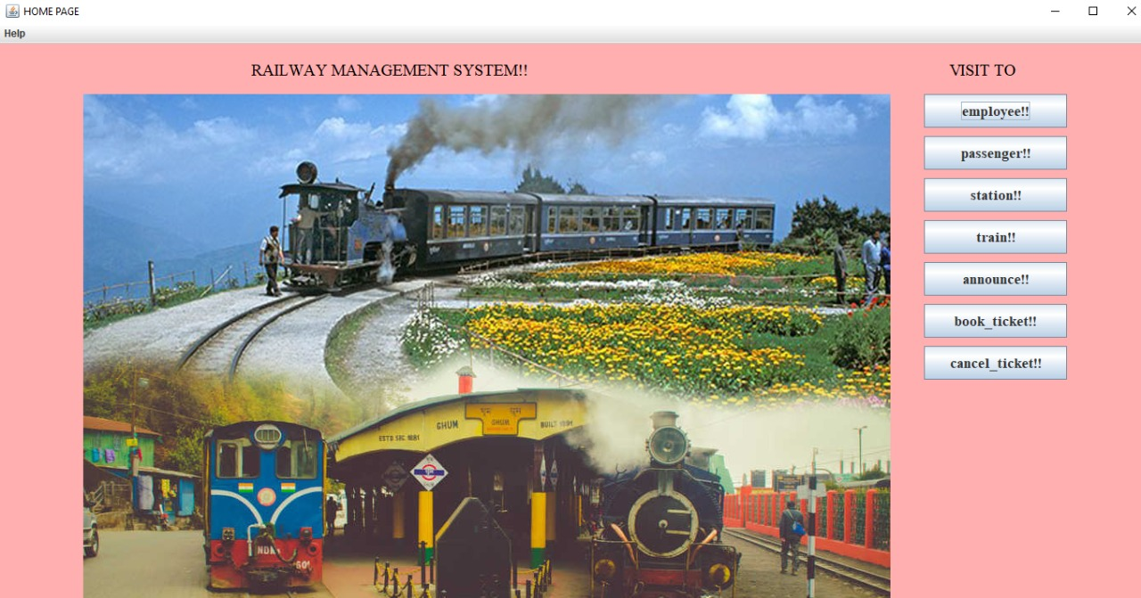

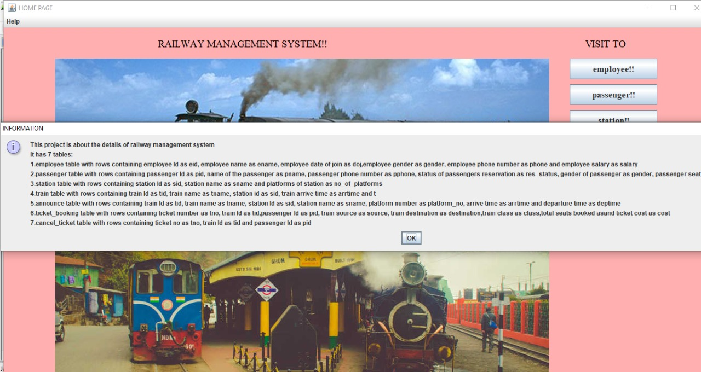

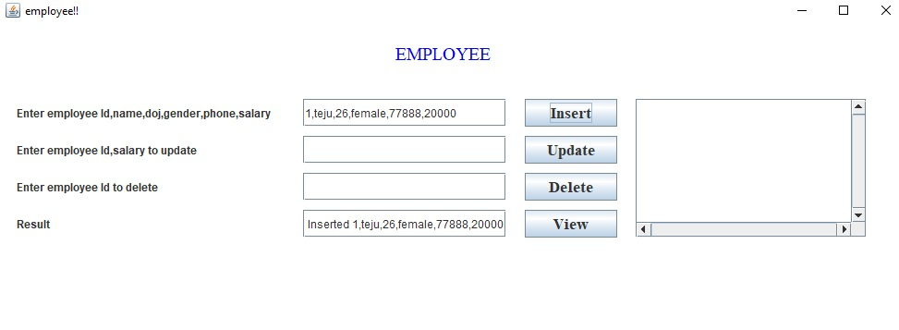

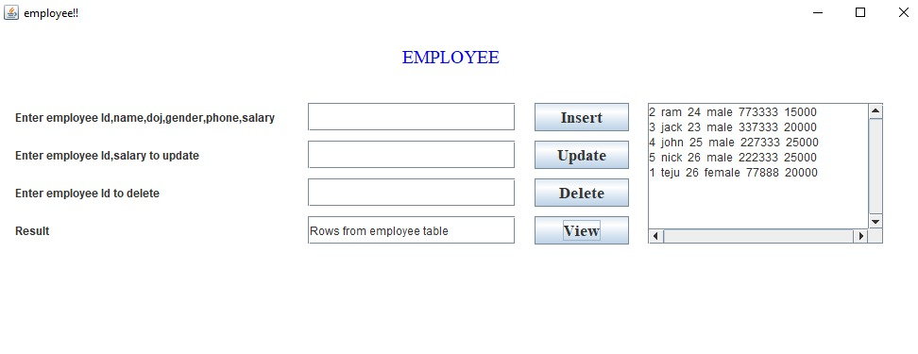

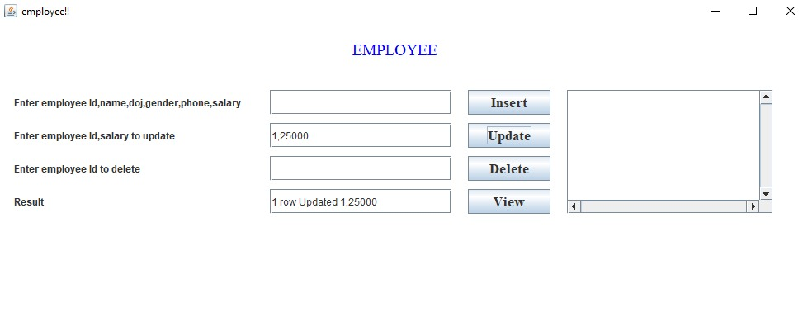

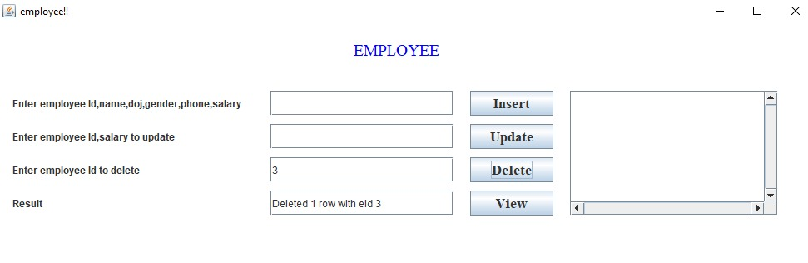

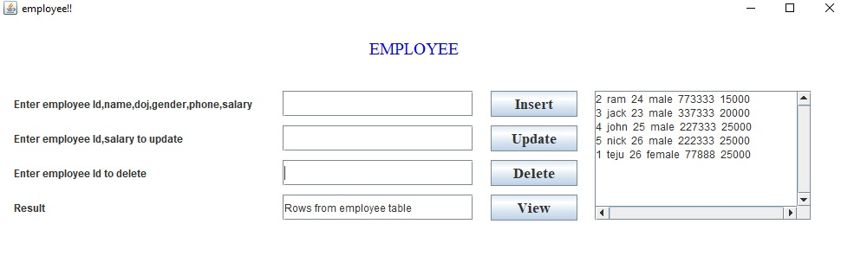

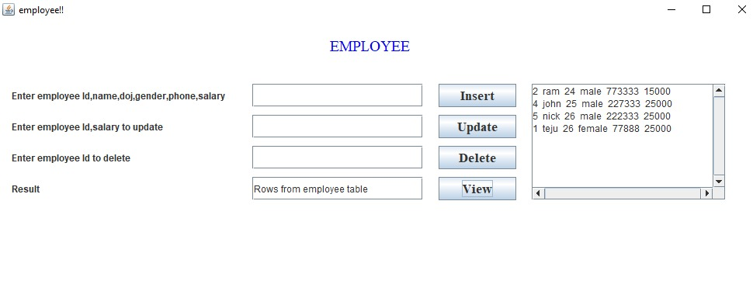

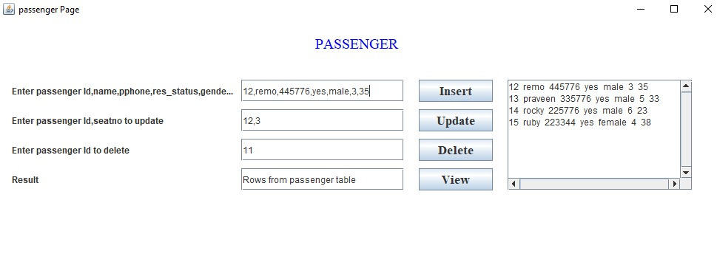

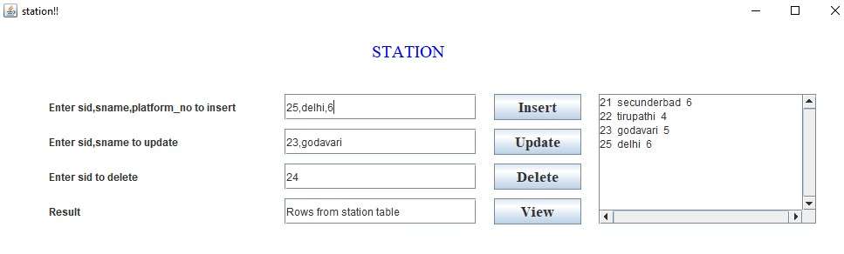

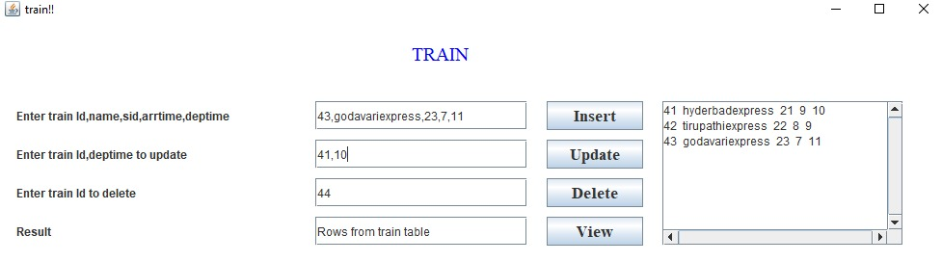

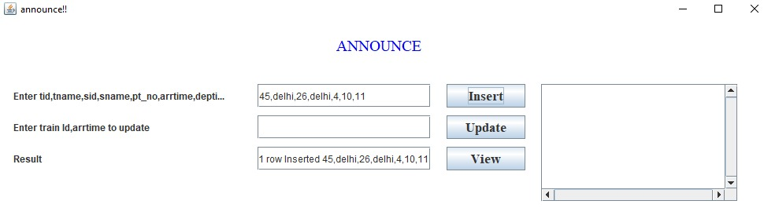

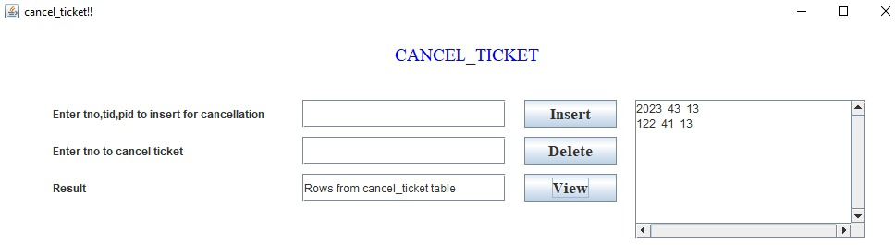

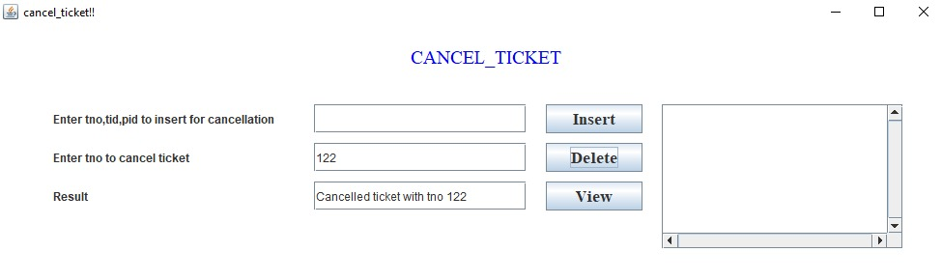

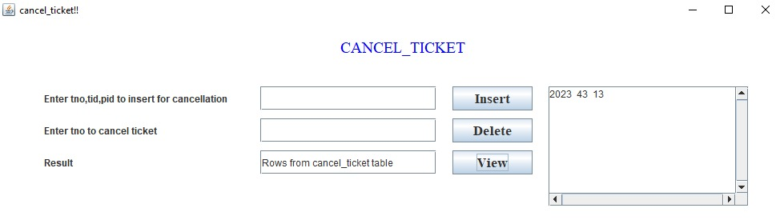

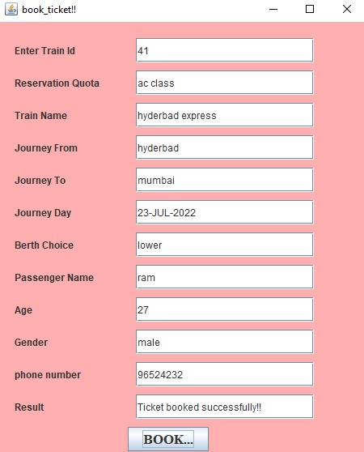

**GitHub link:**<https://github.com/manju-7/Railway-Management-System.git>

**Results**: I have successfully completed my mini project “RAILWAY MANAGEMENT SYSTEM”.

**DISCUSSION AND FUTURE WORK**

All the manual work should be converted and computerized so that the manual work for the employees will be reduced. The database should be stored in computer rather than storing all the records manually. Introduced a new online ticketing system is not only technological innovation. But also will improve the railway services, to a certain extent. Solve the difficult problem of railway ticketing.

**REFERENCES**:

<https://www.irctc.co.in/nget/train-search>

<https://indianrailways.gov.in/>