# APPROCH NOTE AND OUTPUT SCREENSHOTS

## MANAGER HOME PAGE:

* When the Manager Login to the page, the page will list all the employees under the corresponding selected manager with column values Employee ID, Name, Skill, Status, Experience, wfm manager and Request lock Column. The Request Lock Column will have a button for lock Request for the corresponding wfm manager of the current manager.
* Login Page:

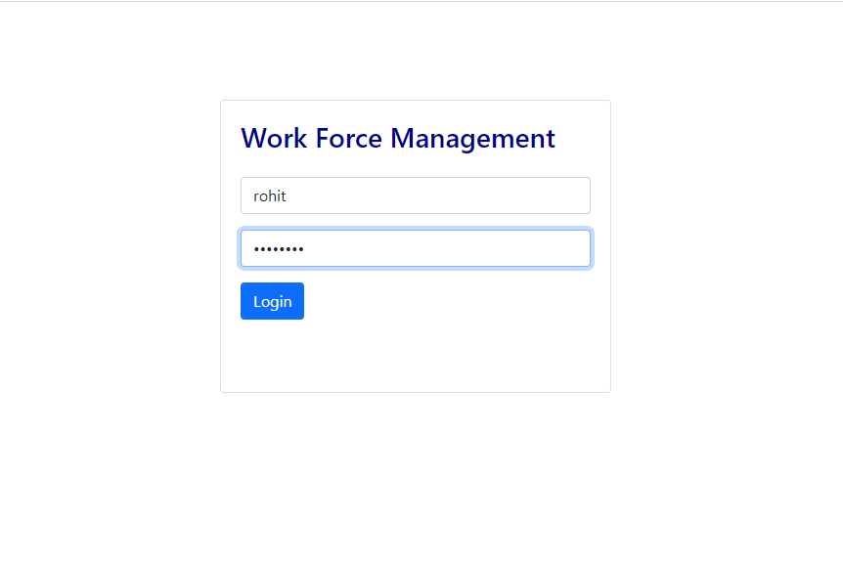

* Manager Home Page: In this example I have selected employee id 1001 and requesting for a lock for the corresponding wfm manager.

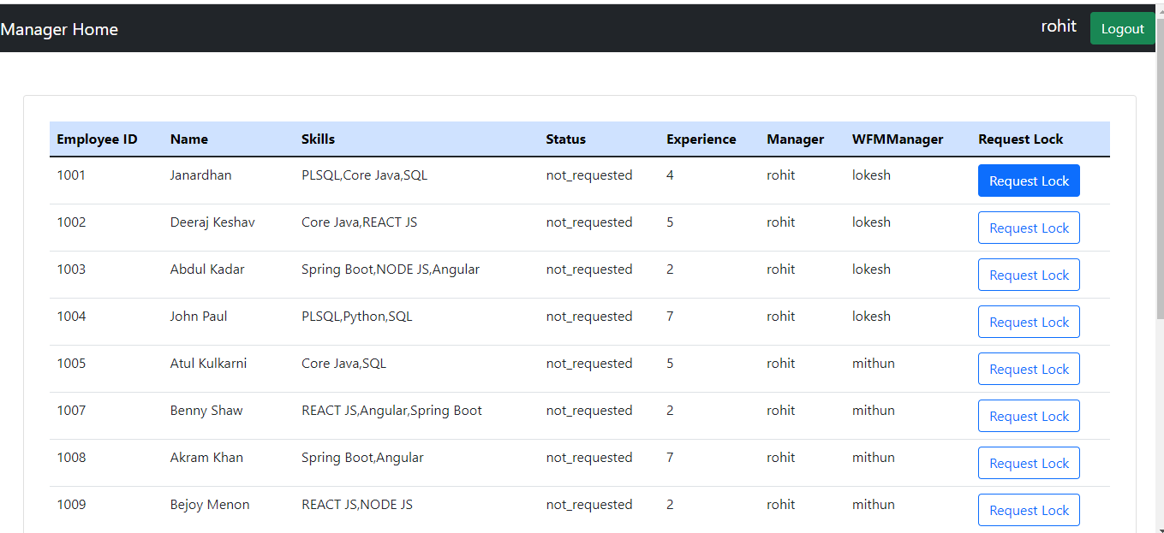

* Soft Lock Request Confirmation: Once the Send Request Button is clicked the employee id manager details and the request message and request date will be stored in the softlock table.

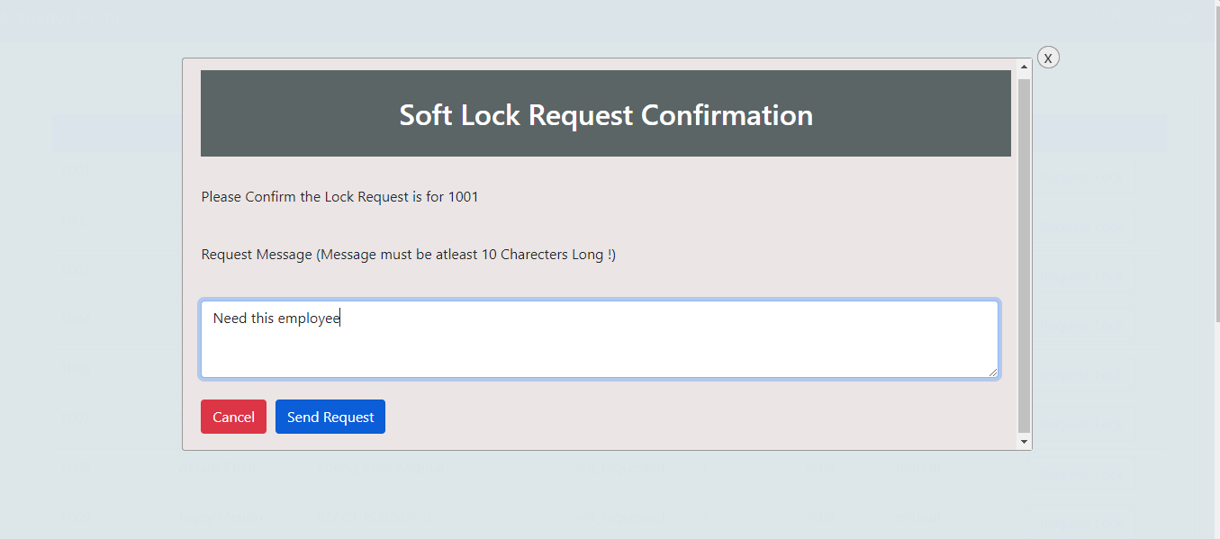

### WORK FORCE MANAGER HOME PAGE:

* Login Page: In this example I have logged in as Lokesh with corresponding password.

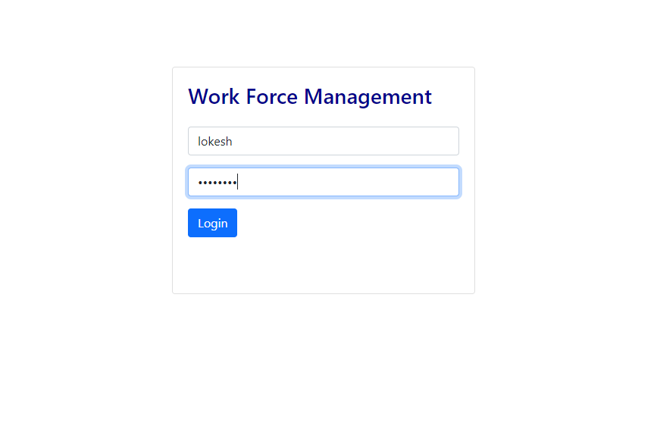

* Work force manager Home page: This page will display a list of details of the manager and the employee under current wfm manager with column values Employee ID, Requestee Request Date, Request Message and View Details.
* The Request send will now be displayed in this list.
* Once a particular row button is clicked( here as a example I have clicked Employee ID=1001) it will pop up a new screen.

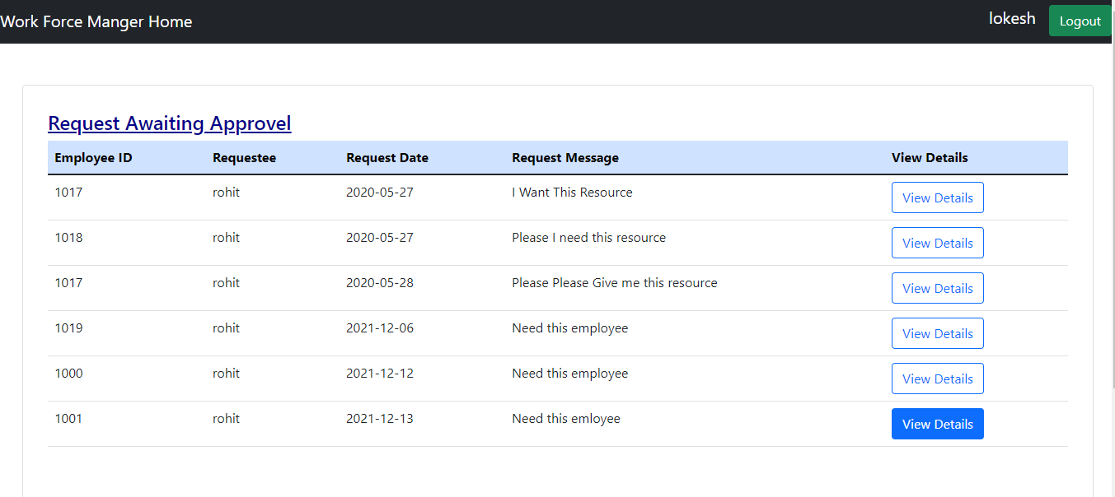

* The Soft Lock Request Confirmation Popup: This will display the details of the Request Awaiting for Approval row details which will not be able to be edited by the wfm manager.
* The wfm manager can Approve or Reject the Request from the manager.
* Based on the input given by the wfm manager the status will be updated both in the employee and the soft lock table.

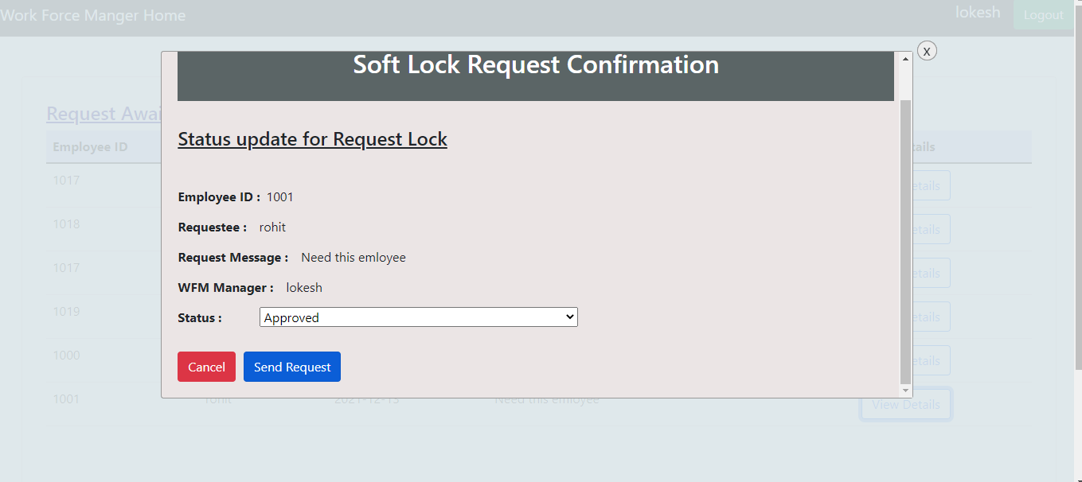

### LOGOUT:

* The Logout button at the top right corner will allow the wfm manager/manager to Logout from the Page.

