**Task1 – Week1**

We are aiming to build a End to end Solution to Workforce Management in an organization

The solution has multiple workflows , Requires API and application to be created

We build the solution on an incremental way with added requirements every week

Given is the data model of the requirement

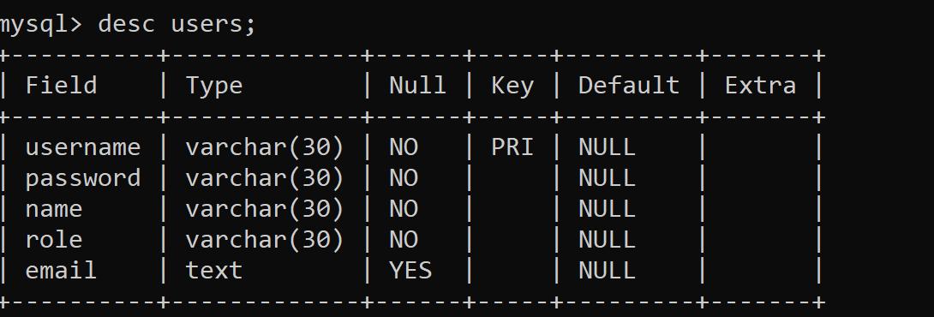

Analyze the above Data model and relations that exist

Create a ASP.net core Project which has the model for the above entities

Create another ASP.net core Project which utilizes the model in the project1 to create an Entity Framework database context for all the entities with relationship defined