ACI Assignment 2 - PS13: Bayesian Network for Medical Diagnosis
Registration Number | Name
2025aa05130 | AMARJIT SINGH
2025aa05935 | MANJUNATH S
2025aa05427 | SAURAV SINHA
2025aa05372 | SOUMYA KANT DAS
2025aa05991 | VIPUL PRAKASH CHAUDHARI

- Problem Overview
The task is to build an intelligent medical diagnosis assistant that reasons under uncertainty. Diseases, symptoms, laboratory findings and exposure factors are modelled as binary random variables in a Bayesian Network. Directed edges encode causal dependence, and exact inference answers conditional probability, posterior probability and independence queries when only partial evidence is available. Two networks are implemented: a Flu diagnosis network and a critical ward alert network.
- Task A: PEAS Description
The agent is a probabilistic diagnostic advisor that sits beside the clinician and keeps a belief over possible diseases as evidence arrives.
- Performance Measure: correctness of the ranked differential diagnosis, calibration of the posterior probabilities against confirmed outcomes, high sensitivity for serious conditions so that critical cases are not missed, low false alarm rate, graceful behaviour when symptoms or lab values are missing, and speed of producing an updated estimate.
- Environment: the clinical setting of a hospital or clinic. It is partially observable because many symptoms and lab results are unknown at any moment, stochastic because the same symptoms can arise from different diseases, dynamic because the patient state and evidence change over time, and sequential because each new finding updates the existing belief rather than resetting it.
- Actuators: the channels the agent acts through, namely the posterior disease probabilities and ranked differential shown to the doctor, alert flags raised for likely critical conditions, recommendations for the next confirmatory laboratory test, and structured notes written back to the patient record.
- Sensors: the inputs it reads, namely symptoms entered by the clinician, laboratory result feeds, patient history and exposure factors, vital sign monitors, and queries into the electronic health record.

- Bayesian Network Design
Both scenarios use a common cause (naive Bayes) structure. A single hidden cause influences two observable effects, so the two effects are conditionally independent given the cause but dependent when the cause is unknown.
- Scenario 1 (Flu): Flu (F) is the cause, Cough (C) and Fever (V) are effects. Edges FC and FV. Factorization P(F, C,V) = P(F) * P(C|F) * P(V|F).
- Scenario 2 (Critical Ward): Emergency Condition (E) is the cause, Alert1 (A1) and Alert2 (A2) are effects. Edges EA1 and EA2. Factorization P(E, A1, A2) = P(E) * P(A1|E) * P(A2|E).

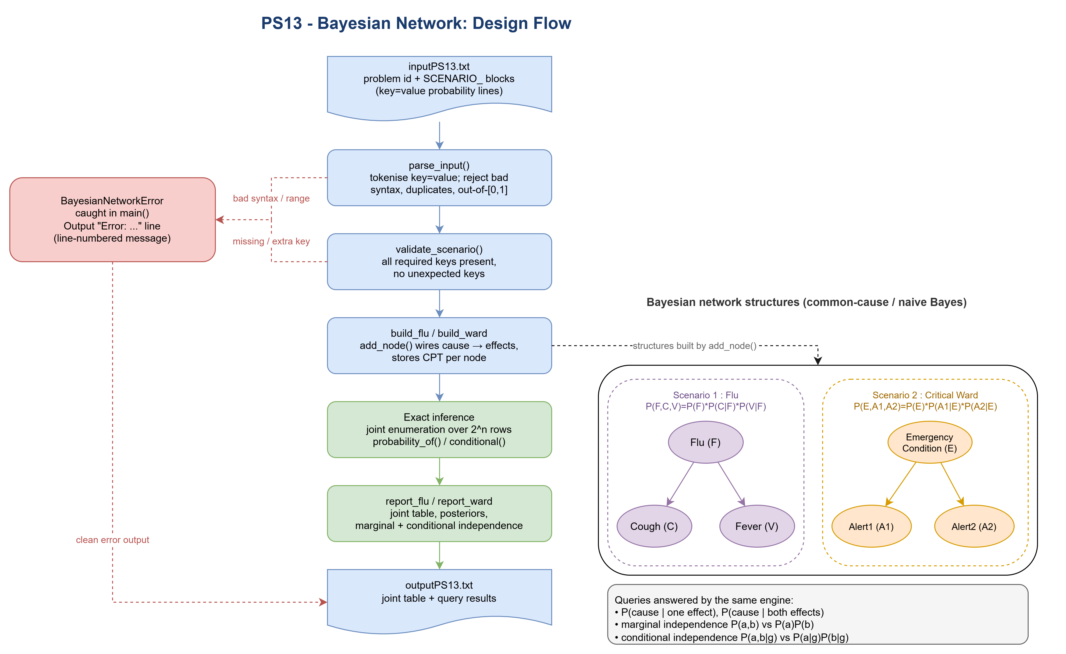
- Data Structures and Inference Algorithm
- Node: stores the variable name, the list of parent names and a conditional probability table held as a dictionary keyed by the tuple of parent values, mapping to P(node = True). This makes lookup of any conditional entry direct.
- Bayesian Network: keeps the nodes in a list in topological order plus a name index dictionary. add_node rejects a repeated variable and a parent that was not added first.
- Exact inference by joint enumeration: joint_probability multiplies the per node factors using the chain rule, probability_of sums the joint over every complete assignment consistent with the evidence. conditional returns P(query and evidence) divided by P(evidence). The same engine answers every query, so no result is hard coded.
- Independence checks: reuse the query engine. Marginal independence compares P(a, b) with P(a)P(b), conditional independence compares P(a, b | g) with P(a | g)P(b | g) across all value combinations within a small tolerance.
- Complexity: enumeration visits 2^n assignments for n variables. With three variables per network this is only eight rows, so the exact method is instant here.

- Input Format and Error Handling
The input file starts with the problem id followed by scenario blocks. Each block has a SCENARIO_ header and a set of key=value probability lines. The parser reports a clear, line numbered message for every failure class: unknown scenario identifier, duplicate scenario, missing required key, duplicate key, unexpected key, malformed line without an equals sign, a
value that is not a number, and a probability outside the range [0, 1]. On any error the program prints a single Error line instead of partial results.

- Computed Results
Query | Scenario 1 (Flu) | Scenario 2 (Ward)
Posterior with one effect | P(F|C) = 0.2286 | P(E|A1) = 0.3214
Posterior with other effect | P(F|V) = 0.2800 | P(E|A2) = 0.2297
Posterior with both effects | P(F|C and V) = 0.5091 | P(E|A1 and A2) = 0.7286
Marginal independence | C, V not independent | A1, A2 not independent
Conditional independence | C, V independent given F | A1, A2 independent given E

Both posteriors rise sharply when the two effects are observed together, which shows how independent evidence reinforces the belief in the shared hidden cause.

- Alternate Modelling Approach and Performance
The chosen method is full joint enumeration, which is exact and easy to trust but scales as 2^n in the total number of variables. An alternate approach is variable elimination, which keeps the same factorised model but sums out hidden variables one at a time while reusing intermediate factors. Its cost grows with the treewidth of the graph rather than the total variable count, so on a larger disease network with many symptoms it is far cheaper while still exact. A library based route such as pgmpy with belief propagation on a junction tree offers the same benefit with less code, and for very large networks approximate sampling methods such as likelihood weighting trade a little accuracy for speed. For the two small networks in this assignment enumeration and variable elimination give identical answers, so enumeration was preferred for clarity and
Verifiability.

- Task C: Bayesian Network versus Rule Based Diagnosis
- Probabilistic versus fixed IF-THEN reasoning: a rule engine fires a fixed conclusion when a condition matches and gives no measure of confidence, while the Bayesian Network returns a graded posterior that reflects how strongly the evidence supports each disease.
- Uncertain, incomplete or overlapping symptoms: rules struggle when a symptom is absent or when several diseases share the same symptom. The network simply sums over the unknown variables and still produces a valid estimate, and it naturally represents one symptom pointing to several diseases.
- Conditional dependencies and accuracy: encoding the true dependence of symptoms on the underlying disease, rather than treating rules as unrelated, keeps the combined estimate coherent and avoids double counting correlated evidence.
- Evidence propagation on posteriors: each new finding updates the belief through Bayes rule. In Scenario 1 the belief in Flu moves from 0.23 with cough alone to 0.51 when cough and fever are both present, which a static rule set cannot express.
- Conditional independence and d-separation: these let the model factorise the joint into small local tables and let inference ignore variables that are blocked from the query, which cuts the number of terms that must be computed and keeps inference tractable as the network grows.

