Chapter-1

Software Quality Assurance (SQA)
Software quality assurance (SQA) is a process that ensures that developed software meets and complies with defined or standardized quality specifications. SQA is an ongoing process within the software development life cycle (SDLC) that routinely checks the developed software to ensure it meets desired quality measures.

Software Quality Assurance Standards:

Some of the most popular standards are discussed below:

ISO 9000: This standard is based on seven quality management principles which help the organizations to ensure that their products or services are aligned with the customer needs’.
7 principles of ISO 9000 are depicted in the below image:

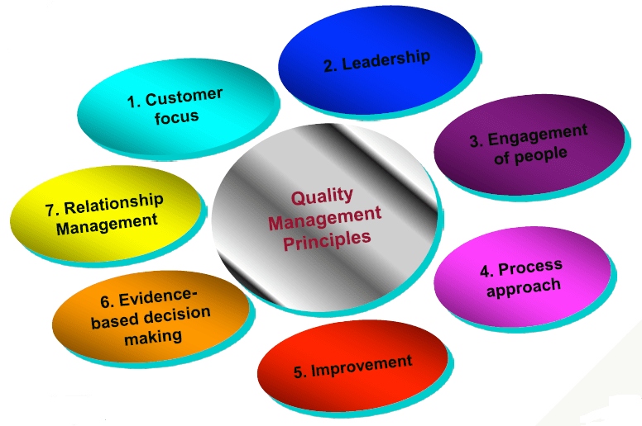
CMMI level: CMMI stands for Capability maturity model Integration. This model was originated in software engineering. It can be employed to direct process improvement throughout a project, department, or an entire organization.

5 CMMI levels and their characteristics are described in the below image:
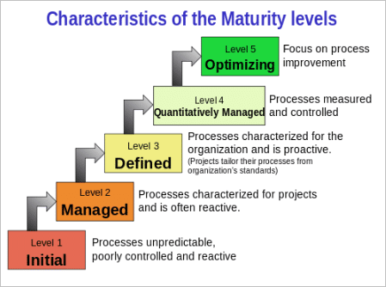

Test Maturity Model integration (TMMi): Based on CMMi, this model focuses on maturity levels in software quality management and testing.
5 TMMi levels are depicted in the below image:
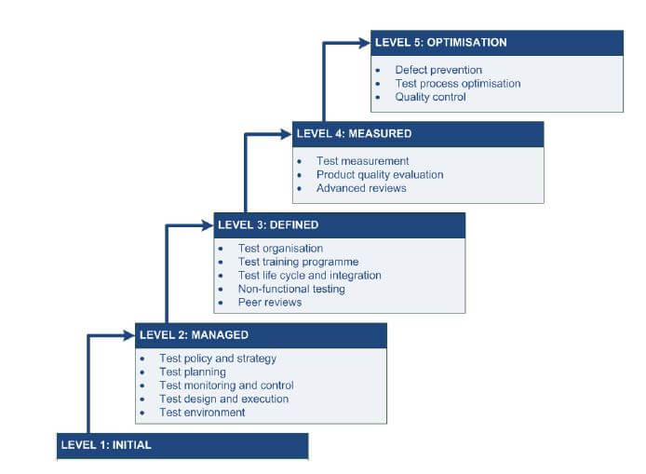

SQA Techniques:
There are several techniques for SQA. Auditing is the chief technique that is widely adopted. However, we have a few other significant techniques as well.
Various SQA Techniques include:
- Auditing: Auditing involves inspection of the work products and its related information to determine if the set of standard processes were followed or not.
- Reviewing: A meeting in which the software product is examined by both the internal and external stakeholders to seek their comments and approval.
- Code Inspection: It is the most formal kind of review that does static testing to find bugs and avoid defect growth in the later stages. It is done by a trained mediator/peer and is based on rules, checklist, entry and exit criteria. The reviewer should not be the author of the code.
- Design Inspection: Design inspection is done using a checklist that inspects the below areas of software design:
  - General requirements and design
  - Functional and Interface specifications
  - Conventions
  - Requirement traceability
  - Structures and interfaces
- Simulation: Simulation is a tool that models the real-life situation in order to virtually examine the behavior of the system under study.
- Functional Testing: It is a QA technique which verifies what the system does without considering how it does. This type of black box testing mainly focuses on testing the system specifications or features.
- Standardization: Standardization plays a crucial role in quality assurance. It decreases the ambiguity and guesswork, thus ensuring quality.
- Static Analysis: It is a software analysis that is done by an automated tool without actually executing the program. This technique is highly used for quality assurance in medical, nuclear and aviation software. Software metrics and reverse engineering are some popular forms of static analysis.
- Walkthroughs: Software walkthrough or code walkthrough is a kind of peer review where the developer guides the members of the development team to go through the product and raise queries, suggest alternatives, make comments regarding possible errors, standard violations or any other issues.
- Path Testing: It is a white box testing technique where the complete branch coverage is ensured by executing each independent path at least once.
- Stress Testing: This type of testing is done to check how robust a system is by testing it under heavy load i.e. beyond normal conditions.
- Six Sigma: Six Sigma is a quality assurance approach that aims at nearly perfect products or services. It is widely applied in many fields including software. The main objective of six sigma is process improvement so that the produced software is 99.76 % defect free.

Need of Software Quality Assurance:
To ensue that software being developed meets the desired goals of the customers.
To ensure that the software/application does what it is supposed to do.
To reduce the cost of development, and maintenance.

Benefits of QA:
- Reduced cost of Development.
- Reduced cost of Maintenance.
- Improved Product Quality
- Improved Customer satisfaction.
- New users reaction.
What is Testing:
Testing is about finding bugs or “It’s a process of executing a program with the intent of finding an error.”In general, testing is finding out how well something works.

What is Software Testing?
Software testing is defined as an activity to check whether the actual results match the expected results and to ensure that the software system is Defect free. It involves execution of a software component or system component to evaluate one or more properties of interest.

Software Testing Importance:
Testing is important because software bugs could be expensive or even dangerous. Software bugs can potentially cause monetary and human loss, and history is full of such examples.
- In April 2015, Bloomberg terminal in London crashed due to software glitch affected more than 300,000 traders on financial markets. It forced the government to postpone a 3bn pound debt sale.
- Nissan cars have to recall over 1 million cars from the market due to software failure in the airbag sensory detectors. There has been reported two accident due to this software failure.
- Starbucks was forced to close about 60 percent of stores in the U.S and Canada due to software failure in its POS system. At one point store served coffee for free as they unable to process the transaction.
- Some of the Amazon’s third party retailers saw their product price is reduced to 1p due to a software glitch. They were left with heavy losses.
- Vulnerability in Window 10. This bug enables users to escape from security sandboxes through a flaw in the win32k system.
- In 2015 fighter plane F-35 fell victim to a software bug, making it unable to detect targets correctly.

Quality Assurance:

Quality Assurance is popularly known as QA Testing, is defined as an activity to ensure that an organization is providing the best possible product or service to customers. QA focuses on improving the processes to deliver Quality Products to the customer. An organization has to ensure, that processes are efficient and effective as per the quality standards defined for software products.

Quality Control:

Quality control popularly abbreviated as QC. It is a Software Engineering process used to ensure quality in a product or a service. It does not deal with the processes used to create a product; rather it examines the quality of the "end products" and the final outcome.

SDLC –Software Development Life Cycle
The software development life cycle (SDLC) is a framework defining tasks performed at each step in the software development process. SDLC is a structure followed by a development team within the software organization. It consists of a detailed plan describing how to develop, maintain and replace specific software. The life cycle defines a methodology for improving the quality of software and the overall development process.
Phases of SDLC
.

Software Development Life Cycle Models

Levels of Testing

Categories for Testing Types
- White Box Testing/Structural Testing: White box is an internal view of the test object and verifies the failures in the code by writing test code against it.
- Black Box Testing/Functional Testing:It is an external view of the test object and verifies the functional behaviour of the test object in the software product to ensure that system does what its “Expected” to do.
- Non Functional Testing:Describes the tests used to measure the software characterstics such as Response times,Page Load times,Peak Load limit,Threshold limit for optimum performance of the software product on varying scale.
Agile and SCRUM Testing
Agile Scrum Methodology is one of the popular Agile software development method. There are some other Agile software development methods but the popular one which is using widely is Agile Scrum Methodology. The Agile Scrum Methodology is a combination of both Incremental and Iterative model for managing product development.
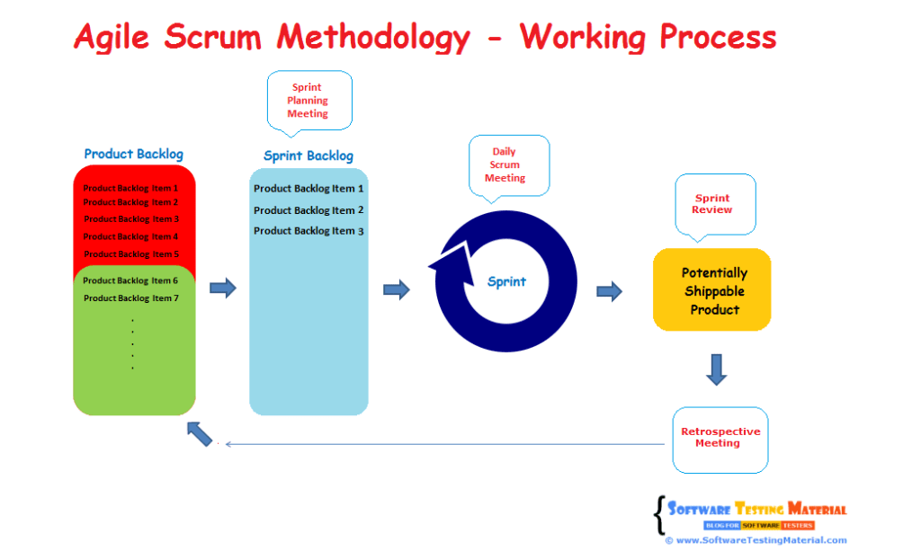
In Scrum, the project is divided into Sprints.
Sprint: Each Sprint has a specified time line (2 weeks to 1 month). This time line will be agreed by a Scrum Team during the Sprint Planning Meeting. Here, User Stories are split in to different modules. End result of every Sprint should be potentially shippable product.

Roles in Agile Scrum Methodology
Product Owner:
Product Owner usually represents the Client and acts as a point of contact from Client side. The one who prioritizes the list of Product Backlogs which Scrum Team should finish and release.
SCRUM Master:
Scrum Master acts as a facilitator to the Scrum Development Team. Clarifies the queries and organizes the team from distractions and teach team how to use scrum and also concentrates on Return on Investment (ROI).
Scrum Development Team:
Developer’s, QA’s. Who develops the product. Scrum development team decides the effort estimation to complete a Product Backlog Item.
Scrum Team:
.A cross-functional, self-organizing group of dedicated people (Group of Product Owner, Business Analyst, Developer’s and QA’s). Recommended size of a scrum team is 7 plus or minus 2 (i.e, between 5 to 9 members in a team)
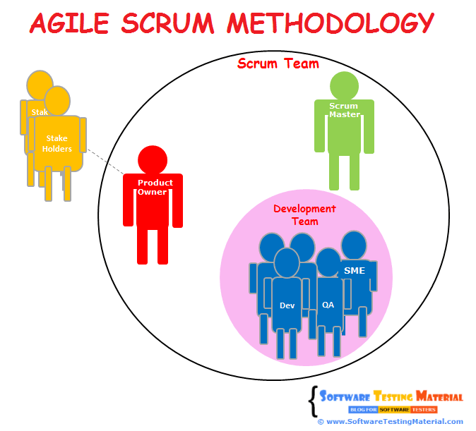

Chapter-2

Testcase Management System
Testcase Management System is most widely used web based open source test management tool. User can create test project and document test cases using this tool. With Testcase Management System you can create an account for multiple users and assign different user roles. Admin user can manage test cases assignment task.
It supports both automated and manual execution of Test cases. The testers can generateTest Plan and Test Report in a fraction of the time with this tool. Since it is a web based tool, multiple users can access its functionality at the same time with their credentials and assigned roles.
We will learn about:
- Advantages of Testcase Management System.
- Login to Testcase Management System.
- Creating a Test Project
- Creating Keyword and Platform.
- Creating a Test Plan
- Build Creation
- Creating Testsuite
- Creating a Testcase
- Assigning test case to test plan
- Creating Users and Assigning Roles in Testcase Management System.
- Executing a test case
- Generating Test Reports
- Export Test case/ Test Suite
- Importing Test case/ Test suite
Advantages of Testcase Management System:
- It supports multiple projects
- Easy export and import of test cases
- Easy filtration of test cases with version, keywords, test case ID and version
- Easy to assign test cases to multiple users
- Easy to generate test plan and test reports in various formats
- Provide credentials to multiple users and assign roles to them

Login to Testcase Management System.
Step 1 : Open the Testcase Management System home-page and enter the login details
- Enter the userID – admin
- Enter the password
- Click on the login tab

Creating a Test Project
Step 1: In the main window click on Test Project Management, it will open another window
Step 2: Click on the tab "create" to create a new project.
Step 3: Enter all the required fields in the window like a category for a test project, name of the project, prefix, description, etc. After filling all necessary details, click on tab "Create" at the end of the window.
Creating Keywords by Keyword Management
Step 1: Click on Project -> Keyword Management.
Step 2: Click on Create Keyword.

Step 3: Enter Keyword and Description.

Step 4: Click on Save button to save the keyword.

Creating Platform by Platform Management
Step 1: Click on Project -> Platform Management.
Step 2: Click on Create Platform.
Step 3: Enter Platform and Description.

Step 4: Click on Save button to save the Platform.

Creating a Test Plan
Test plan holds the complete information like the scope of Software testing, milestone, test suites and test cases. Once you have created a Test Project, next step is to create Test plan.
Step 1: From the home-page, click on Test Plan Management from home-page
Step 2: It will open another page, at the bottom of the page click on a tab "Create"
Step 3: Fill out all the necessary information like name, description, create from existing test plan, etc. in the open window, and click on "create tab"

Build Creation
A build is a specific release of a software
Step 1: Click on Builds/Releases under Test Plan from the home page
Step 2: In the next window, fill all necessary details for a software release and click on create to save your release
- Enter the title name
- Enter the description about the software release
- Mark the check-box for status- Active
- Mark the check-box for status- Open
- Choose the date of release
- Click on create a button

Creating Testsuite
Test suite is a collection of test cases which may be testing or validating the same component. Following steps will explain how to create test suite for your project.
Step 1: Click on test specification option from the home page.
Step 2: Click on Project name and will display a series of test operation.
Step 3: Click on the "create" tab for the test suite
Step 4: Fill-up all the details for test-suite and click on save it tab.
- Enter the test suite name
- Enter the details about your test suite
- Select the keywords
- Click on Create Test Suite

Creating a Testcase
Testcase holds a sequence of test steps to test a specific scenario with an expected result. Below steps will explain how to create a test-case along with test steps.
Step 1: Click on the test suite folder on the left side of the panel under a folder tree structure
Step 2: Click on the Created Test Suite.
Step 3: New window will open, to create test cases click on create button in test-case operations
Step 4: Fill-up all the details for test case creation.
- Enter the test case title.
- Enter the test case summary.
- Enter precondition.
- Select keywords related to the test case.
- Click on Create button.
Step 5: Click on test-case from the folder, as shown above, it will open a window. Click on "create steps" button in a test case. It will open a test case step editor
Step 6) It will open another window on the same page, in that window you have to enter the following details
- Enter the step-action for your test case
- Enter the Expected results.
- Click save it and add another step action OR click save and exit tab if there is no more test step to add

Executing a test case
In TCMS, we can run a test case and change execution status of a test case. Status of a test-case can be set to "blocked" "Passed", or "failed". Initially, it will be in "not run" status but once you have updated it, it cannot be altered to "not run" status again.

Chapter-3

What is Bugzilla?
Bugzilla is an open-source issue/bug tracking system that allows developers to keep track of outstanding problems with their product. It is written in Perl and uses MYSQL database.
Bugzilla is a Defect tracking tool, however, it can be used as a test management tool as such it can be easily linked with other Test Case management tools like Quality Center, Testlink etc.
This open bug-tracker enables users to stay connected with their clients or employees, to communicate about problems effectively throughout the data-management chain.
Key features of Bugzilla includes
- Advanced search capabilities
- E-mail Notifications
- Modify/file Bugs by e-mail
- Time tracking
- Strong security
- Customization
- Localization

How to log-in to Bugzilla
Step 1) Use the following link for your handons. To create an account in Bugzilla tool or to login into the existing account go to New Account or Log in option in the main menu.
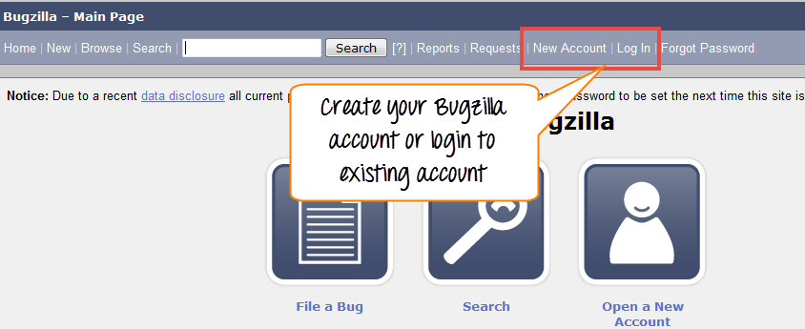
Step 2) Now, enter your personal details to log into Bugzilla
- User ID
- Password
- And then click on "Log in"
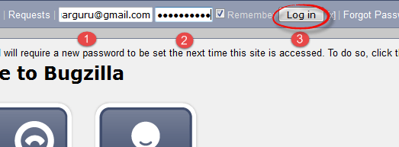
Step 3) You are successfully logged into Bugzilla system

Creating a Bug-report in Bugzilla:
To create a new bug in Bugzilla, visit the home-page of Bugzilla and click on NEW tab from the main menu .In the next window
- Enter Product
- Enter Component
- Give Component description
- Select version,
- Select severity
- Select Hardware
- Select OS
- Enter Summary
- Enter Description
- Attach Attachment
- Submit
NOTE: The above fields will vary as per your customization of Bugzilla
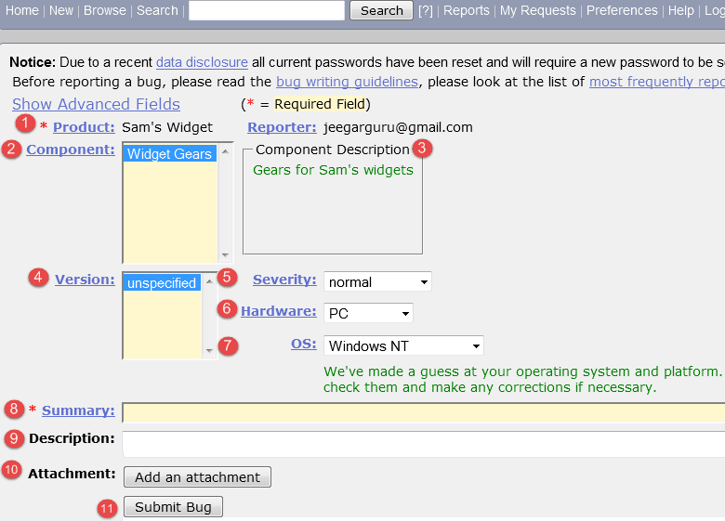
NOTE: The mandatory fields are marked with *.
In our case field's
- Summary
- Description
Are mandatory
If you do not fill them you will get a screen like below
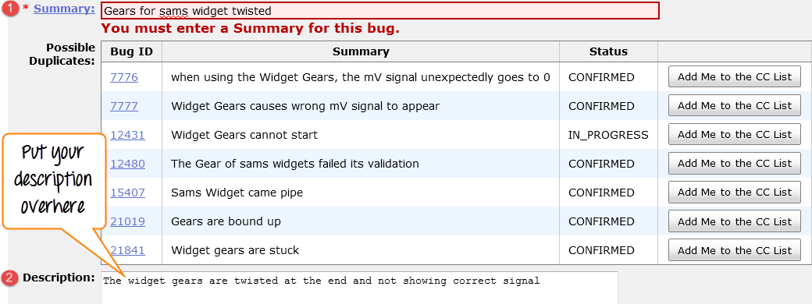
Bug is created ID# 26320 is assigned to our Bug. You can also add additional information to the assigned bug like URL, keywords, whiteboard, tags, etc. This extra-information is helpful to give more detail about the Bug you have created.
In the same window if you scroll down further. You can select deadline date and also status of the bug. Deadline in Bugzilla usually gives the time-limit to resolve the bug in given time frame.

