AIT

Lab

-

Task

1

2

VTU25760

/

MANJUNATH.A

S

8

L

7

**Date:**

**29**

**.**

**10**

**.25**

**TASK:**

**1**

**2**

**Implementation of**

**Knowledge**

**-**

**Based Tutoring System**

**CO**

**4**

**, CO**

**5**

**S3**

**PROBLEM STATEMENT**

Students often struggle with understanding foundational concepts in

mathematics due to lack of personalized guidance. A knowledge

-

based tutoring

system can simulate expert reasoning to provide tailored explanations and

feedback.

**AIM**

To develop a Python

-

based intelligent tutoring system that guides users through

basic math problems using rule

-

based logic and interactive feedback.

**OBJ**

**ECTIVE**

•

Simulate expert tutoring behavior using conditional logic.

•

Provide step

-

by

-

step guidance for arithmetic operations.

•

Offer feedback based on user responses.

•

Demonstrate the feasibility of rule

-

based AI in education.

**DESCRIPTION**

This system acts as a virtual tutor for basic arithmetic (addition, subtraction,

multiplication, division). It uses a knowledge base of rules to evaluate user

input, provide hints, and explain concepts. The system is interactive and adapts

its responses ba

sed on the learner’s answers.

**ALGORITHM**

1.

Start the tutoring session and greet the user.

2.

Present a math problem based on selected topic.

3.

Accept user input as an answer.

4.

Compare the answer with the correct solution.

5.

If correct, praise the user and offer a new problem.

6.

If incorrect, provide hints and re

-

ask the question.

7.

Repeat until the user solves the problem or exits.

|  |
| --- |
| **PROGRAM**  def tutor():  import random print(" Welcome to the Knowledge-Based Math Tutor!")  print("Choose a topic: 1. Addition 2. Subtraction 3. Multiplication 4. Division") choice = input("Enter your choice (1-4): ") operations = {  "1": ("Addition", lambda x, y: x + y),  "2": ("Subtraction", lambda x, y: x - y),  "3": ("Multiplication", lambda x, y: x * y),  "4": ("Division", lambda x, y: round(x / y, 2) if y != 0 else "undefined")  } if choice not in operations:  print(" Invalid choice. Please restart.") return topic, operation = operations[choice] print(f"\n Topic selected: {topic}") print("Type 'exit' anytime to quit.\n") while True:  x = random.randint(1, 20) y = random.randint(1, 10) correct_answer = operation(x, y)  AIT Lab-Task 12 VTU25760/MANJUNATH.A S8L7 |

|  |  |
| --- | --- |
| print(f" Solve: {x} {topic.lower()} {y} = ?") user_input = input("Your answer: ") if user_input.lower() == "exit":  print(" Thanks for learning with us!")  break try:  user_answer = float(user_input) if user_answer == correct_answer: print(" Correct! Great job!\n")  else:  print(f" Incorrect. Hint: Try breaking it down step-by-step.") print(f"Correct answer was: {correct_answer}\n") except ValueError:  print(" Please enter a valid number.\n")    tutor()                AIT Lab-Task 12 VTU25760/MANJUNATH.A | S8L7 |

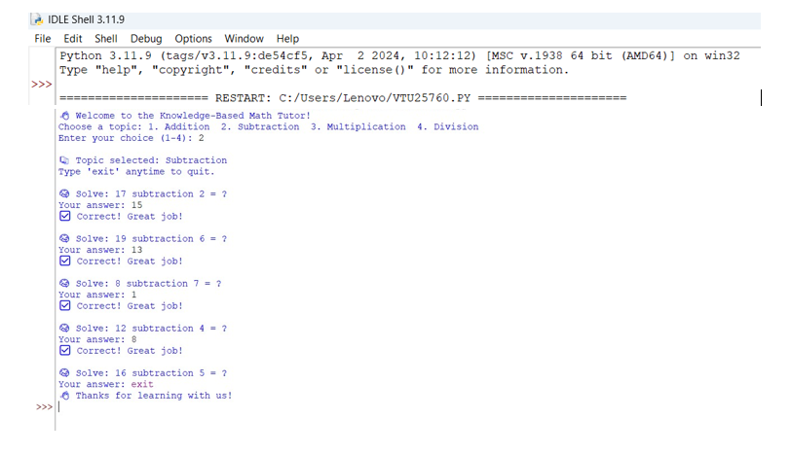

AIT

Lab

-

Task

1

2

VTU25760

/

MANJUNATH.A

S

8

L

7

**OUTPUT**

**CONCLUSION**

This Python

-

based knowledge tutoring system demonstrates how rule

-

based logic

can simulate expert guidance in basic math. It provides interactive feedback,

encourages learning through hints, and showcases the potential of AI in

education. Future enhancemen

ts could include natural language processing,

adaptive difficulty, and multi

-

topic support.