**SECUREIN ASSESSMENT**

**Problem Statement: The Doomed Dice Challenge**

**PART A:**

**CODE:PYTHON**

die_A=[1,2,3,4,5,6]

die_B=[1,2,3,4,5,6]

#1.TOTAL COMBINATION

tot_comb=len(die_A)*len(die_B)

print(f"TOTAL_COMBINATION={tot_comb}\n")

arr={}

#2.possible combination

print("POSSIBLE_COMBINATION")

for i in range(len(die_A)):

for j in range(len(die_B)):

print((die_A[i],die_B[j]),end=" ")

print("\n")

#2.sum

print("SUM")

for i in range(len(die_A)):

for j in range(len(die_B)):

print(die_A[i]+die_B[j],end=" ")

s=die_A[i]+die_B[j]

if s in arr.keys():

arr[s]+=1

else:

arr[s]=1

print("\n")

#print(arr)

#3.PROBABILITY OF SUM

print("| SUM || PROBABILITY |")

for i in arr.keys():

print("| ",i ," || ", round(arr[i]/tot_comb,3)," |")

output:

1.



2.

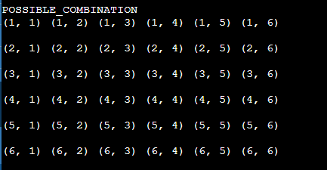

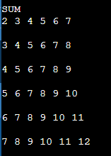

3.

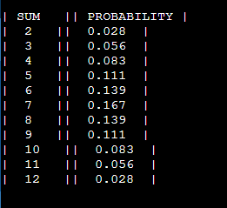

**HOW I CAME UP WITH THE SOLUTION?:**

The problem focused on three parts

1.total combination

2.possible combinations and its sum

3. probability of the sum

Total combination= faces of die_A * faces of die_B

i.e, len(die_A) *len(die_B)

* I employed the method of **matrix addition** in my approach.
* Where I used nested for loops to find the combination of the die_A and die_B
* printed the combination
* calculated the sum of each combination within the for loop and
* inserted it in a dictionary with key as the sum and value as the count
* then printed the sum(which is the key from the dictionary ) and
* the probability(count of the sum /total combination)

**LOGIC:**

* + Total combination= faces of die_A * faces of die_B i.e, len(die_A) *len(die_B)
  + employed the method of **matrix addition** in my approach.
  + Nested for loop gave the possible combination
  + Calculated the sum using the combination
  + Probability = Count of the sum / total combination

**PART B:**

**CODE:PYTHON**

def undoom_dice(a,b):

arr=[]

d1={}

#finding all possible sum of die a and b

for i in range(6):

arr.append([])

for j in range(6):

s=a[i]+b[j]

arr[i].append(s)

if s in d1.keys():

d1[s]+=1

else:

d1[s]=1

# print(arr)

new_b=[]

start=[]

# find possible new_b

c=-1

for i in range(0,-5,-1):

c+=1

if i+5<=4:

start.append(i)

new_b.append(arr[c])

print(start)

print(new_b)

#find new_a

new_a=[]

for i in start:

new_a.append([x for x in range(i ,i+6)])

#checking for equal probability between old and new die

for i in range(len(start)):

d2={}

print(new_a[i])

print(new_b[i])

for j in range(6):

for k in range(6):

s=new_a[i][j]+new_b[i][k]

# print(s,end=" ")

if s in d2.keys():

d2[s]+=1

else:

d2[s]=1

flag=True

for j in d1.keys():

if (d1[j]/36)!=(d2[j]/36):

flag=False

print(flag)

print("\n\n")

return(new_a,new_b)

# old_die_A=[1,2,3,4,5,6]

# old_die_B=[1,2,3,4,5,6]

print("Die_A\n")

old_die_A=[int(x) for x in input().split(" ")]

print("\nDie_B\n")

old_die_B=[int(x) for x in input().split(" ")]

# to print dice

new=undoom_dice(old_die_A,old_die_B)

for i in range(len(new[0])):

print(f"New_die_A = {new[0][i]} , New_die_B = {new[1][i]}")

**INPUT:**

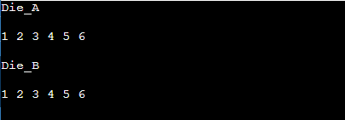

**Output:**

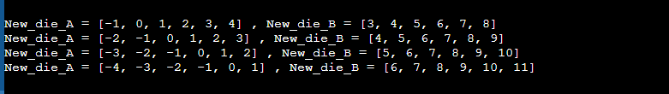

**HOW I CAME UP WITH THE SOLUTION?:**

This problem focused on finding the new_die_A and New_die_B with certain

Constrains:

● Die A cannot have more than 4 Spots on a face.

● Die A may have multiple faces with the same number of spots.

● Die B can have as many spots on a face as necessary i.e. even more than 6.

* To solve this I used a range for die_A as -4 to 4 .
* Then for each value of the range , I generated a list containing 6 elements where each element is <4.
* And got 4 list each containing 6 element where each represent a new_die_A.
* Using each new_die_A , I generated new_die_b from the sum of the old_die_A and old_die_B

i.e.,

c=-1

for i in range(0,-5,-1):

c+=1

if i+5<=4

start.append(i)

new_b.append(arr[c])

* + here I kept the left end as -4 using ‘ for loop ‘ and right end using ‘if ‘condition .
  + the position of zero in the list generated from ‘i’ was given to the variable c
  + and c was used to find the list from the matrix --- sum of the old_die A and old_die_B
* found the count of possible sum from new_die_A and new_die_B
* and checked the probability of possible sum from new_die_A and new_die_B with the probability of possible sum from old_die_A and old_die_B
* printed the New_die_A and New_die_B

**LOGIC:**

* + - Found the possible new_die_A using the limit -4 to 4
    - Found the new_die_B from new_die_A and sum of the old_die_A and old_die_B
    - Checked the probability of old and new
    - Printed the New_die_A and New_die_B