**The Brief:**

Our client, **Halifax Canoe and Kayak** would like a new website. Obviously, they want it to work across a myriad of devices. They would eventually like the ability to post information about upcoming adventures and allow visitors to register for trips, that will be Project 2 and 3.

For Project 1, it is your job to build them a fully functional website using HTML, CSS, and jQuery.

**Responsive Frontend**

Our client would like a ‘responsive’ example of the home page.

It must have 2 break points and navigation that toggles in and out

(Please note: The links do not need to work, this is one single content page)

Home Page Home Page with Navigation Homepage as seen at 1400px wide

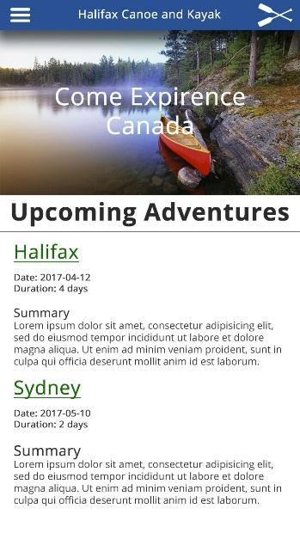 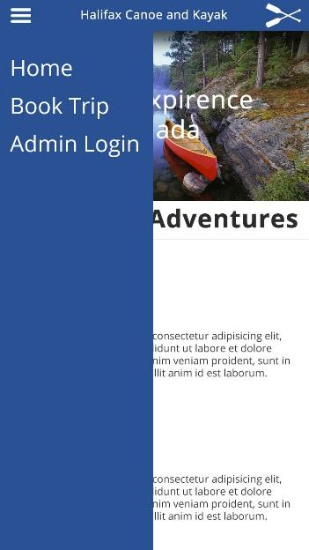 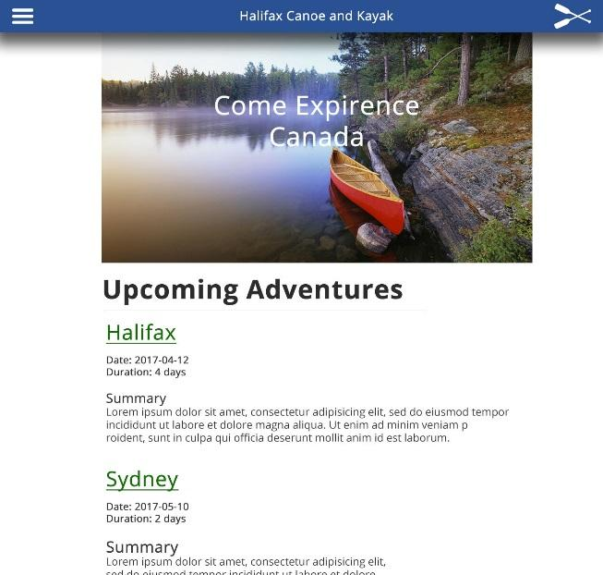

Also note: The text is static for this project, not driven by a database.

**Our client is requesting the following as ‘must haves’:**

* When the hamburger menu is clicked, the menu must ‘toggle’ in and out using jQuery
* The main content, including the image must get no wider than 1200px
* Below 1200px the main content must be 100% across the screen
* Below 800px all font sizes must change
* The top navigation must: include a menu button, title, logo, and have a shadow
* Use filler content (Any text will do)
* Include comments in both the HTML and the CSS about major sections

**General Directions**

* Either coding from scratch or using a CSS Framework, create a single HTML page that l**ooks and operates like the above example (see images)**. The project must include html, css, and jQuery. You must, at a minimum, use the assets our client has supplied.

Feel free to go beyond the minimum.

**Supplied Assets:**

* The main image:

<https://raw.githubusercontent.com/Zulinov/skillsProjects/main/canoe.jpg>

* Hamburger icon: <https://raw.githubusercontent.com/Zulinov/skillsProjects/main/hamburger.png>
* Logo:

<https://raw.githubusercontent.com/Zulinov/skillsProjects/main/paddle-white.png>

(Use these as local or external images in your code)

**Uploading to GitHub:**

Upload your complete project (html file, css file(s), images, etc.) to GitHub.

- You’ll be uploading a bunch of assignments there, so stay organized

1. Commit All Required Files to GitHub in a new Repository
2. Create a pull request and a new Branch
3. Merge Changes Back to Main Branch

**Submitting Instructions:**

**Due: March 1st, by 11:59pm**

Visit the following form and add your information there:

<https://docs.google.com/forms/d/e/1FAIpQLScZWXu8gv0Q8FwnSOqZIvLAGGWI-AwD8z3JaWeatDsDfxCXfQ/viewform>

This project will build on itself over the next few months as our knowledge continues to grow and we introduce new languages and methods of development.