Solution Document
- The approach used in the automation of the given assignment is explained below, In the design I have written a generic framework with details as below. Below are the tools and languages used in design.

Project: Maven Project
Programming Language: Java
Automation Tool: selenium
Browser Used: Chrome, Firefox
Unit Test Framework: TestNg
Reporting API: Extent Report

The Project RakutenVKI is having below main Sections:

- Main: Inside the main Package there are 4 sub packages and each one is used for performing different operations:

1.a. Base: It has TestBase.Java -> In this file the basic initialization methods, property file load and tear down methods after execution are written and this is the parent class for the test case file.

1.b. Config: This Folder has the Properties file from which the configuration details of the application are stored and read like environment details, username, password, and browser details.

1.c. Library: In this package the resusable methods pertaining to the application modules are written like the Java file written here contains methods for login, signup, navigation, search, validation and so on.

1.d. Utility: In this package the package the utility methods like Screenshots capture is written for validation.

- Test: Inside the test Package the actual test scenario is written here the package Test scenarios package contains the test case class which will in turn call the base class, resusable methods and other utility methods to complete the full flow to test case.

- BrowserDriverFiles: This Folder contains the browser executables which are needed for our execution on the different browsers in selenium like the chromedriver.exe, geckdriver.exe

- Screenshot: This folder contains the screenshots captured at the time of validation.

- TestOutput: This folder contains the result files of our execution, here both the testing result file and the Extent report result file is stored.

In the script developed below are the details/assumptions made in development:
- TV Show – Popeye the Sailor is used for checking the TV shows availability and same is used following the in the show genre.
- Movie -- Gulliver's Travels Movie is used as test data for verification
- Collection -- Viki Originals series is used for verification of collections.
- Review - Popeye the Sailor is opened and the same show is used to provide the ratings and review.

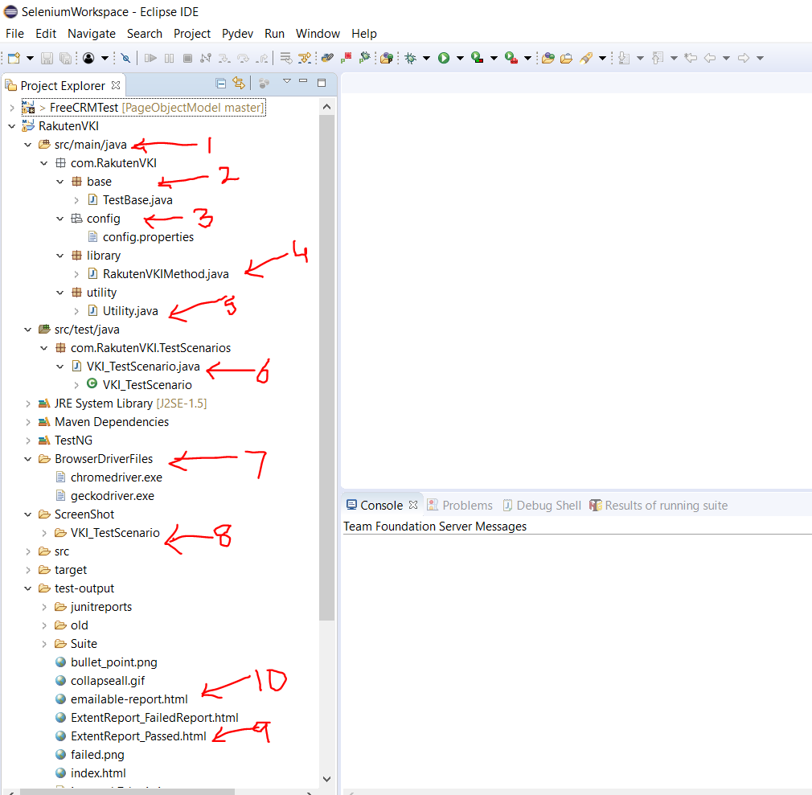

Sample Execution Result:
File: ExtentReport.html
Extent Report provides various addition features in our automation script development like logging, reporting, screenshot capture and so on. A sample report is as below,

Use the RakutenVKI.xml to start execution.
After Execution Report is generated :
1. TestNG Emailable Report 2. ExtentReport.html

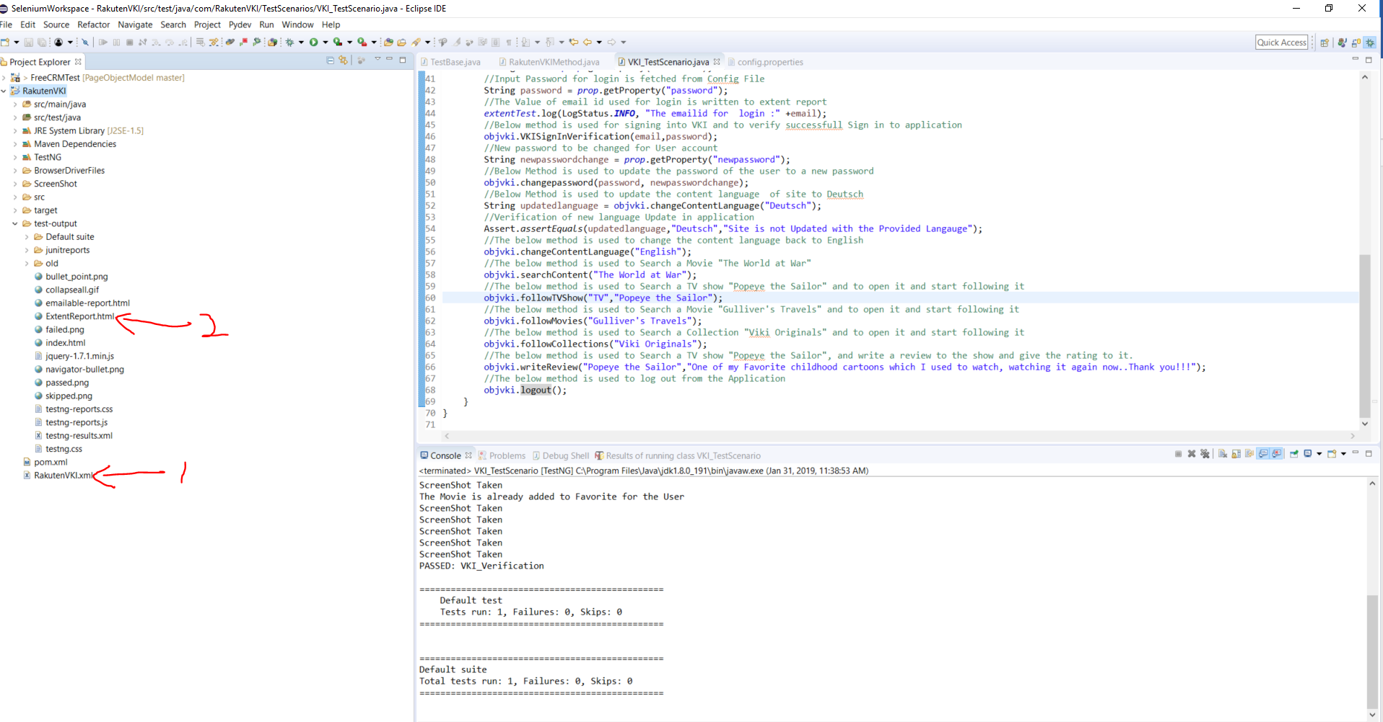

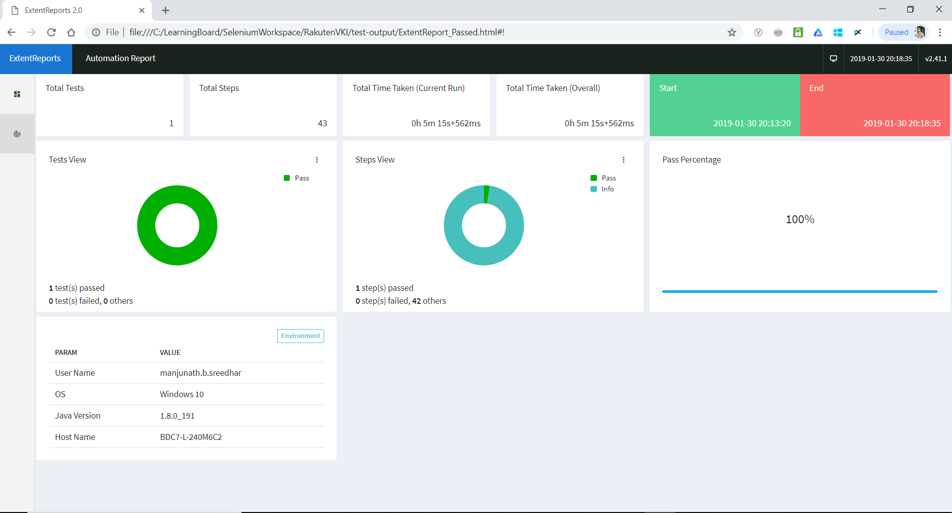

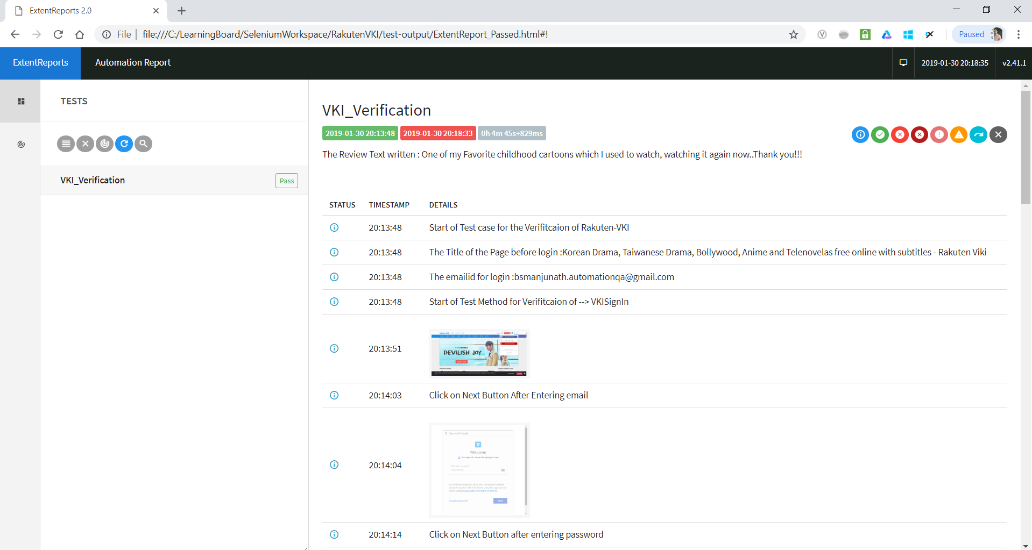

Improvements:
This framework is written only for assignment purpose and in the interest of time, we can further use Page Object Model, Hybrid or other frameworks as needed.
Further there are other features also like using log4j, capturing event logs of selenium and can host dynamic dashboard for executions details capture at runtime.

