**Assignment - 1**

**Tasks To Be Performed:**

**1. Pull Ubuntu container**

**2. Run this container and map port 80 on the local**

**3. Install Apache2 on this container**

**4. Check if you are able to access the Apache page on your browser**

**====================================================================================================================================================================**

1. Pull Ubuntu container

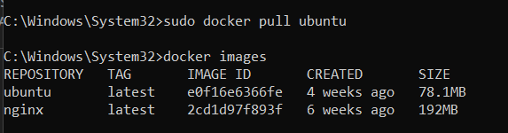

2. Run this container and map port 80 on the local

* We can create one container at one port
* Created container using the command below  
    
  **sudo docker run -itd -p 80:80 --name=mycontainer ubuntu**

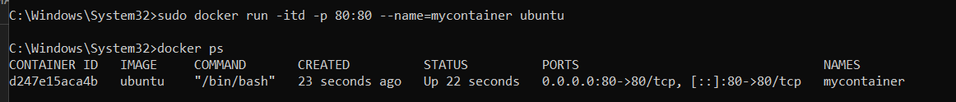

3. Install Apache2 on this container

* First we will go inside the container using the command below:

**sudo docker exec -it a1container bash**



* Now install the Apache using

**apt install apache2**

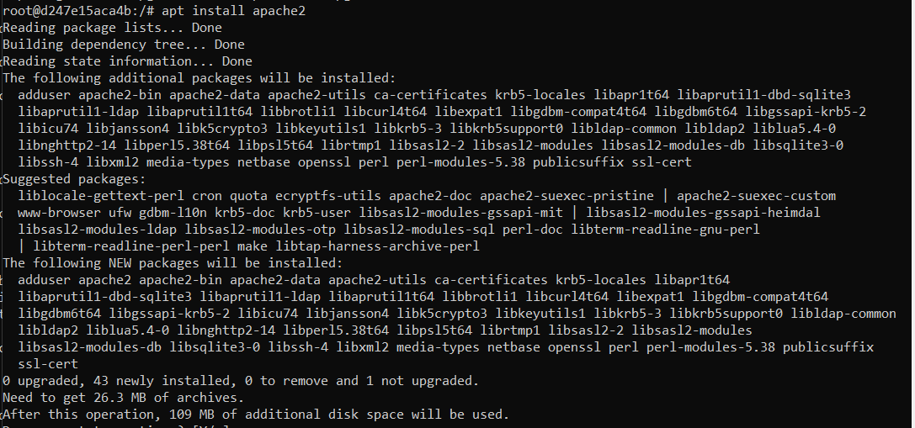

* After installing Apache will check the status using the command below:

**service apache2 status**

* As it is showing not running we will start Apache using the command below:

**service apache2 start**

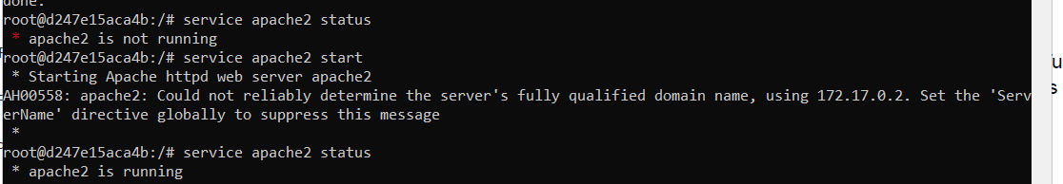

4. Check if you are able to access the Apache page on your browser

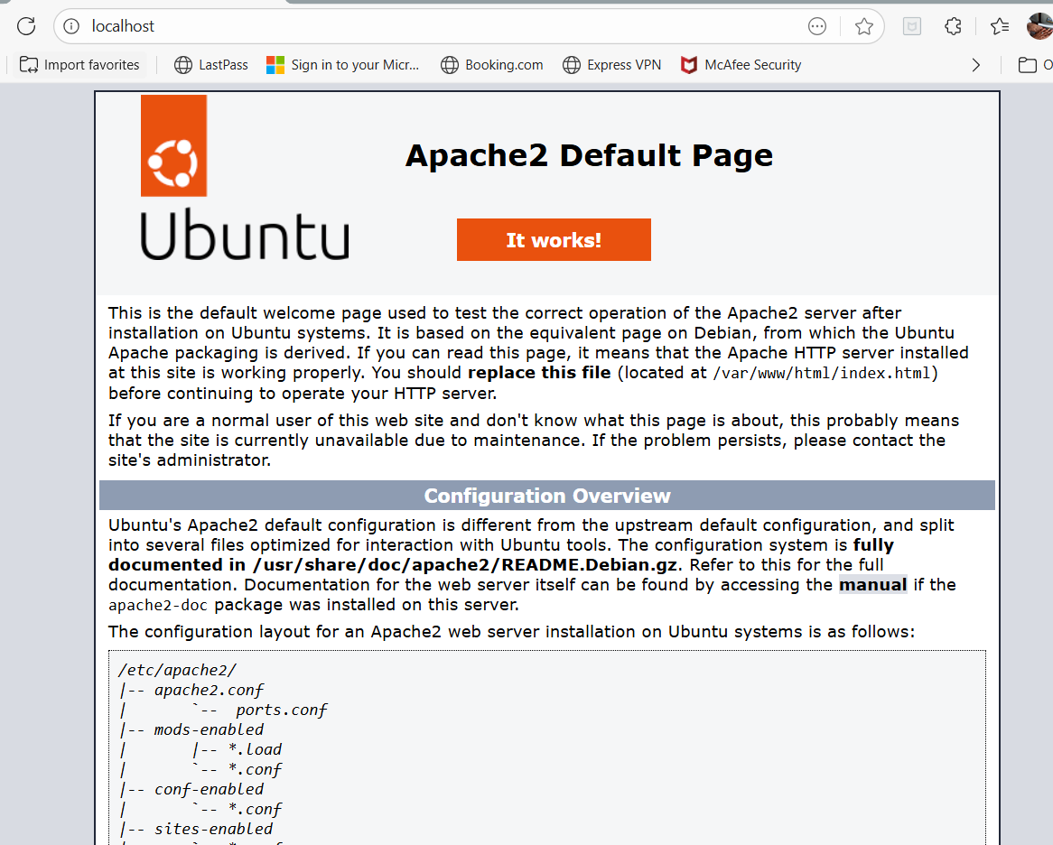

====================================================================================================================================================================

**Assignment - 2**

**Tasks To Be Performed:**

**1. Save the image created in assignment 1 as a Docker image**

**2. Launch container from this new image and map the port to 81**

**3. Go inside the container and start the Apache2 service**

**4. Check if you are able to access it on the browser**

1. Save the image created in assignment 1 as a Docker image

* Once we create the image from the container which we created in assignment1 it will already have apache installed in it
* To create image from the container we will use command

**sudo docker commit <container name> <giveimage name>**



*Screen clipping taken: 27-08-2025 02:13 PM*

* Now we will check the images using docker images command

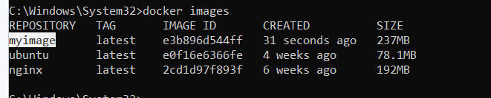

*Screen clipping taken: 27-08-2025 02:14 PM*

2. Launch container from this new image and map the port to 81

* Now we will create container using the same image using the command below

**Sudo docker run -itd -p 81:80 --name=mycontainer2 myimage**

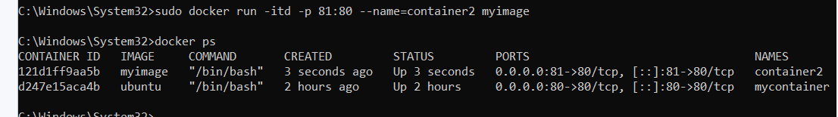

3. Go inside the container and start the Apache2 service

* We will got inside container2

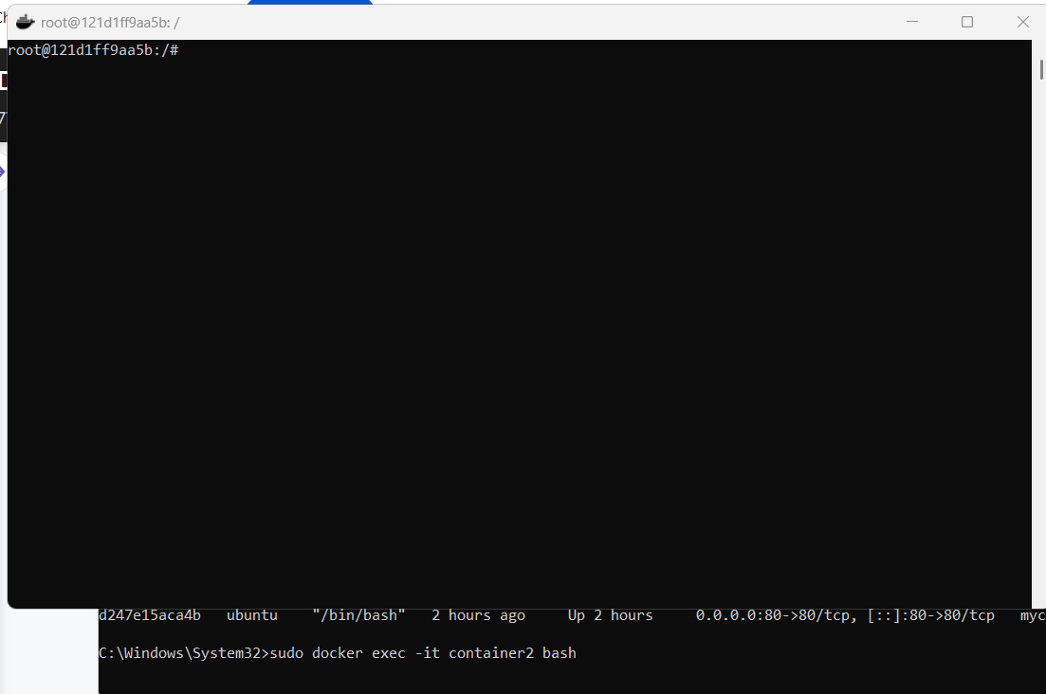

*Screen clipping taken: 27-08-2025 02:25 PM*

* Now we will start the apache2 service inside the container as it will not automatically start the services

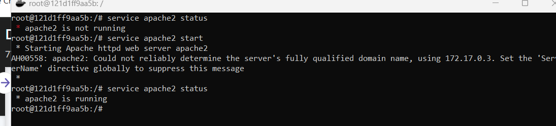

4. Check if you are able to access it on the browser

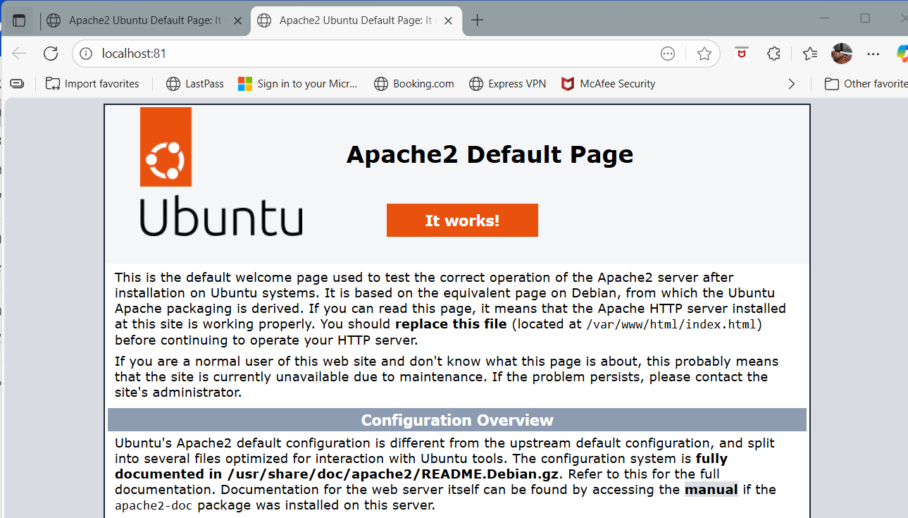

*Screen clipping taken: 27-08-2025 02:30 PM*

====================================================================================================================================================================

**Assignment - 3**

**Tasks To Be Performed:**

**1. Use the saved image in the previous assignment**

**2. Upload this image on Docker Hub**

**3. On a separate machine pull this Docker Hub image and launch it on port**

**80**

**4. Start the Apache2 service**

**5. Verify if you are able to see the Apache2 service**

1. Use the saved image in the previous assignment

* We will check the image which we needs to upload on docker hub

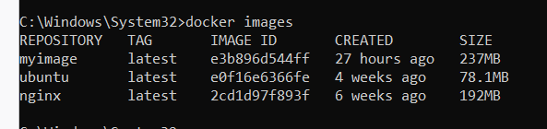

* This image should be in a format in order to upload on docker hub
* Logged in to docker hub

2. Upload this image on Docker Hub

* In docker hub my username is goswami123/myimage (dockerusername/imagename)
* We will rename this image using **sudo docker tag <imagename> <newimagename>**

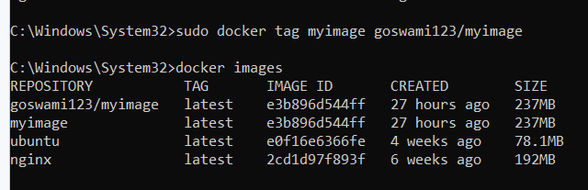

*Screen clipping taken: 28-08-2025 05:25 PM*

* Now we will login using sudo docker login, it will ask for credentials and authenticate

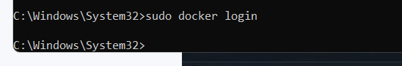

*Screen clipping taken: 28-08-2025 05:32 PM*

* Now we will push the image using sudo docker push <image name>



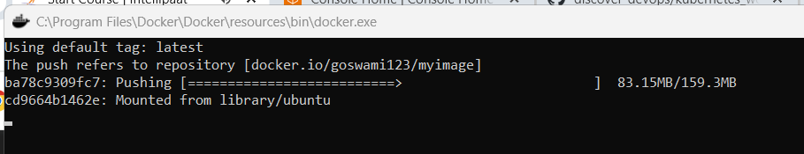

*Screen clipping taken: 28-08-2025 05:35 PM*

* Now we will see on docker hub the image will be there

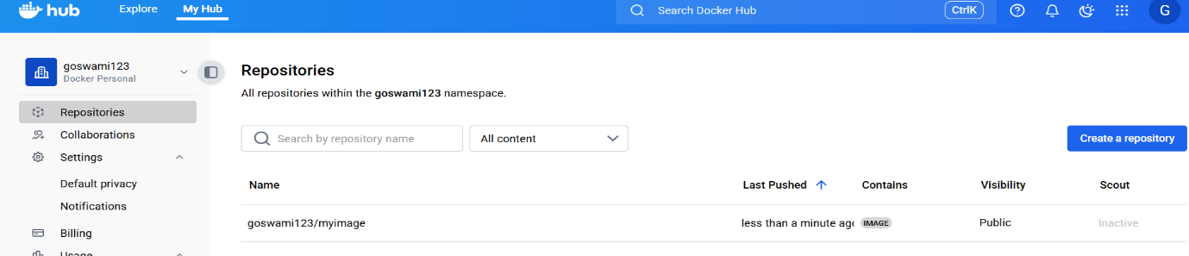

3. On a separate machine pull this Docker Hub image and launch it on port

80

* Now we will pull the image from dockerhub using

**sudo docker pull goswami123/myimage**



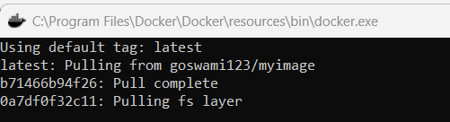

* Now we will luanch the container at port number 80 using

**sudo docker run -itd -p 80:80 --name=containerhub goswami123/myimage**

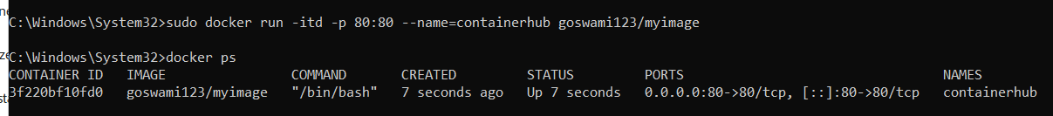

*Screen clipping taken: 28-08-2025 05:44 PM*

4. Start the Apache2 service

* We will go inside the container using   
    
  **sudo docker exec -it containerhub bash**
* We will start the apache service

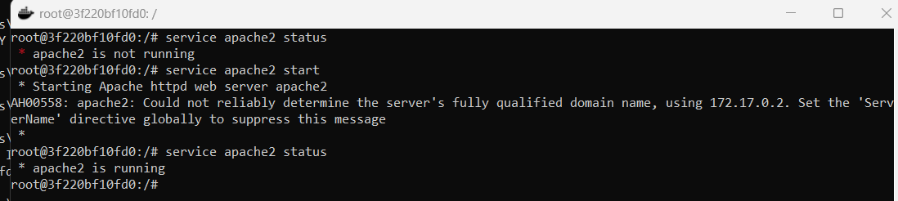

5. Verify if you are able to see the Apache2 service

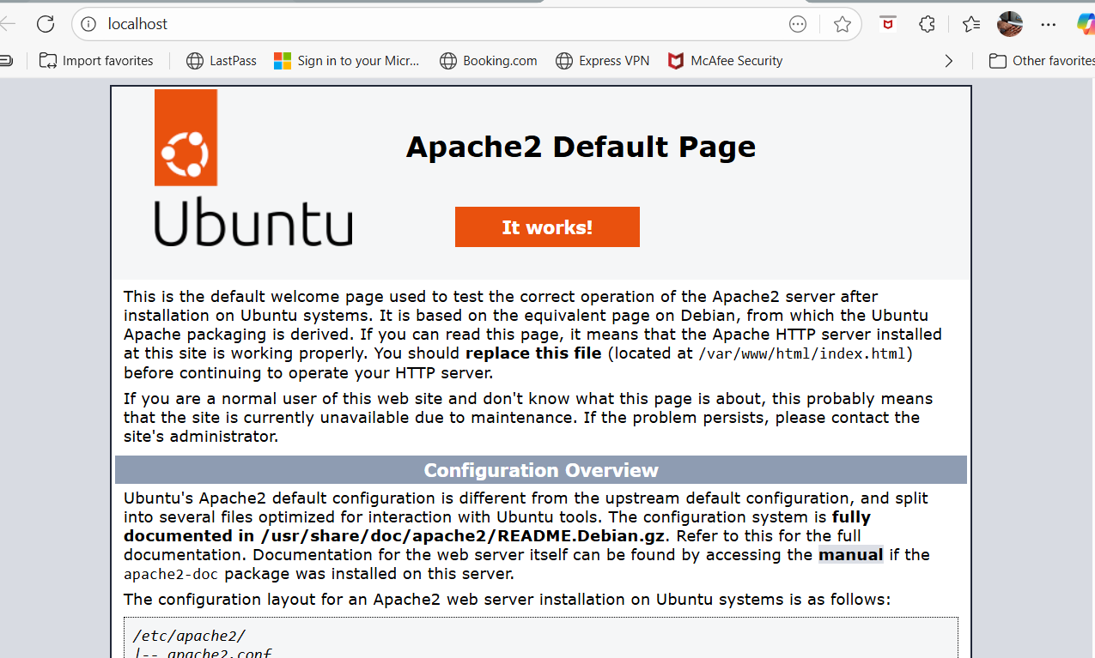

*Screen clipping taken: 28-08-2025 05:47 PM*

====================================================================================================================================================================

**Assignment - 4**

**Tasks To Be Performed:**

**1. Create a Dockerfile with the following specs:**

**● Ubuntu container**

**● Apache2 installed**

**● Apache2 should automatically run once the container starts**

**2. Submit the Dockerfile for assignment completion**

**1. Create a sample HTML file**

**2. Use the Dockerfile from the previous task**

**3. Replace this sample HTML file inside the Docker container with the default**

**Page**

* First we will create docker file

**FROM ubuntu (as we need ubuntu image in first step)**

**RUN apt update (we need to update the ubuntu)**

**RUN apt install apache2 -y (we need to install apache2)**

**ENTRYPOINT apachectl -D FOREGROUND (this will make sure that apache2 is keeps running in the background when the container will be started)**

* Default page of apache2 is shown below, where the html path is mentioned

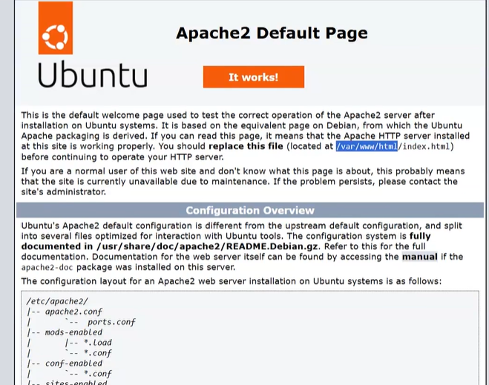

*Screen clipping taken: 16-09-2025 10:37 AM*

/var/www/html/index.html

* Now we will copy the index.html file to the above destination

So we will add this also in the docker file

COPY index.html (file which we want to copy) /var/www/html/ (destination

* Created docker file

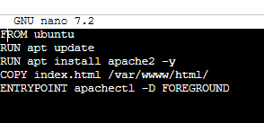

*Screen clipping taken: 16-09-2025 11:58 AM*

* Created indexfile
* Created image using

Docker build . -t a5image

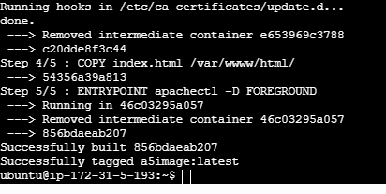



*Screen clipping taken: 16-09-2025 12:10 PM*

* Now we will create the container using this image at port number 90

Sudo docker run -itd -p 90:80 --name=a5container a5image





* Now we will access the page and it will show this

