1.What is Emmet?

Emmet is a built-in feature in Visual Studio Code.

Emmet is a plug in for many popular text editors which greatly improves HTML & CSS workflow

a).Generating HTML Skeleton

just type ! and press enter-->brelow it will show a pop up with the content that will be generated.

<!DOCTYPE html>

<html lang="en">

<head>

<meta charset="UTF-8">

<meta http-equiv="X-UA-Compatible" content="IE=edge">

<meta name="viewport" content="width=device-width, initial-scale=1.0">

<title>Document</title>

</head>

<body>

</body>

</html>

b) Elements with text content inside them

div{This is a div}--><div>this is div</div>

c)Nested elements

ul>li--><ul>

<li></li>

</ul>

d)What about classes and Id

div#main.container.responsive--><div id="main" class="container responsive"></div>

e)custom attributes

div[data-name=logo]--><div data-name="logo"></div>

2.Difference between a Library and Framework?

|  |  |  |
| --- | --- | --- |
|  | **Framework** | **Library** |
| 1 | It comprises of lot of APIs , compilers , support programs , libraries etc | It is a collection of helper modules , classes , objects , functions , pre-written code ,etc. |
| 2 | It is difficult to replace frameworks | A library is easy to be replaced with another library. |
| 3 | A framework development requires a lot of code that decrease performance and increase the load time. | Building a library requires less code , so there is better performance and fast load time. |
| 4 | Including framework smoothly into an existing project is impossible. | Libraries can be integrated easily into existing projects to add some specific functionality. |
| 5 | Its example are AngularJS , Spring , NodeJS , etc. | Its example are JQuery , React JS , etc. |

3. What is CDN? Why do we use it?

Content delivery networks (CDN) are the transparent backbone of the Internet in charge of content delivery.

A CDN is **a network of servers that distributes content from an “origin” server throughout the world by caching content close to where each end user is accessing the internet via a web-enabled device**. The content they request is first stored on the origin server and is then replicated and stored elsewhere as needed.

4. Why is React known as React?

**React makes it painless to create interactive UIs**. Design simple views for each state in your application, and React will efficiently update and render just the right components when your data changes. Declarative views make your code more predictable and easier to debug.

React was developed for applications (Facebook) that have constantly changing data. Since React is a front-end framework or the “View” in MVC, this means that as the user clicks around and changes the app’s data, the view should “react” or change with those user events. User events being mouse clicks, typing, submitting a form.

React is called React because it was designed to be a declarative, efficient, and flexible JavaScript library for building user interfaces.

The name "React" was chosen because the library was designed to allow developers to "react" to changes in state and data within an application, and to update the user interface in a declarative and efficient manner.

5. What is crossorigin in script tag?

The crossorigin attribute **sets the mode of the request to an HTTP CORS Request**. Web pages often make requests to load resources on other servers. Here is where CORS comes in. A cross-origin request is a request for a resource (e.g. style sheets, iframes, images, fonts, or scripts) from another domain.

[**Example: crossorigin with the <script> element**](https://developer.mozilla.org/en-US/docs/Web/HTML/Attributes/crossorigin#example_crossorigin_with_the_script_element)

You can use the following [<script>](https://developer.mozilla.org/en-US/docs/Web/HTML/Element/script) element to tell a browser to execute the https://example.com/example-framework.js script without sending user-credentials.

<script

src="https://example.com/example-framework.js"

crossorigin="anonymous"></script>

Copy to ClipboardCopy to Clipboard

6. What is diference between React and ReactDOM?

**Including Scripts:**Following are the CDN links for React and ReactDOM:

**React:** https://cdnjs.com/libraries/react

**ReactDOM:** https://cdnjs.com/libraries/react-dom

**React** is a library that is specifically designed to interact with DOM for us. From now onwards we don’t update DOM directly instead we’re going to tell react to update the DOM for us. React will take care of rendering and reconciling the element for us through the command we give to react.

*There are some similarities between DOM and React. Both are made up of nodes. DOM is made up of DOM nodes/elements and React is made up of React nodes/elements. Both look exactly the same, but they are quite different.*

**Creating React Element:**

As already described earlier, the React element is the smallest entity. The React element is just a JavaScript object that describes the DOM element in memory. We can create a React element using React’s **createElement**method.

**Syntax:**

React.createElement(type, [props], [...children]);

7. What is difference between react.development.js and react.production.js files via CDN?

<script crossorigin src="https://unpkg.com/react@18/umd/react.development.js"></script>

<script crossorigin src="https://unpkg.com/react-dom@18/umd/react-dom.development.js"></script>

The versions above are only meant for development, and are not suitable for production. Minified and optimized production versions of React are available at:

<script crossorigin src="https://unpkg.com/react@18/umd/react.production.min.js"></script>

<script crossorigin src="https://unpkg.com/react-dom@18/umd/react-dom.production.min.js"></script>

To load a specific version of react and react-dom, replace 18 with the version number.

8. What is async and defer?[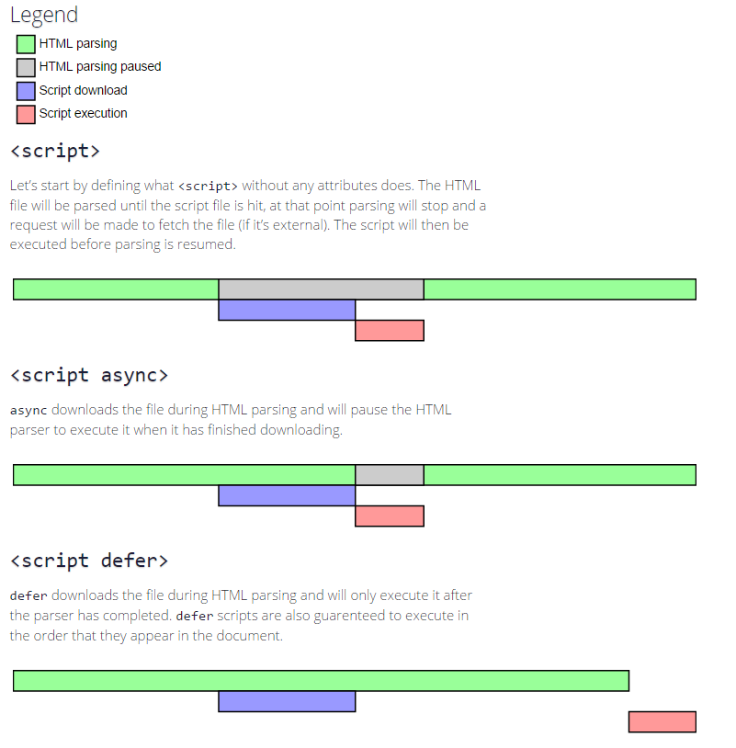](https://i.stack.imgur.com/wfL82.png)

* Async scripts are executed as soon as the script is loaded, so it doesn't guarantee the order of execution (a script you included at the end may execute before the first script file )
* Defer scripts guarantees the order of execution in which they appear in the page.