Collision Avoidance in Pedestrian-Rich Environments with Deep Reinforcement Learning

Now we are entering into an ERA of automation where everything is going to be automated of human daily life activities such as Automatic self-driving cars, home cleaning robots, drone based parcel delivery system and many more. All this sensors based automation require expert knowledge to move freely without collision with any other object. In Robotic automation all robots has to move freely without collision and to avoid collision many existing techniques such as Trajectory based algorithm, cooperative or non-cooperative collision avoidance algorithms and many more.

Trajectory based algorithm will continuously inspect trajectory data to avoid collision but inspecting trajectory require heavy computation. Cooperative or Non-Cooperative algorithms will predict motion of other object and based on others motions algorithm will predict its motion and this algorithm will fall to freezing problem where sometime it fail to predict feasible path.

To overcome from above issues author of this paper employing Deep Reinforcement Learning based LSTM (long short term memory) called Collision avoidance with deep reinforcement learning (CADRL) algorithm, which tackles the aforementioned trade-off between computation time and smooth motion by using reinforcement learning (RL) to offload the expensive online computation to an offline learning procedure. Specifically, a computationally efficient (i.e., real-time implementable) interaction rule is developed by learning a policy that implicitly encodes cooperative behaviours.

Reinforcement learning (RL) helps in taking each robot as Agent and then encode all his movements as vector. RL consists of Agent, State, Environment and action.

Agent refers to an object which is moving such as Robot

Environment is the platform where RL get executed

Action refers to speed and velocity of the robot

State refers to prediction which is based on action and if LSTM predict action as Non-Collision then state will change to non-collision and RL will get rewarded and if predicted value is collision then state will change to collide and RL will get penalty.

LSTM get trained on robot movement data and based on TEST data it will predict state of the robot.

Author has implemented propose CADRL algorithm on GA3C environment but that environment is not getting installed so we design our own simulation where RL will be applied to calculate state based on LSTM prediction. All input to LSTM will be from sensors but we don’t have any sensor we are using randomly generated data as Robot X and Y location.

To train LSTM we are using below Robot movement data which we generate randomly

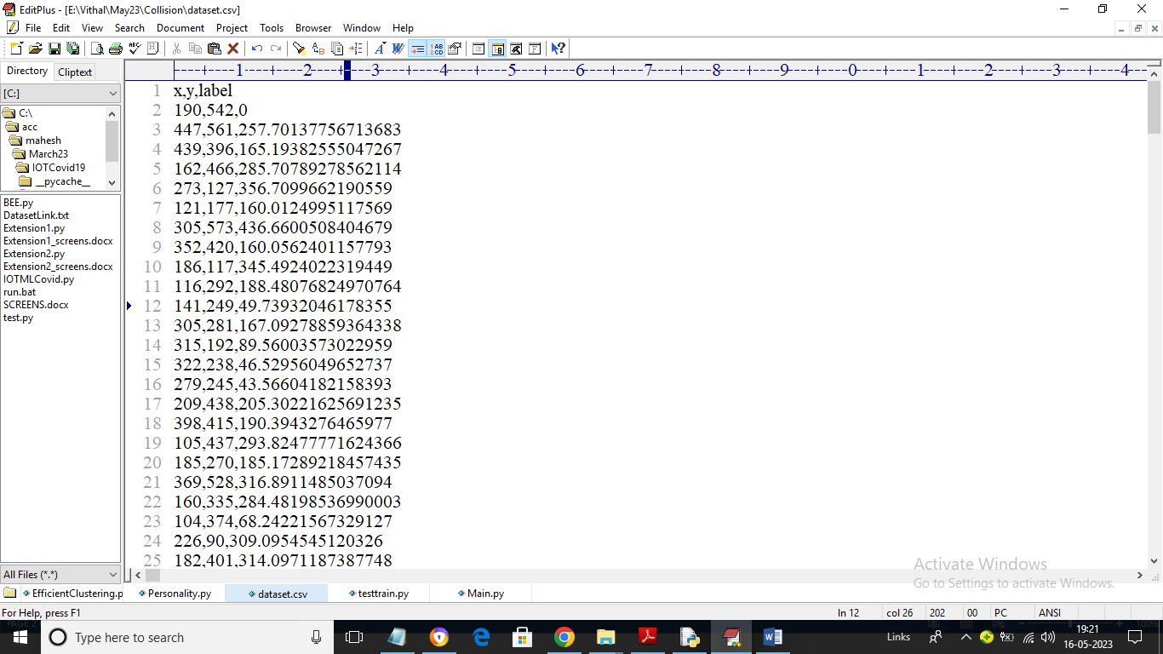

In above dataset we have X and Y values and label is consider as the distance so by using above dataset will train LSTM algorithm

To implement this project we have designed following modules

1. Generate Pedestrian Simulation: using this module we will create pedestrian simulation as CIRCLES
2. Run GA3C-CADRL Simulation: using this module we will apply CADRL algorithm on pedestrian simulation to predict states such as collision and avoiding collision. In this simulation all circles will move at random location and if two circles about to collide then they will avoid collision and choose random location. For each collision algorithm will get penalty and for avoiding collision and for free movement algorithm will get awarded
3. Stop Simulation: using this module we will stop simulation
4. Collision Graph: using this module we will plot collision penalty and award earned graph

SCREEN SHOTS

To run project double click on ‘run.bat’ file to get below screen

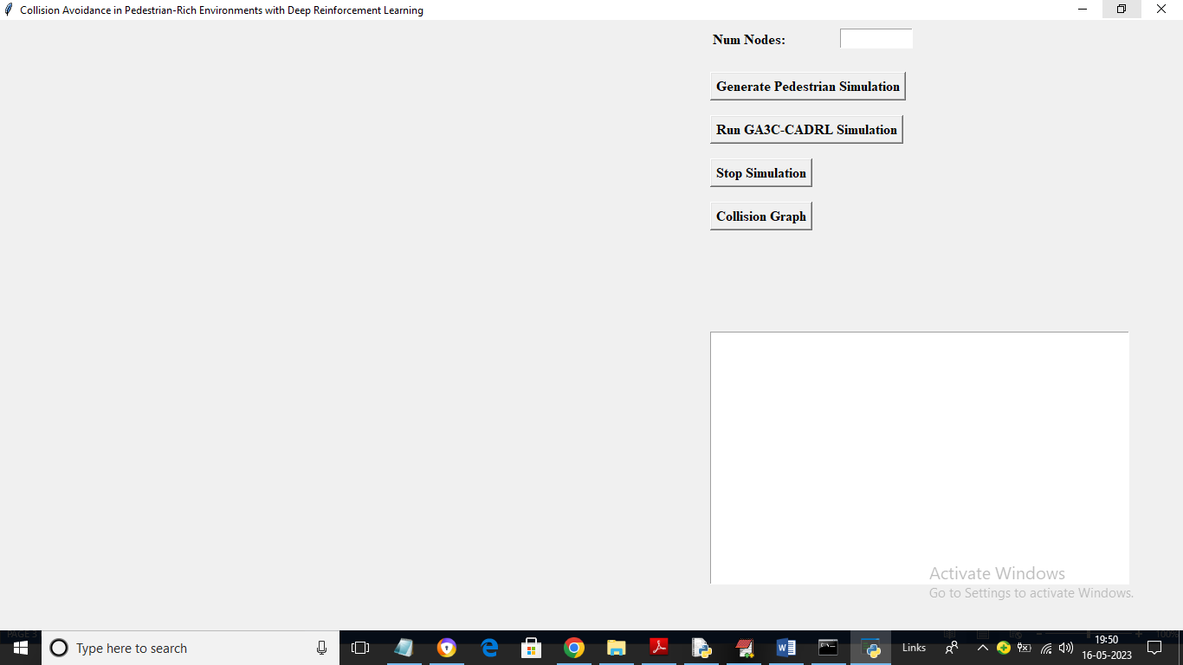

In above screen enter number of nodes as simulation and then click on ‘Generate Pedestrian Simulation’ button to generate pedestrian simulation and then will get below output

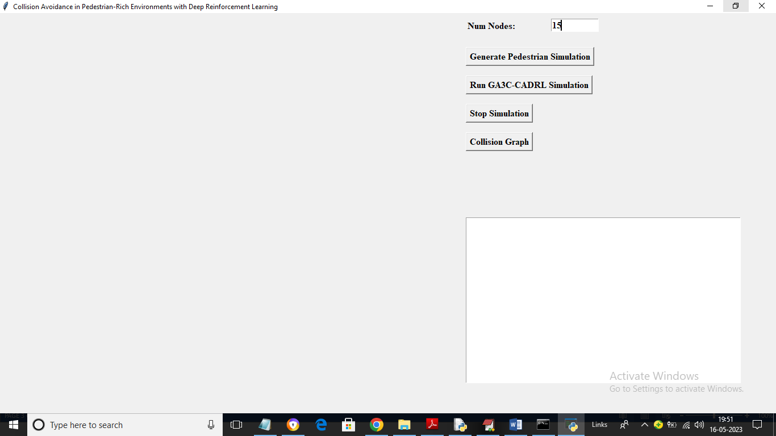

In above screen I entered number of nodes as 15 and then press ‘Generate Pedestrian Simulation’ button to get below output

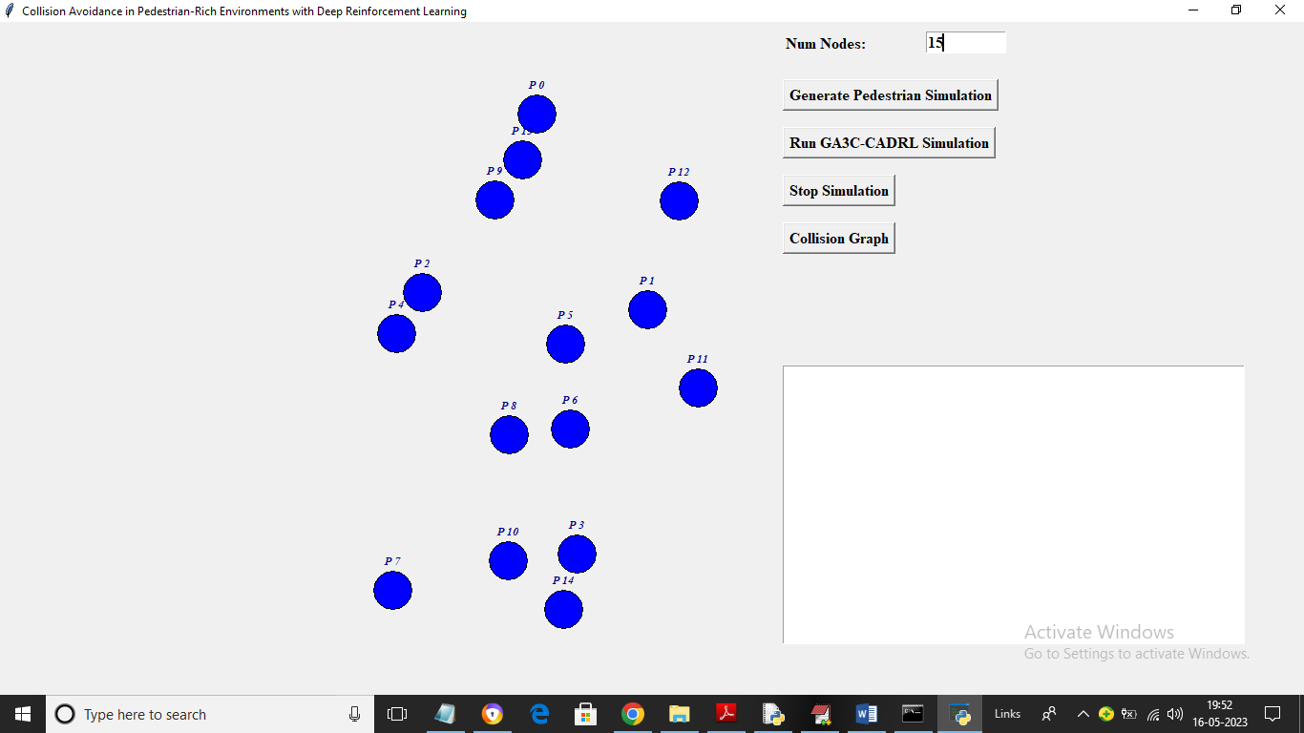

In above screen each blue circle is represented as one pedestrian and now click on ‘Run GA3C-CADRL Simulation’ button to start simulation and get below output

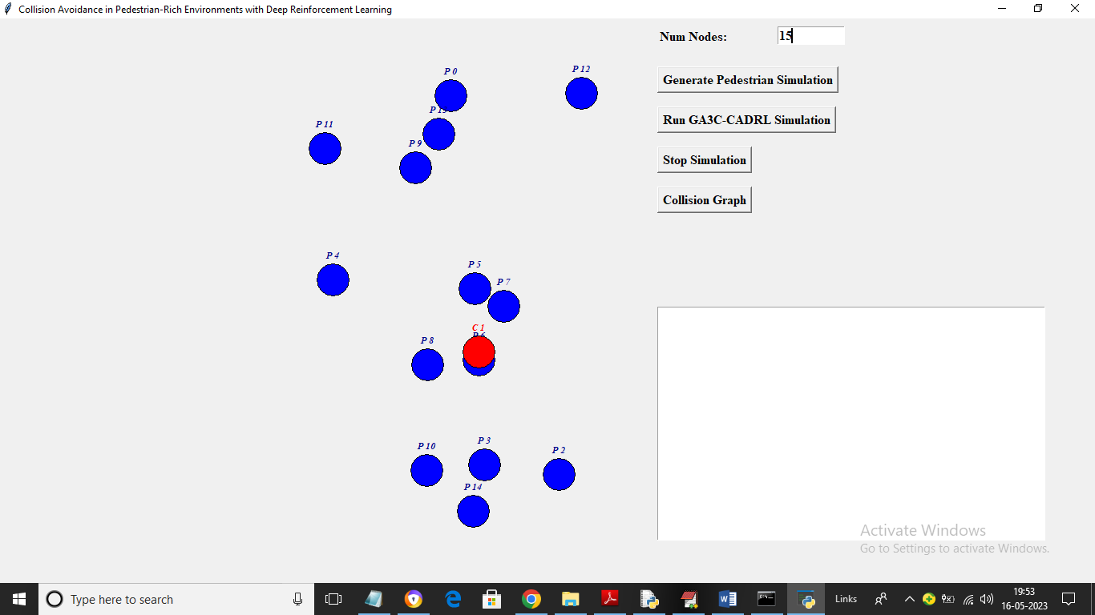

In above two screens you can see all circles are moving as their locations get changing randomly and in above screen if node is predicted as collision then algorithm will change its state to RED COLOR and then algorithm will instruct node to take another location

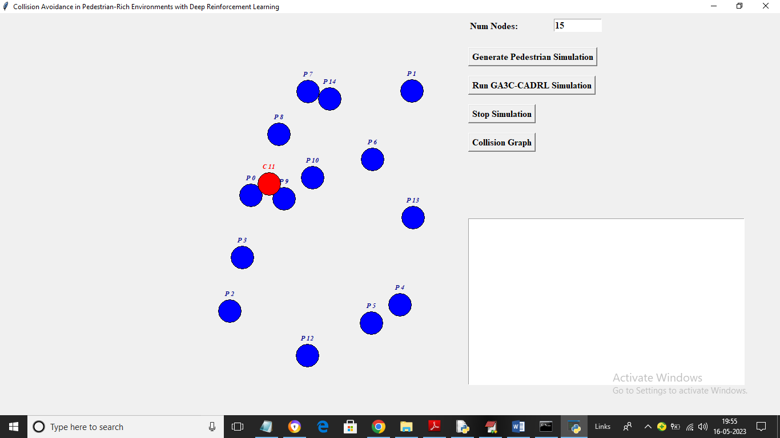

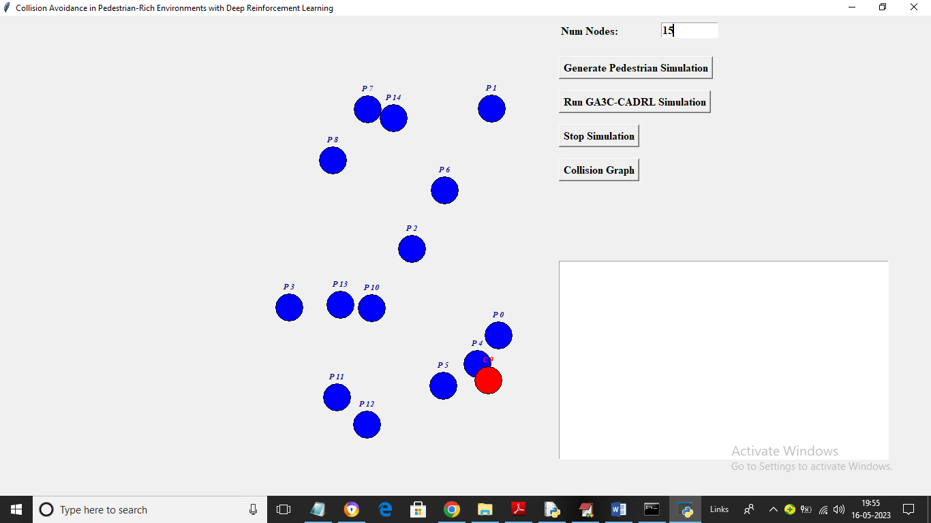

In above screens we can see all nodes are moving and now click on ‘Stop Simulation’ button to get below output

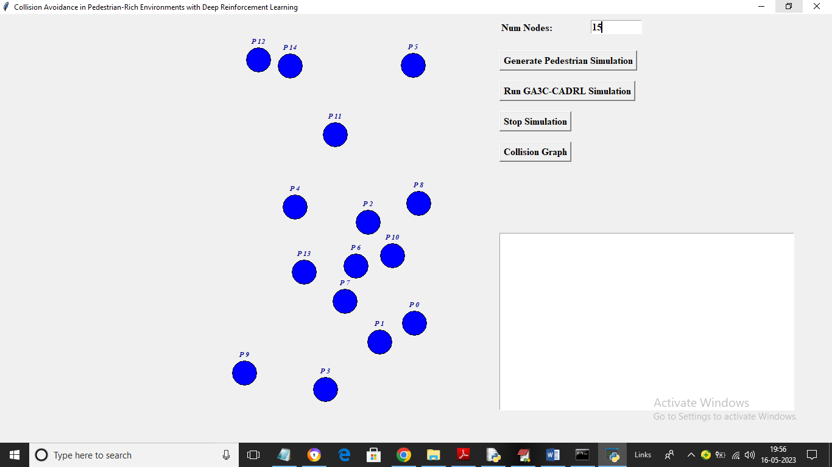

In above screen simulation get stopped and now click on ‘Collision Graph’ button to get below output

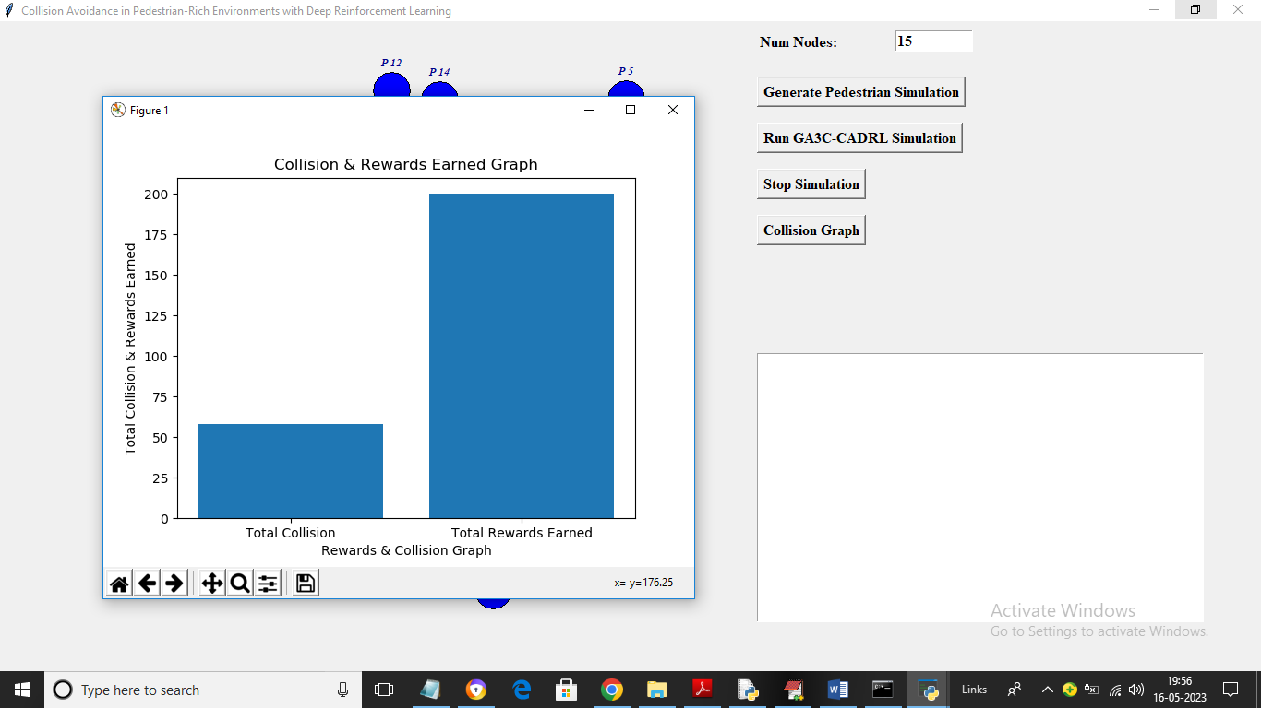

In above graph x-axis represents Collision or Rewards and y-axis represents count and we can see total rewards earned by the algorithm and total collisions occurred and predicted by the algorithm.

Similarly by following above screens you can run the project