1.Login to FIrebase

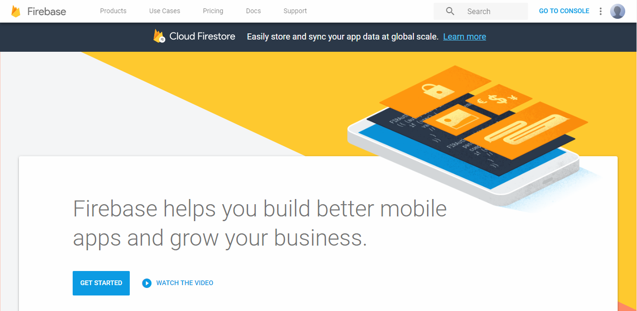

2.Go to console

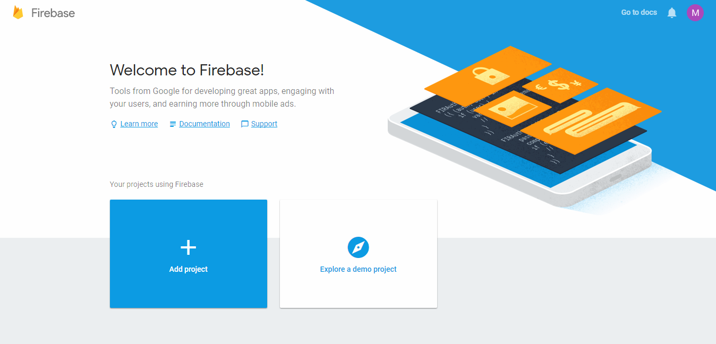

3.Add a new project

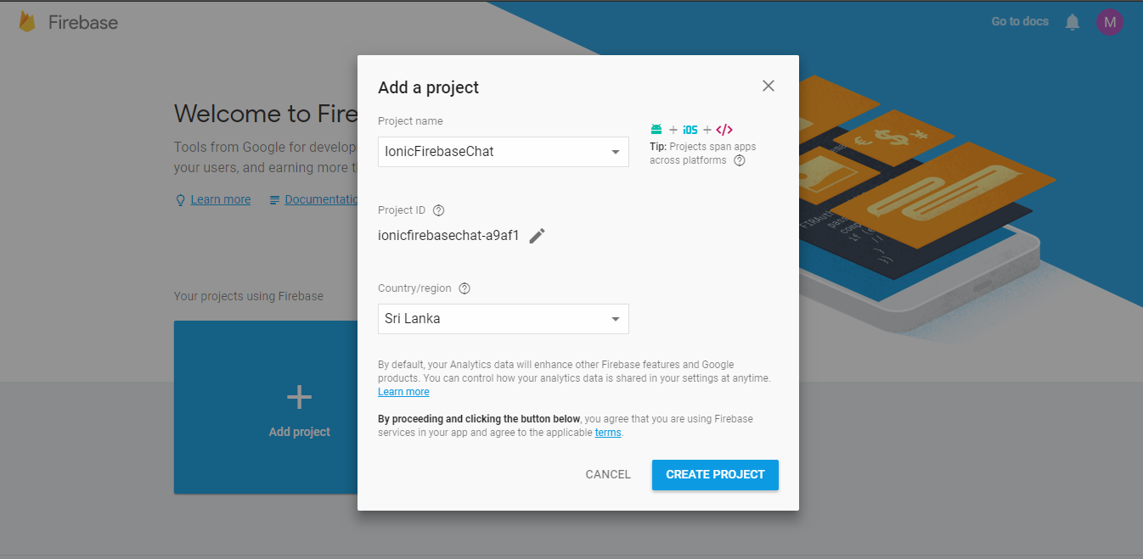

4.For Ionic project, select 3rd option(Add Firebase to your web app)

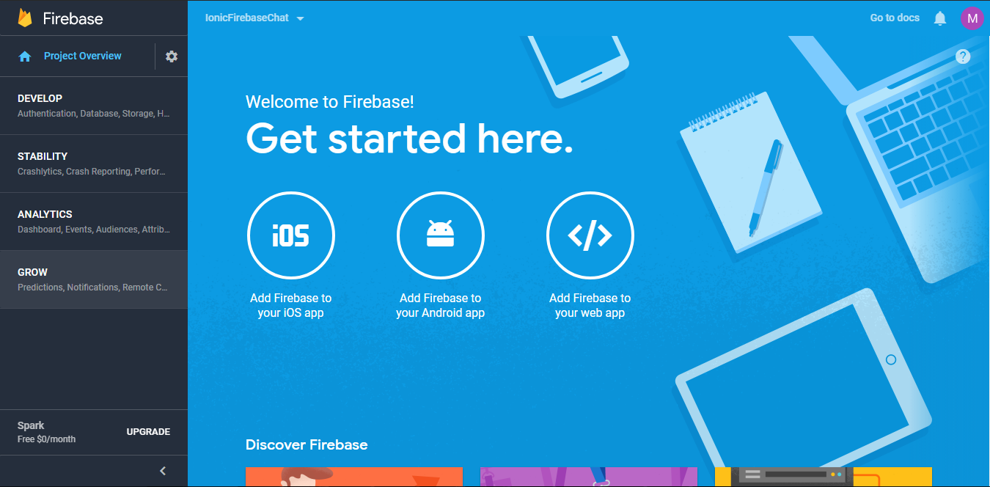

5.Copy the given showing snippet and add to index.html. In addition add AngularFire to index.html

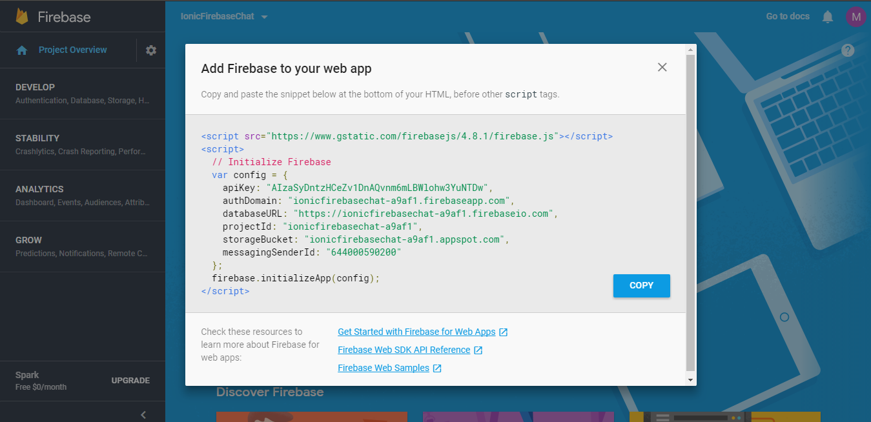

<!-- AngularFire -->

<script src="https://cdn.firebase.com/libs/angularfire/1.2.0/angularfire.min.js"></script>

6.Go to Develop -> Database and select Get Started

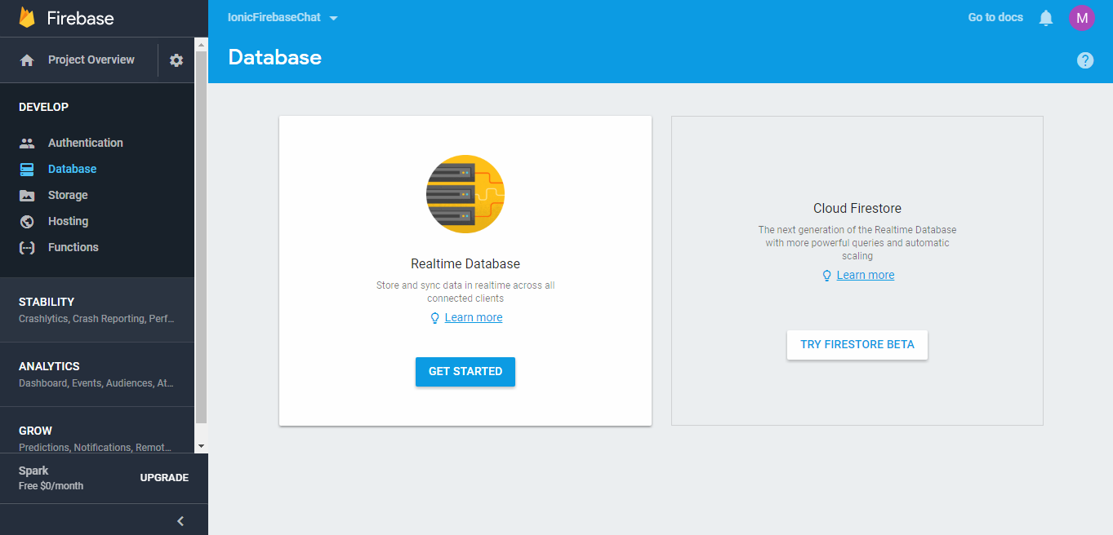

7.New DB is created

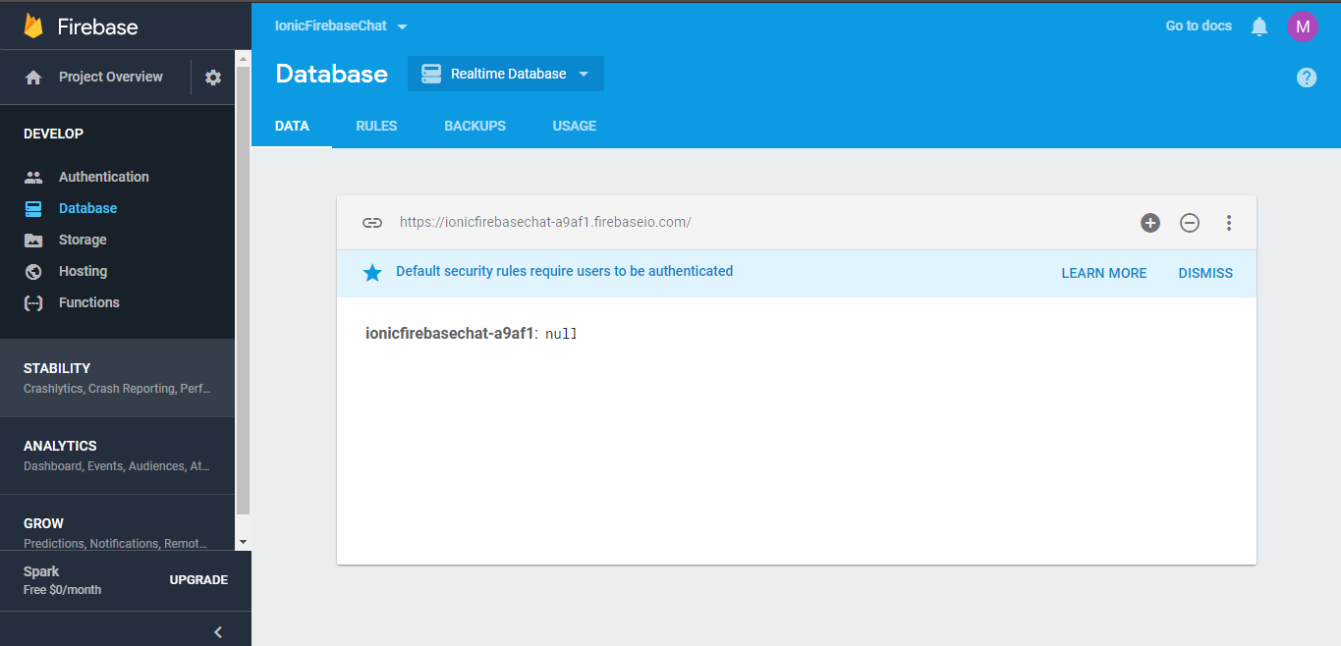

8.Go To Rules tab

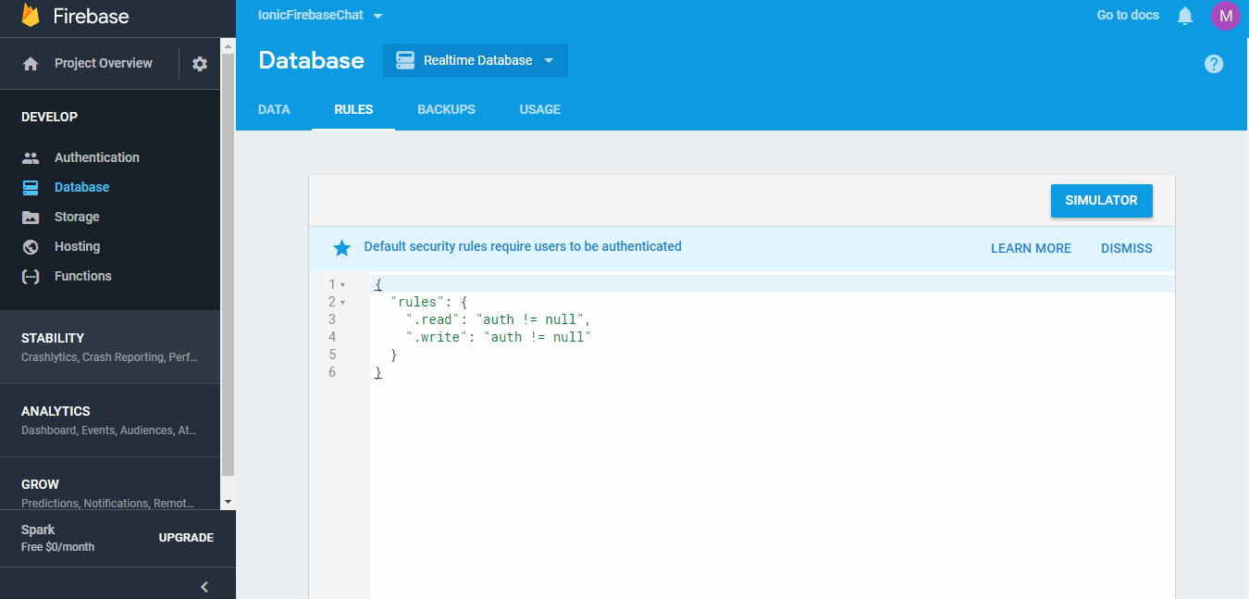

9.Change rules to not use Auth

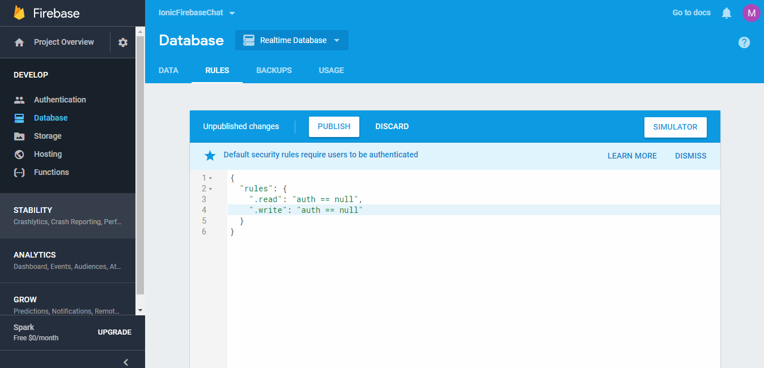

That is all you want to configure in Firebase.

After create the application, following will be the data that is stored in the real time DB

